**Question 1 :- Generate an API key with given link below**

[https://openweathermap.org/guide](https://meet.google.com/linkredirect?authuser=1&dest=https%3A%2F%2Fopenweathermap.org%2Fguide)

Print the current weather data in console- By city name, By city ID, By lat long.

**BY CITY NAME :-**

**console:**

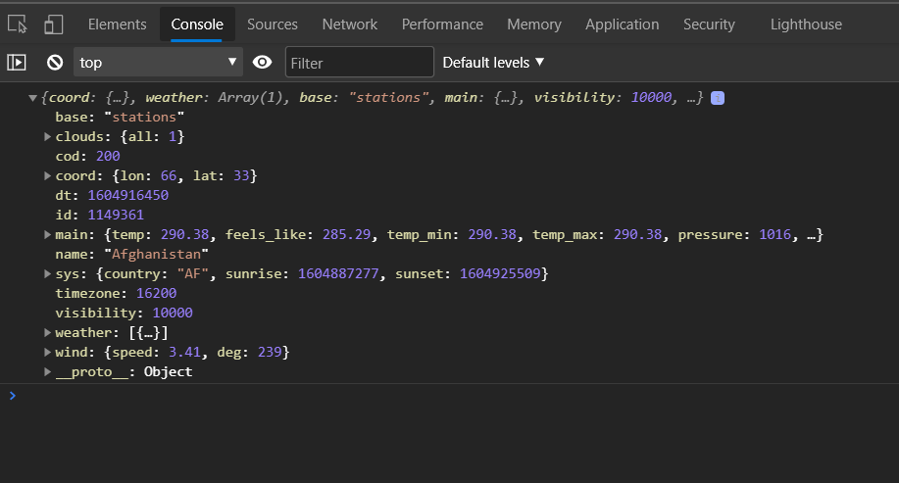

Code to print data in console by city name.

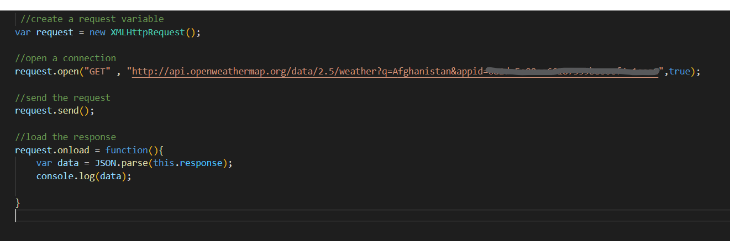

**BY CITY ID:-**

**console:**

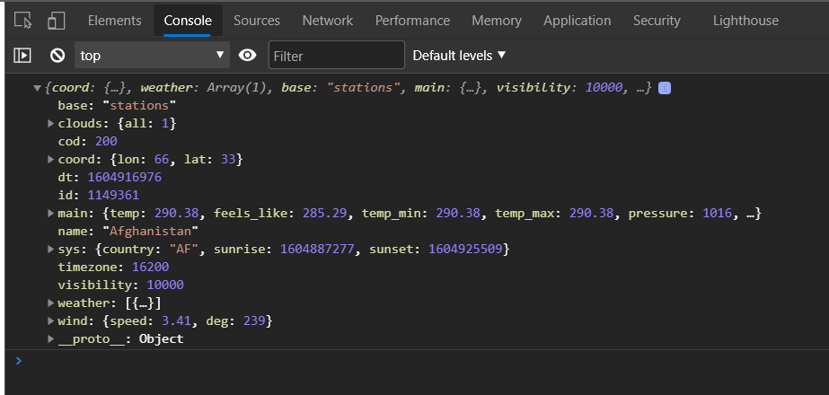

Code to print data in console by city ID.

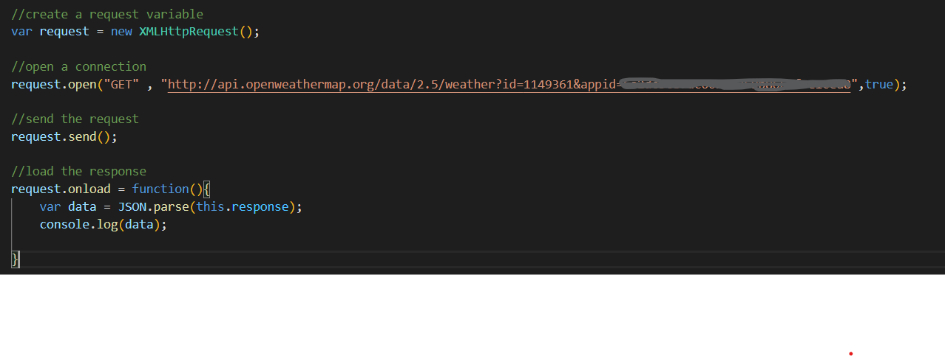

**-**

**BY GEOGRAPHIC COORDINATES(LATLONG) :-**

**Console:**

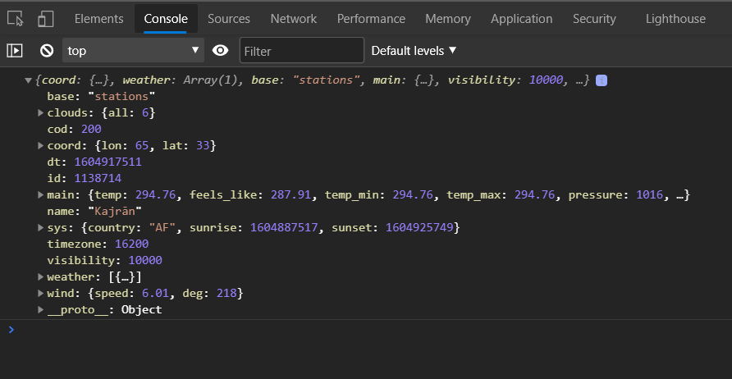

Code to print data in console by geographic coordinates.

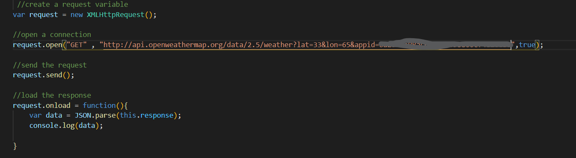

-

**Question 2. Use HTML tags to create your simple Resume**

**SAMPLE RESUME USING HTML TAGS:-**

