NEWS TODAY Tuesday

Top of Form

Bottom of Form

Top of Form

Bottom of Form

**Life Story of Ratan Tata: A Legacy of Leadership, Humility, and Vision**

**Life Story of Ratan Tata: A Legacy of Leadership, Humility, and Vision**

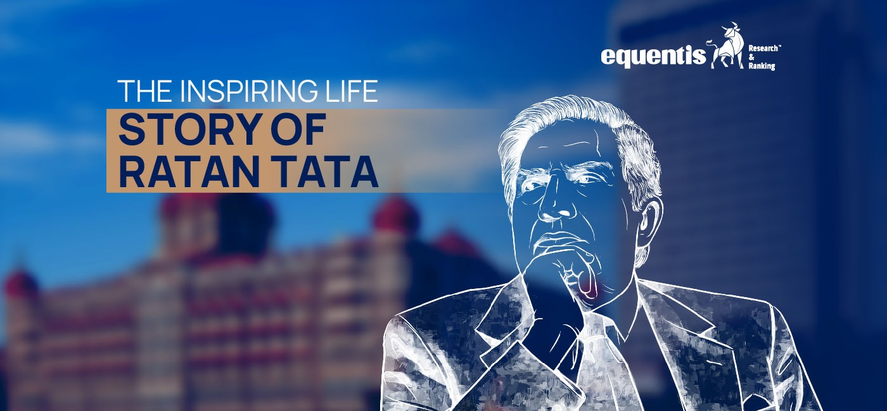

**Autobiography of Ratan Tata**

**Ratan Naval Tata, one of India’s most beloved industrialists, passed away on Wednesday at 86 at Breach Candy Hospital, Mumbai. Known for his visionary leadership, integrity, and compassion, the life story of**[**Ratan Tata**](https://www.equentis.com/blog/ratan-tatas-legacy-what-it-means-for-tata-sons-investors/)**has left an indelible mark on India’s corporate landscape and society. His legacy combines global business achievements with a solid commitment to social good and empathy for all living beings.**

**Ratan Tata Biography: Early Life and Education**

**Born on December 28, 1937, Ratan Tata grew up in the influential Tata family, known for its industrial prowess and philanthropic focus. Raised by his grandmother, Navajbai Tata, after his parents’ separation, Tata was instilled with values of service, humility, and responsibility. After completing his studies in architecture at Cornell University in 1962, Tata returned to India to**

**contribute to the family business, marking the beginning of a remarkable journey.**

**Transforming Tata Group: Strategic Acquisitions that Shaped an Empire**

**Ratan Tata’s appointment as Chairman of Tata Sons in 1991 came at a critical time when India opened its economy to global markets. Under his leadership, Tata Group transformed dramatically from a largely India-centric business into a global powerhouse. His strategic vision led to high-profile international acquisitions that expanded the group’s global footprint and showcased Indian business acumen.**

**1. Tetley Acquisition (2000):**

**The journey towards globalization began with the acquisition of UK-based Tetley Tea in 2000 for $450 million. At the time, Tetley was the second-largest tea brand globally, and this acquisition marked the Tata Group’s first major international purchase. This bold move elevated Tata Tea (now Tata Consumer Products) on the global stage and established the group’s expertise in large-scale mergers and acquisitions.**

**2. Corus Group (2007):**

**Tata Steel’s acquisition of the Anglo-Dutch steelmaker Corus for $12 billion was one of the largest deals in India’s corporate history. This strategic move turned Tata Steel into one of the world’s largest steel producers, significantly expanding its global presence. Though the global financial crisis of 2008 posed challenges for the steel industry, Tata’s long-term vision allowed the company to stabilize and build a solid international base.**

**3. Jaguar Land Rover (JLR) Acquisition (2008):**

**Perhaps the most iconic of Tata’s acquisitions was the purchase of the British luxury car brands Jaguar and Land Rover from Ford for $2.3 billion. This move elevated Tata Motors to the ranks of global automakers. It was a personal triumph for Tata, especially after earlier negotiations with Ford for the sale of Tata Motors had fallen through. Under Tata’s leadership, JLR revived its fortunes and became a key revenue generator for Tata Motors, significantly contributing to its global success.**

**4. Other Notable Acquisitions:**

**Tata Motors’ purchase of South Korean Daewoo’s commercial vehicle division and Tata Steel’s acquisition of Singapore’s NatSteel further highlighted Tata’s ambition to expand internationally. These strategic acquisitions showcased his vision of turning Tata Group into a truly global conglomerate in scale, reputation, quality, and innovation.**

**Through these acquisitions, Ratan Tata realized his dream of making the Tata Group a global entity. In his own words, “I hope that a hundred years from now we will spread our wings far beyond India.”**

**A Commitment to Philanthropy**

**Ratan Tata’s leadership was not solely about corporate expansion; he was equally committed to uplifting society. Deeply rooted in the Tata family’s philosophy of giving back, he channeled much of the group’s wealth into philanthropic initiatives. Over 65% of Tata Sons’ ownership is held by charitable trusts, and through these trusts, Tata invested heavily in education, healthcare, rural development, and more.**

**1. Education:**

**Ratan Tata believed that access to education was essential for India’s development. He funded scholarships, including the Tata Scholarship for students at Cornell University, ensuring Indian students from economically weaker backgrounds could pursue higher education at top institutions. Tata Trusts also supports various initiatives in India to improve literacy and educational infrastructure in rural and underserved areas.**

**2. Healthcare:**

**Tata’s contributions to healthcare are vast, including developing cancer treatment centers, hospitals, and research facilities across India. The Tata Memorial Centre in Mumbai, one of India’s leading cancer research and treatment hospitals, is a testament to the group’s commitment to health. Tata Trusts have also contributed to improving maternal and child healthcare and combating malnutrition in rural India.**

**3. Social Development:**

**Tata’s philanthropy touched millions, from rural development projects to disaster relief efforts. His initiatives aimed at empowering rural communities, promoting sustainable farming practices, and improving sanitation and drinking water access have had a long-lasting impact on Indian society.**

**In 2020, during the COVID-19 pandemic, Tata pledged significant donations to support relief efforts, showcasing his unwavering commitment to society’s well-being.**

**A Deep Compassion for Animals**

**The Ratan Tata story would be incomplete without the mention of his compassion towards animals, especially dogs. His love for dogs is well-known, and throughout his life, he actively supported initiatives to protect and care for animals.**

**1. Bombay House Kennel:**

**In 2018, Tata ensured that a dedicated kennel was built at Bombay House, the Tata Group’s iconic headquarters, to provide shelter for the stray dogs that frequented the premises. This gesture symbolized his empathy and deep love for animals, as he ensured that these often-overlooked creatures had a safe and comfortable place.**

**2. Small Animal Hospital:**

**In July 2023, Ratan Tata inaugurated India’s first state-of-the-art Small Animal Hospital in Mumbai. The hospital spans 98,000 square feet and offers advanced treatments, including ICUs, CT scans, and specialized care for pets. This hospital highlights Tata’s love for animals and reflects his commitment to improving the lives of all beings, human and animal alike.**

**A Legacy Beyond Measure**

**Ratan Tata stepped down as Chairman of Tata Sons in 2012, but his influence continued as Chairman Emeritus. Under his leadership, Tata companies became global giants, and his name became synonymous with trust, innovation, and ethical business practices.**

**In addition to his business acumen, Tata’s legacy is defined by his humility, philanthropy, and genuine care for people and animals. His passing leaves a void, but his life’s work continues to inspire countless entrepreneurs, business leaders, and ordinary citizens.**

**Tata once said, “I don’t believe in making the right decisions; I make them and then make them right.” This philosophy, combined with his relentless drive for excellence and compassion, ensures that his legacy will endure for generations.**

**For a deeper dive into his extraordinary journey, readers can explore A.K. Gandhi’s bestseller, “A Complete Biography of Ratan Tata.”**

**The Life Story of Ratan Tata: An Inspiring Journey**

**The life story of Ratan Tata is a tale of remarkable achievements, unwavering integrity, and boundless compassion. From transforming the Tata Group into a global conglomerate to his deep-**

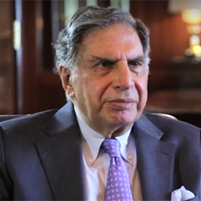

**His story embodies the ideals of leadership, vision, and humility, demonstrating how one man’s dedication can impact millions. As we reflect on his legacy, it is clear that Ratan Tata’s life was not just about business success but about creating a lasting difference in the world. His legacy will forever remain a guiding light for future**

**generation.**