**Creating Dashboard in Tableau**

Data Source is created by writing a custom SQL query joining FactSales, Channel, Date, Product dimensions, Store, Geography, Promotion. Created a Custom SQL (Data-> Covert to Custom SQL) and removed unnecessary attributes. It is then changed to Extract, there by adding filters to extract: Year =2008 to 2009, Region = United States, State = Washington, Channel =Store. This results in the extract that stores relevant data, there by avoiding the irrelevant data, storage and performance issues.

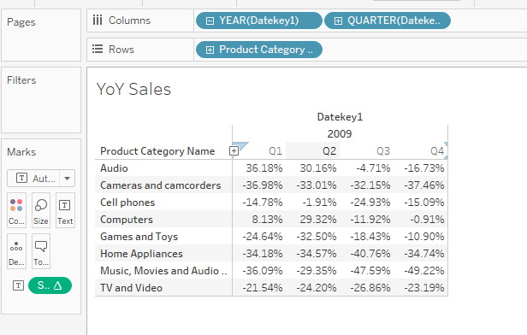

The above figure gives the change in difference of the quarters from the previous year, i.e. difference in Q1 sales of 2009 in comparison to Q1 sales of 2008. This figure gives the details of how have the sales in each Quarter across different product categories compared to the same Quarter in the previous year.

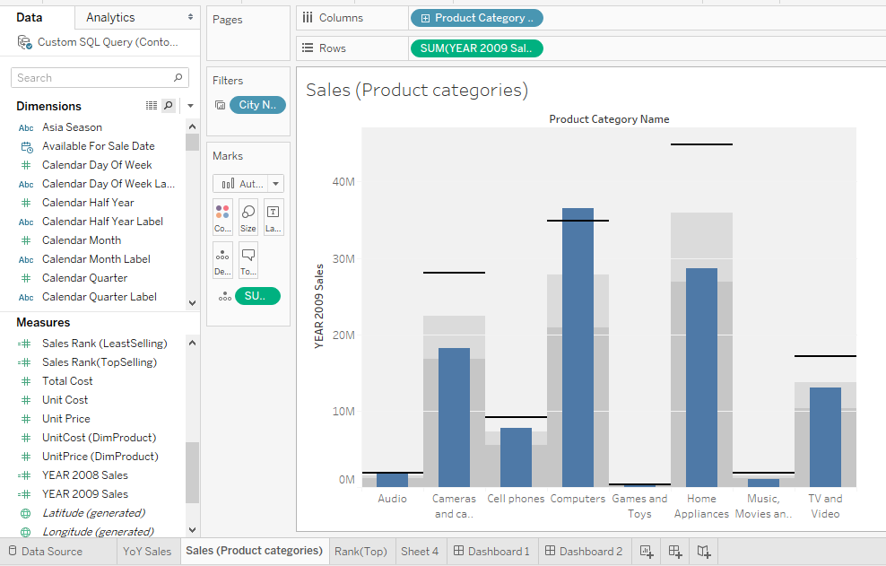

With the help of two calculated fields of: year 2008 Sales and Year 2009 Sales, the above figure gives the bullet graph depicting 2009 Sales as Bar graph while the lines in the figure shows the 2008 Sales (targets). It can be noted from the figure that Cameras & Camcorders, Home Appliances and TV & Video product categories are far from reaching the 2008 targets unlike the Computers, Audio and Games & Toys.

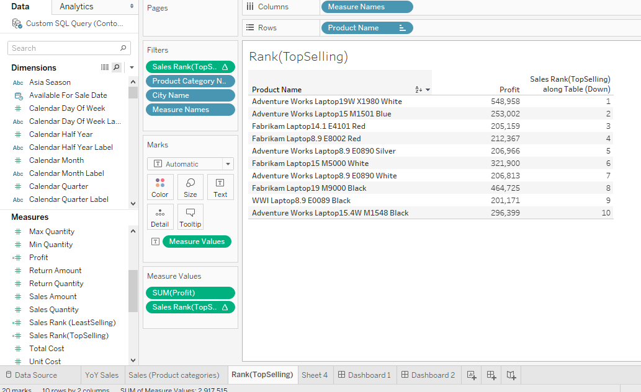

The figure above gives the top 10 selling products. It shows the top selling products as laptops, but to get a glimpse of the top selling products of different categories, we can apply filter on product category. The below figure shows one such filter application on different categories.

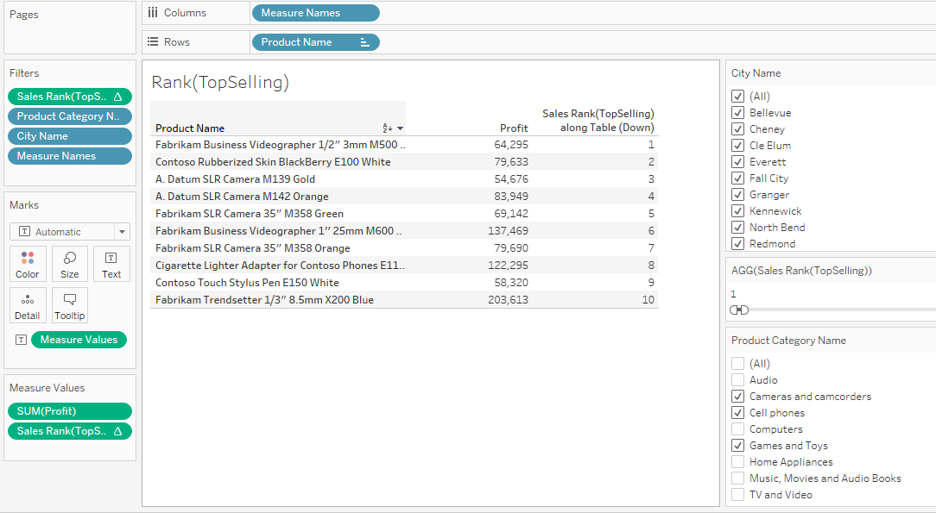

**10 Least Selling Products**

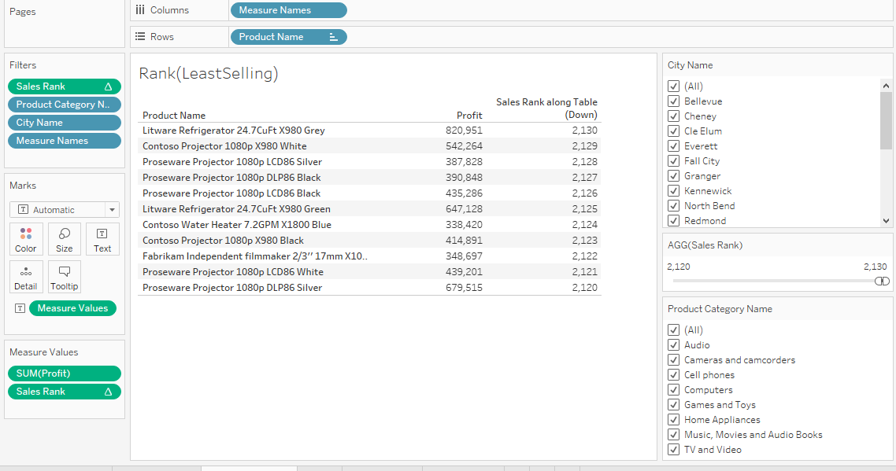

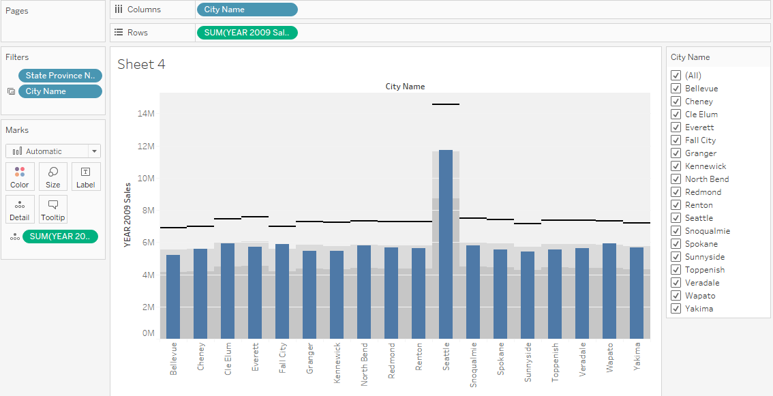

This figure shows us bullet graph that shows for each city the sales of 2009(current performance) with respect to 2008 targets.

**DASHBOARD** (Changing filters would give the insights w.r.t product categories & sales across cities)

