**PROJECT**

1. **Screenshot of Tableau Data Source view showing Tables and Joins from Contoso DW**

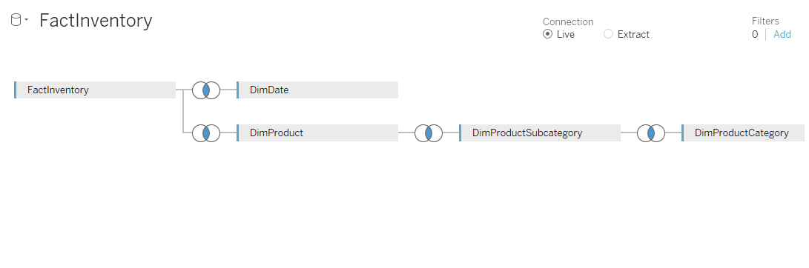

**Joins:**

Inner join of FactInventory and DimDate: Date Key = Date Key

Inner join of FactInventory and DimProduct: Product Key = Product Key

Inner join of DimProduct and DimProductSubCategory: Product Subcategory Key = Product Subcategory Key

Inner join of DimProductSubCategory and DimProductCategory: Product Category Key = Product Category Key

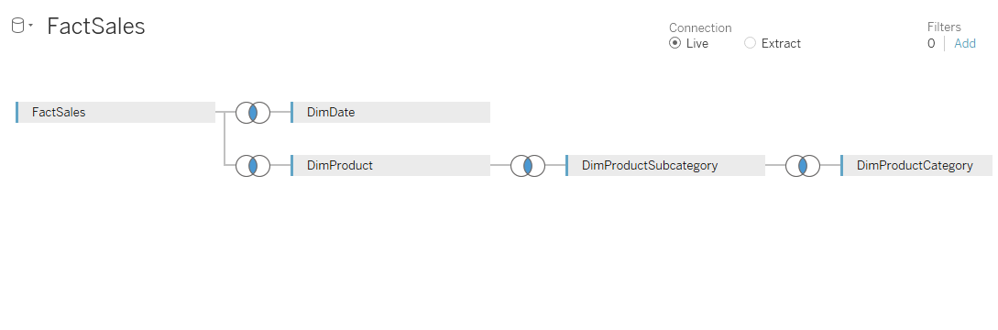

**Joins:**

Inner join of FactSales and DimDate: Date Key = Date Key

Inner join of FactSales and DimProduct: Product Key = Product Key

Inner join of DimProduct and DimProductSubCategory: Product Subcategory Key = Product Subcategory Key

Inner join of DimProductSubCategory and DimProductCategory: Product Category Key = Product Category Key

1. **Screenshot of Worksheet 1 with Category as Rows and Months of 2009 as Columns**

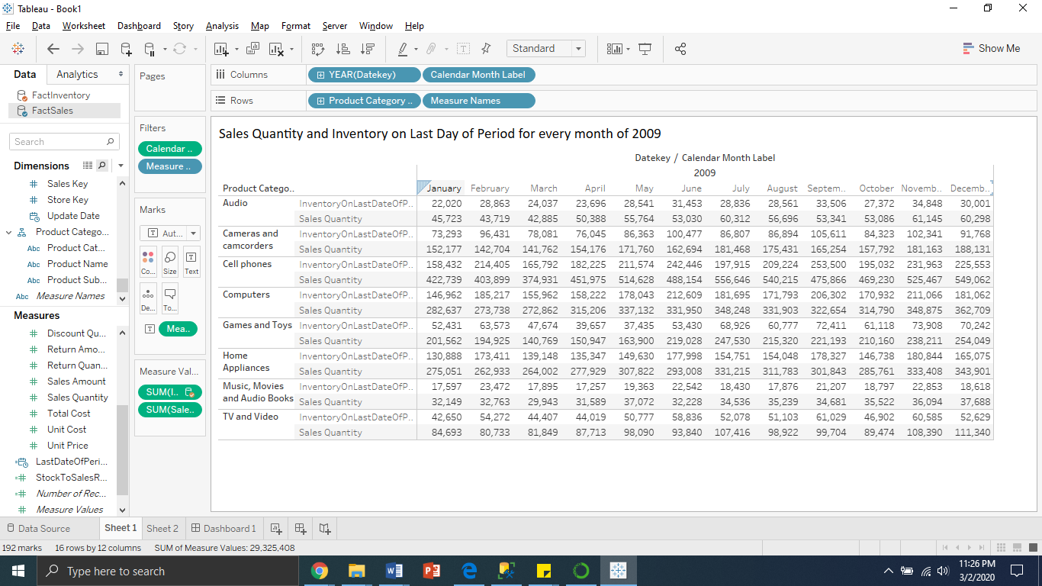

1. **Screenshot of Worksheet 2 with Line graphs of Stock to Sales ratio for each Category across months for 2009**

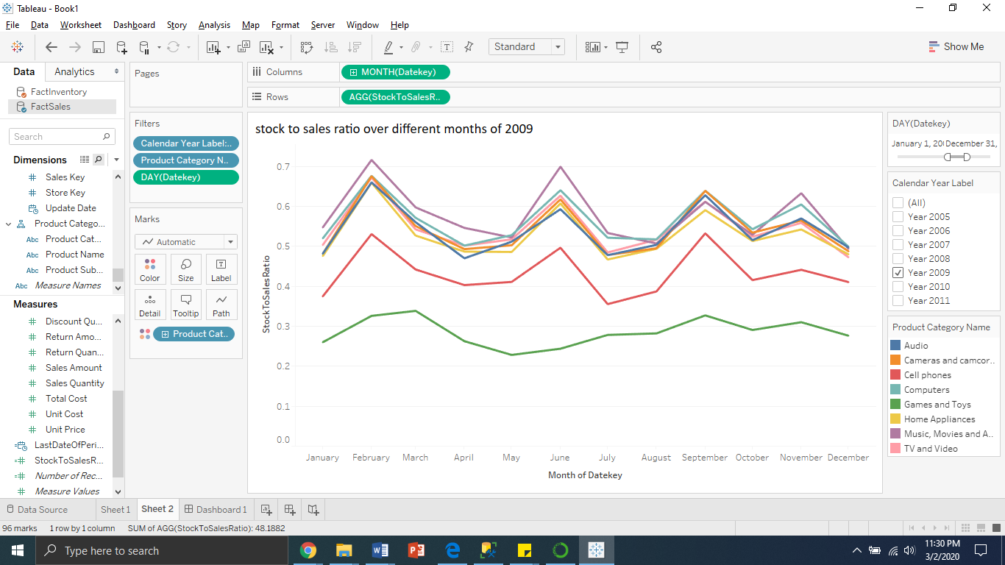

1. **Brief summary of analysis of stock to sales ratio (SSR)**

As the retail stores stock up on the products at the beginning of November(season), the stock to sales ratio is expected to increase. But it is expected to reflect a trend downward towards end of December(season) as inventory depletes. Based on the result of worksheet1 and worksheet2, stock to sales ratio trends of different products within the Audio category, Bluetooth headphone subcategory are analyzed. On filtering the Months to October, November and December (Thanksgiving-Christmas Holiday Season) for the Year 2009; Category – Audio, Subcategory – Bluetooth Headphones and products that fall under this subcategory. Following observations and deviations are identified:

Note: October-November, November-December are the two months considered as Holiday Season.

1. **Product: NT Bluetooth Active Headphones E202 Black**

Fig-a.1: It displays the stock to sales ratio of October, November and December for 2009

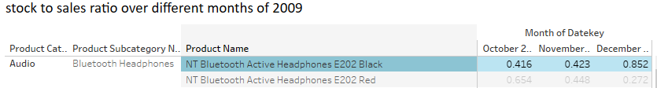

Fig-a.2: Graphical representation ofstock to sales ratio of October, November and December for 2009

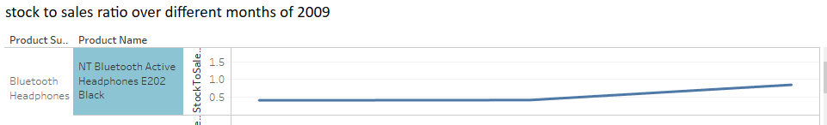

Fig-a.3: It displays Inventory on Last date of period and Sales Quantity - October, November and December for 2009

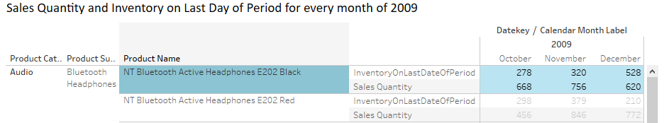

According to the visualization of the data, figures above show a deviation in the trend during holiday season. It can be examined that stock to sales ratio for the product “NT Bluetooth Active Headphones E202 Black” has raised from 0.423 in November to 0.852 in the month of December. This deviation can be attributed to lower sales of 620 in December, when compared to 756 in November 2009.It can also be looked from the perspective of stocking up Inventory of 528 in December compared to 320 in November 2009.

1. **Product: WWI Stereo Bluetooth Headphones E1000 White**

Fig-b.1: It displays the stock to sales ratio of October, November and December for 2009

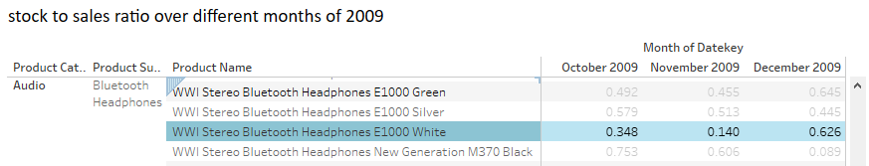

Fig-b.2: Graphical representation ofstock to sales ratio of October, November and December for 2009

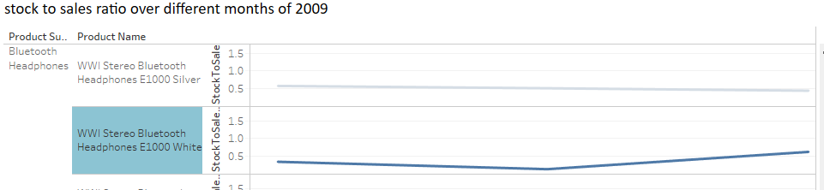

Fig-b.3: It displays Inventory on Last date of period and Sales Quantity - October, November and December for 2009

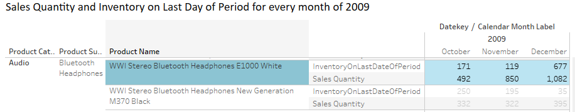

According to the visualization of the data, figures above show a deviation in the trend during holiday season. It can be examined that stock to sales ratio for the product “Product: WWI Stereo Bluetooth Headphones E1000 White” has raised from 0.140 in November to 0.626 in the month of December. This deviation can be attributed to stocking up Inventory of 677 in December compared to 119 in November 2009.

1. **Product: WWI Wireless Bluetooth Stereo Headphones M170 Pink**

Fig-b.1: It displays the stock to sales ratio of October, November and December for 2009

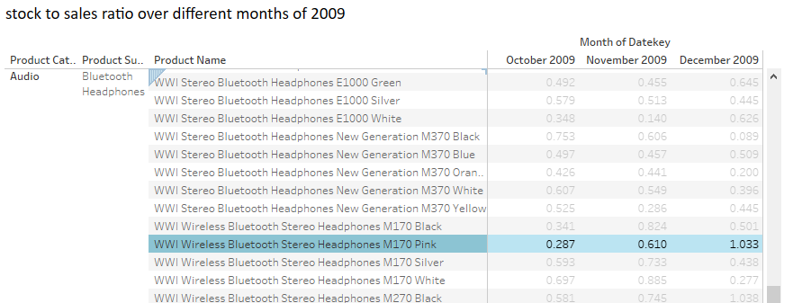

Fig-c.2: Graphical representation ofstock to sales ratio of October, November and December for 2009

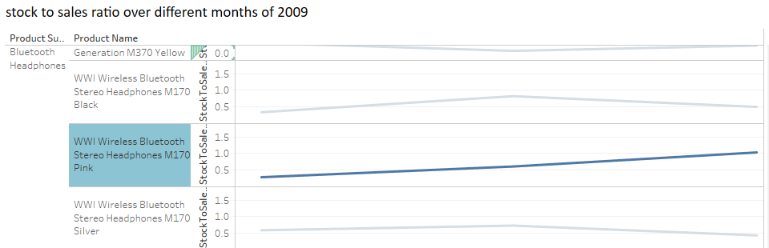

Fig-c.3: It displays Inventory on Last date of period and Sales Quantity - October, November and December for 2009

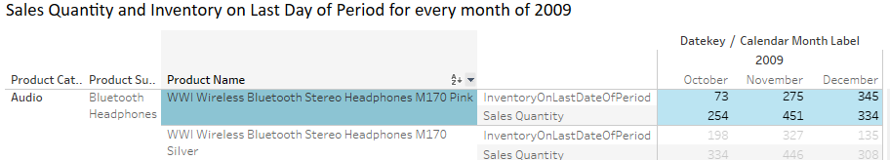

According to the visualization of the data, figures above show a deviation in the trend during holiday season. It can be examined that stock to sales ratio for the product “WWI Wireless Bluetooth Stereo Headphones M170 Pink” has raised from 0.610 in November to 1.033 in the month of December. This deviation can be attributed to lower sales of 334 in December, when compared to 451 in November 2009.It can also be looked from the perspective of stocking up Inventory of 345 in December compared to 275 in November 2009.