

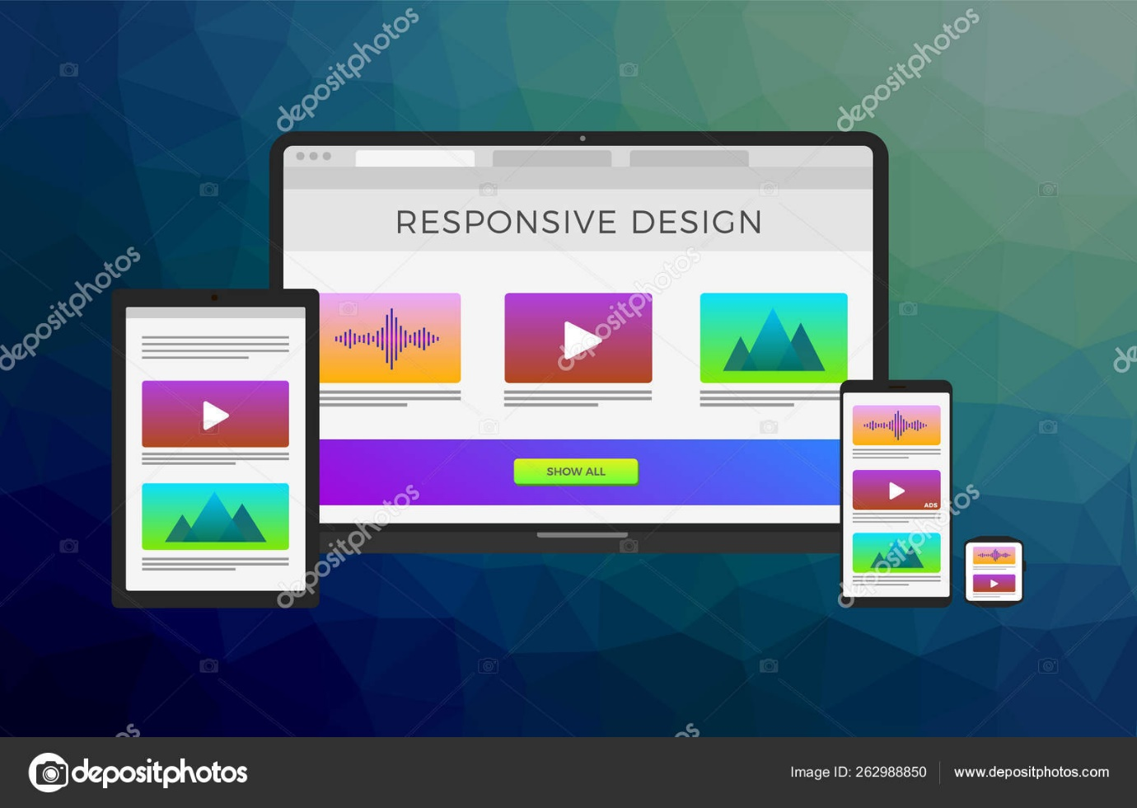

**Software Engineering Iteration 0 Report**

**Project Name: Bidwork**

**Client: TAMU Business School Mays**

Team Members:

Sorush Omidvar

Seyedhooman Sajjadi

Ruben Lopez V

Shrinath Prahalathan

Zhenyu Wu

Rahul Sridhar

* Customer Meeting Time and Zoom link:

Wednesday 3:30-4 PM

<https://tamu.zoom.us/j/93688045175>

* Pivotal tracker

<https://www.pivotaltracker.com/n/projects/2467299>

Dr. Walker has been already added to the account

* Github repo:

<https://github.com/somidvar/team01>

[git@github.com:somidvar/team01.git](mailto:git@github.com:somidvar/team01.git)

* Project Summary

BidWorkis a website that allows multiple users to bid for a common shared resource. Imagine an IT support department at a corporation that must serve multiple departments. The website will operate an auction where buyers (of time) can bid on blocks of time of the seller. The auction will be a reverse Dutch auction, where prices start high and fall until the market clears. Once finished, the website will be implemented at the Mays Business School, where a single data scientist from the Texas Institute of Data Science (TAMIDS) serves multiple faculties. Below is a description of the problem, as well as some simple analytics. This ultimately will be a part of a larger research project on auction design and computation.

Organizations of all kinds must share common resources to individuals. For example, corporations employ IT support departments to serve multiple departments. Traditionally, these central resources have been allocated based on priority or on a first come, first serve basis. However, such allocation mechanisms suffer from the public goods problem, in which individual agents acting in a selfish and decentralized way will over-consume the shared resource. A price mechanism can be effective in better allocating this common resource, as it forces individuals to pay for their usage. We implement such a mechanism through a reverse Dutch auction, in which a single seller auctions blocks of time to several buyers. We develop theoretical properties of this auction and provide a design of the actual website, as well as experimental results on the performance of the auction.

* User Stories

In this project, we implement several numbers of features. All features implemented will be deployed on our website online.

**Feature 1: Home Page**

As an user

I should be able to see the home page when I enter the main internet address of the auction website.

So that I will be able to see all the services on the website.

Description: The home page is the entry point to access all the main services:

. Register

. My personal page

. Browse

. Help

The home page is referred by the main internet address of the auction site : www. Bidwork

**Feature 2: Registration**

As an user,

I want to register

So that I would be able to login

Description : The registration page is meant for the user to provide his/her personal data, and receive a user ID and a password. The user ID and the password allows the user to have access to his/her personal page and to take part in the auction.

**Feature 3: Registration form**

As an user,

I should fill the registration form

So that I could create an account

And I would be able to take part in the auction

Description: The registration page contains the information such as the First Name, Last Name, Birth Date, Address, SSN, Phone, Email ID, Credit card details, user ID, password and confirm password. It performs basic checks on the entered data,and it provides user registration or an error message if the user id and /or user SSN are already present in the system

**Feature 4: Login**

As an user,

I should be able to login

So that I would be able to access my personal page and buying time

Description: Every time the user tries to access the areas (i.e, personal page, buying time), he/she is asked to provide his/her user ID and password . These are entered through a form. If user ID and password are correct, the user will be logged in, else an error message will be displayed. The user is no longer asked to login throughout the session.

**Feature 5: Personal page**

As a user,

I want to view the seller’s time I bought in the past and currently available

So that I can plan which time to buy

Description: The user will be able to access his personal page, by providing his user ID and password. The personal page contains information about the time the user bought in the recent past and is presently trying to buy.

**Feature 6: Browse**

As an user,

I want to view the available seller’s time

So that I can plan which time to buy

Description: The users can look at the times on auction, navigate them by the start and end date. Browsing capabilities are available to registered and unregistered users.

**Feature 7: Bidding view**

As a bidder,

I would like to see the bidding view

So that I will be aware of the Available hours and the Current price per hour

Description: The bidding view consists of a table, which includes the Week no., the available hours for that week and the current price per hour. This will help the bidders in submitting their bids, where they will specify the number of hours they would like for the week, and the maximum price he/she is willing to pay per hour. This also contains the button “ PLACE YOUR BID”, where the bidder can submit their bid.

**Feature 8: Bid**

As an user, I want to make a bid when I am logged in

So that when my bid gets accepted, it will be displayed on my personal page and

The status will be updated on the bidding view

Description: The user who makes a bid is asked to login, if not already logged in. Once the user’s bid is accepted by the system, that specific time is listed in the user’s personal page, and the status is updated in the bidding view. The bid should be at least one bid increment above the current price. The bidder could also set a maximum bid price.

**Feature 9: Help**

As an user,

I want a help button

So that I get tips on how to perform all possible actions on the website

Description: The system must provide certain tips, explaining how to perform all possible actions such as registering, making a bid etc.,The contact details, such as phone and email should be provided.

**Feature 10: Administration activities**

As an administrator,

I want to have administrative rights

So that I can have privileges to manage the auction

Description: The system administrator is the person responsible for the entire system functionality. He could access the system through a specific administrator ID and password. The administrator is allowed to add new times, updating current times, deleting times etc., The administrator must be able to access user’s data, according to different searching criteria such as by name,by user ID, by address etc.,

In addition, the administrator must have an interface, where she/he can select a budget for each registered user and a panel to select the auction parameters.

**Feature 11: Bid status**

As an user,

I want to receive email notifications and text message for my bid status

So that I remain informed when not using the website

Description: The users are asked, if they are willing to receive email notifications and text messages, about their bid status.

**Feature 12: Seller**

As a seller,

I would like to enter the units to be auctioned,

So that the buyers will be able to input their bid

Description: The seller inputs the units to be auctioned on her interface. She should also be able to see the current winning bids on her dashboard.

* Lo-fi User interface:

Please see below for the lo-fi UI.

