**Pipelines:- Assignment-1:-**

creating a pipelines , dev, test, prod we have to clone it.

and creating branches then releasing it.

After creating webapp- in deployment – add a deployment slot as dev and test, then goto overview and copy paste the default domain link in browser

**Steps:**

1. Navigate to Dev.azure.com and create a project

2. Clone a project

3. Create 3 branches - test,dev and prod

4. Create a CI pipeline for Prod, Test, Dev

a. Go with classic editor

b. Choose the branch as(test, dev, prod)

c. Chose template (ASP.Net Core (.net framework ))

d. Choose Agent Specification as Windows-Latest instead of windows-2019

e. Chooose nuget at 6.0.0

f. Save it

You've to repeat Step 4 this 3 times for test, dev and prod pipeline

5. Create a web app with -

a. Code stack - Dotnet 6

6. Create deployment slots as dev and test

5. Create a release pipeline by clicking on Release

**ScreenShots:**

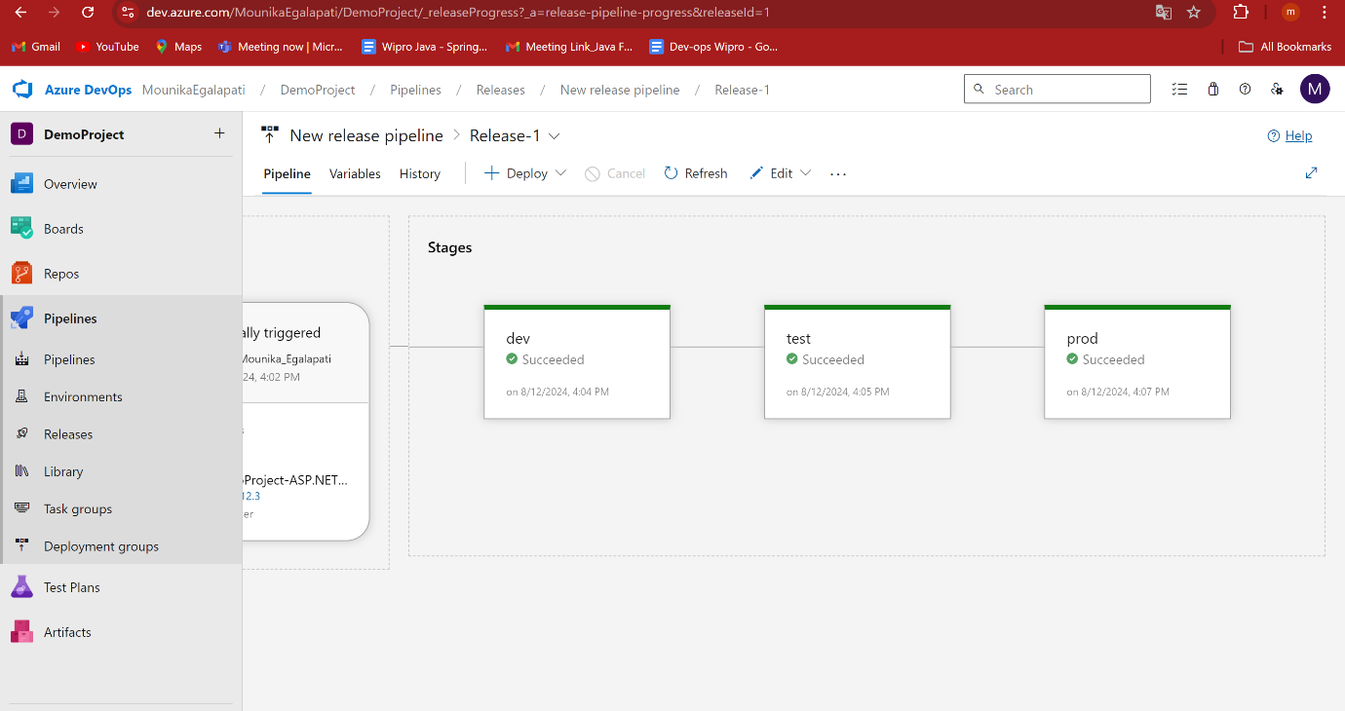

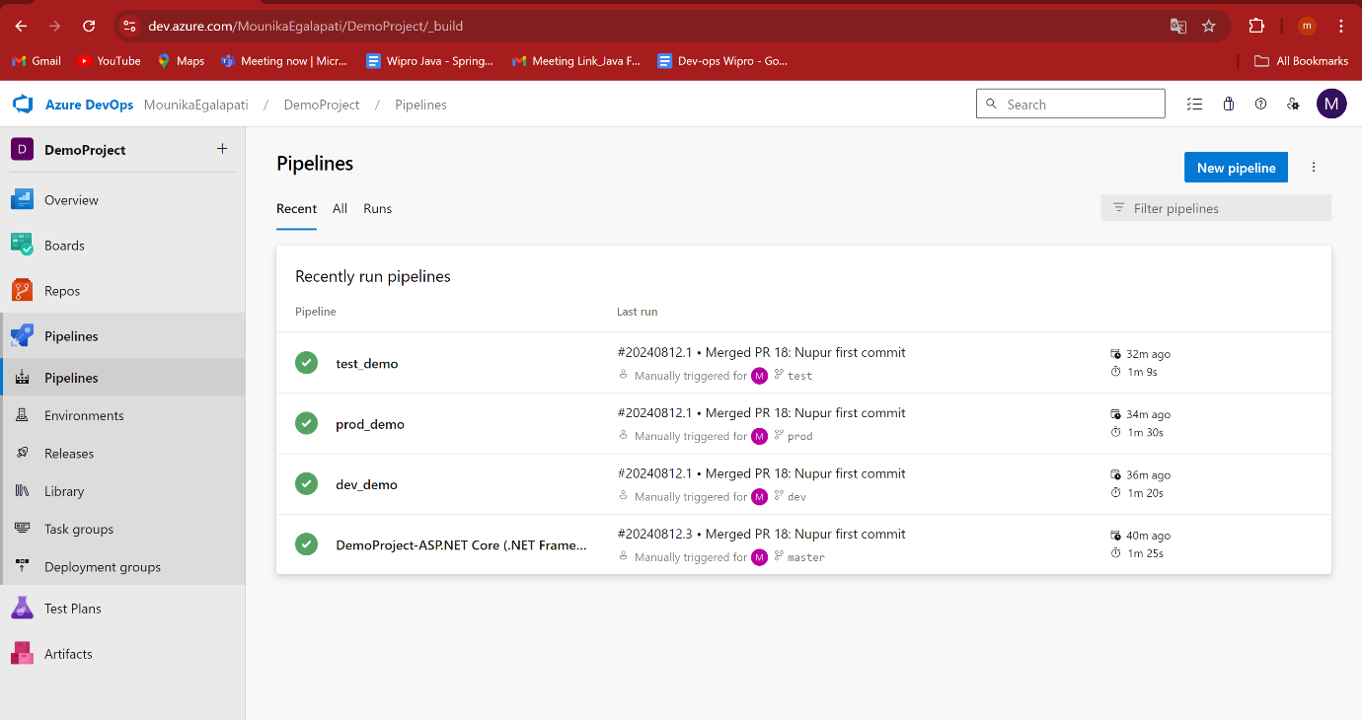

Test-output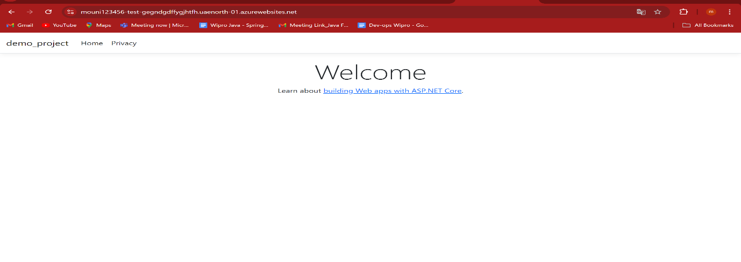

Prod-output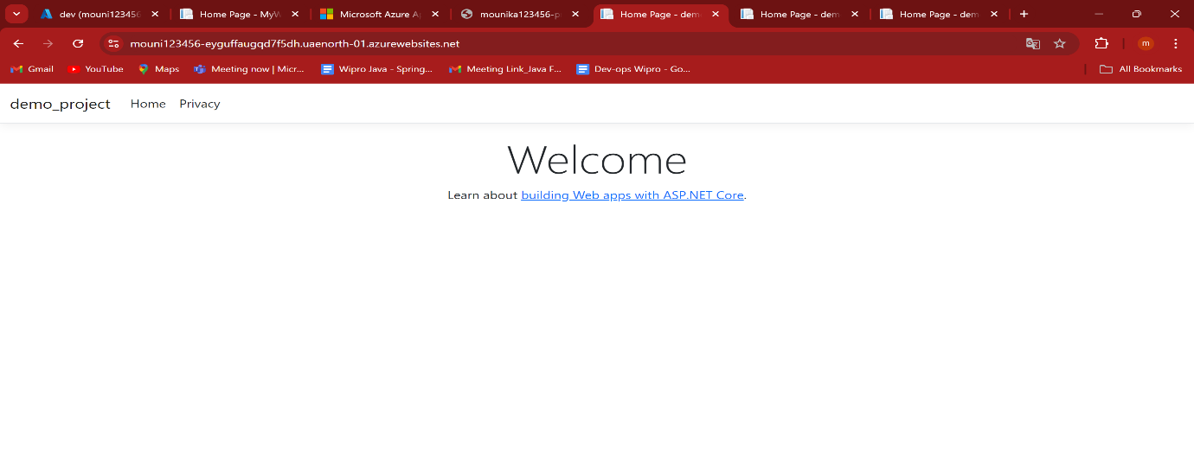

Dev-output

