VPC

Go to AWS management console

VPC dashboard

Select VPC

Launch VPC

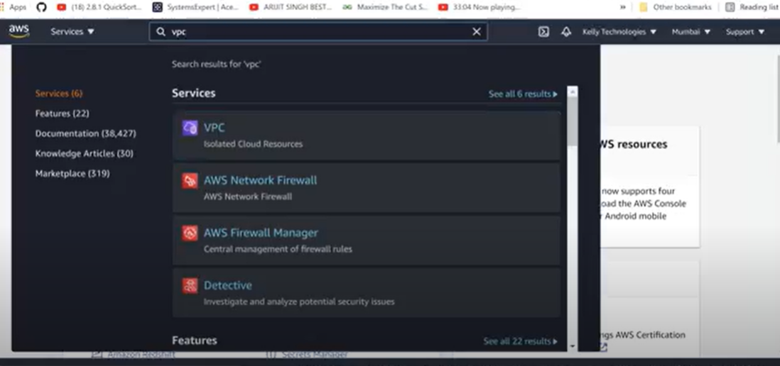

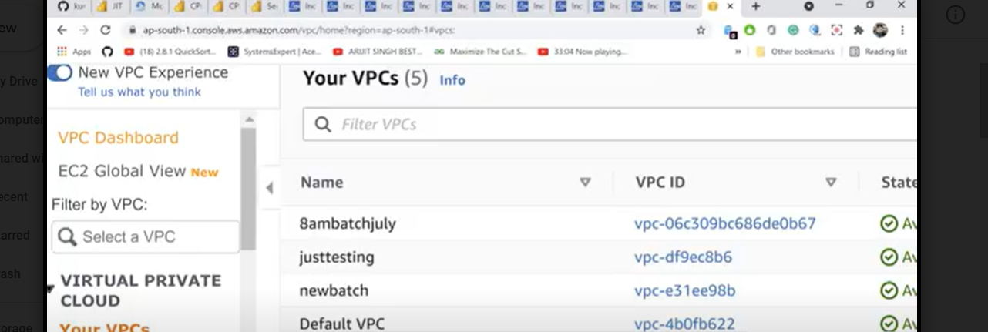

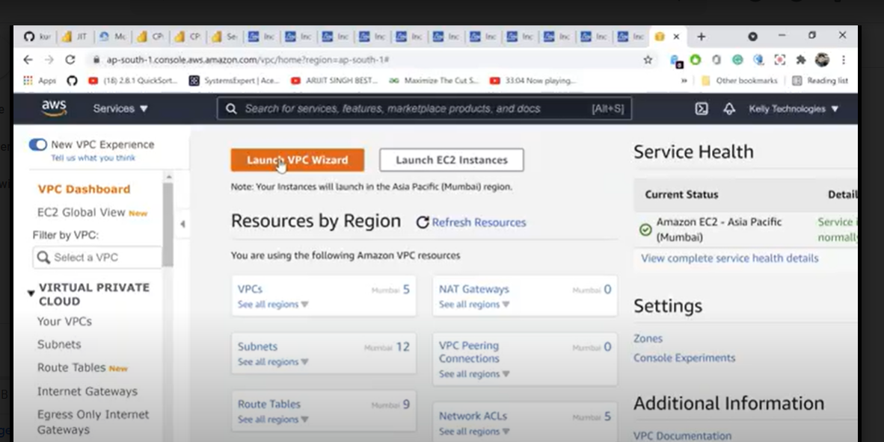

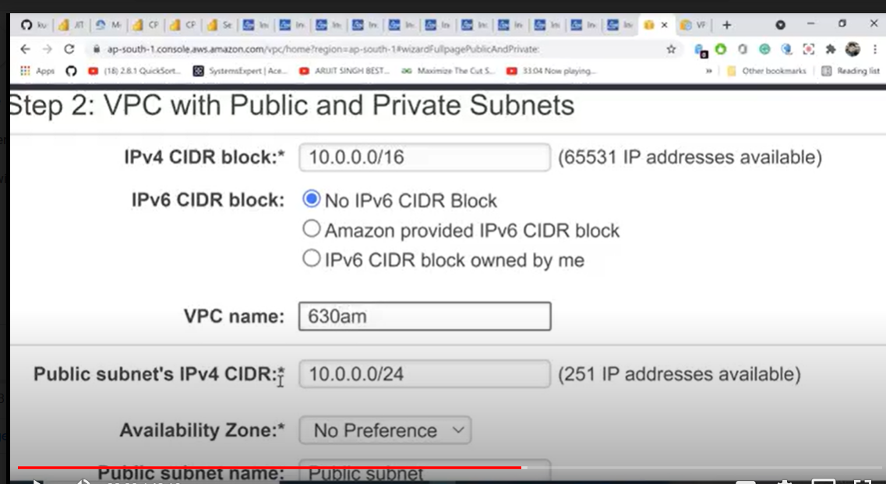

In aws small limitation not allowing 18

In aws maximum allowing a/16 and minimum is /28 limitation

VPC NAME : give any name

Public subnet : u can select any number

Availability zone : u can select anything

Public subnet name : public subnet

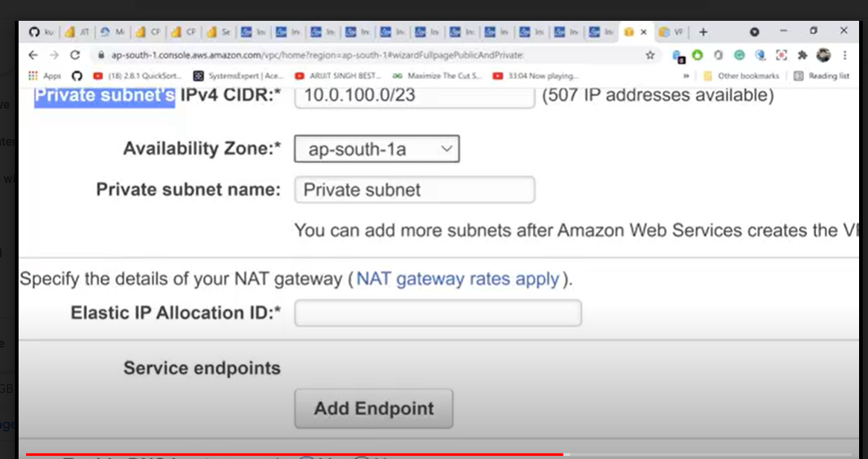

Private subnet : 10.0.0.0/23

Availability zone : u can select anything

Subnet name : private subnet

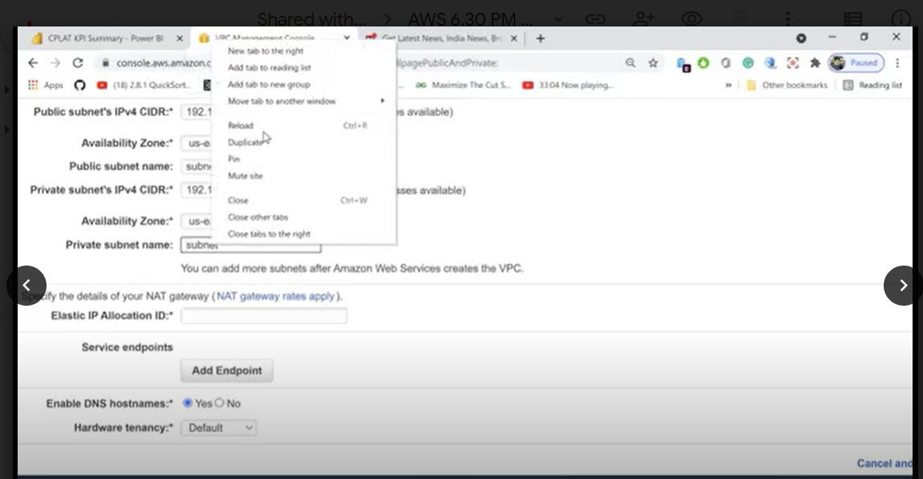

NAT gatway require one elastic ip

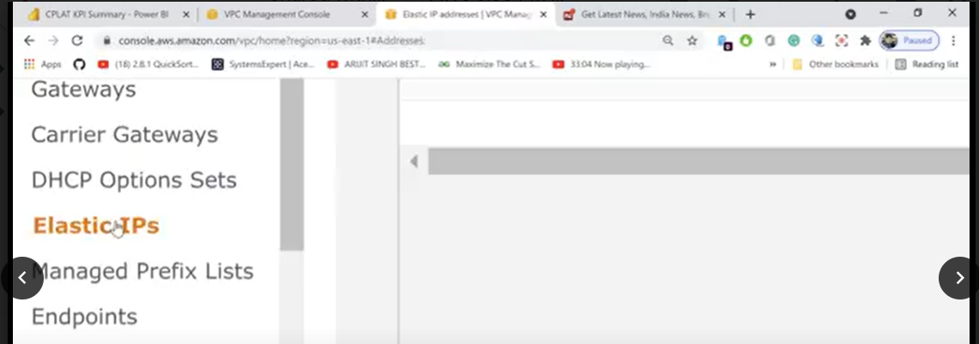

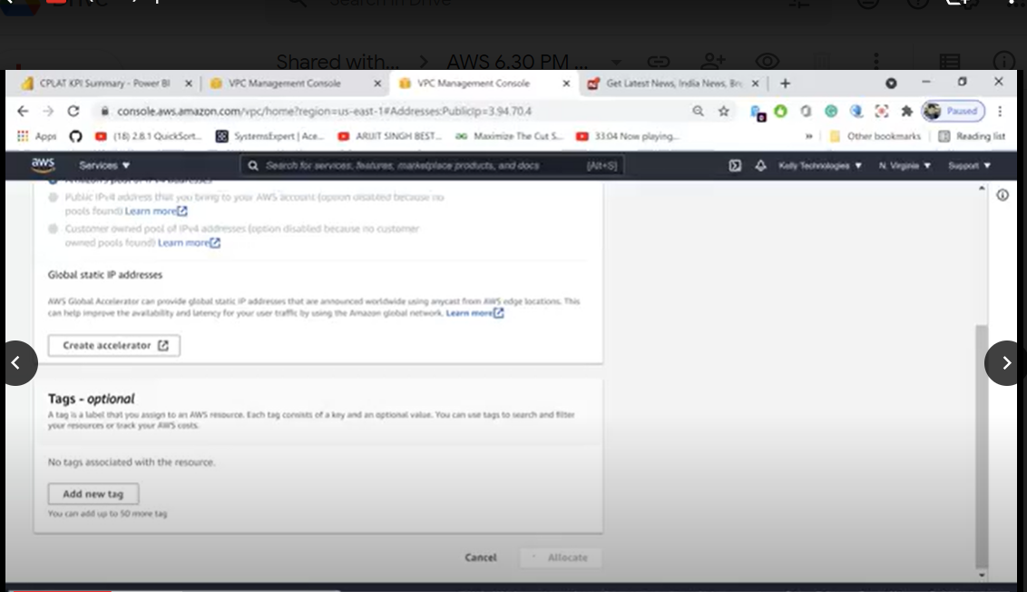

NAT gateway : NAT is a public ip address

Elastic ip : fixed ip address

DNS hostname : yes amazon provides DNS name automathically

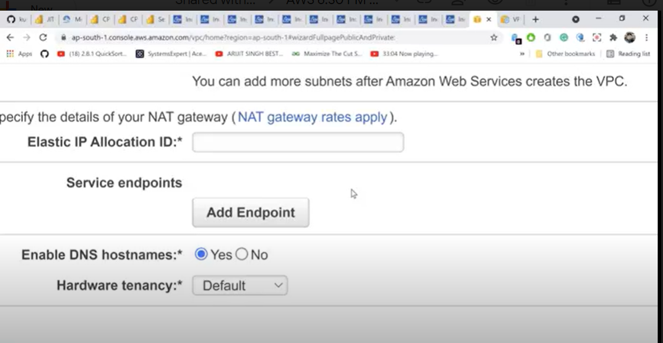

Hardware tenancy

Dedicated : if u select dedicated only will get dedicated harddisk from aws, not another servers not created, only ur servers created

Default : it is created different boxes

Hardware tenancy : create server that is called

Create vpc