Creating a folder sentiment/input and copying files from local all input files to it.
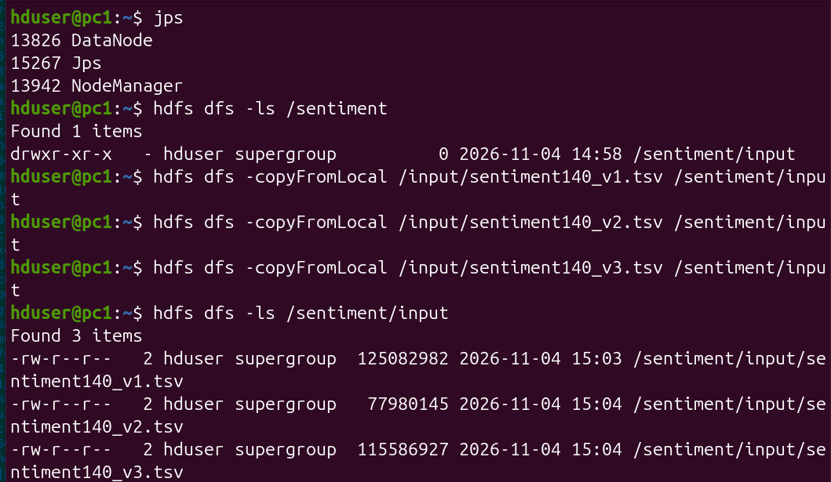
Checking whether input files are copied correctly.
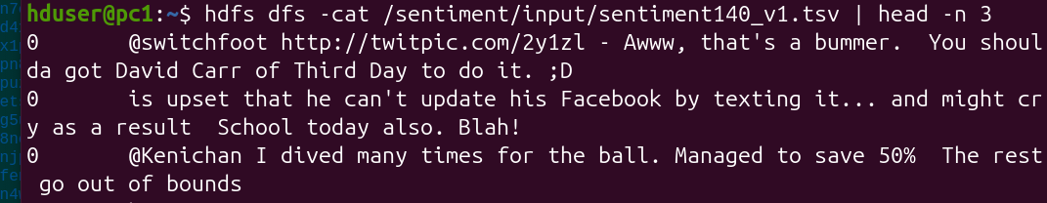

Creating python virtual environment
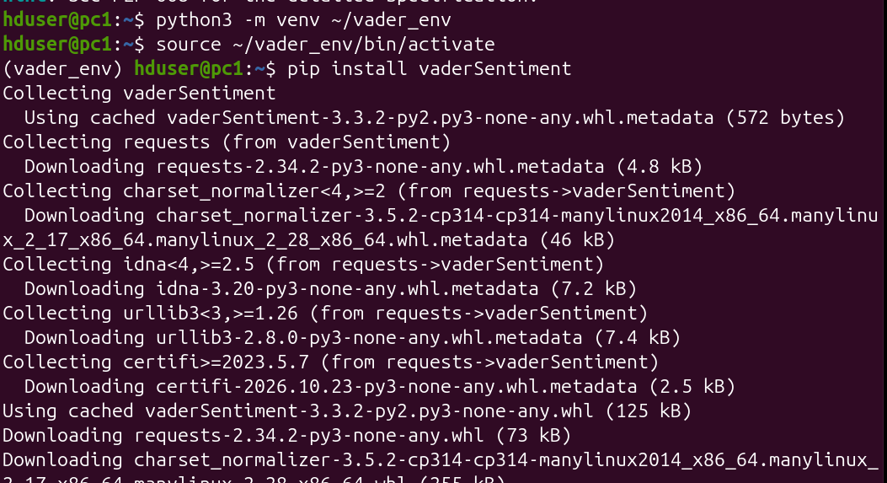
Creating mapper.py, reducer.py
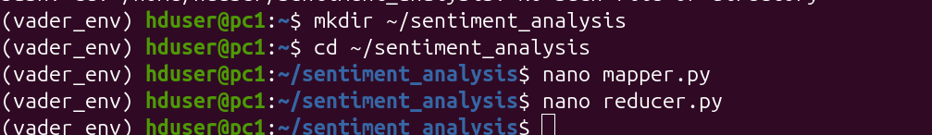
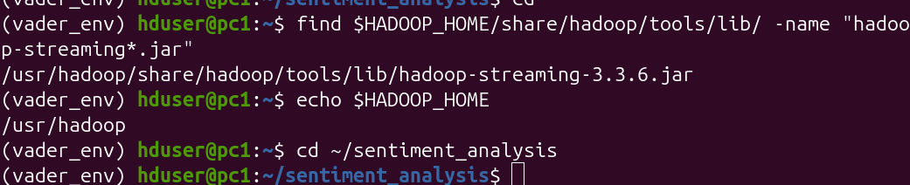

Hadoop jarring
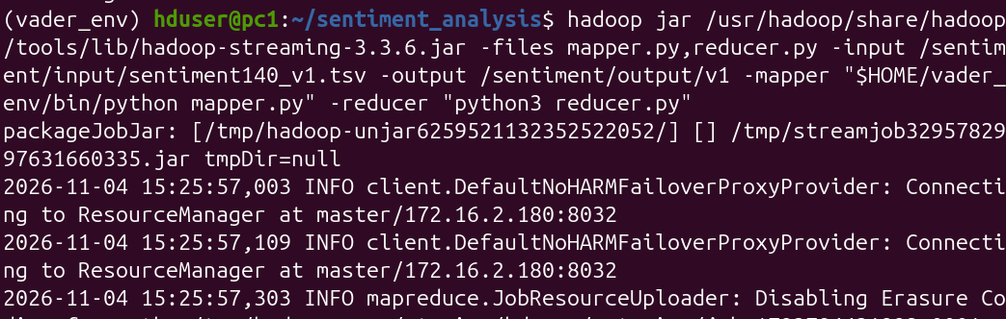
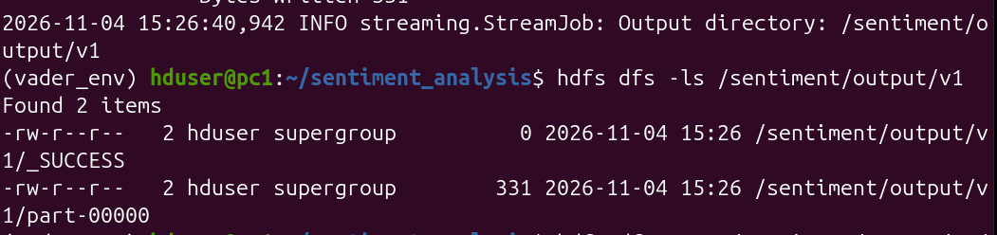
Outputs for version 2 and 3
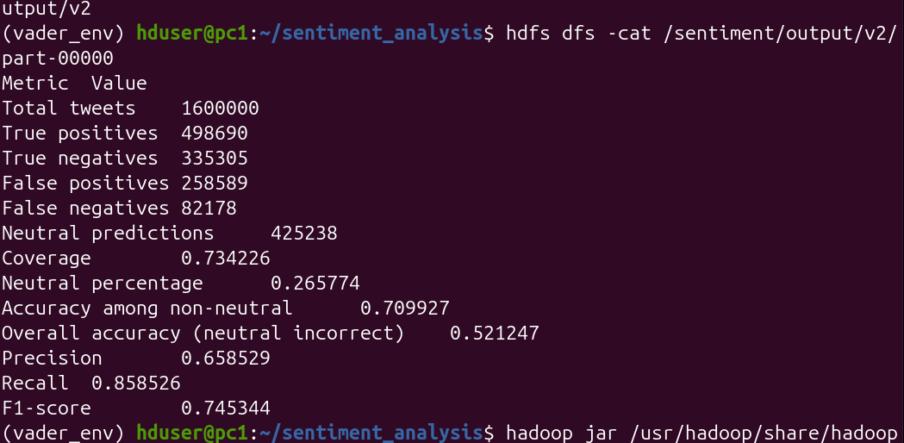
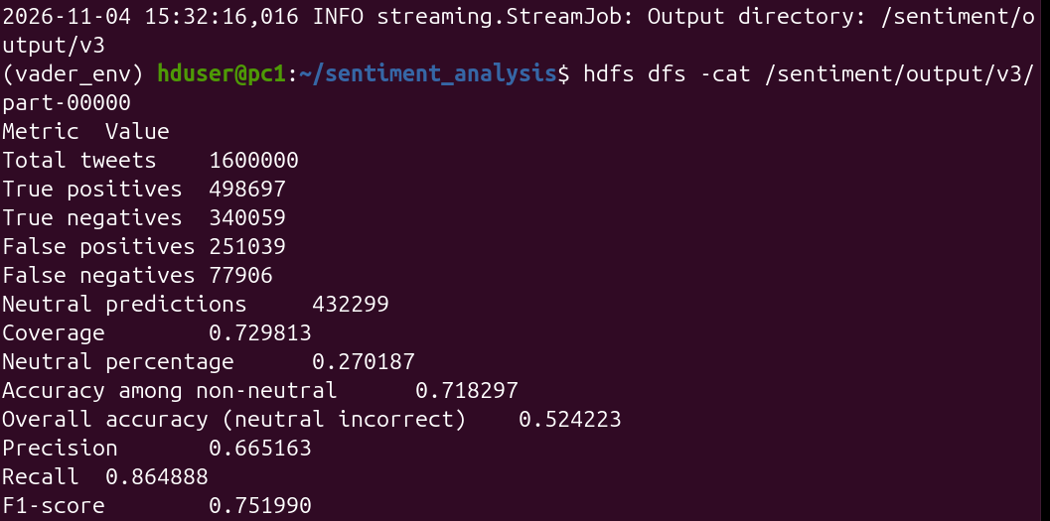
Finding Execution time for all versions.
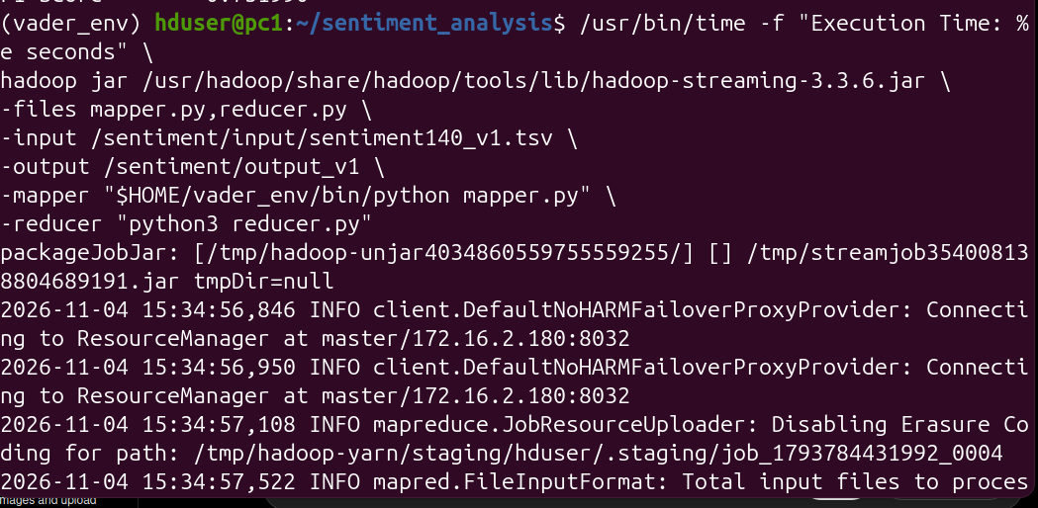

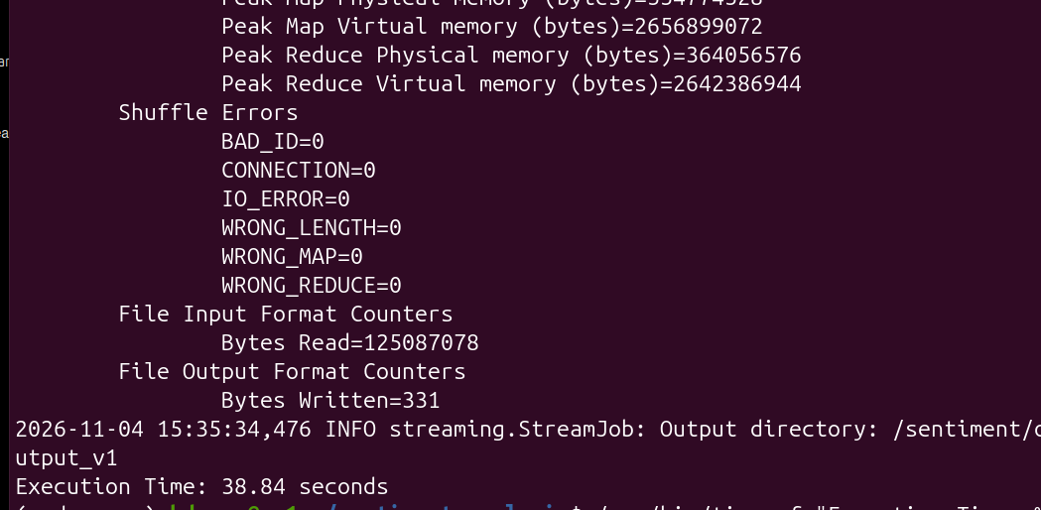
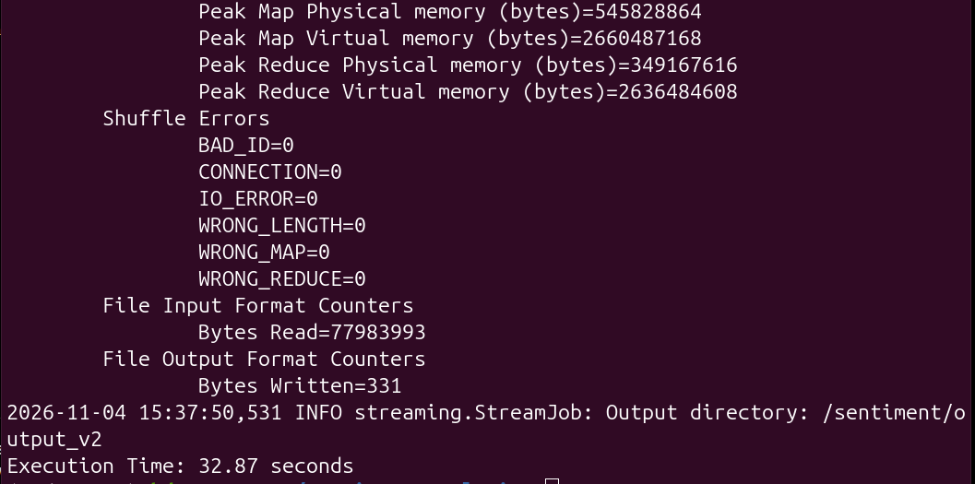
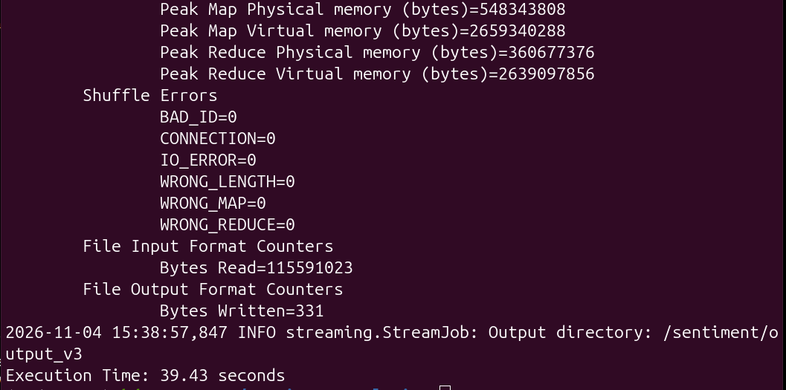
Task 5: Ethical Considerations
Privacy: Tweets may contain personal information, usernames, locations, opinions, and other identifiable details. This project focuses on analyzing tweet content rather than identifying individual users. Personally identifiable information should not be disclosed in visualizations or project reports.
Bias: We use VADER, which is a rule-based sentiment analysis tool designed especially for social media text. Although it is designed for social media text, it may fail to correctly interpret sarcasm, slang, ambiguous expressions, and context-dependent meanings.
Sentiment analysis should be used responsibly.

