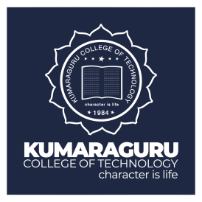
RESUME
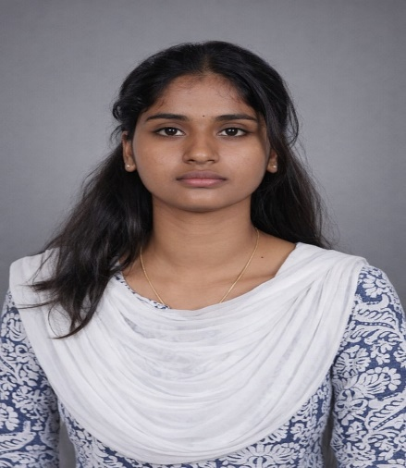
Education:
Master of Computer Applications 2025-2027
Kumaraguru College of Technology
B. Sc Computer Science 2022-2025
Kongu Arts and Science College CGPA-7.72

Soft Skills:
Teamwork
Communication skills
Adaptability
Leadership
Technical Skills:
••Hardware Design
Proteus
Power BI
Microsoft Office
Canva

Objective:
Technology-focused individual with a strong interest in computer hardware, embedded systems, and emerging technologies. Experienced in applying theoretical knowledge through hands-on academic projects, with a keen understanding of hardware–software integration. A motivated problem-solver and quick learner who works well in team environments and is eager to contribute technical skills to innovative projects while continuously growing in a dynamic organization.
MOUNIKA DHARANI P V
Master of Computer Applications
9159702109
mounikadharani214@gmail.com
LinkedIn: https://www.linkedin.com/in/mounika-dharani-90a0a2292
GitHub: https://github.com/mounikadharani

Project:
Crowd Management System Using IoT:
Built an IoT-based system using IR sensors, RFID, and Arduino to monitor real-time crowd count and automate access control for improved safety
DOB: 21/04/2005
Address: 11/1/17 PILLUKURICHI, IDAPPADI,SALEM.
Personal Interest
Reading
Problem Solving
Learning new technology
Listening Podcast
Languages Known
Tamil
English
Malayalam
.
Certification:
NPTEL Online Certification – Cloud Computing
Android –App Development
Electronics and home appliances using Arduino

