**Distributed Computing (SSZG526)**

**Assignment 1**

**Name: Mounika Jalda**

**ID: 2020mt13060**

**Date : 15-April-2021**

**ASSIGNMENT PROBLEM STATEMENT**

1. Write a program to implement the Lai-Yang algorithm for global snapshot recording. Your program should work for both FIFO and non-FIFO communication channels (since this algorithm is meant for non-FIFO communication channels).

**Lai Yang Algorithm:**

* Every process is initially white
* Process turns red while taking a snapshot. Equivalent of the “marker sending rule” is executed when a process turns red.
* Every message sent by a white process is colored white. A white message is a message that was sent before the sender of that message recorded its local snapshot
* Every message sent by a red process is colored red. A red message is a message that was sent after the sender of that message recorded its local snapshot
* Every white process takes its snapshot no later than the instant it receives a red message.
* When a white process receives a red message, it records its local snapshot before processing the message.
* Every white process records a history of all white messages sent or received by it along each channel.
* When a process turns red, it sends these histories along with its snapshot to the initiator process that collects the global snapshot
* Initiator process evaluates transit (LSi, LSj) to compute the state of a channel Cij as:

**SCij = {white messages sent by pi on Cij} − {white messages received by pj on Cij}**

**= {mij | send(mij) ∈ LSi} − {mij | rec(mij) ∈ LSj}**

**Platform:** Windows OS

**Steps to Run:**

1. Import project to Eclipse
2. Run the LaiYangMain.java as Java Application
3. Enter the inputs as follows

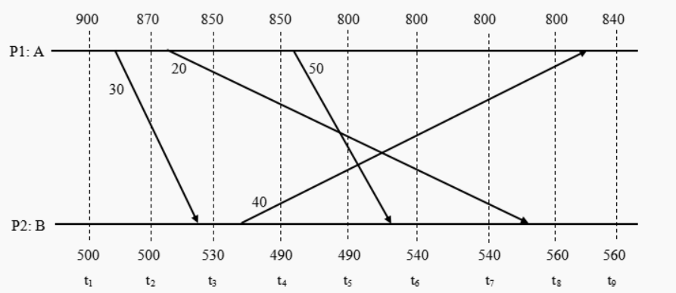

Fig. 1 Example for Lai Lang Algorithm

**Case 1:** Assuming that process P1 initiates the Algorithm at time instance t3.

**Expected Results:** Send event of P1(Amount 20) is recorded in the Local state of the P1 but the receive is not recorded during snapshot.

So, the Snapshot remains inconsistent

**Actual Results:**

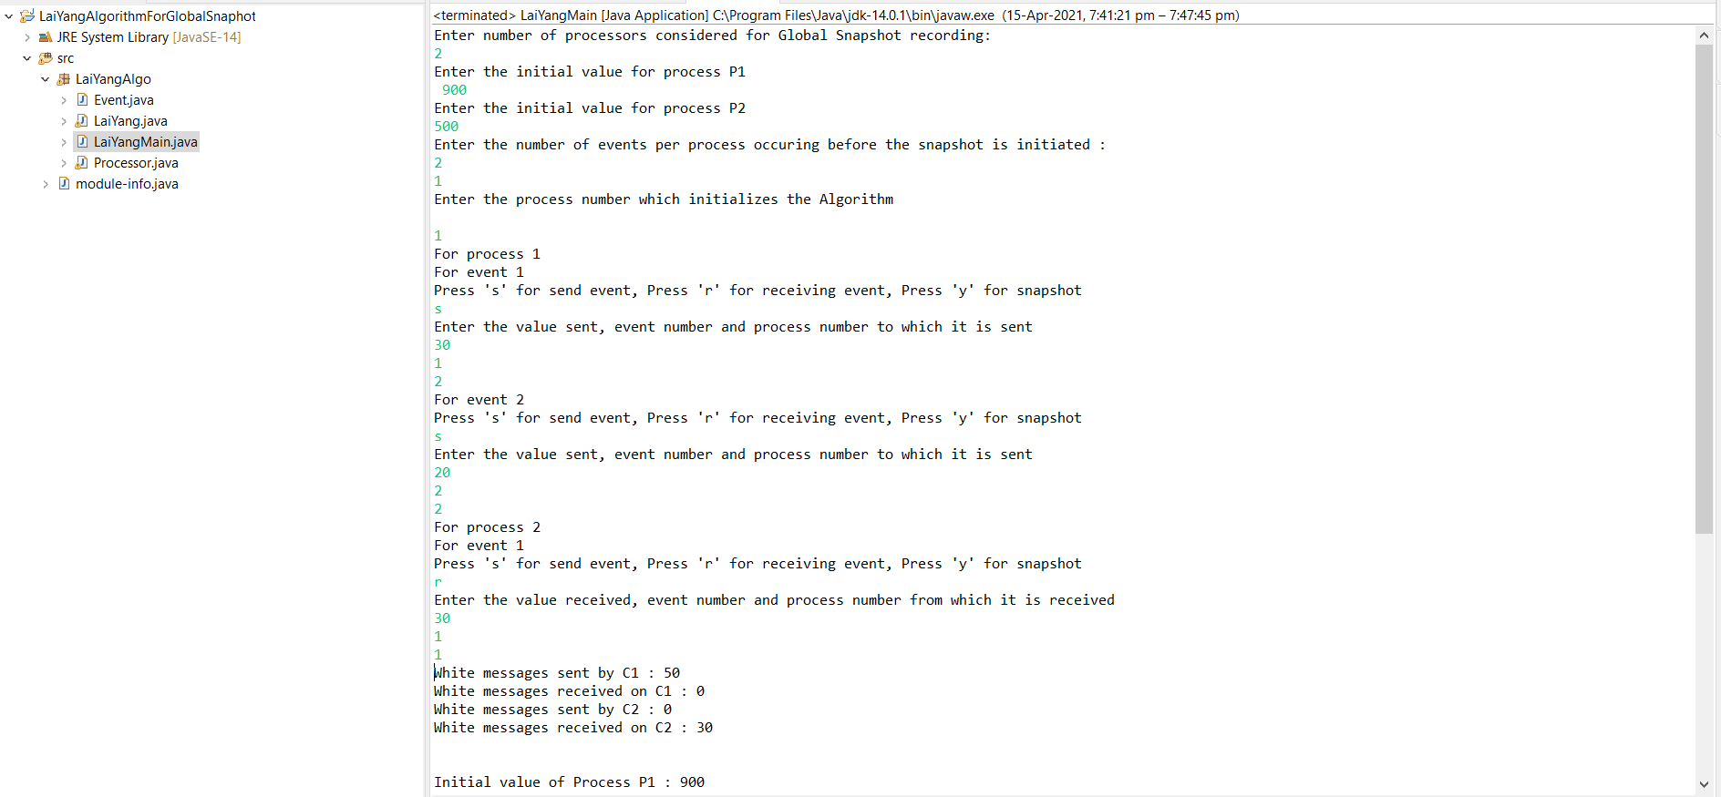

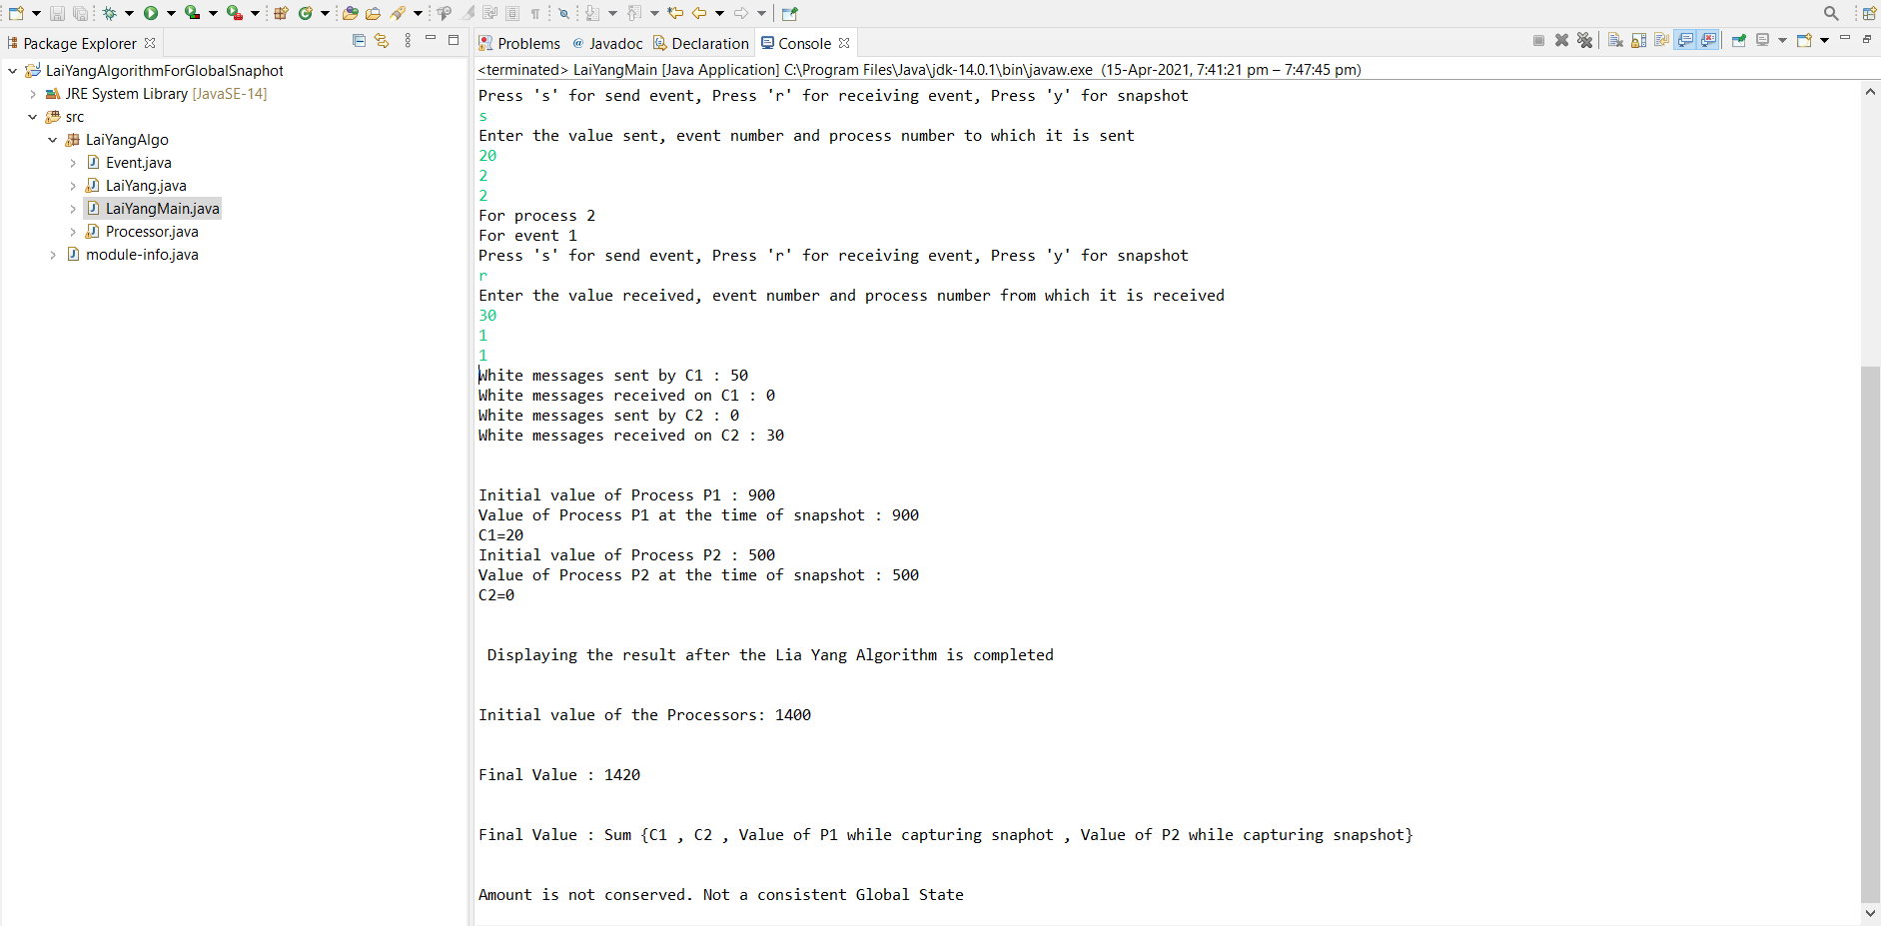

**Case 2:** Assuming that process P2 initiates the Algorithm at time instance t9.

**Expected Results:** All the send and receive are addressed and there is no message in transit.

The amount would be preserved and it would be a consistent global state.

**Actual Results:**

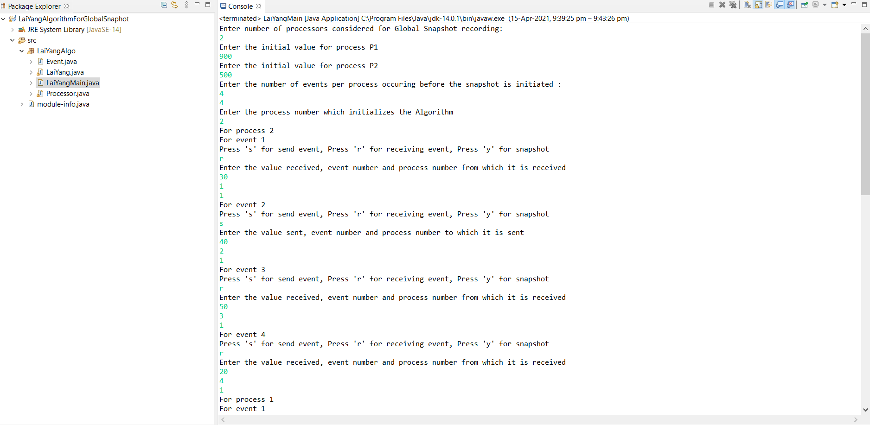

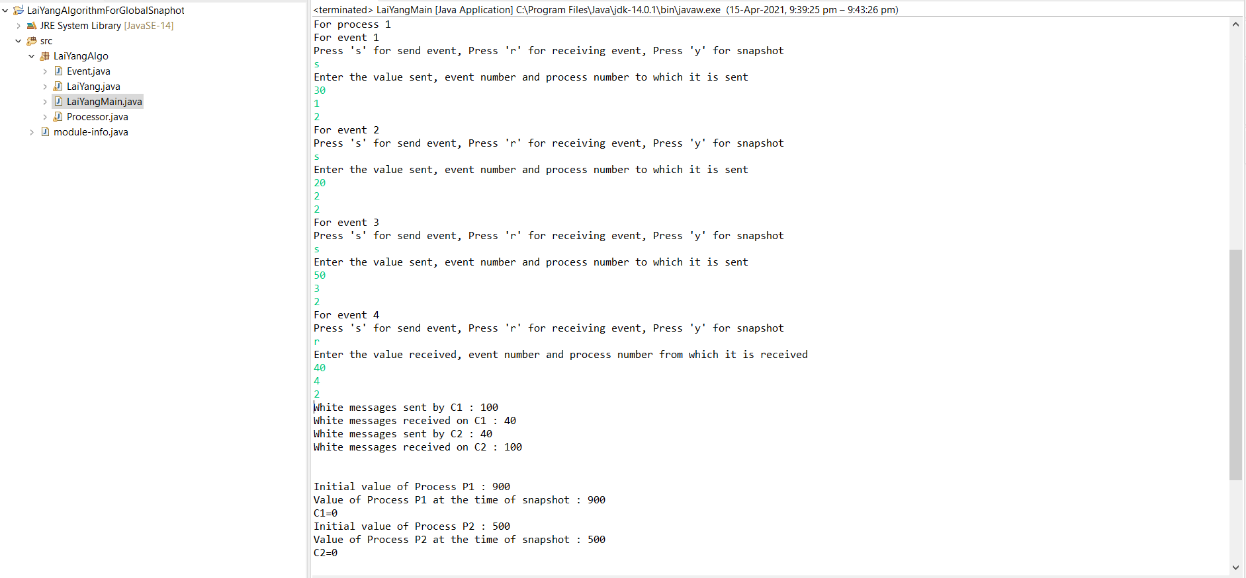

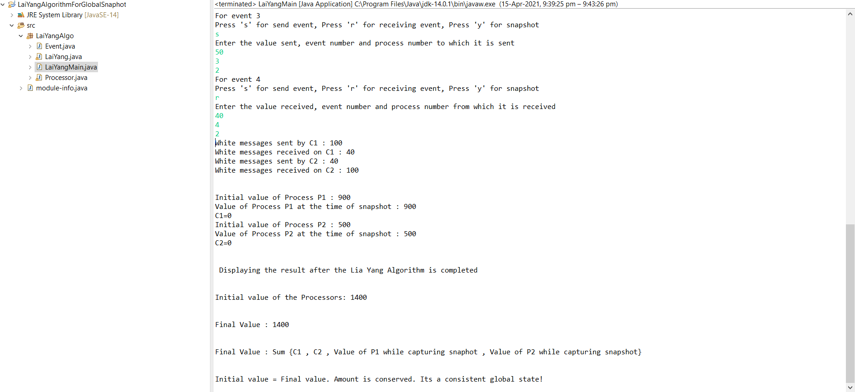

Conclusion: Lai Yang Algorithm is implemented in this experiment.