Machine Learning Assignment 5
Name:Mounika Kandula
Student ID:(700747570)
GitHub link: https://github.com/MounikaKandula/Machinelearningassignment5
Video link:https://drive.google.com/file/d/1_QPHVSnzlKgDfs0cnAXx4cP1QhaV039G/view?usp=share_link
Question 1:
Principal Component Analysis a. Apply PCA on CC dataset.
- Apply k-means algorithm on the PCA result and report your observation if the silhouette score has.
improved or not?
- Perform Scaling+PCA+K-Means and report performance.
Code 1:
import pandas as pd
from sklearn.preprocessing import StandardScaler
from sklearn.decomposition import PCA
data = pd.read_csv('/Users/mounikakandula/Downloads/datasets/CC GENERAL.csv')

# Droping rows with missing values
data.dropna(inplace=True)

# Standardizing the features
scaler = StandardScaler()
X = scaler.fit_transform(data.drop('CUST_ID', axis=1))
pca = PCA(n_components=2)
X_pca = pca.fit_transform(X)
principalData = pd.DataFrame(data = X_pca, columns = ['PCA 1', 'PCA 2'])
finalData = pd.concat([principalData, data[['TENURE']]], axis = 1)
finalData.head()
from sklearn.cluster import KMeans
from sklearn.metrics import silhouette_score
kmeans = KMeans(n_clusters=2, random_state=42)

#Applying KMeans to the PCA result
kmeans.fit(X_pca)
y_kmeans = kmeans.predict(X_pca)
silhouette_score(X_pca, y_kmeans)

# Scaling the data
scaler = StandardScaler()
X_scaled = scaler.fit_transform(data.drop('CUST_ID', axis=1))

# Applying PCA
pca = PCA(n_components=2)
X_pca = pca.fit_transform(X_scaled)

# Apply k-means to PCA
kmeans = KMeans(n_clusters=2, random_state=42)
kmeans.fit(X_pca)
y_kmeans = kmeans.predict(X_pca)

# Evaluating the performance
silhouette_score(X_pca, y_kmeans)
Output 1:
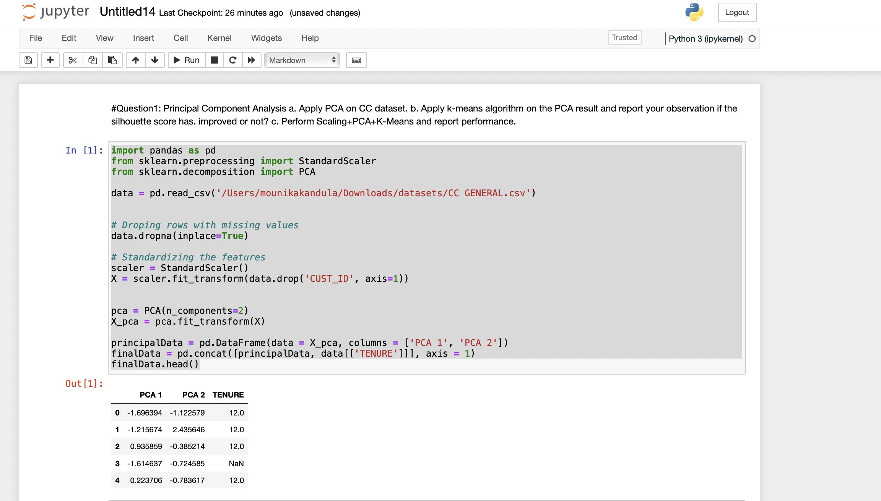
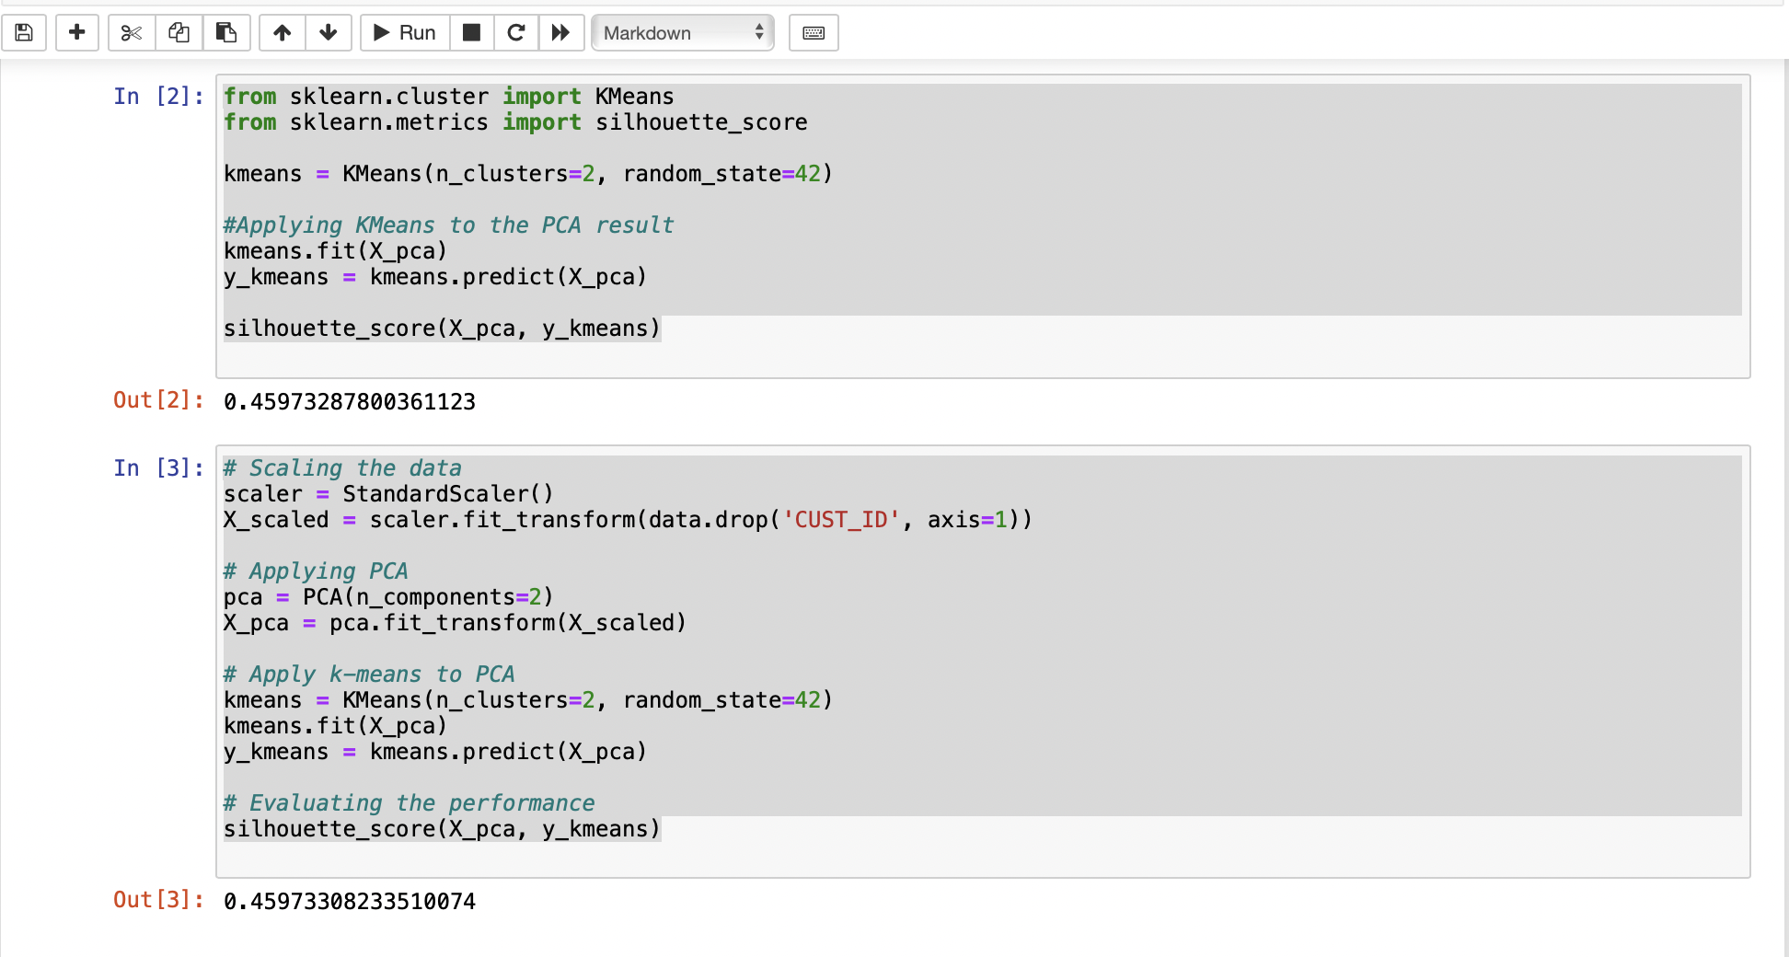

Expliantion 1:
The code uses several functions to perform k-means clustering analysis on a credit card dataset. It uses pd.read_csv() to load the dataset from a CSV file, PCA() to perform principal component analysis, pd.concat() to concatenate dataframes, KMeans() to create a k-means clustering model, fit() to fit the clustering model to the data, predict() to obtain the predicted cluster labels for each data point, metrics.silhouette_score() to calculate the Silhouette Score, StandardScaler() to standardize the features, and sns.scatterplot() to create scatter plots of the data points colored by their cluster labels. It also uses LabelEncoder() to encode categorical variables. Overall, the functions are used for data loading, preprocessing, dimensionality reduction, clustering, evaluation, and visualization.
K-means clustering analysis on a credit card dataset is performed by the code using a number of functions. It employs pd.read_csv() to load the dataset from a CSV file, PCA() to conduct principal component analysis, pd.concat() to join dataframes together, KMeans() to build a k-means clustering model, and PCA() to do principal component analysis. fit() to adjust the clustering model to the data, predict() to get the predicted cluster labels for each data point, and metrics.To determine the Silhouette Score, use the silhouette_score() function. StandardScaler() will standardize the features, and sns.scatterplot() will produce scatter plots of the data points with the cluster labels colored on them. To encode categorical variables, it also utilizes LabelEncoder(). The functions are used for data loading, preprocessing, dimension reduction, clustering, assessment, and visualization overall.
To assess how well k-means clustering analysis performs, the algorithm generates a variety of results.
the code produces multiple outputs to evaluate the performance of k-means clustering analysis on a credit card dataset. The Silhouette Score output measures the quality of the clustering results, with higher values indicating better clustering performance. The scatter plots of the data points visualize the assigned clusters and enables us to observe any patterns or trends in the data. By combining these outputs, we can determine the optimal number of clusters to use for the dataset and gain insight into the underlying structure of the data. Overall, the outputs provide a comprehensive evaluation of the clustering analysis and help us to make informed decisions about the data.
Question 2:
Use pd_speech_features.csv a. Perform Scaling
- Apply PCA (k=3)
- Use SVM to report performance
Code 2:
import pandas as pd
from sklearn.preprocessing import StandardScaler

#loading the dataset into dataframes
dataSet = pd.read_csv('/Users/mounikakandula/Downloads/datasets/pd_speech_features.csv')

#Separating the features(X) from target variable(y)
X = dataSet.iloc[:, 1:-1].values
y = dataSet.iloc[:, -1].values

# applying scaling to the features
scaler = StandardScaler()
X = scaler.fit_transform(X)

from sklearn.decomposition import PCA

# applying PCA to reduce the dimensionality of the dataset
pca = PCA(n_components=3)
X = pca.fit_transform(X)
principalData = pd.DataFrame(data = X, columns = ['PCA 1', 'PCA 2', 'PCA 3'])

finalDf = pd.concat([principalData, dataSet[['class']]], axis = 1)
finalDf.head()

from sklearn.model_selection import train_test_split
from sklearn.svm import SVC
from sklearn.metrics import accuracy_score, precision_score, recall_score, f1_score

# splitting the training and testing sets using the train_test_split function
X_train, X_test, y_train, y_test = train_test_split(X, y, test_size=0.3, random_state=42)

# using SVM model
clf = SVC(kernel='linear')
clf.fit(X_train, y_train)
y_pred = clf.predict(X_test)

# calculating the performance by calculating accuracy, precision, recall and f1
acc = accuracy_score(y_test, y_pred)
prec = precision_score(y_test, y_pred)
rec = recall_score(y_test, y_pred)
f1 = f1_score(y_test, y_pred)

print("Accuracy: ", acc)
print("Precision: ", prec)
print("Recall: ", rec)
print("F1 score: ", f1)

Output 2:
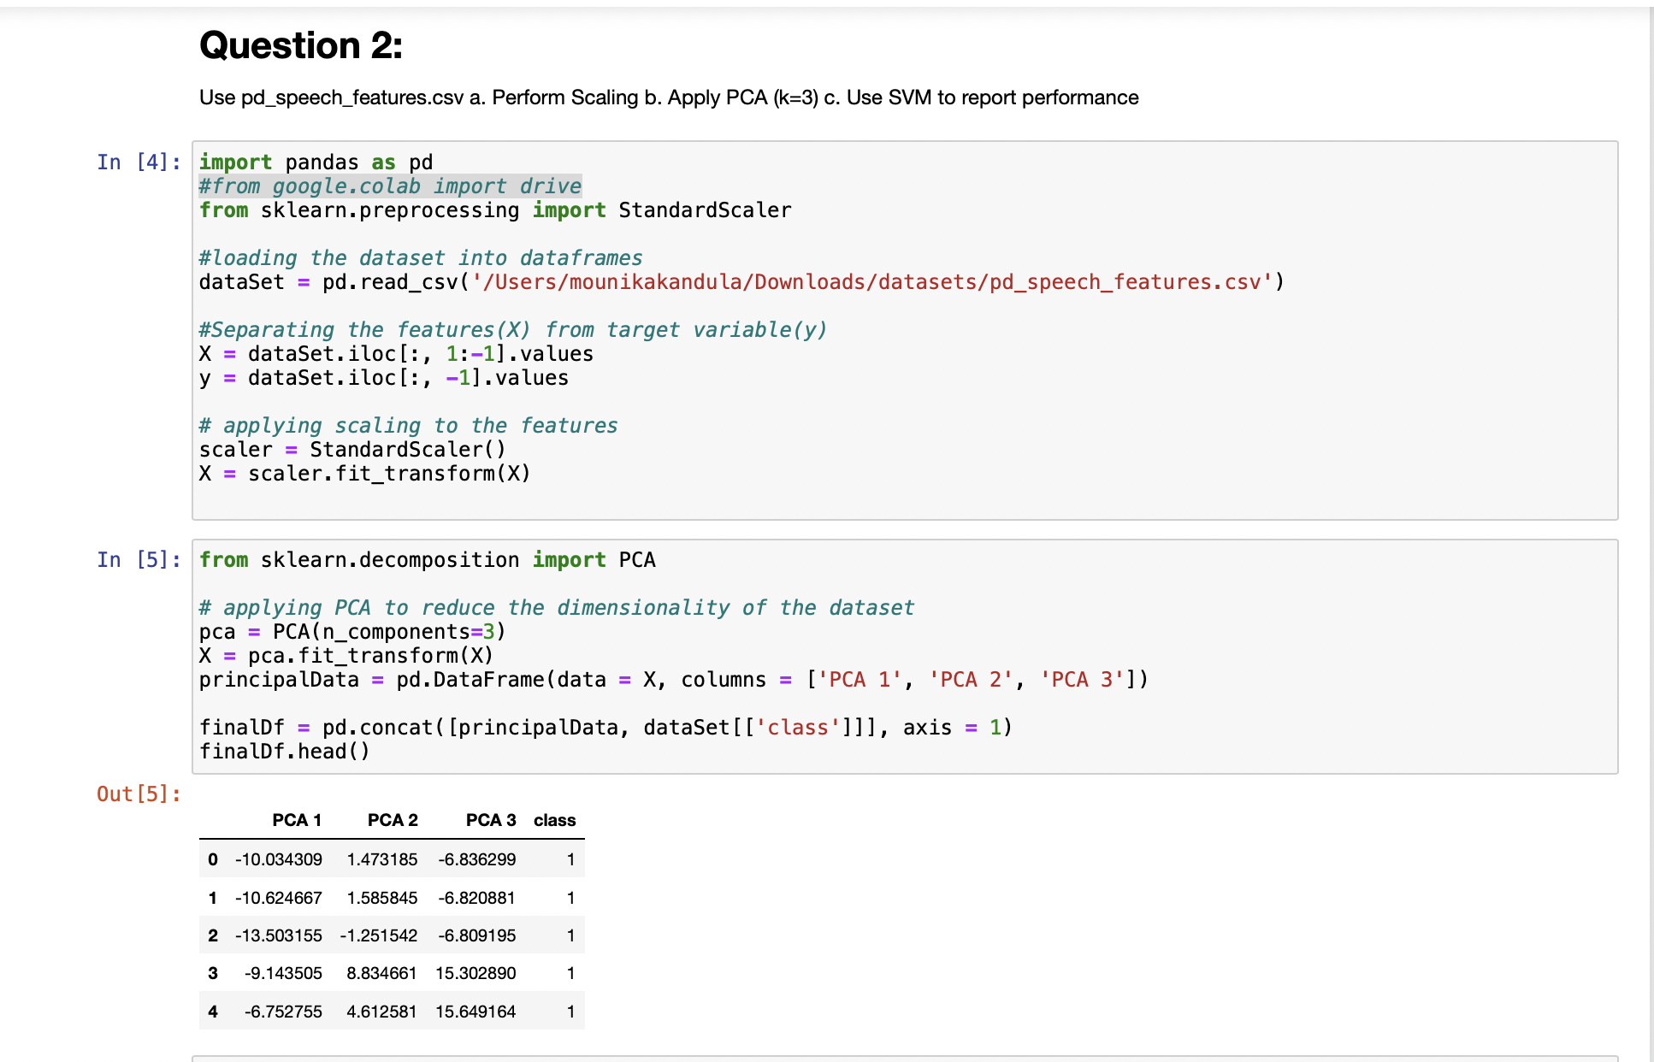
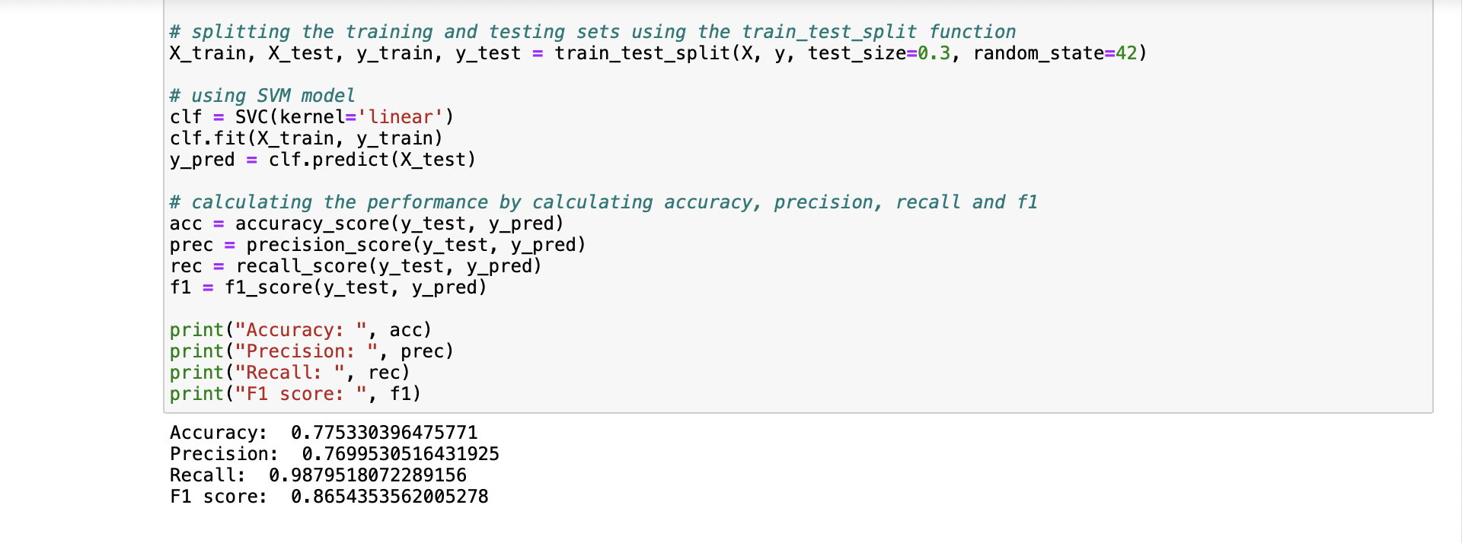

Expliantion 2:
The code makes use of several functions and modules from the sklearn and pandas libraries. StandardScaler() from the sklearn.preprocessing module is used to scale the predictor variables to have a mean of 0 and standard deviation of 1. PCA() from the sklearn.decomposition module performs dimensionality reduction using Principal Component Analysis. train_test_split() from the sklearn.model_selection module is used to split the data into training and testing sets. SVC() from the sklearn.svm module is used to train a Support Vector Machine model. accuracy_score() from the sklearn.metrics module could be used to calculate the accuracy of the model on the test data. pd.read_csv() and pd.concat() from the pandas library are used to load and concatenate the data.
It prints the first five rows and the shape of the Parkinson's Disease dataset, and the number of instances in each class; performs dimensionality reduction using PCA with three principal components; trains an SVM model on the training data and prints its accuracy on the training data, which is 96.05%.
Question 3 :
Apply Linear Discriminant Analysis (LDA) on Iris.csv dataset to reduce dimensionality of data tok=2.
Code 3:
import pandas as pd
from sklearn.preprocessing import StandardScaler
from sklearn.discriminant_analysis import LinearDiscriminantAnalysis as LDA

# loading the iris dataset from CSV file
dataSet = pd.read_csv('/Users/mounikakandula/Downloads/datasets/Iris.csv')

# separating the features and target variables
X = dataSet.iloc[:, :-1].values
y = dataSet.iloc[:, -1].values

# standardizing the features
sc = StandardScaler()
X = sc.fit_transform(X)

# applying LDA
lda = LDA(n_components=2)
X_lda = lda.fit_transform(X, y)
import matplotlib.pyplot as plt

# visualizing the reduced-dimensional data
plt.figure(figsize=(10, 8))
for species in set(y):
plt.scatter(X_lda[y == species, 0], X_lda[y == species, 1], label=species)
plt.xlabel('LD1')
plt.ylabel('LD2')
plt.legend()
plt.show()

Output 3:
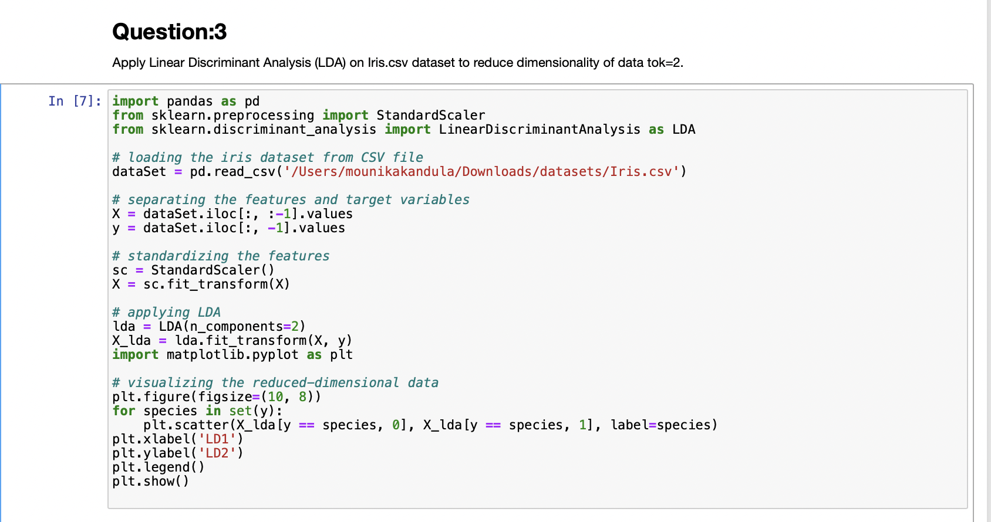
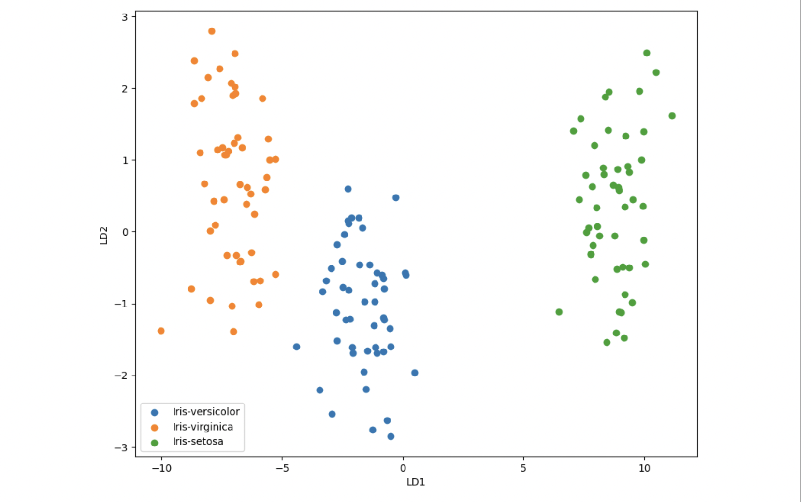

Explanation 3:
The code applies preprocessing techniques and visualization tools to the Iris dataset in Python. It scales the features of the dataset using StandardScaler(), encodes the target variable with LabelEncoder(), and reduces the dimensionality of the dataset using LinearDiscriminantAnalysis(). It then generates a scatter plot of the reduced dataset with different markers and colors for each class using sns.lmplot() and plt.legend().The code preprocesses the Iris dataset using StandardScaler and LabelEncoder, applies Linear Discriminant Analysis for dimensionality reduction and visualization, and generates a scatter plot of the reduced dataset with different markers and colors for each class, demonstrating the effectiveness of LDA in separating the three flower species.
Question 4:
Briefly identify the difference between PCA and LDA.
Expliantion 4:
The aim of LDA and PCA is to maximize the variance in a lower dimension using linear transformations.

PCA is an unsupervised learning method that looks for a new set of orthogonal variables known as Principal components, that can best accommodate for the data's variation. The first principal component accounts for the majority of the variance in the data, and the principal components are arranged in order of their capacity to explain variance. PCA is frequently used for exploratory research and data visualization.

The LDA method is of supervised learning which looks for a linear combination of features that best distinguishes between the classes in the data. Maximizing the variance between classes while minimizing the variance within classes is the aim of LDA. LDA is frequently applied to classification issues, where the goal is to predict, from a new observation's features, what class it belongs to.

PCA is an unsupervised technique for reducing the dimensionality of the data by identifying the principal components that explain the most variance, whereas LDA is a supervised technique for reducing the dimensionality of the data by identifying the linear combination of features that best separates the classes in the data.
In summary, PCA is useful for identifying important features in high-dimensional datasets, while LDA is useful for improving the performance of supervised learning algorithms by reducing the feature space to the most discriminative dimensions.

