**Project Title: Smart Dealer & Distributor CRM – Manufacturing Supply Chain Management System**

**Industry:** Manufacturing

**Target Users:** Sales Managers, Dealers, Distributors, and Customer Support Teams

**Problem Statement**

A manufacturing company distributes its products through multiple dealers and distributors across different regions. Currently, all dealer onboarding, order requests, stock updates, and complaint resolutions are handled via emails, phone calls, and spreadsheets.

This leads to:

* Delayed order processing and delivery.
* No visibility into real-time inventory or dealer performance.
* Miscommunication between sales teams and distributors.
* Lack of centralized data for decision-making.

To solve this, the company wants to implement a **Salesforce CRM solution** to streamline dealer management, automate order tracking, and provide real-time insights into supply chain performance.

**Project Overview**

The system will provide a centralized platform for managing dealers and distributors, automating order lifecycle (from placement to delivery), and enabling real-time communication.

It will:

* Simplify dealer onboarding and profiling.
* Automate distributor order capture and stock allocation.
* Track complaints and service requests with automated assignment.
* Generate dashboards for regional sales, dealer performance, and pending orders.

This will reduce delays, improve communication, and enhance dealer satisfaction.

**Objectives**

* Automate **order management** and reduce manual errors.
* Provide a **single view of dealer/distributor data**.
* Enable **faster issue resolution** through automated case management.
* Improve **supply chain visibility** with dashboards and reports.
* Strengthen **dealer relationships** with timely updates and personalized engagement.

**Use Cases**

1. **Dealer Onboarding**
   * Register new dealers with company profile, location, and sales region.
   * Assign appropriate sales managers automatically.
2. **Order Management**
   * Allow dealers to place orders via a self-service portal.
   * Track status (Pending, Approved, Dispatched, Delivered).
3. **Inventory Tracking**
   * Maintain real-time product stock availability.
   * Alert managers when inventory is low.
4. **Complaint & Service Requests**
   * Dealers log complaints (damaged goods, delayed delivery).
   * Automatically assign cases to the right department.
5. **Reporting & Dashboards**
   * Regional sales performance.
   * Top-performing dealers/distributors.
   * Pending orders and complaint resolution times.

**PHASES**

**Phase 1: Problem Understanding & Industry Analysis**

* Gather requirements from manufacturing managers, dealers, and distributors.
* Identify key challenges: order delays, inventory tracking, dealer complaints.
* Map the current manual process (emails, calls, spreadsheets).
* Analyze manufacturing industry best practices and explore existing CRM solutions.

**Phase 2: Org Setup & Configuration**

**Step 2.1: Salesforce Editions**

* Using **Developer Edition Org** for setup and testing.
* Full Salesforce license reserved for **Sales Head**.
* **Salesforce Platform licenses** used for Regional Managers, Dealers, and Support Agents.

**Step 2.2: Company Profile Setup**

**Navigation**: Setup → Company Information

* **Company Name** → Smart Dealer & Distributor CRM – Manufacturing
* **Address** → Hyderabad, India
* **Phone** → +91 9876543210
* **Primary Contact Email** → [support@smartcrm.com](mailto:support@smartcrm.com)
* **Default Locale** → English (India)
* **Currency** → INR – Indian Rupee
* **Time Zone** → (GMT +5:30) Asia/Kolkata

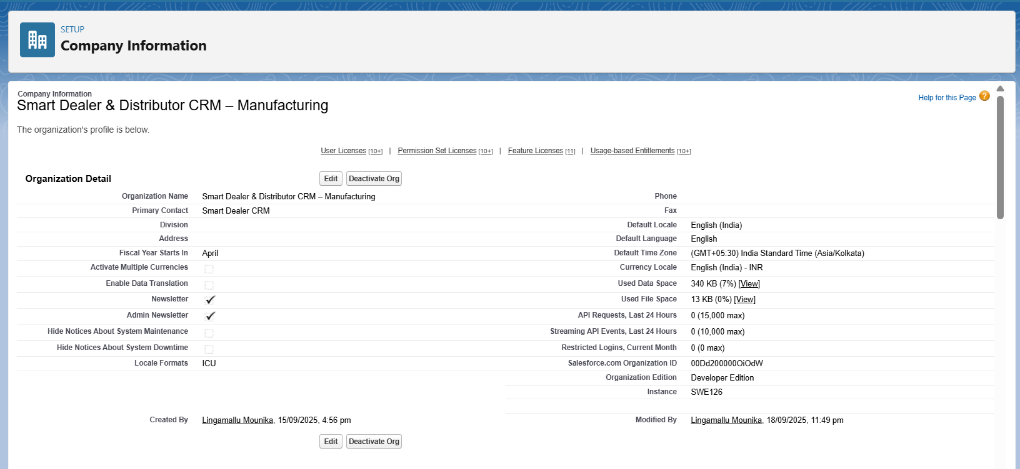

**Step 2.3: Business Hours & Holidays**

Business hours and holidays were defined to ensure proper service-level agreements (SLAs) and realistic scheduling:

1. Business Hours:
   * Days: Monday to Saturday
   * Timings: 9:00 AM – 6:00 PM
2. Holidays Added:
   * Republic Day (26th January)
   * Independence Day (15th August)
   * Diwali (Festival, annual date varies)

This configuration allows Salesforce to automatically consider holidays and working hours in workflows, escalations, and support processes.

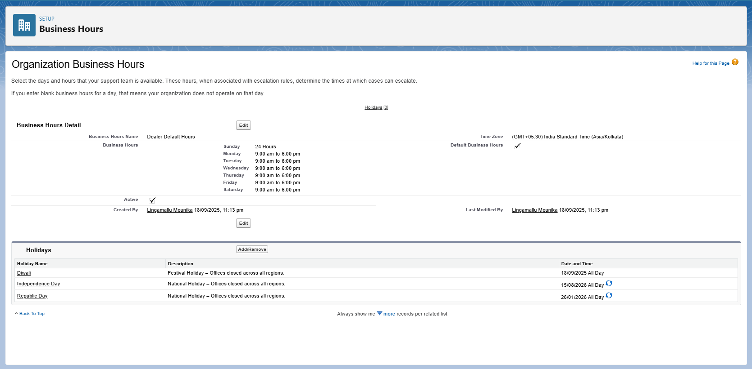

**2.4 Fiscal Year Settings**

To reflect Indian manufacturing practices, the fiscal year was set as:

* **Custom Fiscal Year**: April – March

This is particularly important for financial forecasting, sales reporting, and annual planning in the context of the manufacturing sector.

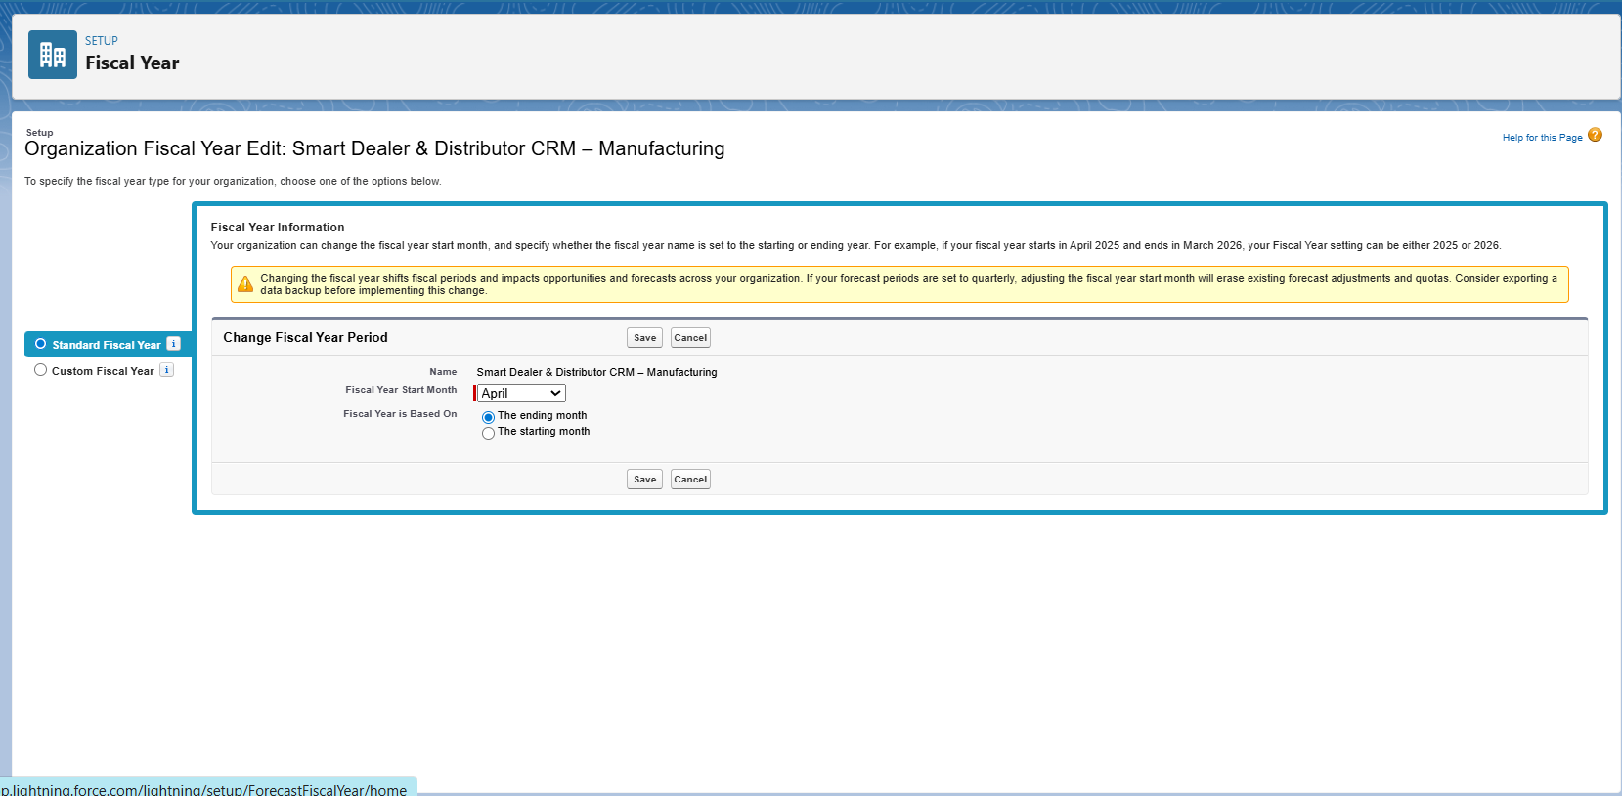

**2.5 User Setup & Licenses**

**Goal:** Create the required users for Smart Dealer & Distributor CRM with correct licenses, profiles, and roles.

**Step 1: Check Available Licenses**

1. Go to **Setup → Company Information**.
2. Scroll to **User Licenses**.
3. Note:
   * Only **1 Salesforce license** available → reserved for Sales Head.
   * Multiple **Salesforce Platform licenses** available → used for other users.

**Step 2: Clone Standard Platform Profile**

1. Go to **Setup → Profiles**.
2. Open **Standard Platform User**.
3. Click **Clone**.
4. Create new profiles:
   * *Sales Manager Profile (Platform)*
   * *Dealer Manager Profile (Platform)*
   * *Support Profile (Platform)*
5. Save each profile.

**Step 3: Configure Profile Permissions**

* **Sales Manager Profile (Platform)** → CRUD on Dealers, Distributors, Orders; Read on Complaints, Inventory.
* **Dealer Manager Profile (Platform)** → CRUD on own Account & Orders; Read-only on Distributors, Inventory.
* **Support Profile (Platform)** → Read/Edit on Cases & Complaints; Read-only on other objects.

**Step 4: Create Users**

1. Go to **Setup → Users → New User**.
2. Enter required details: *First Name, Last Name, Email, Username, Alias*.
3. Assign license and profile:
   * **Sales Head** → Salesforce license with *Sales Manager Profile (Salesforce)*
   * **Regional Sales Manager** → Salesforce Platform license with *Sales Manager Profile (Platform)*
   * **Dealer Manager** → Salesforce Platform license with *Dealer Manager Profile (Platform)*
   * **Support Agent** → Salesforce Platform license with *Support Profile (Platform)*
4. Choose the appropriate **Role**.
5. Click **Save** to create the user.

**Created Users**

**Sales Head**

* **License:** Salesforce
* **Profile:** Sales Manager Profile (Salesforce)
* **Role:** Sales Head

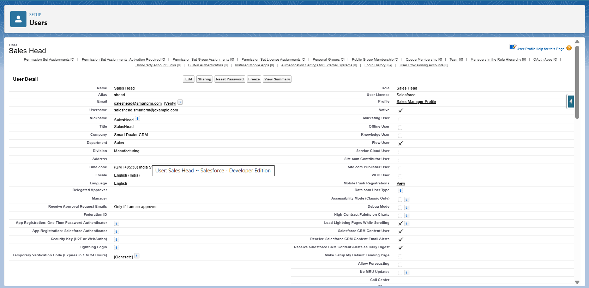

**Regional Sales Manager**

* **License:** Salesforce Platform
* **Profile:** Sales Manager Profile (Platform)
* **Role:** Regional Sales Manage

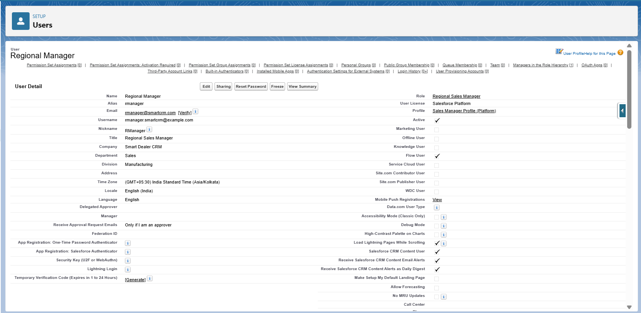

**Dealer Manager**

* **License:** Salesforce Platform
* **Profile:** Dealer Manager Profile (Platform)
* **Role:** Dealer Manager

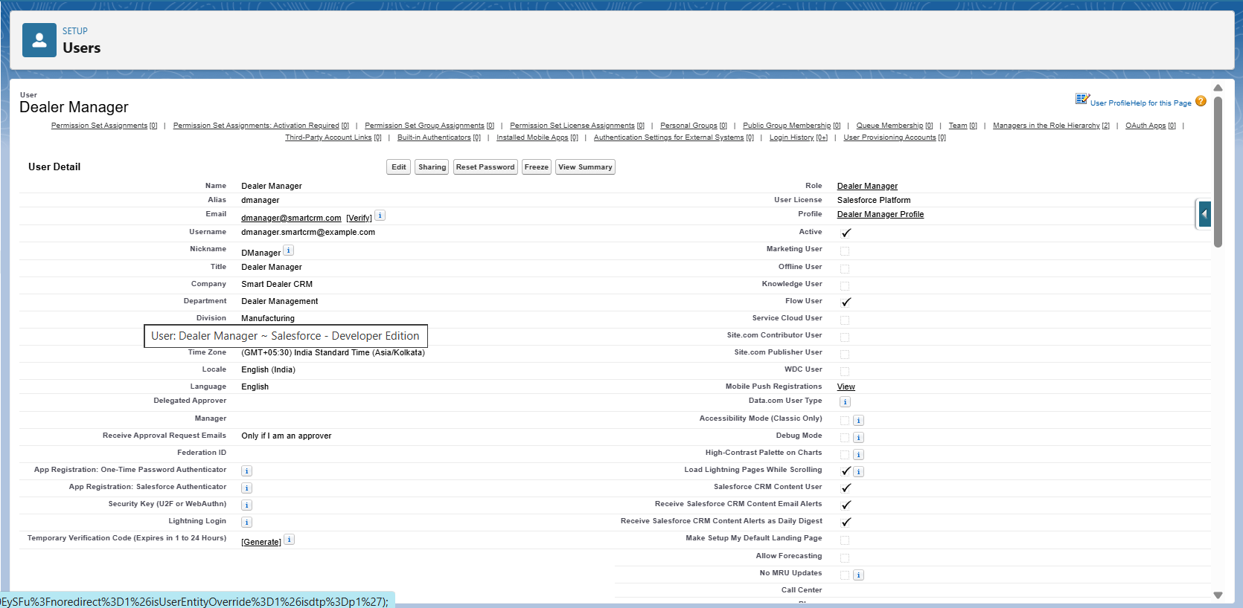

**Support Agent**

* + **License:** Salesforce Platform
  + **Profile:** Support Profile (Platform)
  + **Role:** Support Agent

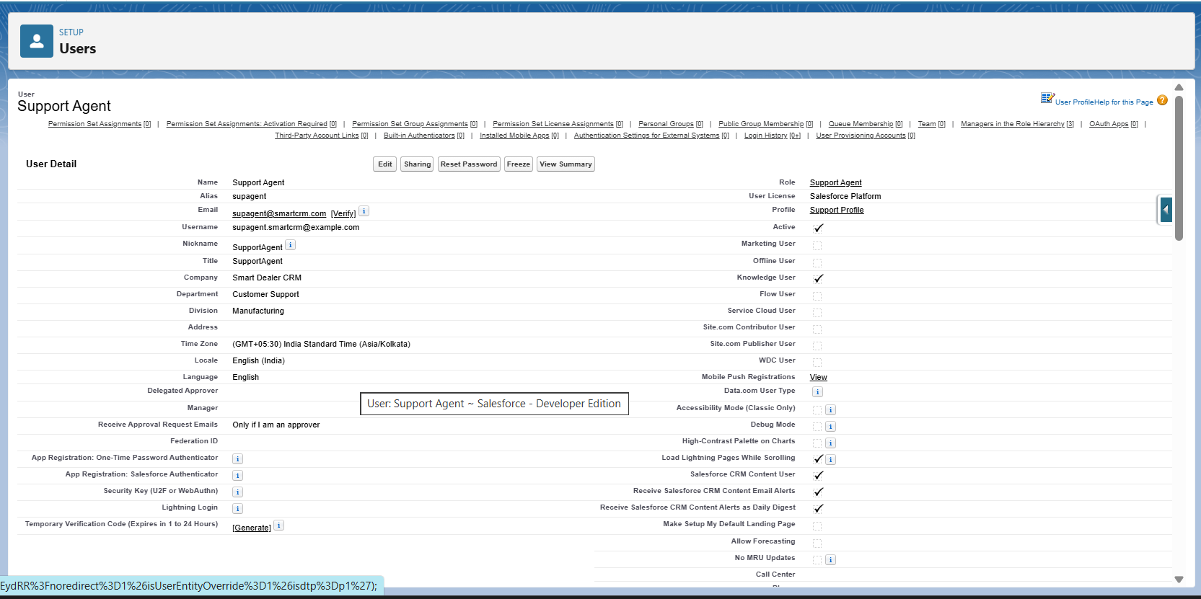

**2.6 Profiles**

Profiles were created and customized to control access for different types of users in the Smart Dealer CRM. Since Salesforce licenses were limited, new **Platform-based profiles** were cloned from the *Standard Platform User* profile.

**Sales Manager Profile (Salesforce)**

* + Used by: Sales Head
  + Full access to all dealer and distributor records
  + Can create, edit, and delete Orders, Accounts, and Reports
  + Complete reporting and dashboard access

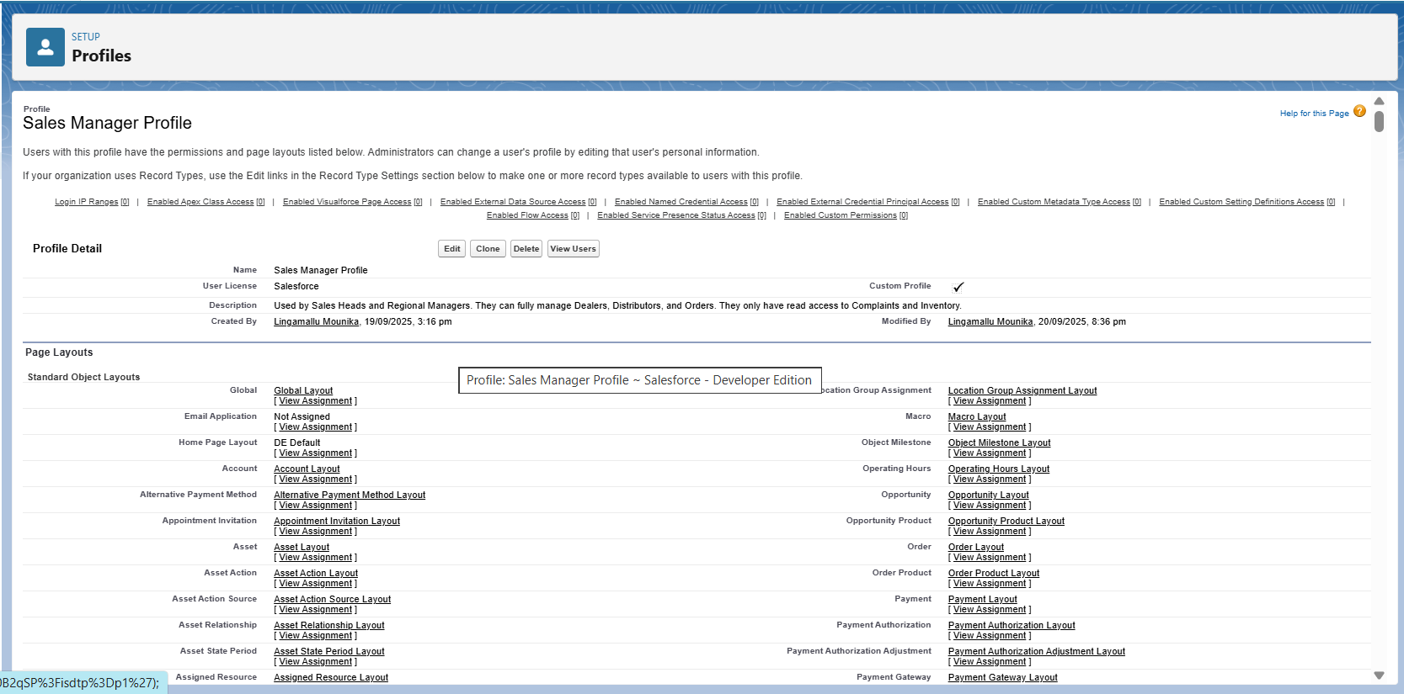

**Sales Manager Profile (Platform)**

* + Used by: Regional Sales Managers
  + CRUD access on Dealers, Distributors, and Orders
  + Read-only on Complaints and Inventory
  + Limited reporting access

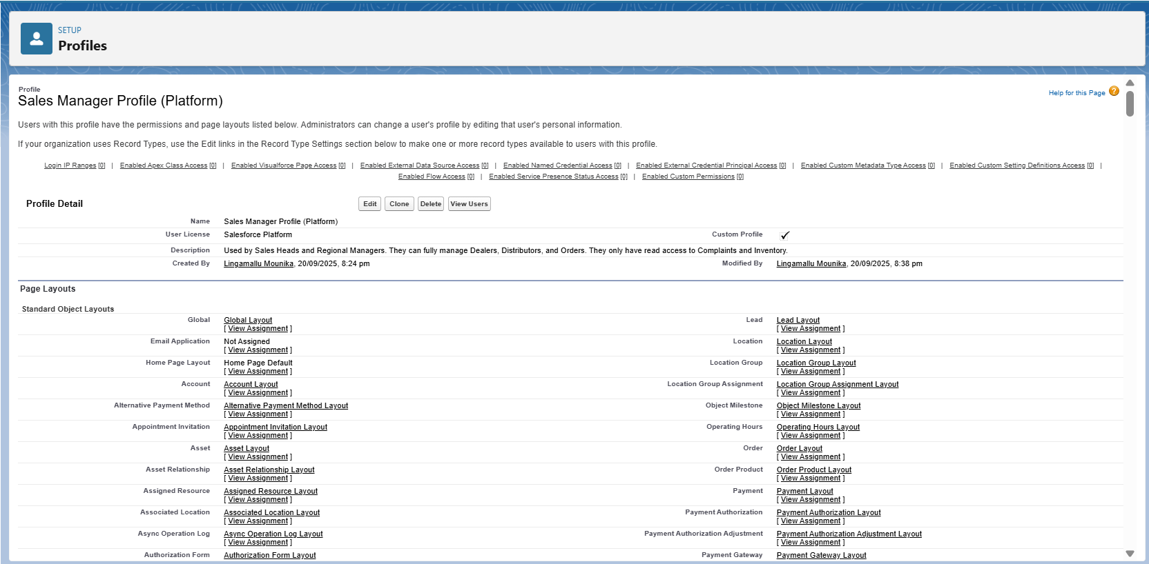

**Dealer Manager Profile (Platform)**

* + Used by: Dealer Managers (external users)
  + CRUD access on their own Account and Orders
  + Read-only access to Distributors and Inventory
  + Restricted to community/portal access

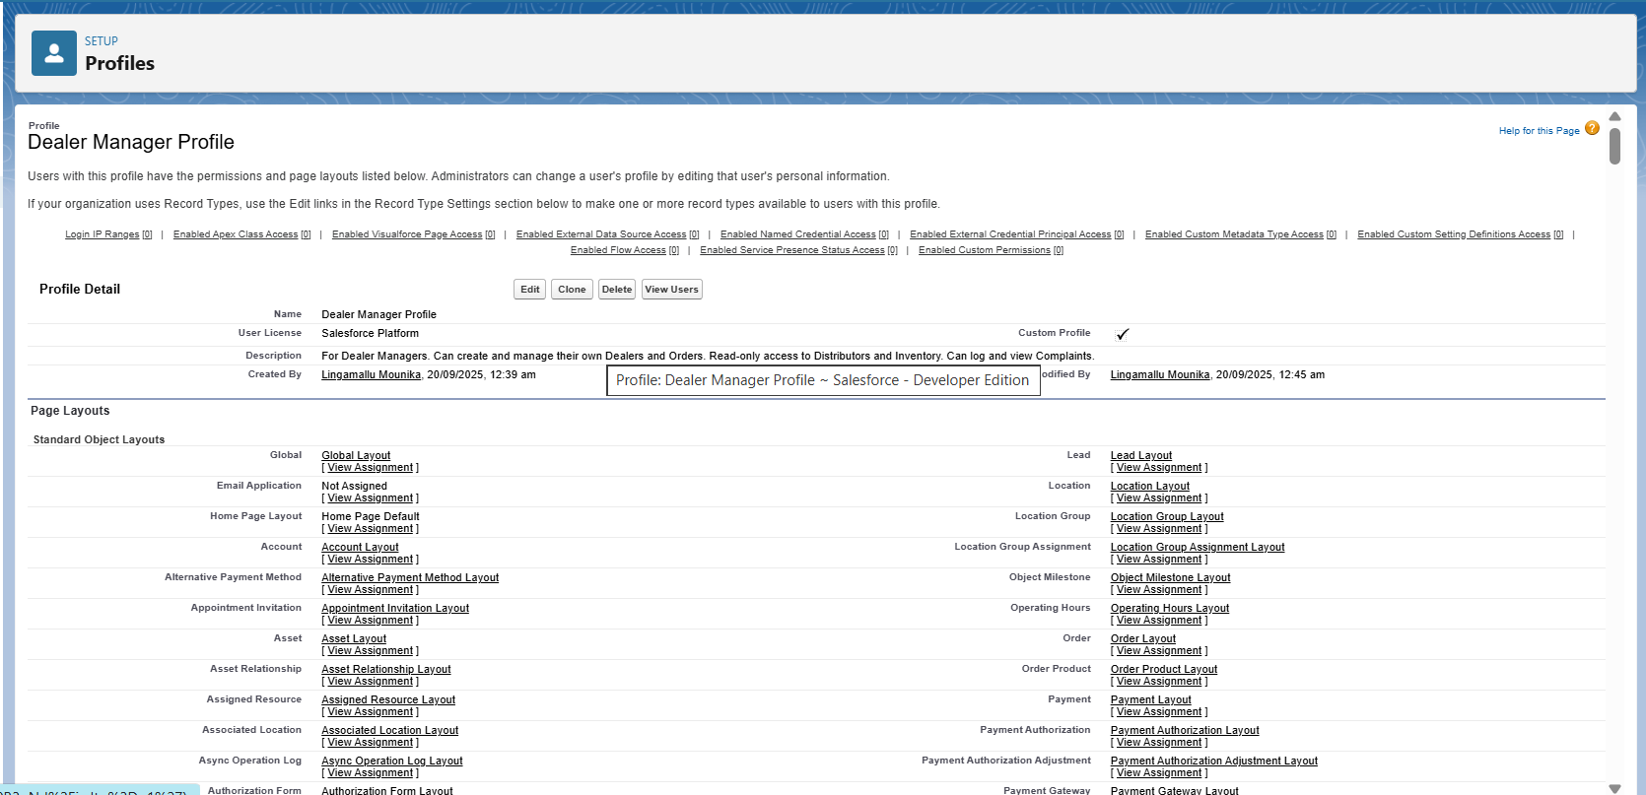

**Support Profile (Platform)**

* + Used by: Support Agents
  + Read/Edit on Complaints and Cases
  + Read-only on Accounts and Orders
  + Service-focused access only



**2.7 Roles**

Roles were defined to create a **hierarchy** for record visibility and reporting. Data rolls up through this structure, ensuring managers can see subordinate records.

* **Sales Head**
  + Top role in the hierarchy
  + Can view all records across the organization
* **Regional Sales Manager**
  + Reports to the Sales Head
  + Can access only the records of dealers in their assigned region
* **Dealer Manager**
  + Sits under the Regional Sales Manager
  + Can access and manage only their own Account and related Orders
* **Support Agent**
  + Created as a parallel role (not under Sales Head)
  + Can access Complaints and Cases across dealers for service management

