**TERADATA CASE STUDY-1**

Name : NAGURU MOUNIKA

Employee ID : 2320670

Cohort Code : CSDAIA24DB002

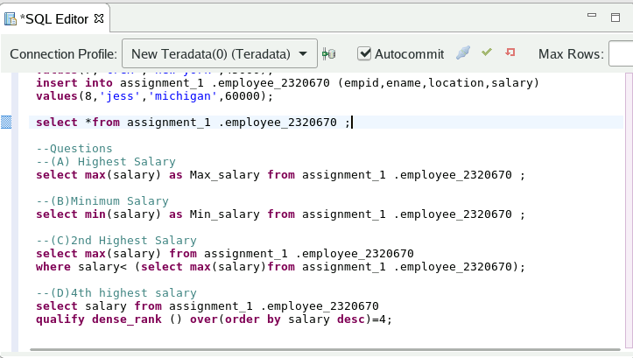

Q) Write a query to find the highest salary from the above table.

(A)solution

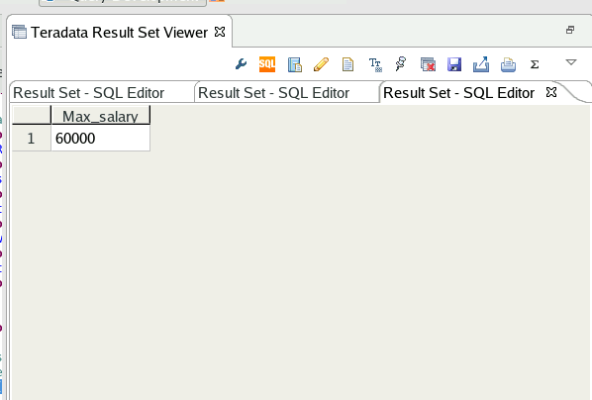

Q)Write a query to find the lowest salary from the above table.

(B)Solution

Q)Write a query to find the second highest salary from the above table.

©Solution

Q) Write a query to find the fourth highest salary from the above table.

(D)solution

**TERADATA CASE STUDY-2**

Name : NAGURU MOUNIKA

Employee ID : 2320670

Cohort Code : CSDAIA24DB002

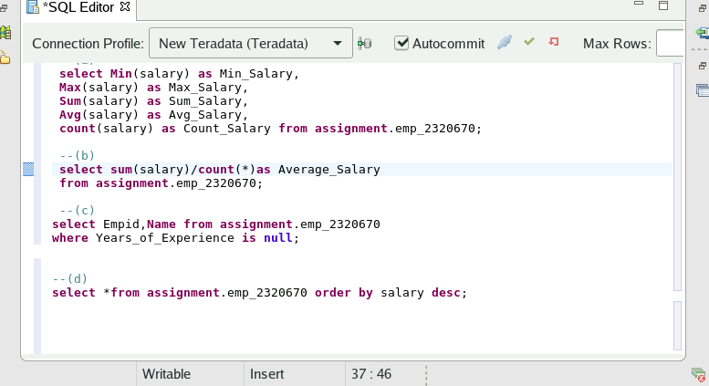

Q)Given the table above, perform all the possible Aggregate Functions based on the salary (Min, Max, Sum, Count, Average etc.).

1. Solution

Q)Calculate the average of salary without using Avg() Function.

B)Solution

1. Select the employees with the years of experience NULL (Do not using any operator, such as ‘=’, EQ).

C)Solution

Q) Sort the employee record based on the salary (highest to lowest).

D)Solution

**TERADATA CASE STUDY-3**

Name : NAGURU MOUNIKA

Employee ID : 2320670

Cohort Code : CSDAIA24DB002

1. Create a column named ‘Total’ and populate the total amount of salary for each designation.

(A)Solution

1. Find the average amount of salary for each designation with and without using Avg() Function.

B)Solution

Q) Create a new column named ‘Cumulative_Sal’ and populate the cumulating sum of salary based on the order of employee ID.

C)Solution

**TERADATA CASE STUDY-4**

Name : NAGURU MOUNIKA

Employee ID : 2320670

Cohort Code : CSDAIA24DB002

Q)Create a column named ‘Count_des’, and populate the total number of designation with the names of designation for the above table.

(A)Solution

1. Create a new column named ‘Move_Sal’, and populate the moving sum of salary for 2 employees based on the order of Employee ID. For example: Refer below, Sum of salary for Empid 1 and 2 is populated in Move_sal.

* Sal(empid1)+Sal(empid2) = Move_Sal(emp_id2)
* Sal(empid2) + Sal(empid3) = Move_Sal(empid3)

(B)Solution

**TERADATA CASE STUDY-5**

Name : NAGURU MOUNIKA

Employee ID : 2320670

Cohort Code : CSDAIA24DB002

--Insertion of data

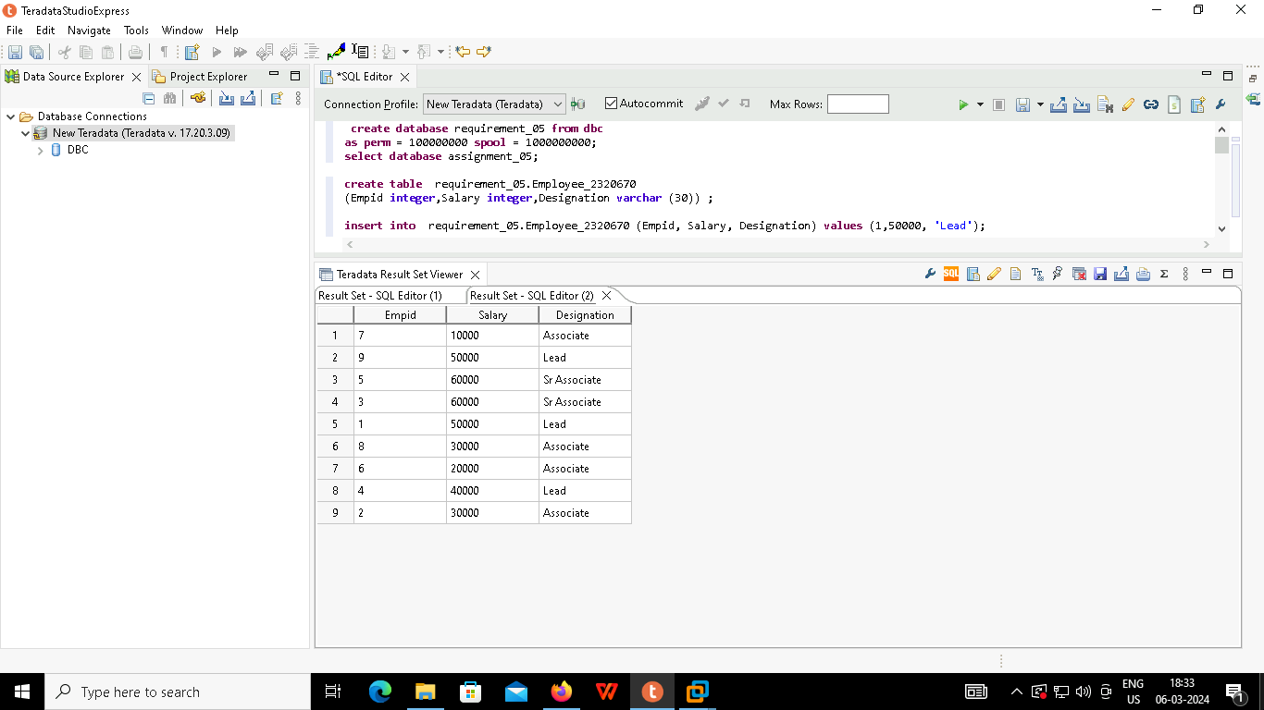

Q) Write a query to fetch the sum of salaries given to each designation.

(A)Solution

Q)Write a query to fetch employees whose designation is Associate, and increase their salary by 10000

(B)Solution

Q) Create a new column ‘Quant_Sal’, and populate the Quantile values for all the employees based on the salary column. (Quantile constant – 100)

©Solution

