**TERADATA CASE STUDY-2**

Name : NAGURU MOUNIKA

Employee ID : 2320670

Cohort Code : CSDAIA24DB002

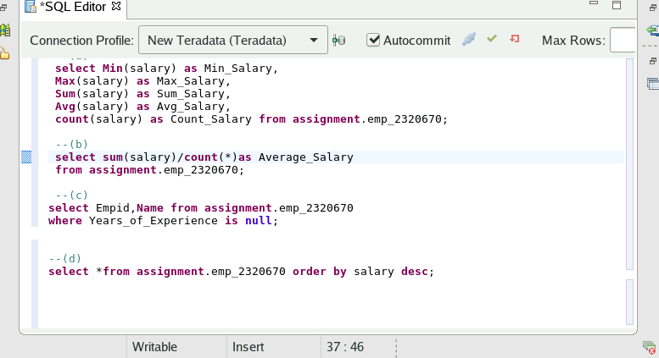

Q)Given the table above, perform all the possible Aggregate Functions based on the salary (Min, Max, Sum, Count, Average etc.).

1. Solution

Q)Calculate the average of salary without using Avg() Function.

B)Solution

1. Select the employees with the years of experience NULL (Do not using any operator, such as ‘=’, EQ).

C)Solution

Q) Sort the employee record based on the salary (highest to lowest).

D)Solution

