**TERADATA CASE STUDY-3**

Name : NAGURU MOUNIKA

Employee ID : 2320670

Cohort Code : CSDAIA24DB002

1. Create a column named ‘Total’ and populate the total amount of salary for each designation.

(A)Solution

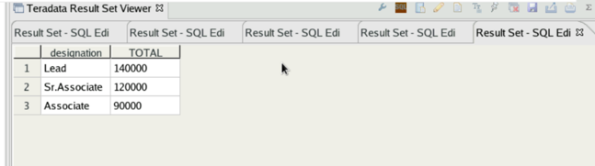

1. Find the average amount of salary for each designation with and without using Avg() Function.

B)Solution

Q) Create a new column named ‘Cumulative_Sal’ and populate the cumulating sum of salary based on the order of employee ID.

C)Solution

