**TERADATA CASE STUDY-4**

Name : NAGURU MOUNIKA

Employee ID : 2320670

Cohort Code : CSDAIA24DB002

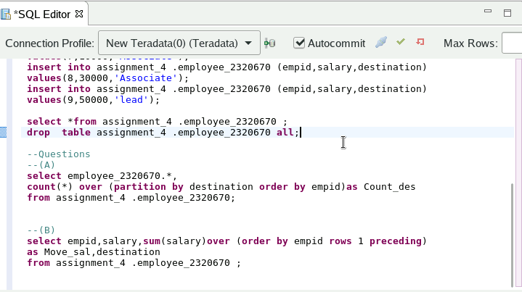

Q)Create a column named ‘Count_des’, and populate the total number of designation with the names of designation for the above table.

(A)Solution

1. Create a new column named ‘Move_Sal’, and populate the moving sum of salary for 2 employees based on the order of Employee ID. For example: Refer below, Sum of salary for Empid 1 and 2 is populated in Move_sal.

* Sal(empid1)+Sal(empid2) = Move_Sal(emp_id2)
* Sal(empid2) + Sal(empid3) = Move_Sal(empid3)

(B)Solution

