**TERADATA CASE STUDY-5**

Name : NAGURU MOUNIKA

Employee ID : 2320670

Cohort Code : CSDAIA24DB002

--Insertion of data

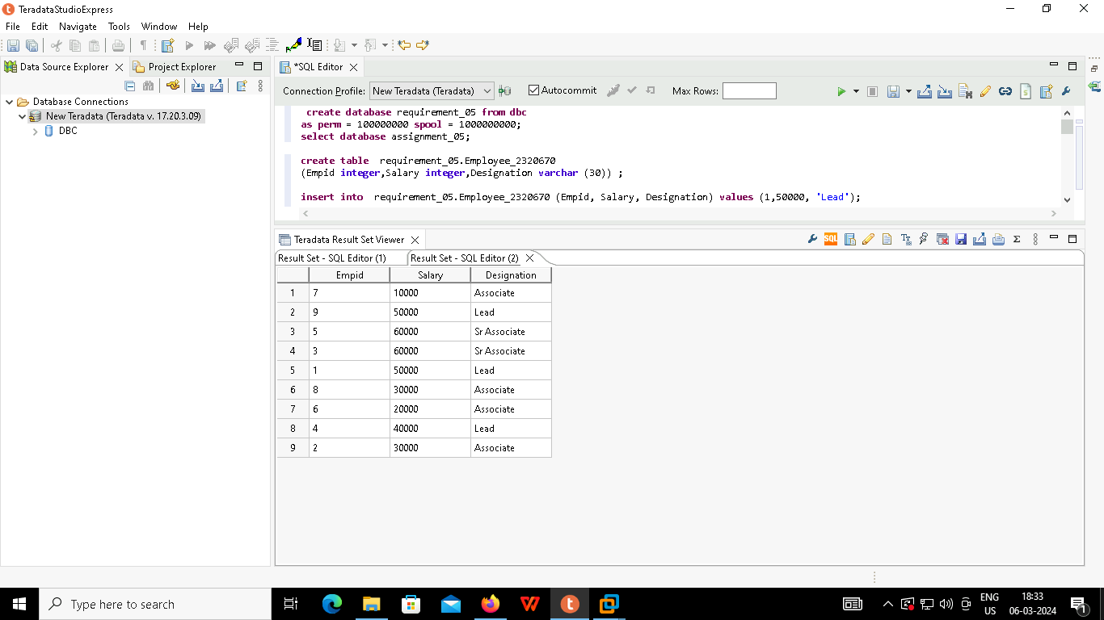

Q) Write a query to fetch the sum of salaries given to each designation.

(A)Solution

Q)Write a query to fetch employees whose designation is Associate, and increase their salary by 10000

(B)Solution

Q) Create a new column ‘Quant_Sal’, and populate the Quantile values for all the employees based on the salary column. (Quantile constant – 100)

©Solution

