ResourceTbl Table

CREATE TABLE ResourceTbl

(

ResNo varchar2(8) CONSTRAINT ResNoabsent not null,

ResName varchar2(50) CONSTRAINT ResNameabsent not null,

Rate decimal(10,2) CONSTRAINT Rateabsent not null,

CONSTRAINT resnoPK PRIMARY KEY (ResNo),

CONSTRAINT rateCheck CHECK (Rate > 0)

);

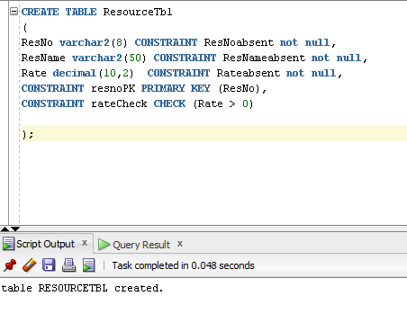

**Table data**

