**Report**

Understanding the Dataset:

data=pd.read_csv('application_data.csv')

rows , columns =data.shape

print('Rows:',rows)

print('Columns:',columns)

#### Output:

**Rows: 307511**

**Columns: 122**

Let’s retrieve the data info:

data.info()

output:

<class 'pandas.core.frame.DataFrame'>

**RangeIndex:** 307511 entries, 0 to 307510

**Columns:** 122 entries, SK_ID_CURR to AMT_REQ_CREDIT_BUREAU_YEAR

**dtypes:** float64(65), int64(41), object(16)

**memory usage:** 286.2+ MB

* Numerical data -> **quantitative data**
* Categorical data is referred to as “**qualitative data**” in data science since it describes the quality of the entity it represents.

**Null Values:**

import pandas as pd

data=pd.read_csv('application_data.csv')

rows , columns =data.shape

pd.set_option('display.max_rows', 200)

print(data.isnull().sum())

**SK_ID_CURR 0**

**REG_REGION_NOT_WORK_REGION 0**

**LIVE_REGION_NOT_WORK_REGION 0**

**REG_CITY_NOT_LIVE_CITY 0**

**REG_CITY_NOT_WORK_CITY 0**

**LIVE_CITY_NOT_WORK_CITY 0**

**ORGANIZATION_TYPE 0**

**EXT_SOURCE_1 173378**

**EXT_SOURCE_2 660**

**EXT_SOURCE_3 60965**

**APARTMENTS_AVG 156061**

**BASEMENTAREA_AVG 179943**

**YEARS_BEGINEXPLUATATION_AVG 150007**

**YEARS_BUILD_AVG 204488**

**COMMONAREA_AVG 214865**

**ELEVATORS_AVG 163891**

**ENTRANCES_AVG 154828**

**FLOORSMAX_AVG 153020**

**FLOORSMIN_AVG 208642**

**LANDAREA_AVG 182590**

**LIVINGAPARTMENTS_AVG 210199**

**LIVINGAREA_AVG 154350**

**NONLIVINGAPARTMENTS_AVG 213514**

**NONLIVINGAREA_AVG 169682**

**APARTMENTS_MODE 156061**

**BASEMENTAREA_MODE 179943**

**YEARS_BEGINEXPLUATATION_MODE 150007**

**YEARS_BUILD_MODE 204488**

**COMMONAREA_MODE 214865**

**ELEVATORS_MODE 163891**

**ENTRANCES_MODE 154828**

**FLOORSMAX_MODE 153020**

**FLOORSMIN_MODE 208642**

**LANDAREA_MODE 182590**

**LIVINGAPARTMENTS_MODE 210199**

**LIVINGAREA_MODE 154350**

**TARGET 0**

**NAME_CONTRACT_TYPE 0**

**CODE_GENDER 0**

**FLAG_OWN_CAR 0**

**FLAG_OWN_REALTY 0**

**CNT_CHILDREN 0**

**AMT_INCOME_TOTAL 0**

**AMT_CREDIT 0**

**AMT_ANNUITY 12**

**AMT_GOODS_PRICE 278**

**NAME_TYPE_SUITE 1292**

**NAME_INCOME_TYPE 0**

**NAME_EDUCATION_TYPE 0**

**NAME_FAMILY_STATUS 0**

**NAME_HOUSING_TYPE 0**

**REGION_POPULATION_RELATIVE 0**

**DAYS_BIRTH 0**

**DAYS_EMPLOYED 0**

**DAYS_REGISTRATION 0**

**DAYS_ID_PUBLISH 0**

**OWN_CAR_AGE 202929**

**FLAG_MOBIL 0**

**FLAG_EMP_PHONE 0**

**FLAG_WORK_PHONE 0**

**FLAG_CONT_MOBILE 0**

**FLAG_PHONE 0**

**FLAG_EMAIL 0**

**OCCUPATION_TYPE 96391**

**CNT_FAM_MEMBERS 2**

**REGION_RATING_CLIENT 0**

**REGION_RATING_CLIENT_W_CITY 0**

**WEEKDAY_APPR_PROCESS_START 0**

**HOUR_APPR_PROCESS_START 0**

**REG_REGION_NOT_LIVE_REGION 0**

**NONLIVINGAPARTMENTS_MODE 213514**

**NONLIVINGAREA_MODE 169682**

**APARTMENTS_MEDI 156061**

**BASEMENTAREA_MEDI 179943**

**YEARS_BEGINEXPLUATATION_MEDI 150007**

**YEARS_BUILD_MEDI 204488**

**COMMONAREA_MEDI 214865**

**ELEVATORS_MEDI 163891**

**ENTRANCES_MEDI 154828**

**FLOORSMAX_MEDI 153020**

**FLOORSMIN_MEDI 208642**

**LANDAREA_MEDI 182590**

**LIVINGAPARTMENTS_MEDI 210199**

**LIVINGAREA_MEDI 154350**

**NONLIVINGAPARTMENTS_MEDI 213514**

**NONLIVINGAREA_MEDI 169682**

**FONDKAPREMONT_MODE 210295**

**HOUSETYPE_MODE 154297**

**TOTALAREA_MODE 148431**

**FLAG_DOCUMENT_12 0**

**FLAG_DOCUMENT_13 0**

**FLAG_DOCUMENT_14 0**

**FLAG_DOCUMENT_15 0**

**FLAG_DOCUMENT_16 0**

**FLAG_DOCUMENT_17 0**

**FLAG_DOCUMENT_18 0**

**FLAG_DOCUMENT_19 0**

**FLAG_DOCUMENT_20 0**

**FLAG_DOCUMENT_21 0**

**AMT_REQ_CREDIT_BUREAU_HOUR 41519**

**AMT_REQ_CREDIT_BUREAU_DAY 41519**

**AMT_REQ_CREDIT_BUREAU_WEEK 41519**

**AMT_REQ_CREDIT_BUREAU_MON 41519**

**AMT_REQ_CREDIT_BUREAU_QRT 41519**

**AMT_REQ_CREDIT_BUREAU_YEAR 41519**

**Treating Null Values:**

emptycol=data.isnull().sum()

emptycol=emptycol[emptycol.values>(0.3*len(emptycol))]

print(len(emptycol))

checking weather the columns having data loss more than 30%

I got 61

* Lets remove these 61 columns
* emptycol=emptycol[emptycol.values>(0.3*len(emptycol))]
* emptycol = list(emptycol[emptycol.values>=0.3].index)
* data.drop(labels=emptycol,axis=1,inplace=True)
* print(len(emptycol))
* print(data.shape)

* Lets remove rows which has data loss more the 30%

emptyrow=emptyrow[emptyrow.values>(0.3*len(emptyrow))]

emptyrow=list(emptyrow[emptyrow.values>=0.3].index)

data.drop(labels=emptyrow,axis=0,inplace=True) emptyrow=data.isnull().sum(axis=1)

print(len(emptyrow))

* Lets remove the unwanted column from the sheet
* no_need = ['FLAG_MOBIL', 'FLAG_EMP_PHONE', 'FLAG_WORK_PHONE', 'FLAG_CONT_MOBILE', 'FLAG_PHONE', 'FLAG_EMAIL', 'DAYS_LAST_PHONE_CHANGE', 'FLAG_DOCUMENT_2',
* 'FLAG_DOCUMENT_3', 'FLAG_DOCUMENT_4', 'FLAG_DOCUMENT_5', 'FLAG_DOCUMENT_6', 'FLAG_DOCUMENT_7', 'FLAG_DOCUMENT_8', 'FLAG_DOCUMENT_9', 'FLAG_DOCUMENT_10', 'FLAG_DOCUMENT_11', 'FLAG_DOCUMENT_12', 'FLAG_DOCUMENT_13', 'FLAG_DOCUMENT_14', 'FLAG_DOCUMENT_15', 'FLAG_DOCUMENT_16', 'FLAG_DOCUMENT_17', 'FLAG_DOCUMENT_18', 'FLAG_DOCUMENT_19', 'FLAG_DOCUMENT_20', 'FLAG_DOCUMENT_21']
* data.drop(labels=no_need, axis=1, inplace=True)
* Lets remove the xna values which mean not available

Checking where we have xna values in ‘CODE_GENDER’ and 'ORGANIZATION_TYPE'.

print(data[data['CODE_GENDER']=='XNA'].shape)

print(data[data['ORGANIZATION_TYPE']=='XNA'].shape)

(4, 34) (55374, 34)

CODE_GENDER has only 4 xna values so we will retrieve them by placing mode value.

data.loc[data['CODE_GENDER'] == 'XNA', 'CODE_GENDER'] = 'F'

Lets drop the rows which have XNA in ORGANIZATION_TYPE

data = data.drop(data.loc[data['ORGANIZATION_TYPE'] == 'XNA'].index)

data[data['ORGANIZATION_TYPE'] == 'XNA'].index

* Creating bins and slot for AMT_INCLOME_RANGE
* It will use for plotting pie charts, histograms

bins = [0, 25000, 50000, 75000, 100000, 125000, 150000, 175000, 200000, 225000, 250000,275000, 300000, 325000, 350000, 375000, 400000, 425000, 450000, 475000, 500000, 10000000000]

slot = ['0-25000', '25000-50000', '50000-75000', '75000,100000', '100000-125000', '125000-150000', '150000-175000', '175000-200000',

'200000-225000', '225000-250000', '250000-275000', '275000-300000', '300000-325000', '325000-350000', '350000-375000','375000-400000', '400000-425000', '425000-450000', '450000-475000', '475000-500000', '500000 and above']

data['AMT_INCOME_RANGE'] = pd.cut(data['AMT_INCOME_TOTAL'], bins, labels=slot)

* Creating bins and slot for AMT_CREDIT_RANGE
* It will use for plotting pie charts, histograms

bins = [0, 150000, 200000, 250000, 300000, 350000, 400000, 450000, 500000,

550000, 600000, 650000, 700000, 750000, 800000, 850000, 900000, 1000000000]

slots = ['0-150000', '150000-200000', '200000-250000', '250000-300000', '300000-350000', '350000-400000', '400000-450000','450000-500000', '500000-550000', '550000-600000', '600000-650000', '650000-700000', '700000-750000', '750000-800000','800000-850000', '850000-900000', '900000 and above']

data['AMT_CREDIT_RANGE'] = pd.cut(data['AMT_CREDIT'], bins=bins, labels=slots)

* Dividing the data set into two parts they are…
  + Target1_df 🡪 customers who having difficulties in payback
  + Target0_df 🡪 other than that
* We will find out the calculate imbalance percentage
* print(round(len(target0_df)/len(target1_df),2))

10.55

Creating a function to create to plot a graph.

def uniplot(df,col,title,hue =None):

    sns.set_style('whitegrid')

    sns.set_context('talk')

    plt.rcParams["axes.labelsize"] = 20

    plt.rcParams['axes.titlesize'] = 22

    plt.rcParams['axes.titlepad'] = 30

    temp = pd.Series(data = hue)

    fig, ax = plt.subplots()

    width = len(df[col].unique()) + 7 + 4*len(temp.unique())

    fig.set_size_inches(width , 6)

    plt.xticks(rotation=45)

    plt.yscale('log')

    plt.title(title)

    ax = sns.countplot(data = df, x= col,order=df[col].value_counts().index,hue = hue,palette='magma')

    plt.show()

* **analysing the data for customers who having no payment difficulties**

uniplot(target0_df,col='AMT_INCOME_RANGE',title='Distribution of income range',hue='CODE_GENDER')

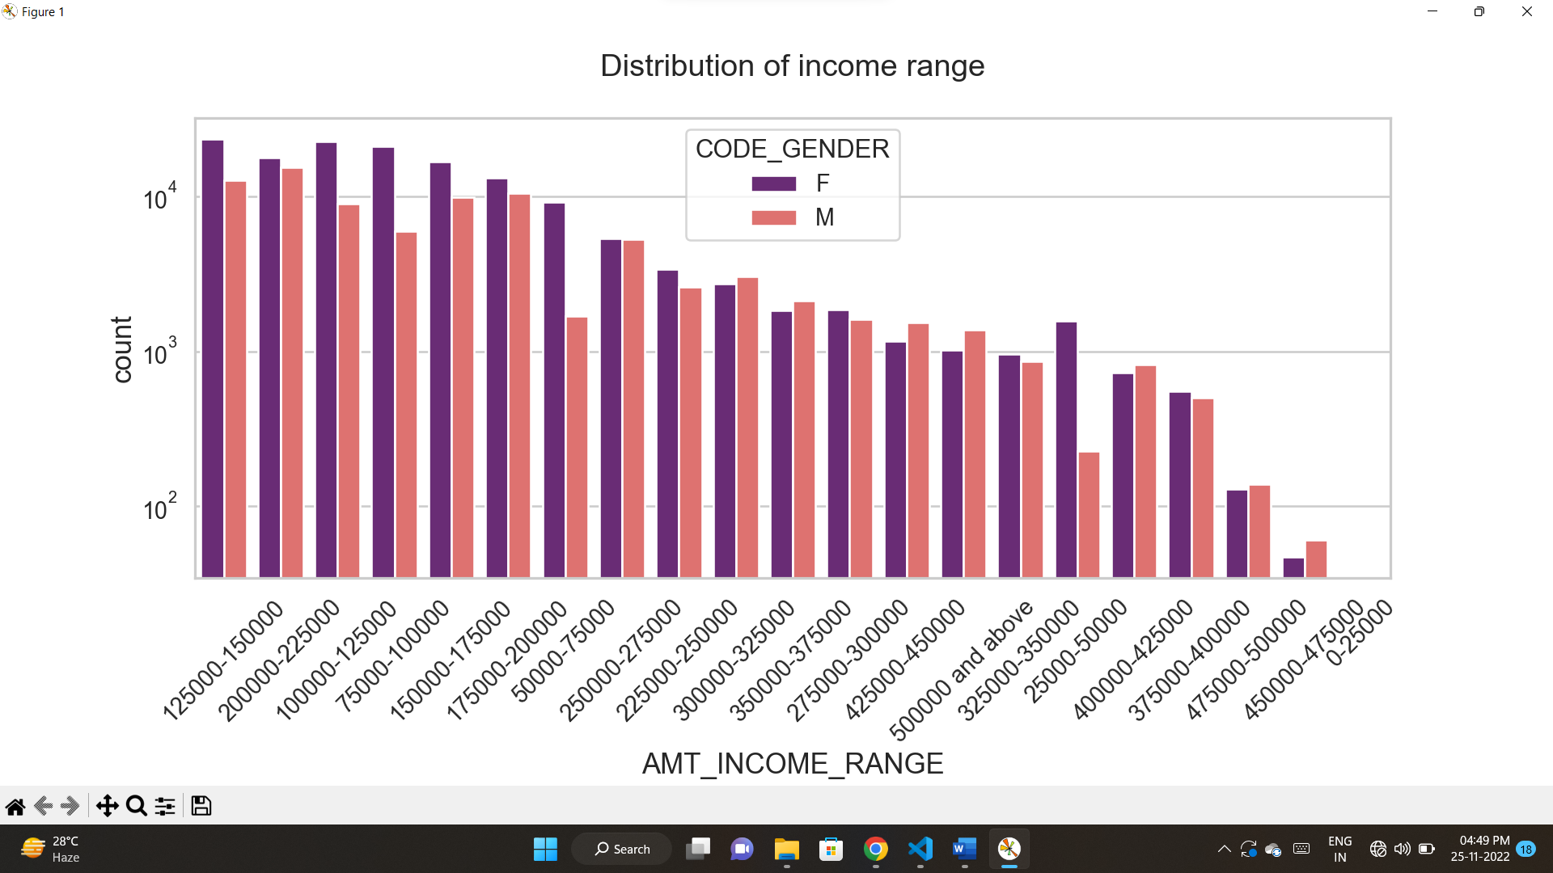

* from this graph we can observe that
  + there are a greater number of credits in 100000-200000
  + in that range there are number of females
  + very less count of credits presents at 450000-475000
  + No one is there at 0-25000
* Plotting a graph for income distribution

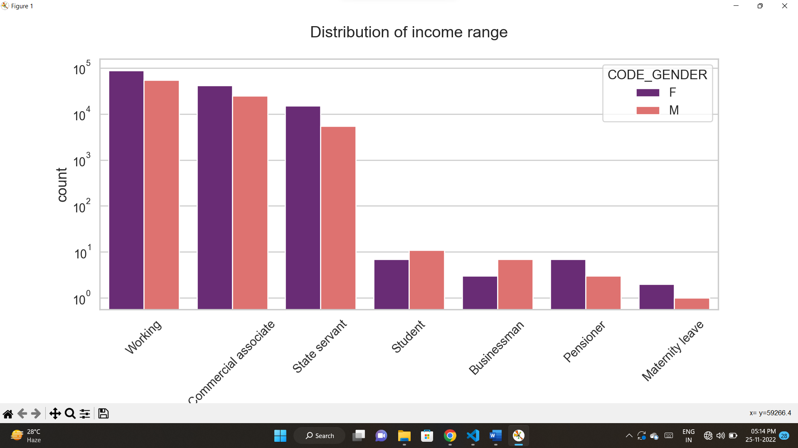

* From this graph we can observe that
  + Working, Commercial associate and state servant are having high range of income.
  + For this range, females are majority.
  + Student, Businessman, Pensioner and Maternity leave has less range of income
* 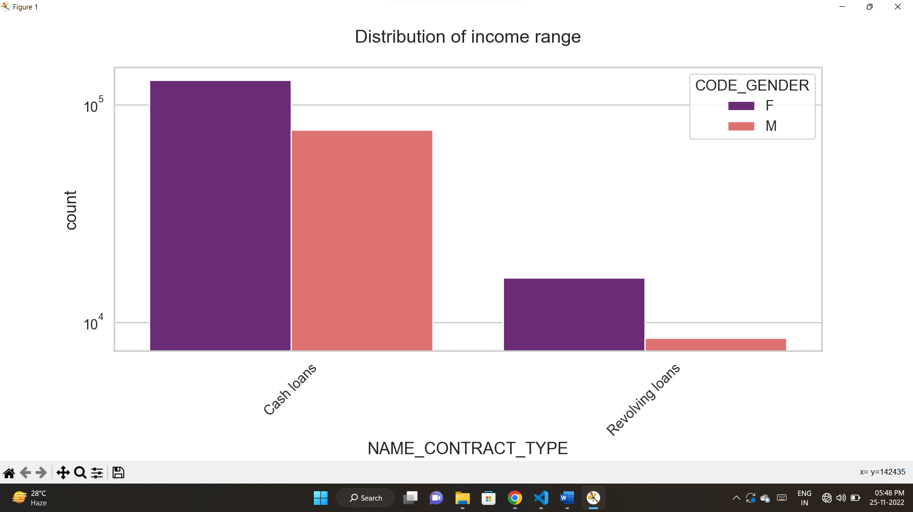Plotting a graph for contract distribution
* From this graph we can analyse that
  + Cash loans are in higher count
  + Females are more in this range
* Plotting a count graph on organization type

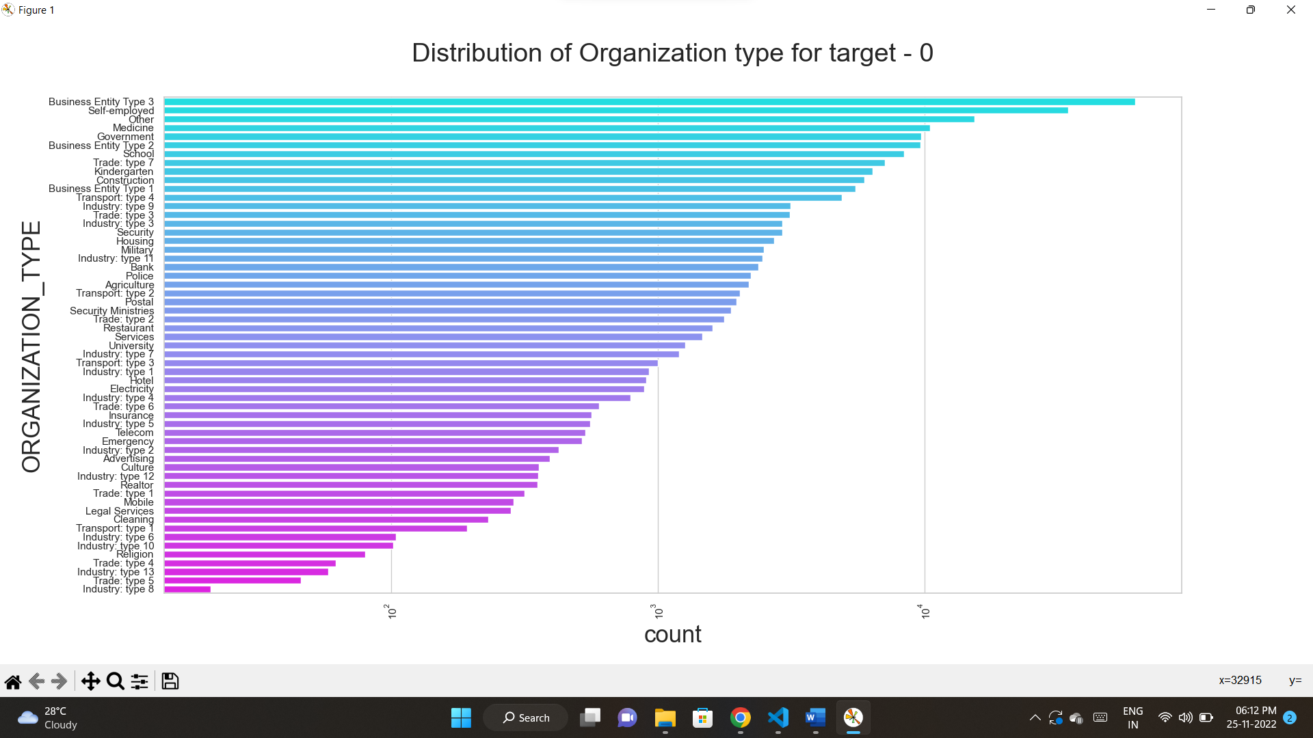

* From this graph we can analyse that
  + Business entity type 3, self-employed, other, medicine and Government has more number of clients.
  + Religion, trade: type 4,industry:type 4, industry:type 13, trade:type 5, industry: type 8 has less number clients
* **analysing the data for customers who having payment difficulties**
* Plotting a graph for income distribution
* uniplot(target1_df,col='AMT_INCOME_RANGE',title='Distribution of income range',hue='CODE_GENDER')

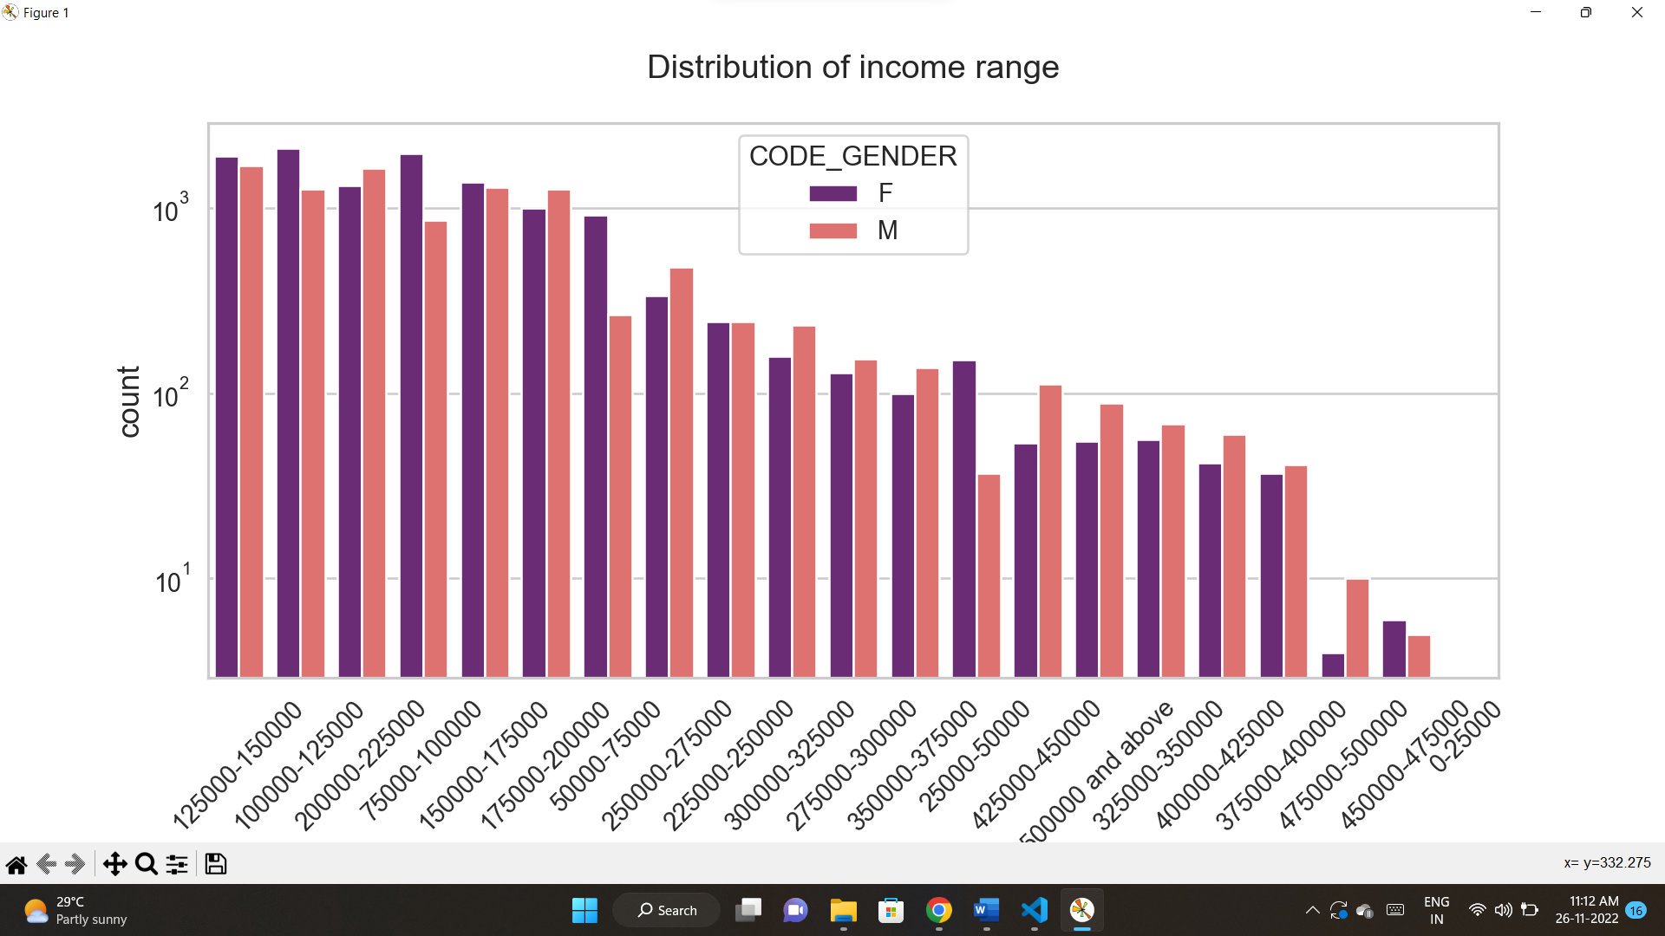

* from this graph we can analyse that
  + there are a greater number of credits from 100000 – 200000 range
  + there are more males than female
  + there are less number of credits greater than 400000
  + males
* 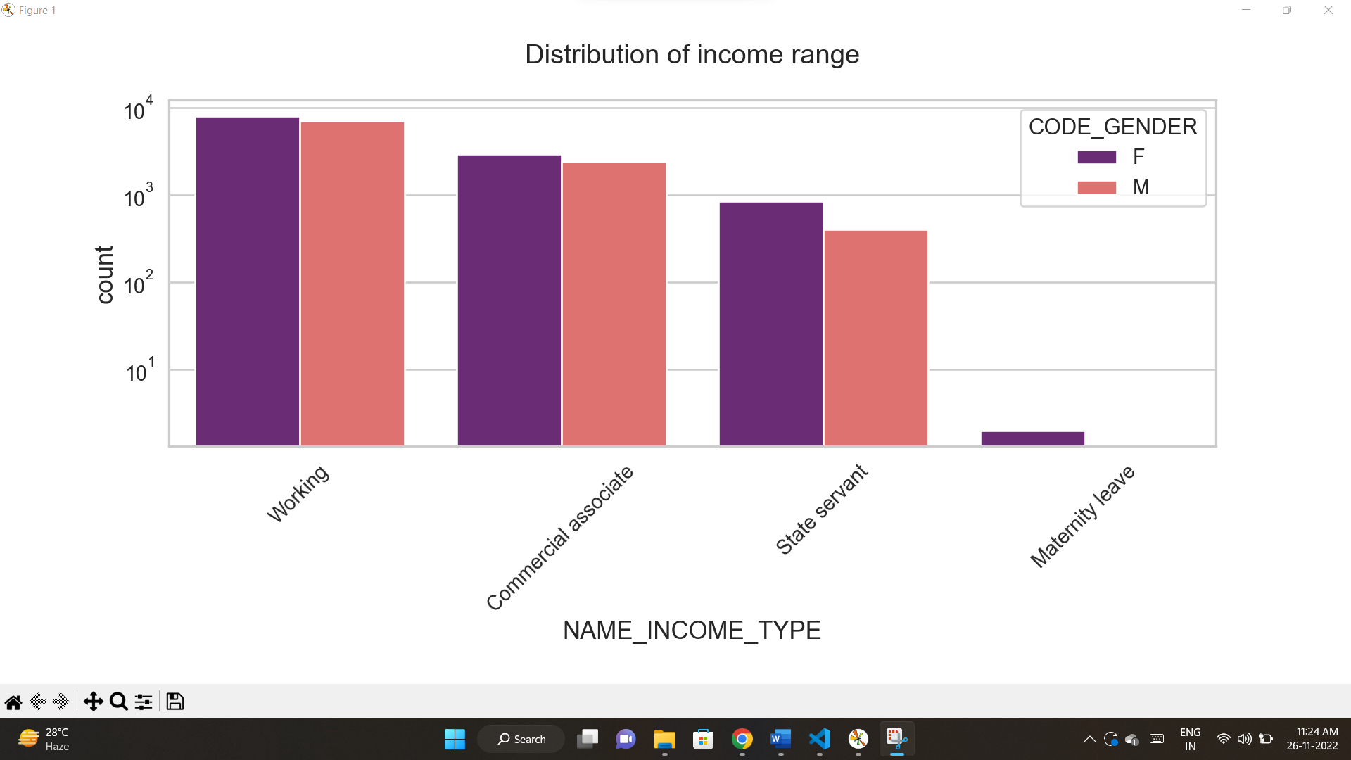plotting a graph on income distribution
* From this graph we can analyse that
  + Working, commercial associate has more range of income
  + In that range male are greater than female
  + State servant and maternity leave has less range of income
  + In that range also males are greater than female
* Plotting a graph on distribution of income range on contract type.

* From this graph we can analyse that
  + Cash loans are more than revolving loans
  + In this too males are greater
* Plotting a count graph on organization.

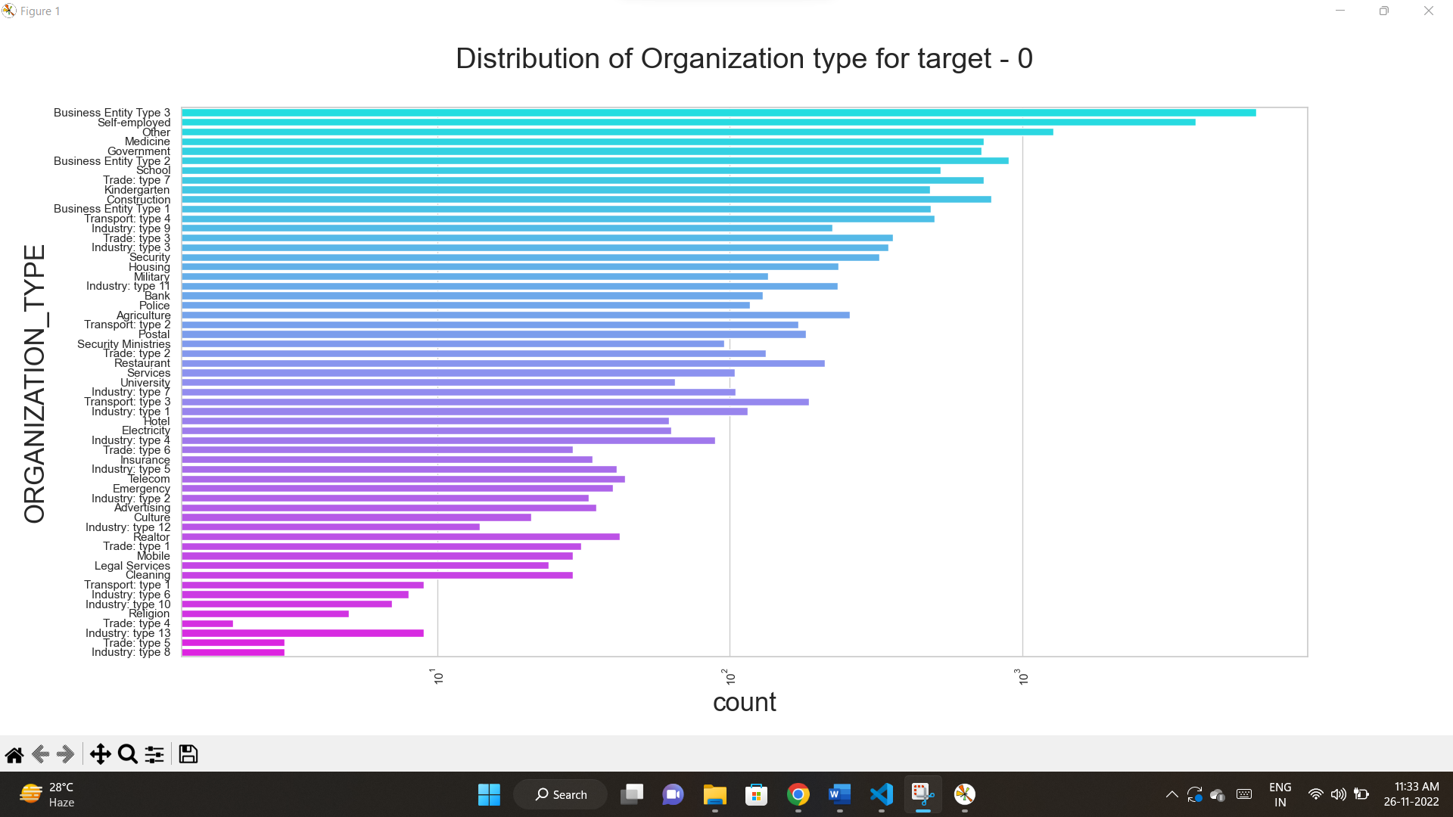

* From this graph we can analyse that
  + Business entity type 3, self-employed, other, medicine and Government has more number of clients.
  + Religion, trade: type 4,industry:type 4, industry:type 13, trade:type 5, industry: type 8 has less number clients
* Box plots for same kind of data
  + Same kind of data are ‘AMT_INCOME_TOTAL’,AMT_CREDIT’, ‘AMT_ANNUITY’
* Let’s plot the graphs for target0_df

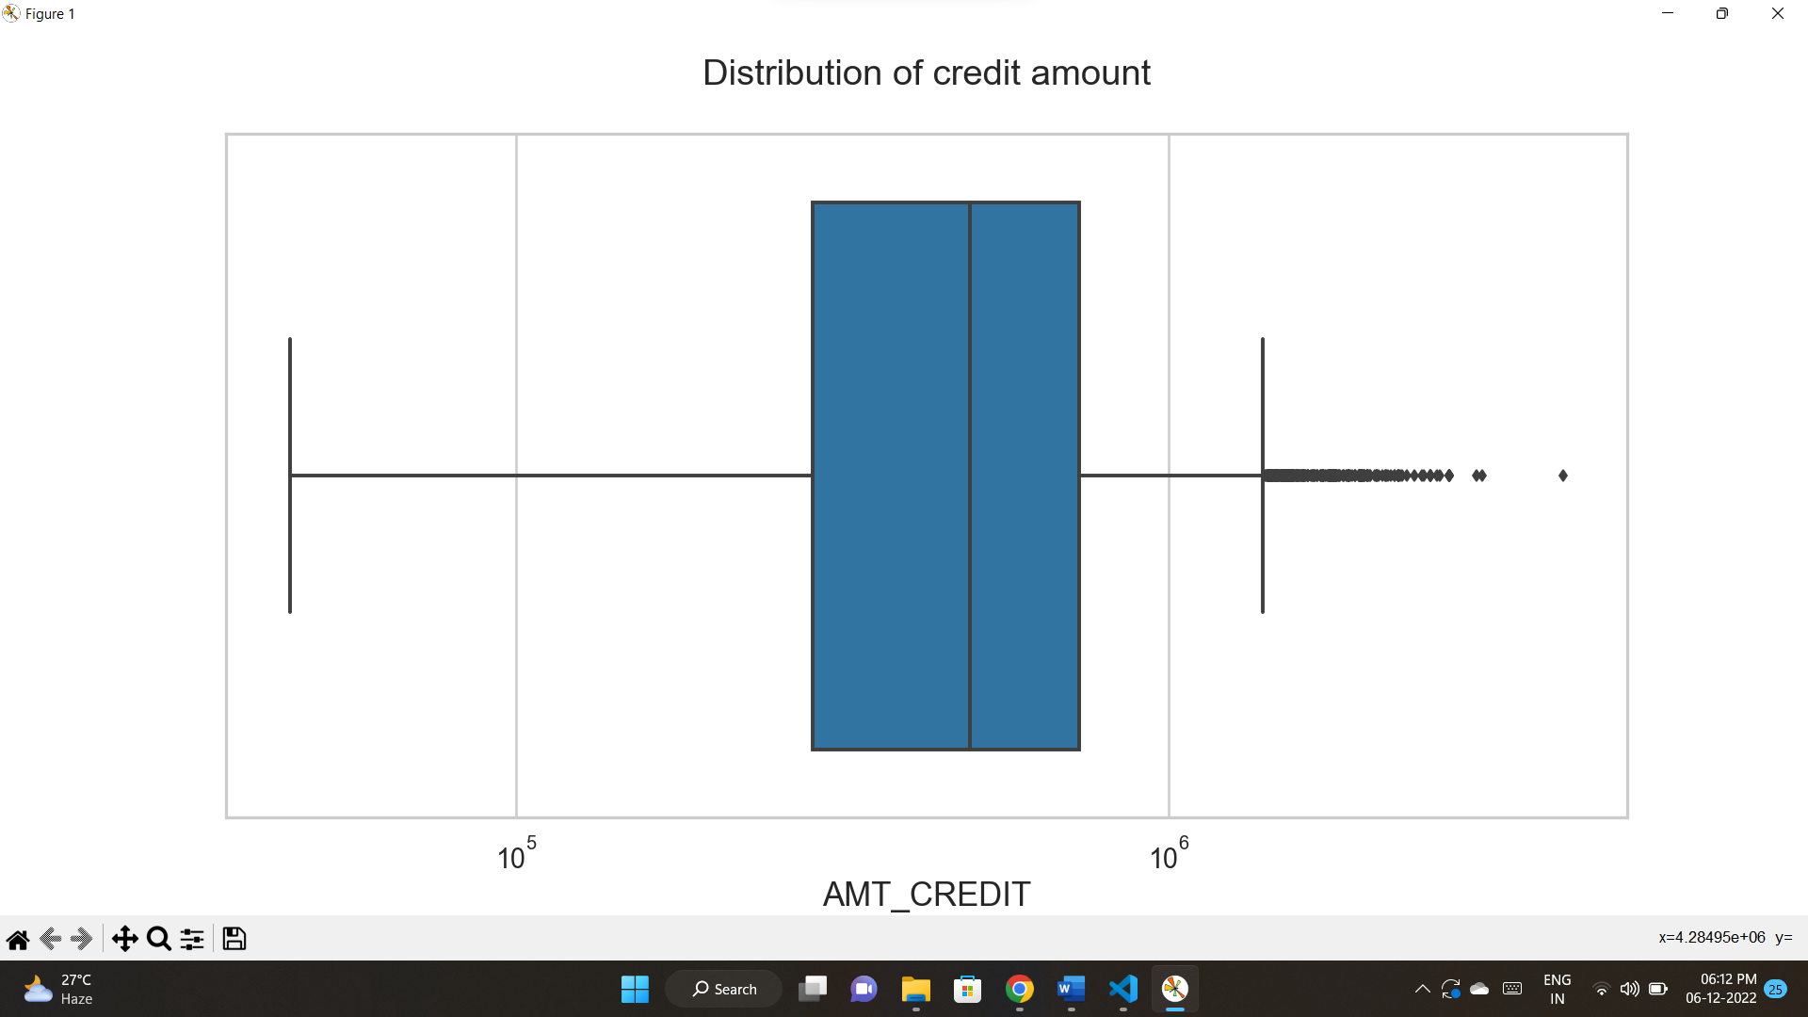

* From this graph we can conclude that
  + Q1 is bigger than Q3 many of customers lies in Q1
  + There are outliers in credit distribution

* There are some outliers in income distribution
* q1 in bigger than the q3 so the more customers are in q1

* Let’s plot the graphs for target1_df

From this graph

* Q1 is larger than the q3
* Some outliers also present in the graph.

* There are some outliers in income distribution
* q1 in bigger than the q3 so the more customers are in q1

* there are some outliers in the AMT_ANNUITY
* First quartile is bigger than the third one. so many of outliers present in the first outlier.

**BI-VARIATE ANALYSIS**

Plotting graphs for bi-variate analysis for target0_df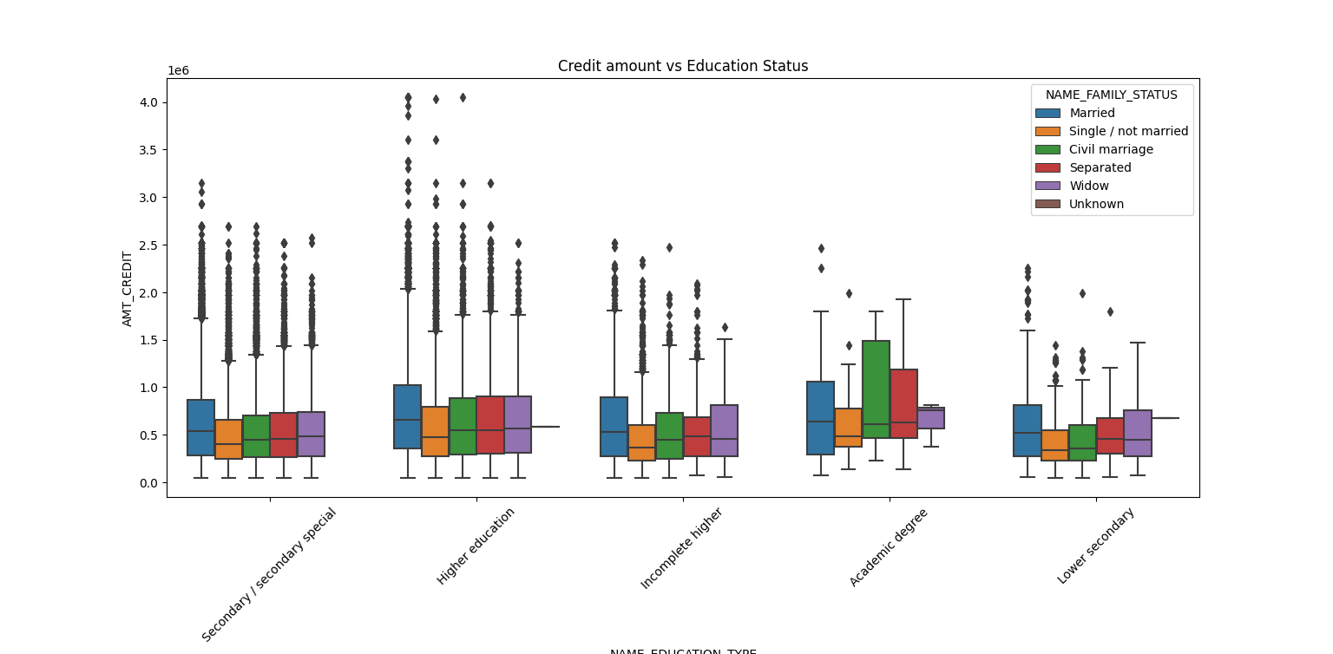

* Academic degree of married, Civil marriage separated has a greater number of credits than any other else.
* Higher education of family status married, single, civil marriage has a greater number of outliers.
* 3rd quartile of civil marriage in academic degree are having greater number of credits than any others

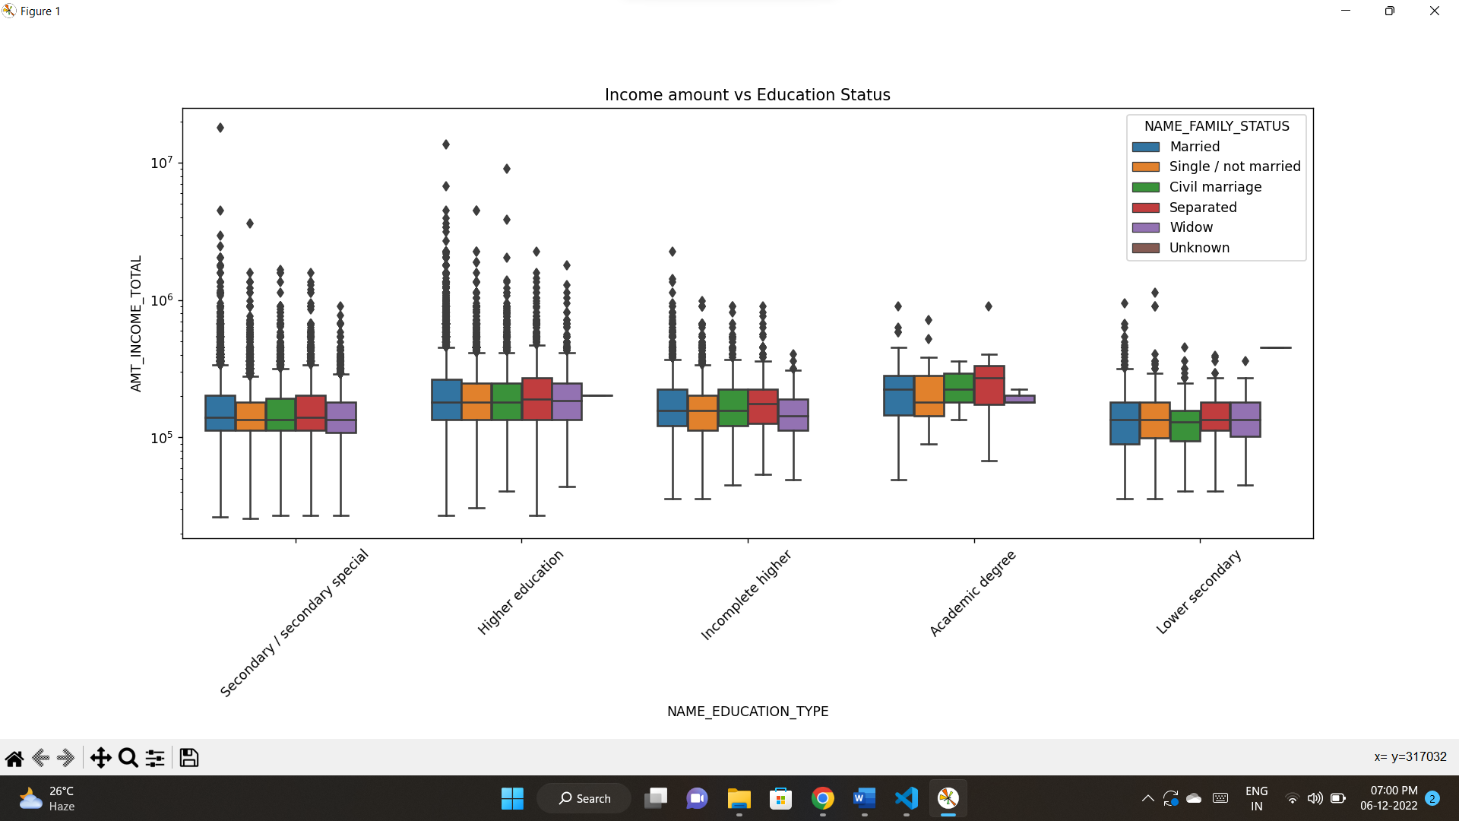

* In Higher education, almost family types have same income amount.
* And it also contains outliers.
* Academic degree has a smaller number of outliers.
* Lower secondary has less income amount than others.
* Plotting graphs for bi-variate analysis for target1_df

* In Academic degree married has a greater number of amount credit and this doesn’t contain any outlier.
* Lower secondary group has less number of credits compare to others.

From this graph we can say that,

* Academic degree has only one status that is married. This has more income and no outliers.
* Almost all status of Higher education has almost same income.
* Lower secondary has less income than others.

Let’s analysis the previous application details.

* Importing dataset

data1 = pd.read_csv("previous_application.csv")

* Knowing the null values sum and dropping the columns where it has 30% data loss
* emptycol1 = data1.isnull().sum()
* emptycol1 = emptycol1[emptycol1.values>(0.3*len(emptycol1))]
* emptycol1 = list(emptycol1[emptycol1.values>=0.3].index)
* data1.drop(labels=emptycol1,axis=1,inplace=True)
* data1 = data1.drop(data1[data1['NAME_CASH_LOAN_PURPOSE']== 'XNA'].index)
* data1 = data1.drop(data1[data1['NAME_CASH_LOAN_PURPOSE']== 'XNA'].index)
* Merge the previous application data with application data
* new_data=pd.merge(left=data,right=data1,how='inner',on='SK_ID_CURR',suffixes='_x')
* Renaming the data
* new_data1 = new_data.rename({'NAME_CONTRACT_TYPE_' : 'NAME_CONTRACT_TYPE','AMT_CREDIT_':'AMT_CREDIT','AMT_ANNUITY_':'AMT_ANNUITY','WEEKDAY_APPR_PROCESS_START_' : 'WEEKDAY_APPR_PROCESS_START','HOUR_APPR_PROCESS_START_':'HOUR_APPR_PROCESS_START','NAME_CONTRACT_TYPEx':'NAME_CONTRACT_TYPE_PREV','AMT_CREDITx':'AMT_CREDIT_PREV','AMT_ANNUITYx':'AMT_ANNUITY_PREV','WEEKDAY_APPR_PROCESS_STARTx':'WEEKDAY_APPR_PROCESS_START_PREV','HOUR_APPR_PROCESS_STARTx':'HOUR_APPR_PROCESS_START_PREV'}, axis=1)
* Dropping the unnecessary data
* new_data1.drop(['SK_ID_CURR','WEEKDAY_APPR_PROCESS_START','HOUR_APPR_PROCESS_START','REG_REGION_NOT_LIVE_REGION','REG_REGION_NOT_WORK_REGION','LIVE_REGION_NOT_WORK_REGION','REG_CITY_NOT_LIVE_CITY','REG_CITY_NOT_WORK_CITY','LIVE_CITY_NOT_WORK_CITY','WEEKDAY_APPR_PROCESS_START_PREV','HOUR_APPR_PROCESS_START_PREV','FLAG_LAST_APPL_PER_CONTRACT','NFLAG_LAST_APPL_IN_DAY'],axis=1,inplace=True)
* **Performing univariate analysis**

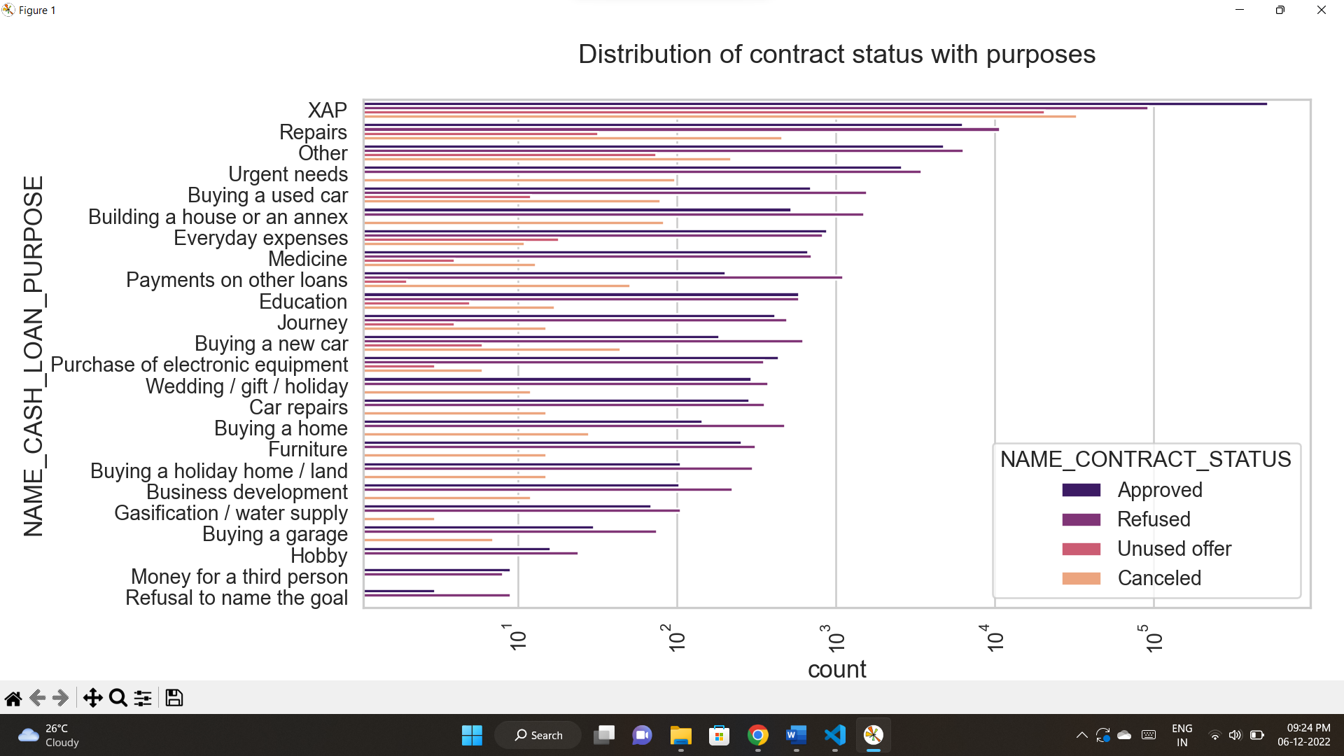

* Most of loans are cancelled in XAP
* Most of loans are approved in XAP
* Less number of approved loans are in Refusal to name the goal.

* XAP has difficulties in payment of their loans.
* Least number of loans are in Refusal to name the goal with target 1.

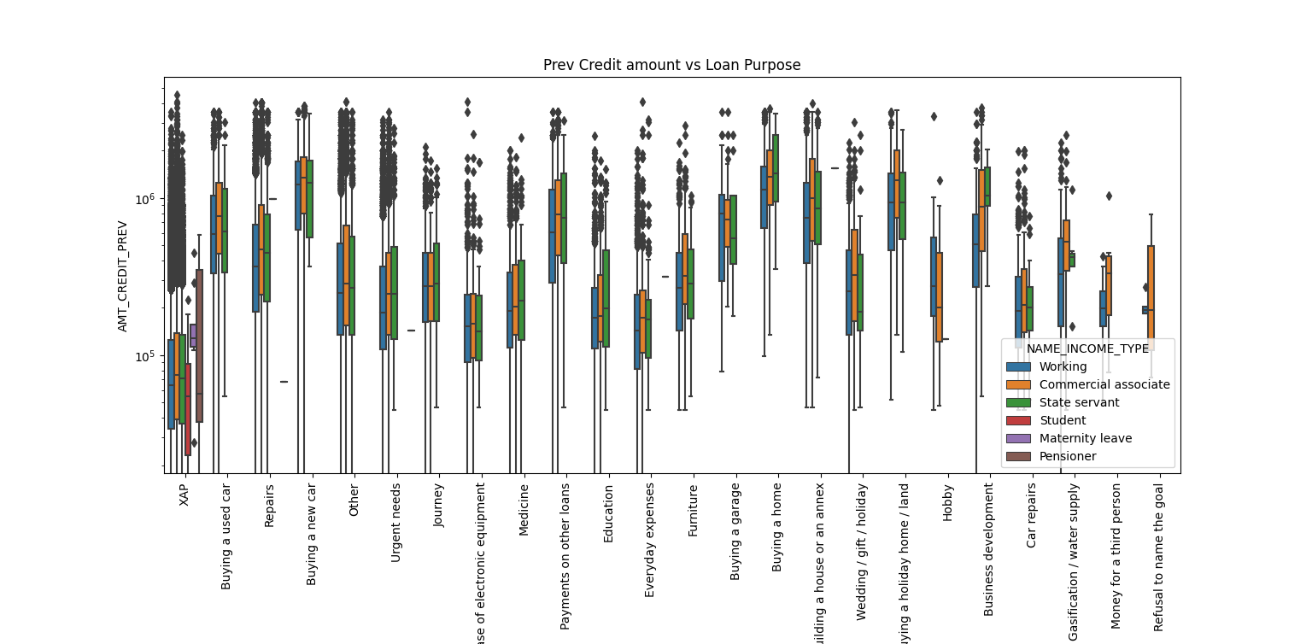

* Loan purpose of house buying has more amount of credit.
* Least amount credited to XAP

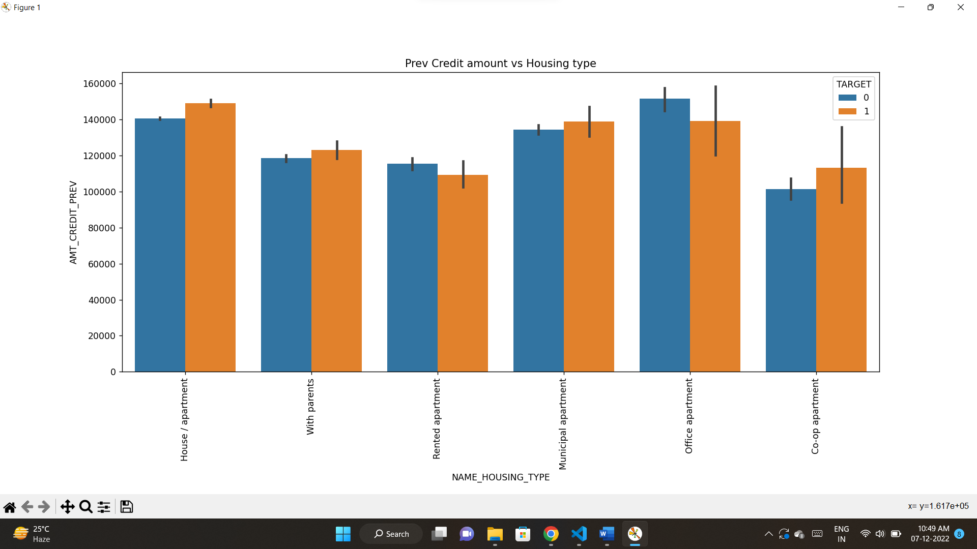

* Office apartment has more loan repayment difficulties. So bank need to avoid giving loans to them
* House/apartment has more have no payment difficulties. So bank should focus on these groups.