1. **Query to get Top 10(N) rows from the Table**

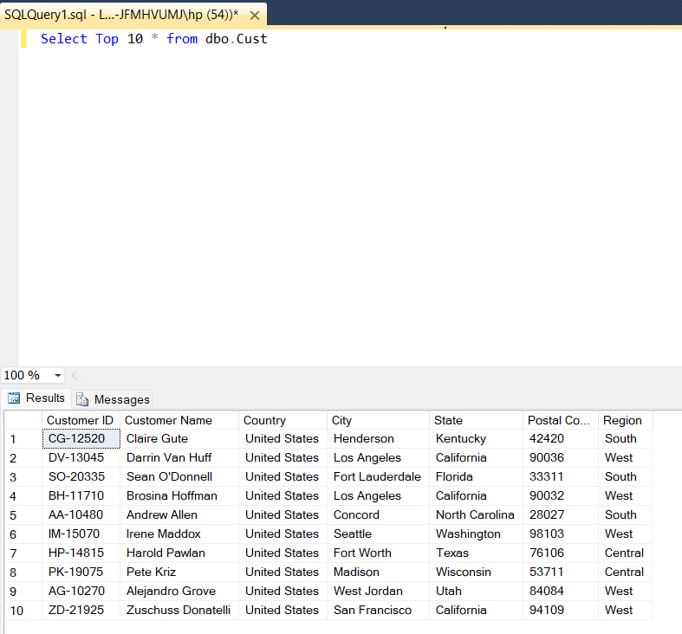

**2)Query to get Bottom 10(N) rows from the Table**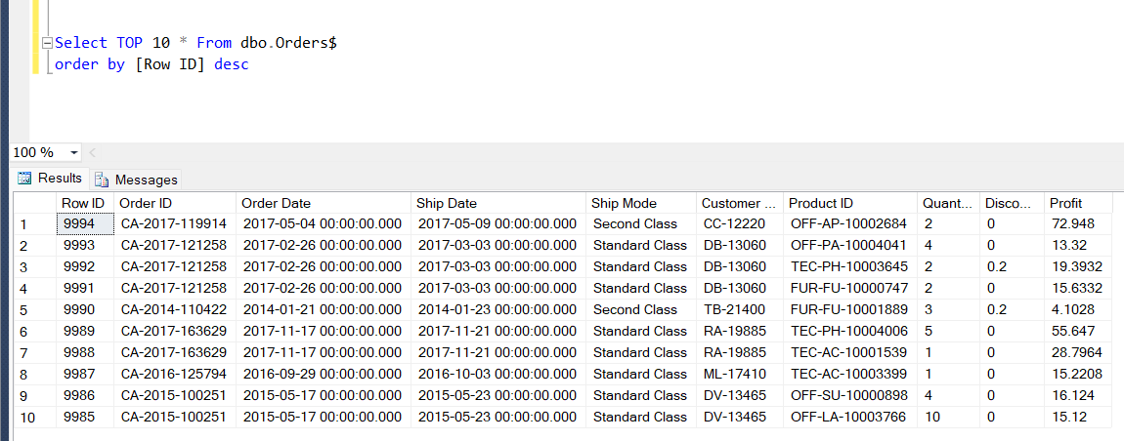

**3) SQL Query to aggregate the data from Orders table. To Find out total profit from each Ship Mode?**

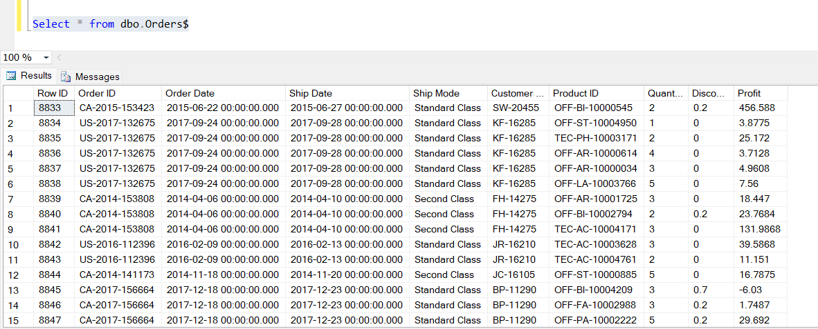

RESULT:

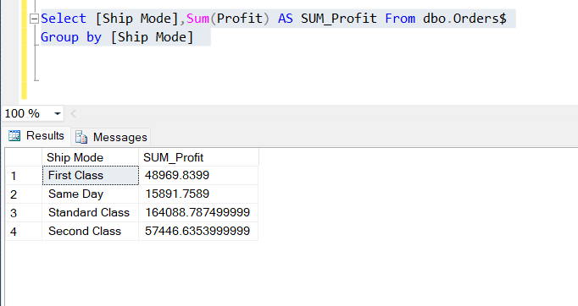

**4) SQL Query to adjust Decimal Values?**

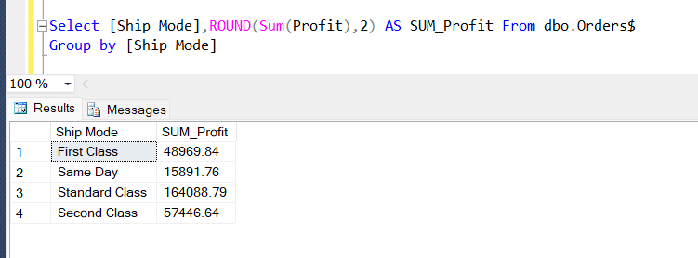

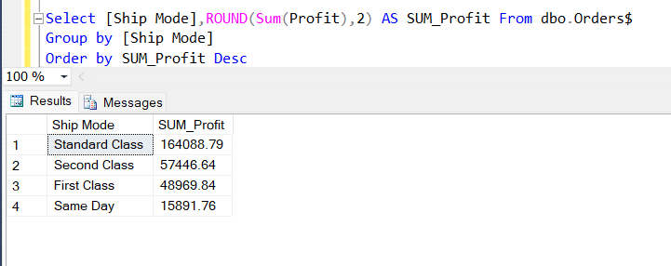**5) SQL Query to sort the above result**

**6) Query to find out sum of profit only for Positive Values?**

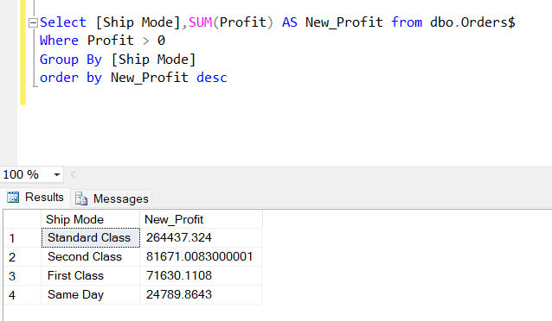

**7) SQL Query to get MIN, MAX and AVG of Profit.**

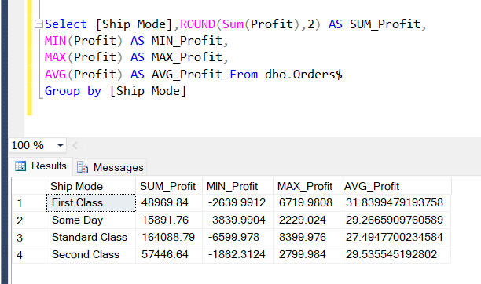

**8) SQL Query to find the to find out the percentage of Profit.**

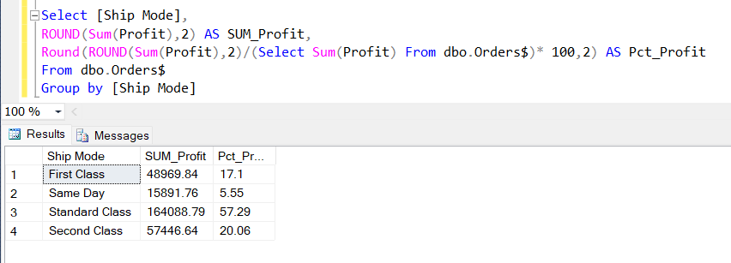

**9) SQL Query to get the Percentage of profit more than 20.**

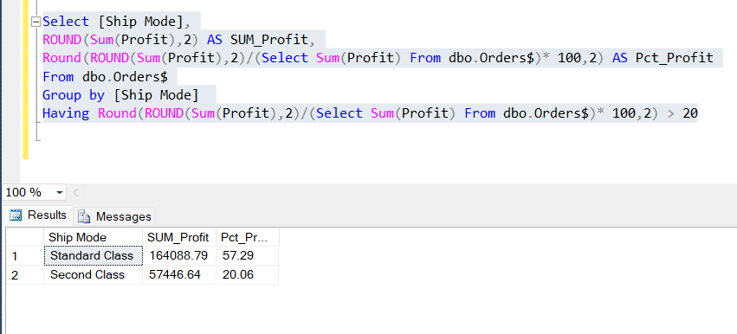

**10) SQL Query for Having condition on Aggregate Function**

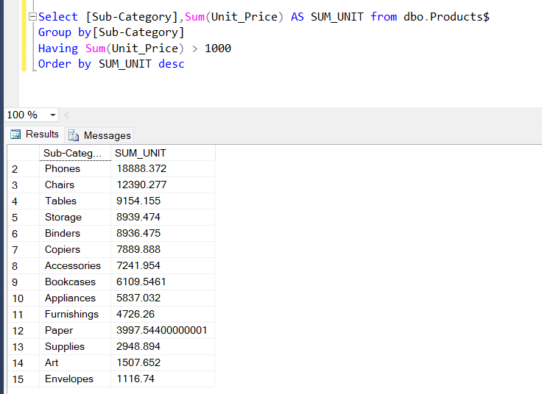

**11) SQL Query to get sum of Unit Price from Furniture and Technology Category whose sum of Unit Price greater than 1000**

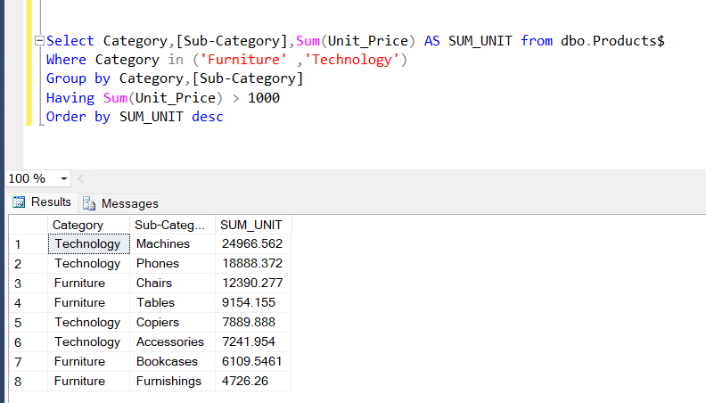

**12) SQL query to get the Product name, which has ‘Printer’ in it.**

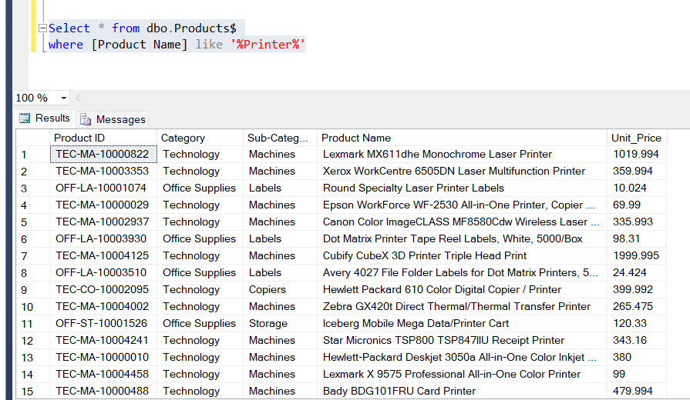

**13) SQL query to get the Product name which ends with both a, b.**

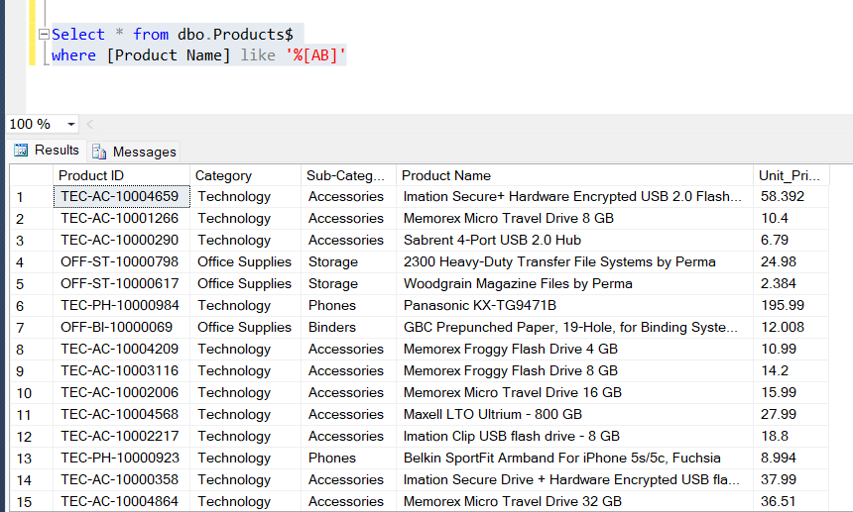

**14) SQL Query to print product Name, and the 3rd letter of the product Name Should be ‘a’.**

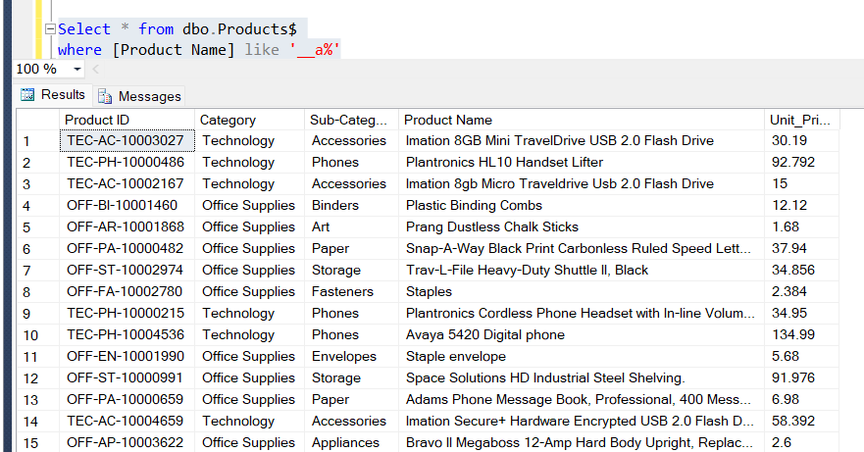

**15) Write an SQL Query to get Region wise Total profit from two different tables**

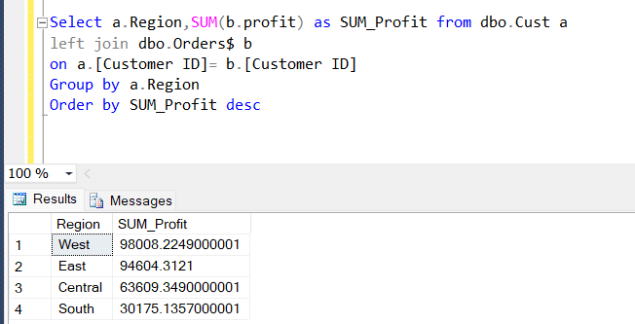

**16) WSQL Query to get Region wise Total profit per Category from 3 different tables.**

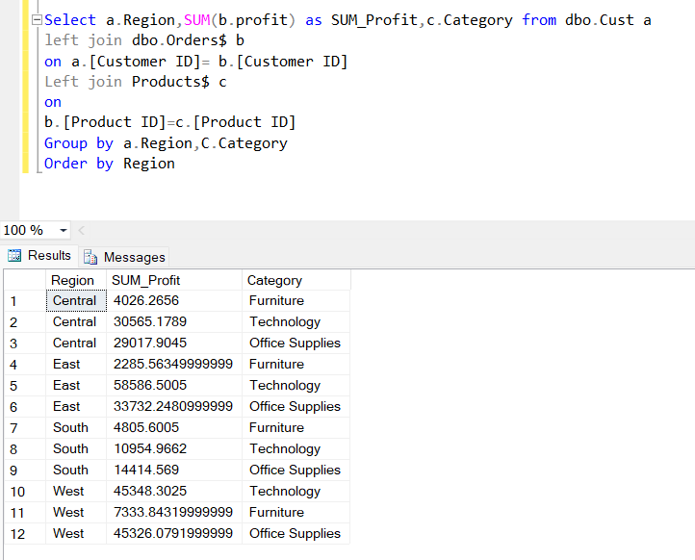

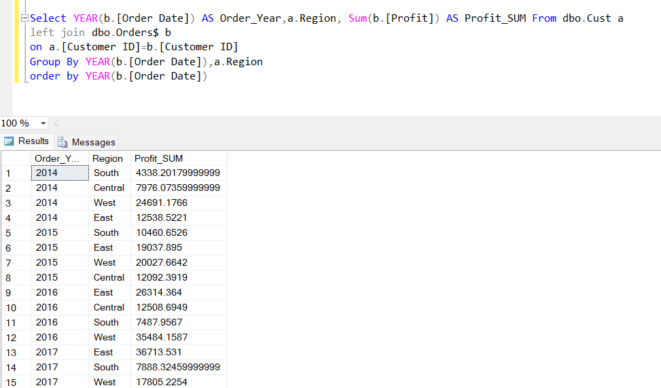**17) Query to find Yearly Total profit for all the regions. From 2 different tables**

**18)Query to find out the AVG_Sal for each Department?**

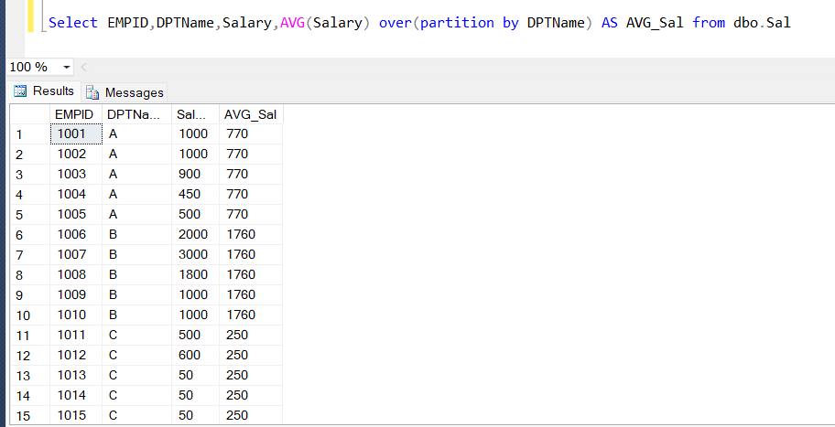

**19) Query to find out whose salary is more than the Avg_Salary (Reference above result table)**

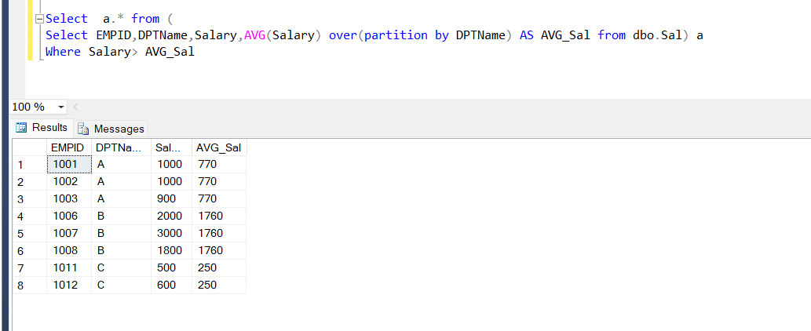

**20) Write a Query Display the rank for all the EMPIDs along with there DPT Name and salary. Highest salary has to get lowest Rank.**

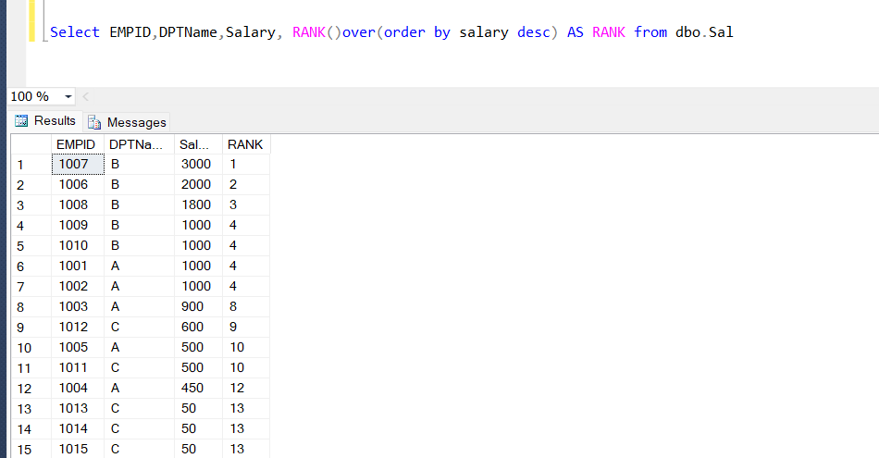

**21) Query to Remove the Gap in the Rank Column (Sequence of rank should not have gaps)**

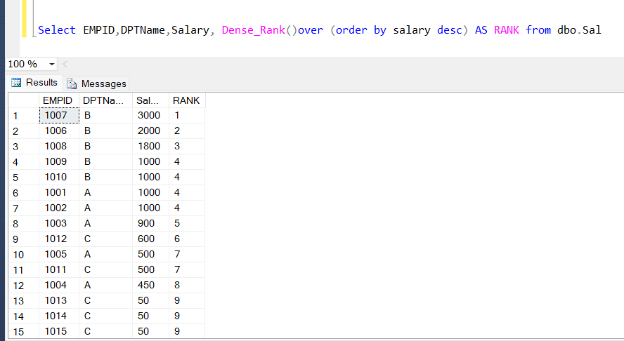

**22) For Printing the Ranks separately for each department Individually**

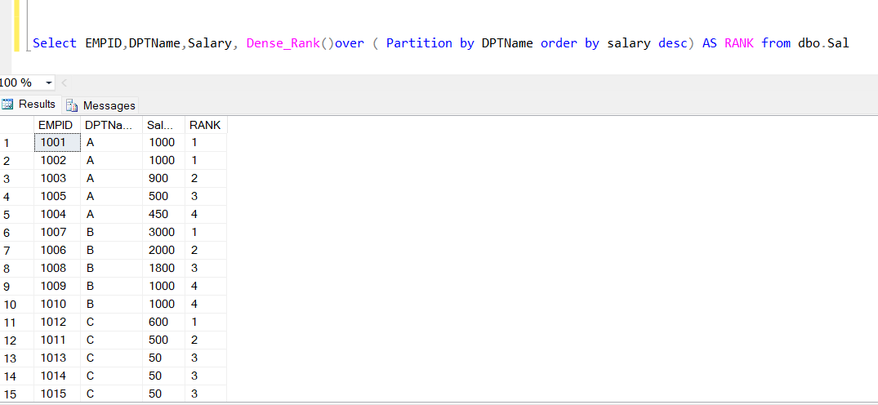

**23) Query to find 3rd highest rank in each DPT**

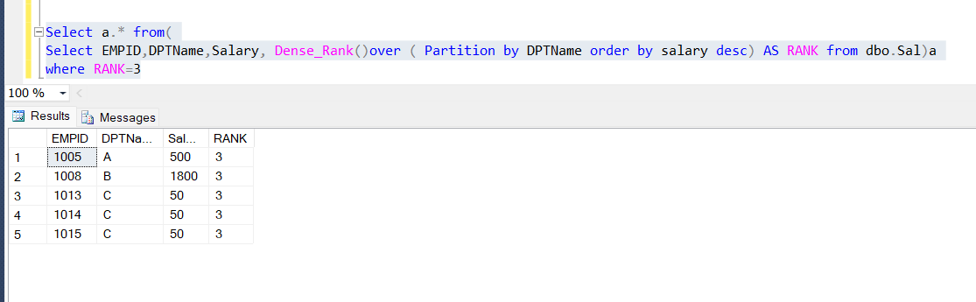

**24) Query to print only the Even rows from Sal table**

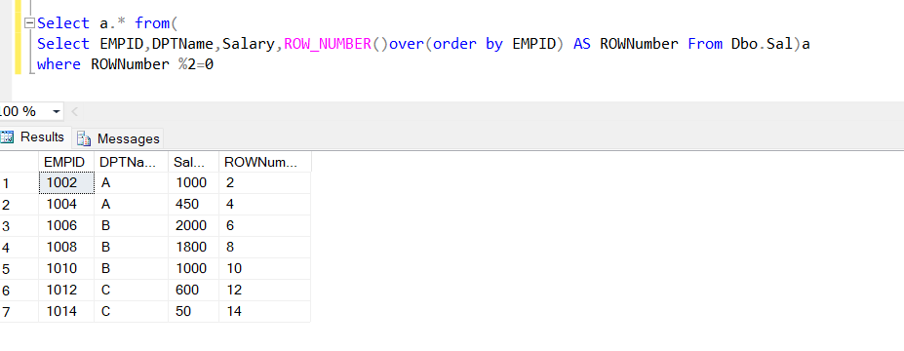

**25) Query to print only the ODD rows from Sal table**

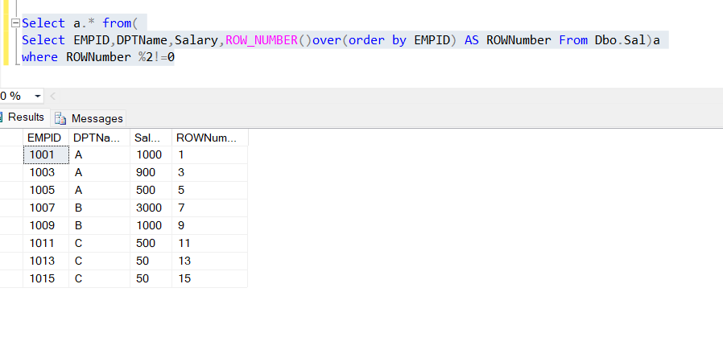

**25) Query to show difference b/w UNION AND UNION-ALL**

Table C1 Table C2

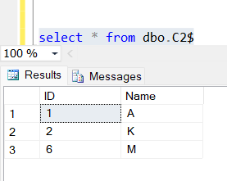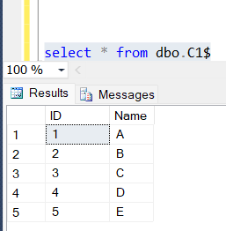

**UNION operation**

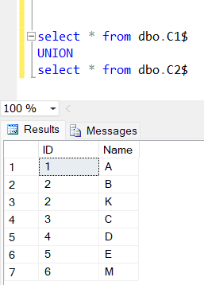

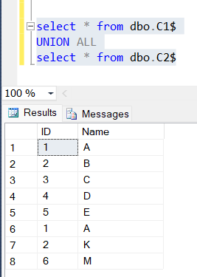**UNION ALL Operation**

**INTERSECT Operation**

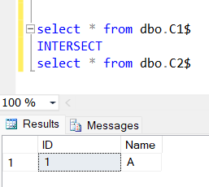

**EXCEPT Operation**

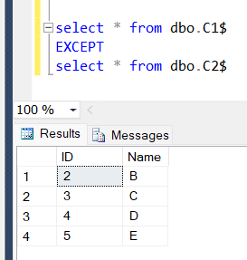

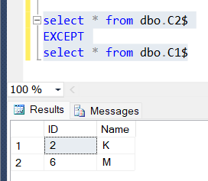

**26) Query to print all positive values of Profit As “Positive” and Negative Values as “Negative”**

Sample Table:

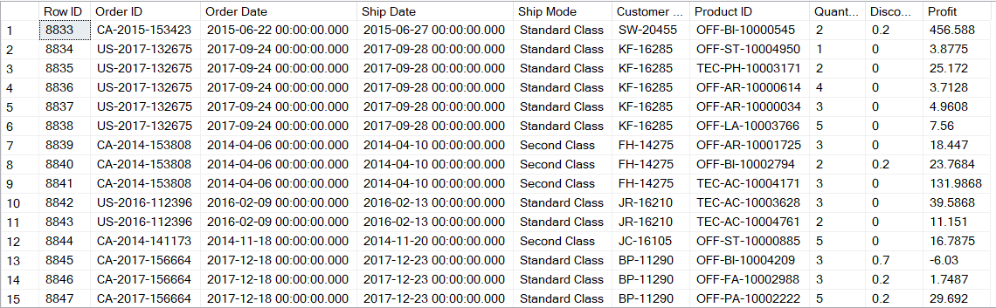

Querry:

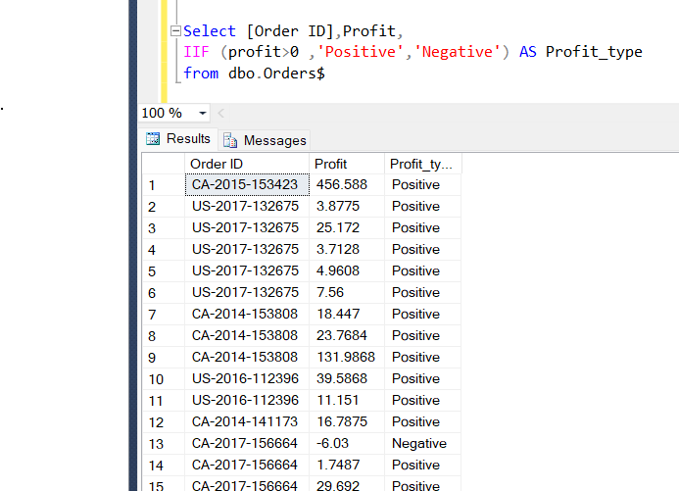

**27) Query to get the new Column as ‘Proft_Types’ with different conditions on profit value**

**Sample Table**

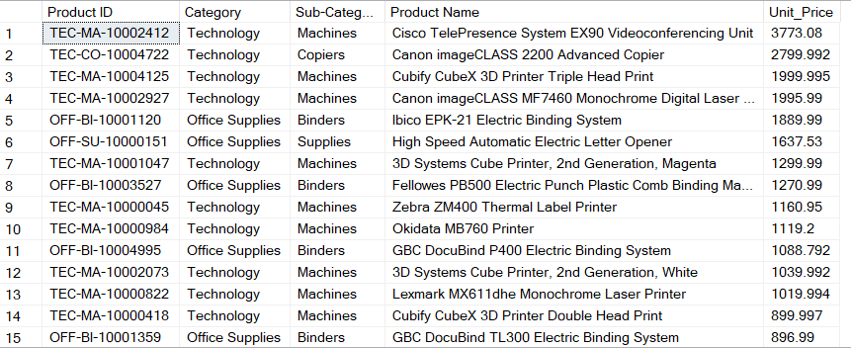

**Result Table:**

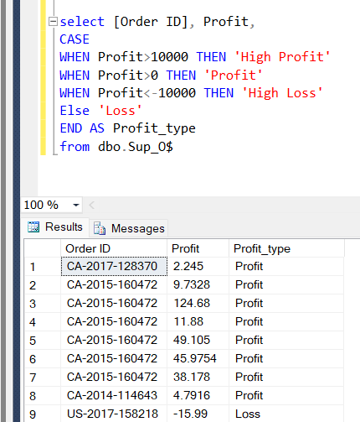

**28) Query to extract Year from Order Date**

**Sample Table:**

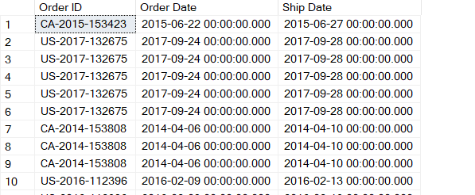

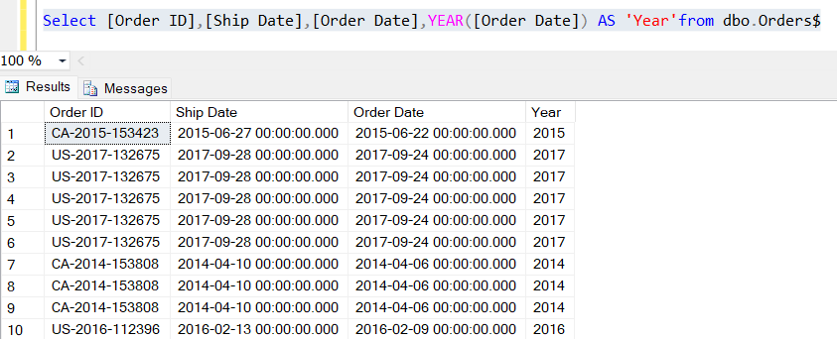**Result:**

**29) Query to get the Month Name from Orders Table? (Reference Above Sample Table)**

Result Table:

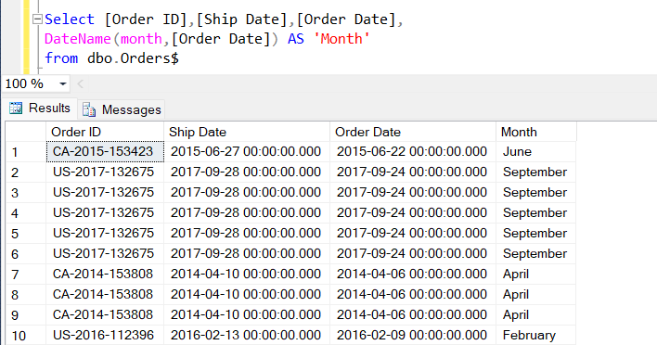

**30) Query to find the Difference of Year between Order Date and Today? (Ref above Sample Table)**

Result Table:

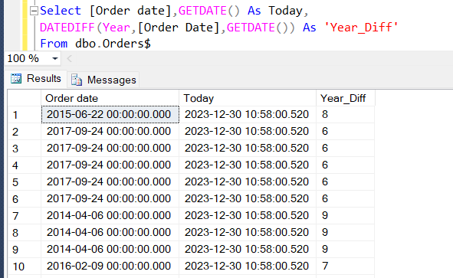

**31) Query to find the No of Employees belongs to 1st quarter of 2021 from Emps table**

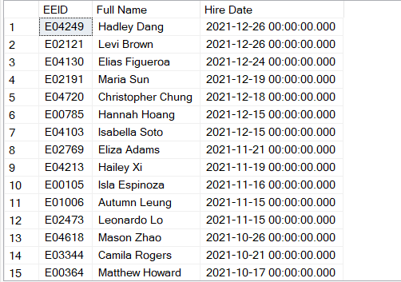Sample table:

Result:

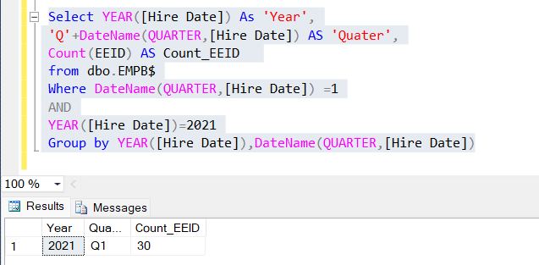

**32) SQL Query to Print week day name from the given date**

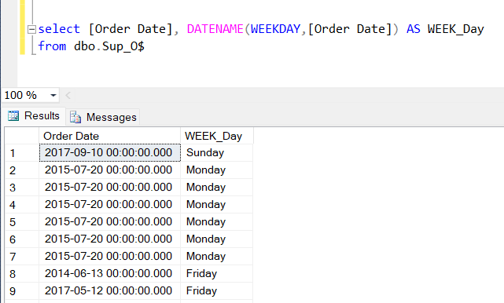

**33) SQL Query to Print total orders per each week day with in a rage of time period.**

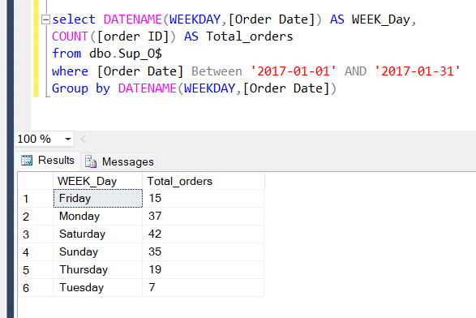

**34) creating a view from complex query. Which pulls data from more than one table.**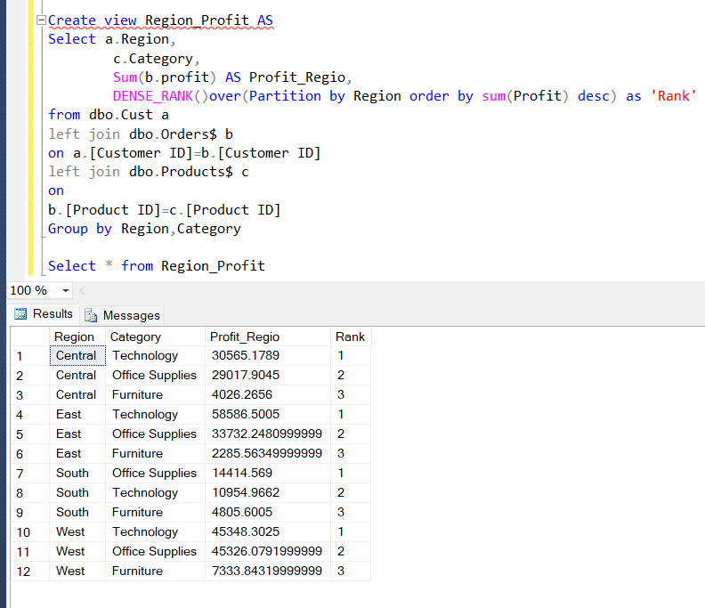

**35) creating stored procedure and calling stored procedure in SQL.**

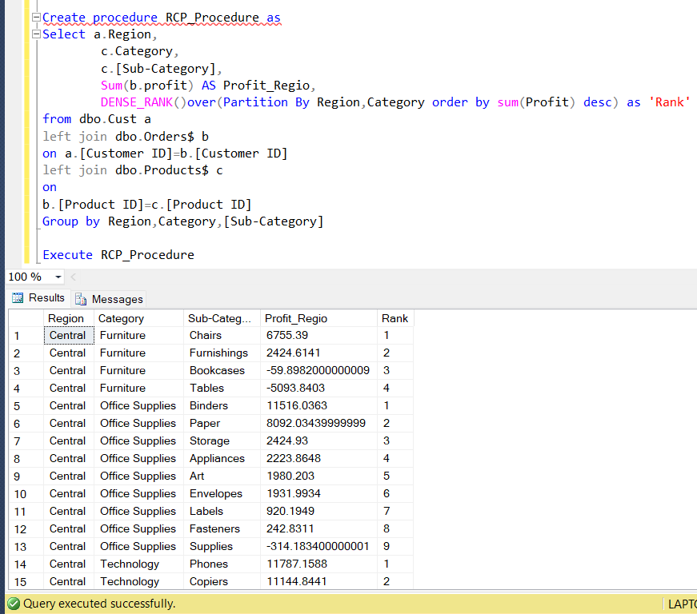

**36) Creating Indexing for improving the performance.**

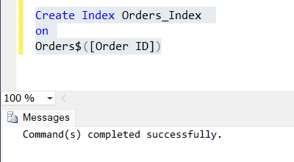

**37) common table expressions in SQL**

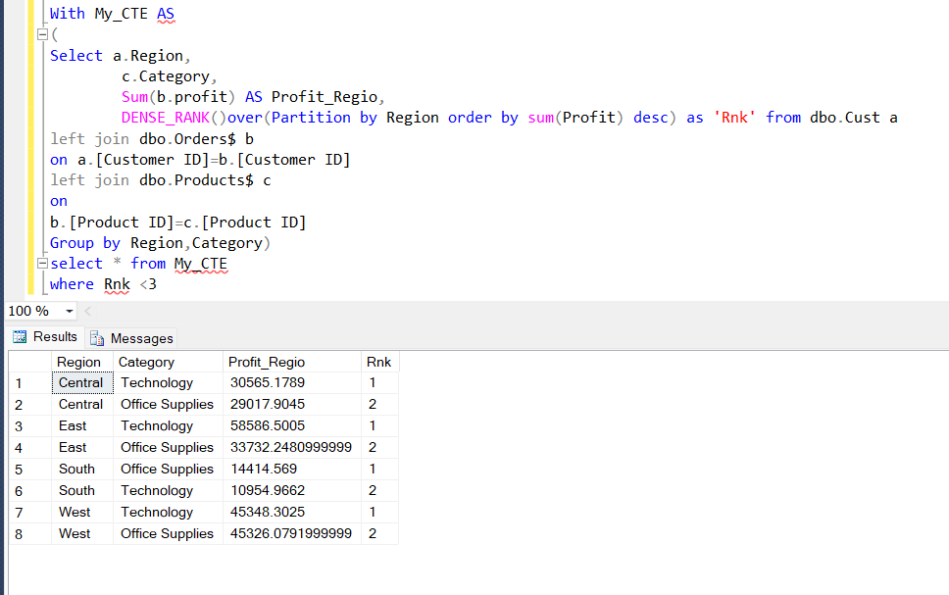

**39) Query to fetch domain from mail address**

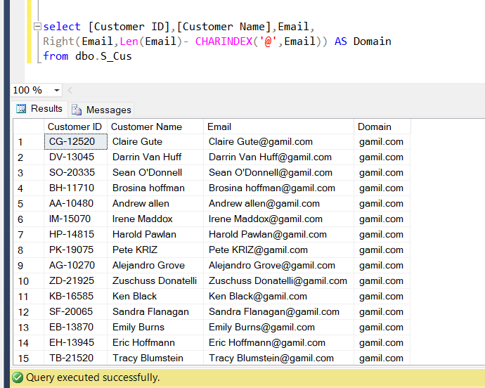

**40) Query to find count of Customers from each domain**

