ASSIGNMENT – 2.1
NAME : Bethi Mounika
HT.NO : 2303A52196
BATCH : 35

Lab 2: Exploring Additional AI Coding Tools beyond Copilot – Gemini (Colab) and Cursor AI.
Task 1: Statistical Summary for Survey Data
Scenario: You are a data analyst intern working with survey responses stored as numerical lists.
Task: Use Google Gemini in Colab to generate a Python function that reads a list of numbers and calculates the mean, minimum, and maximum values.
Expected Output:
Correct Python function
Output shown in Colab
Screenshot of Gemini prompt and result

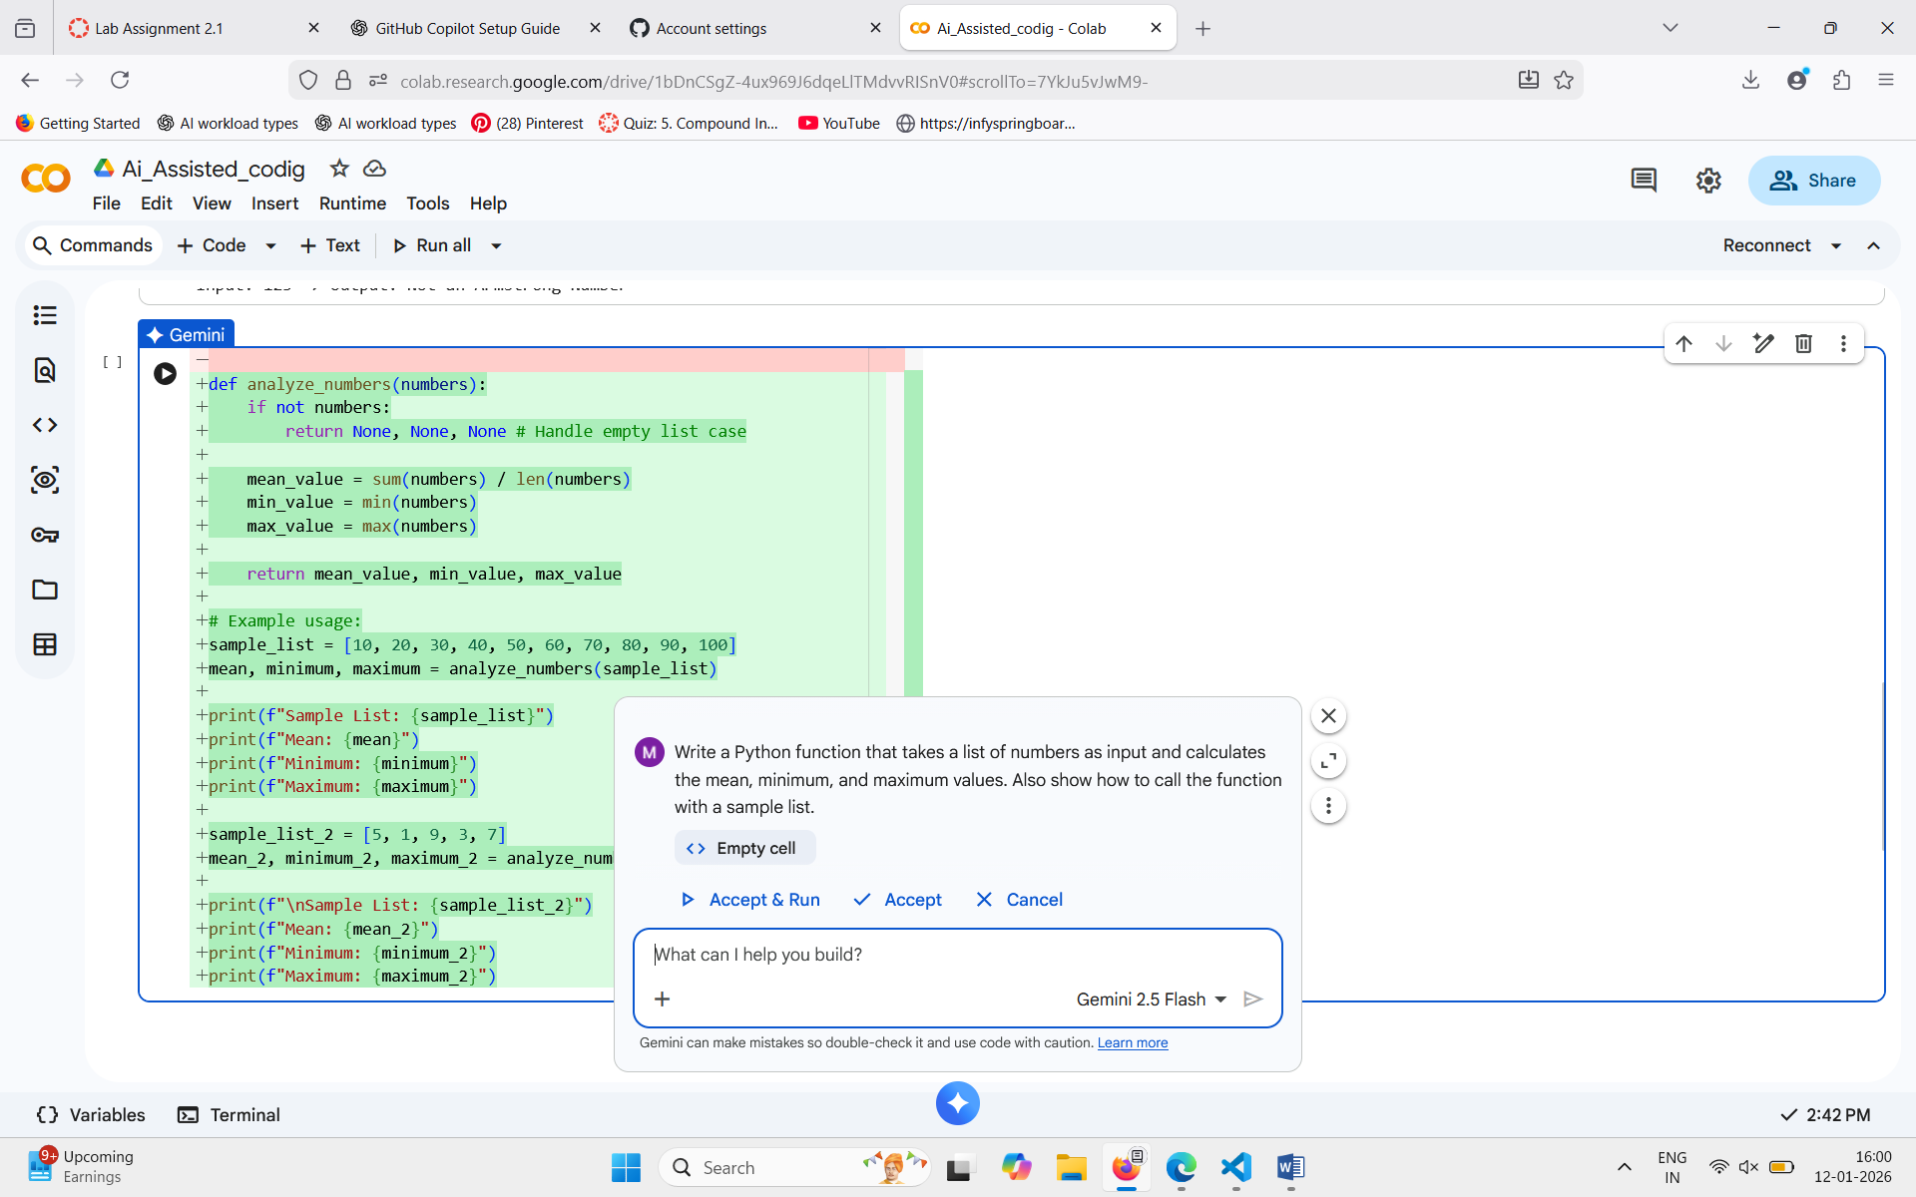
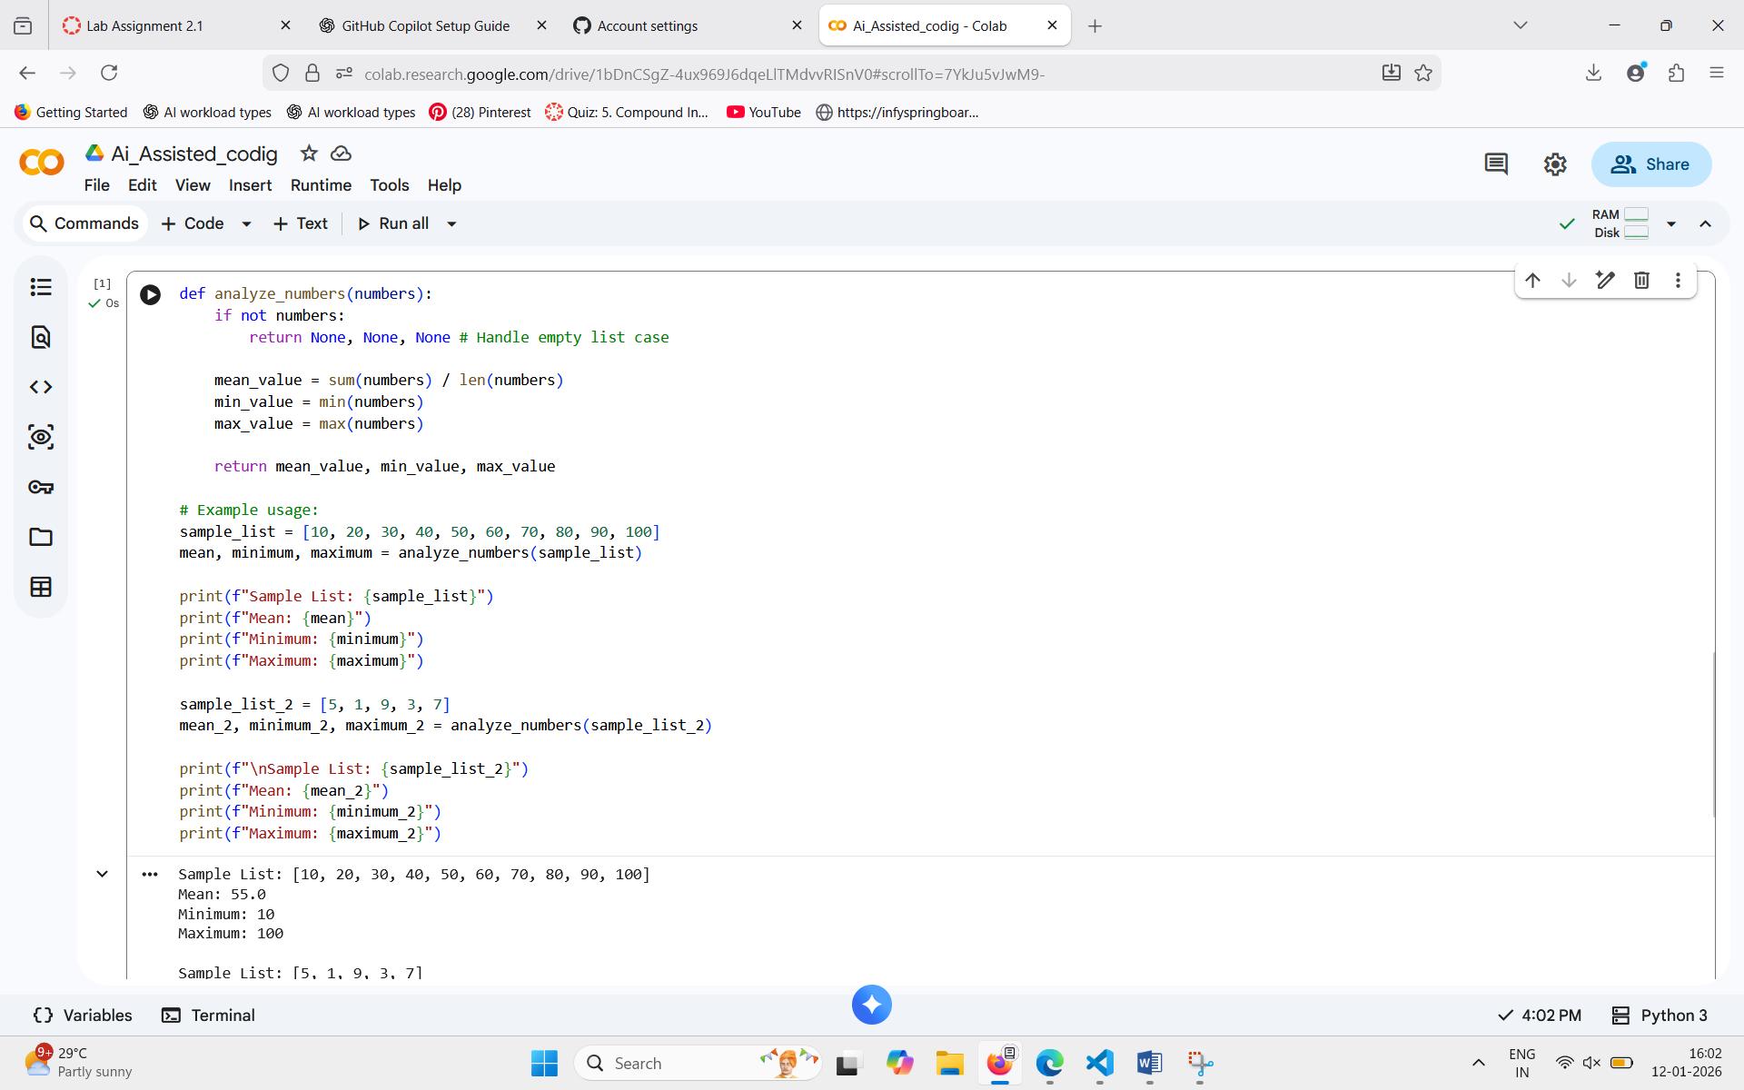

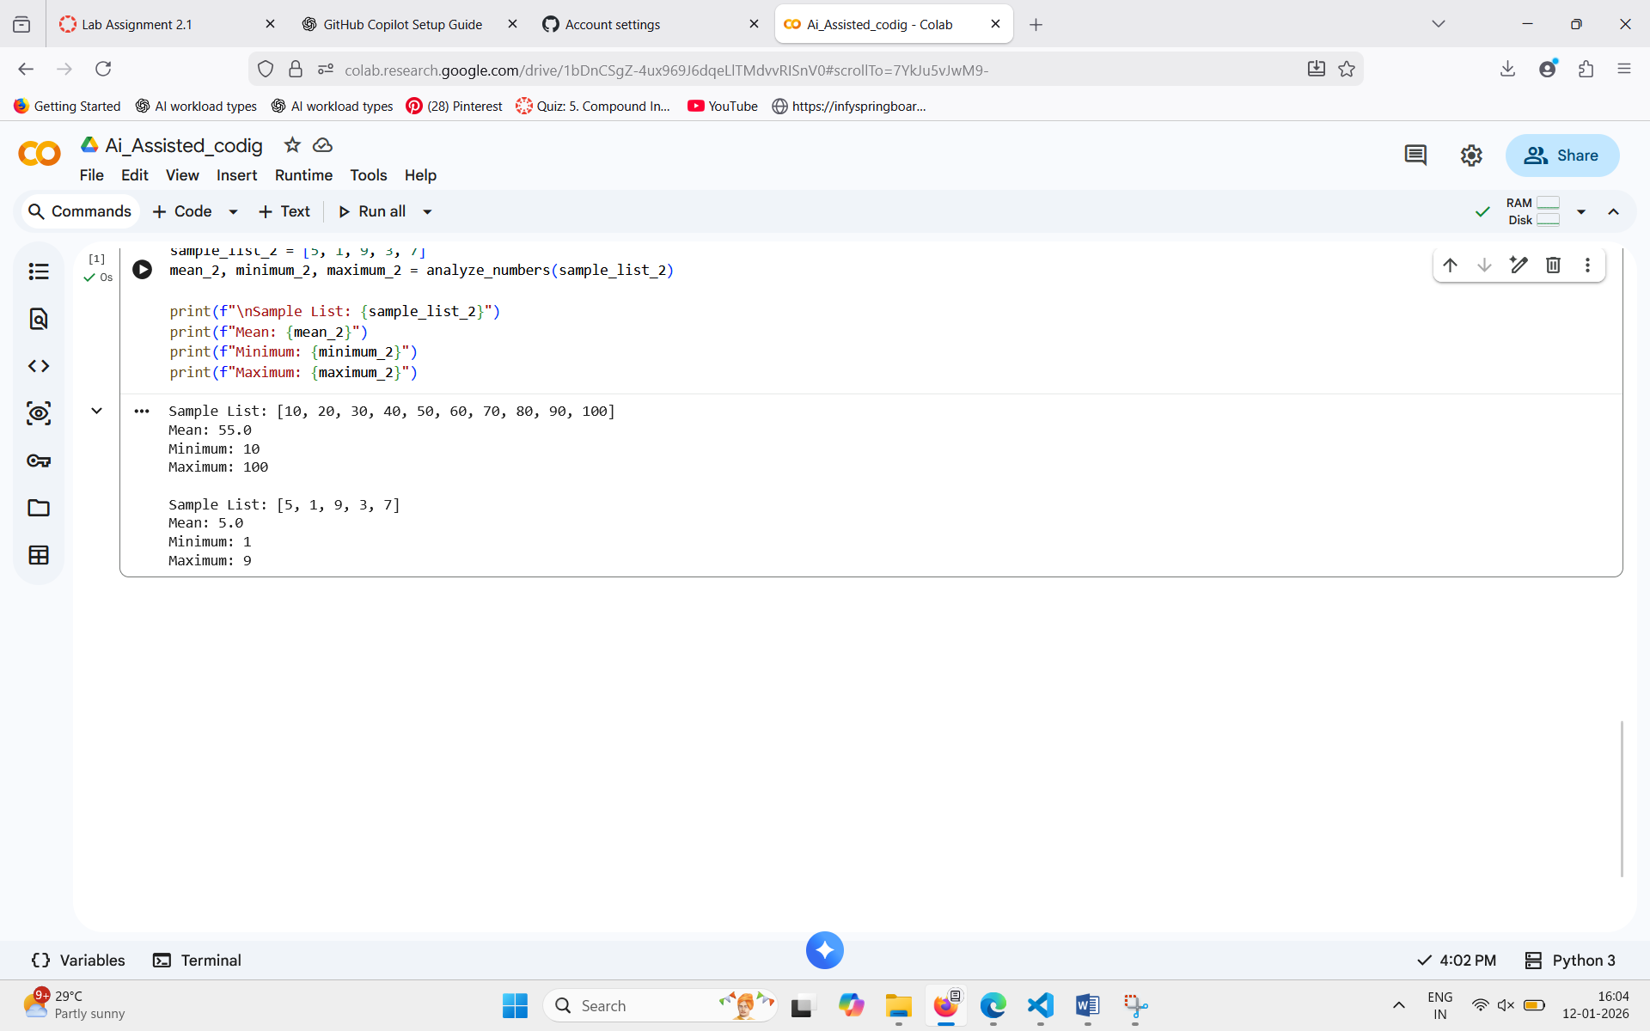

Task 2: Armstrong Number – AI Comparison
Scenario: You are evaluating AI tools for numeric validation logic.
Task: Generate an Armstrong number checker using Gemini and GitHub Copilot. Compare their outputs, logic style, and clarity.
Expected Output:
Side-by-side comparison table
Screenshots of prompts and generated code.

Gemini (GoogleColab): 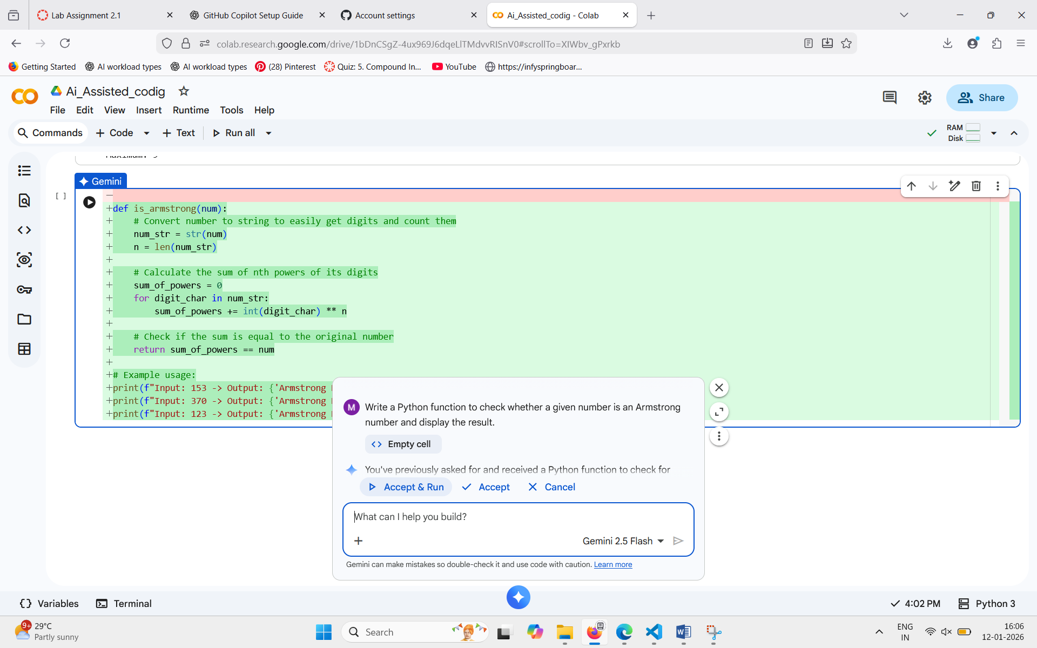

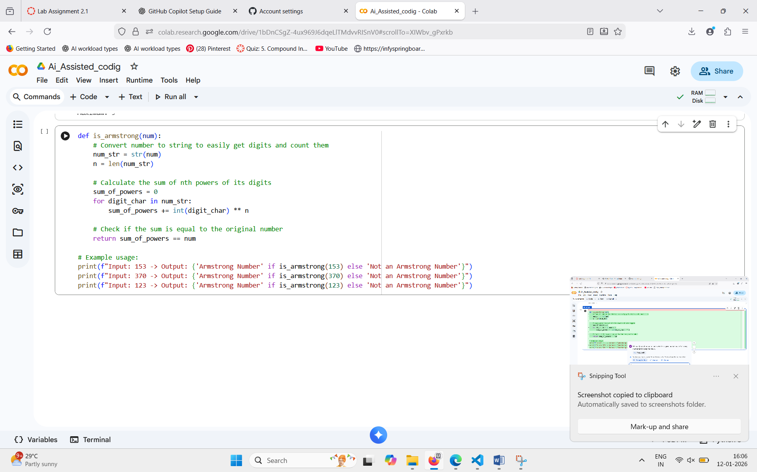

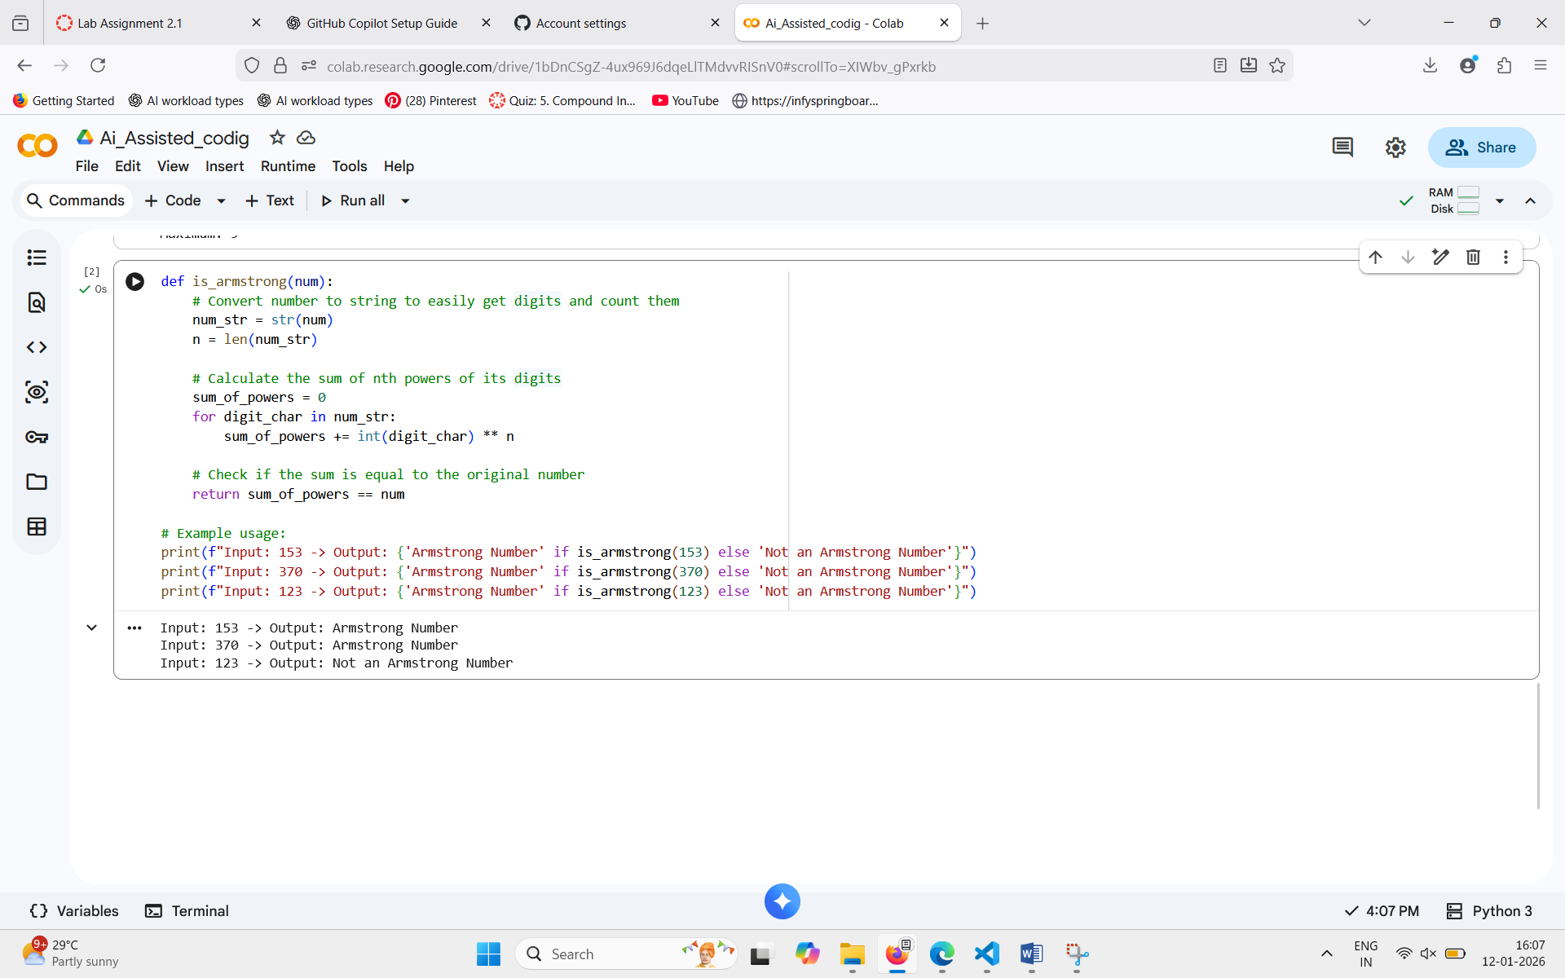

GithubCopilot (VSCode):
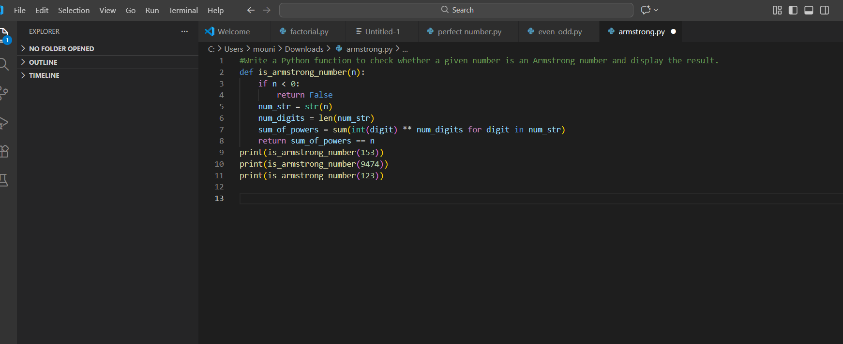

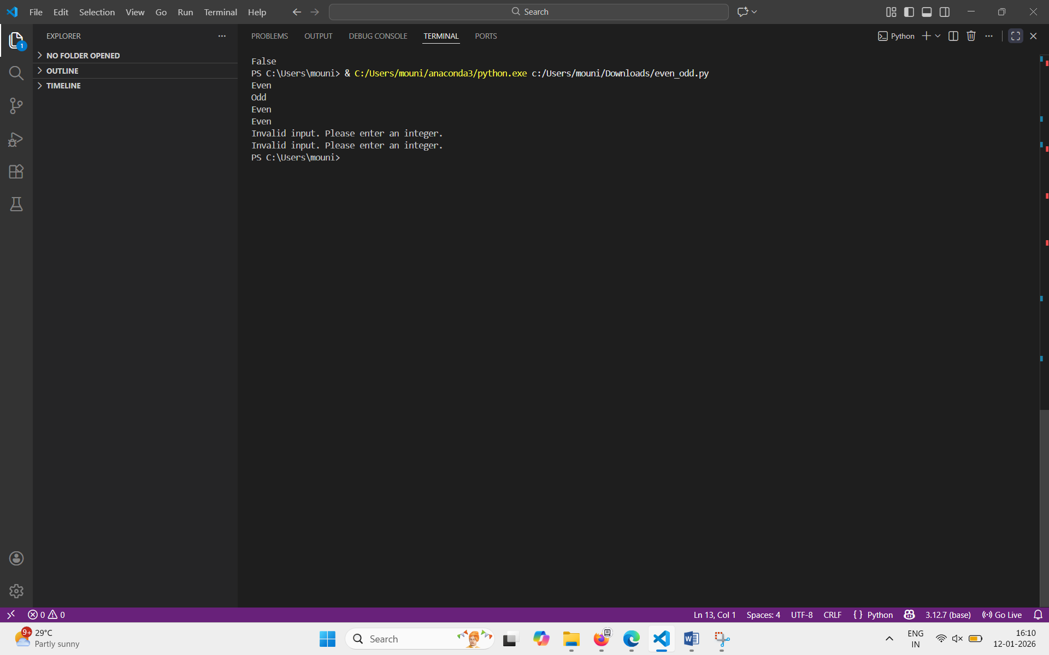
Task 3: Leap Year Validation Using Cursor AI
Scenario: You are validating a calendar module for a backend system.
Task: Use Cursor AI to generate a Python program that checks whether a given year is a leap year. Use at least two different prompts and observe changes in code.
Expected Output:
Two versions of code
Sample inputs/outputs
Brief comparison

Prompt-1: generate a Python program that checks whether a given year is a leap year.
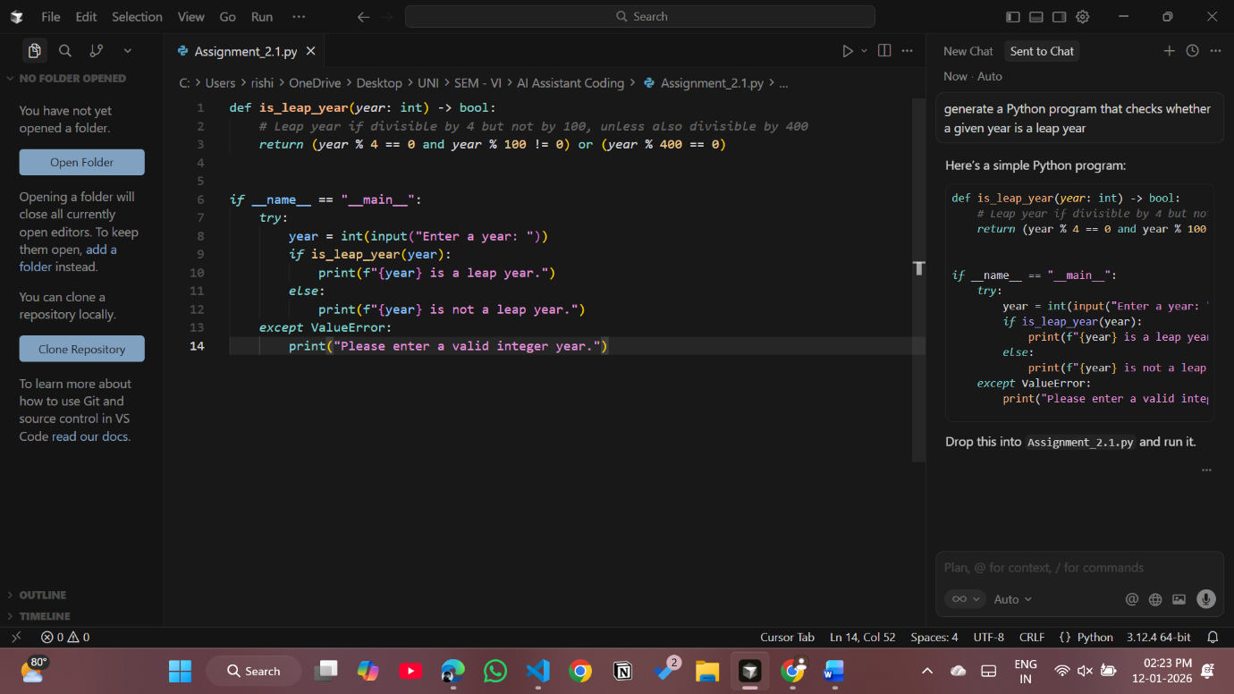



Prompt-2: give a python code to find if the year is leap year or not without functions.
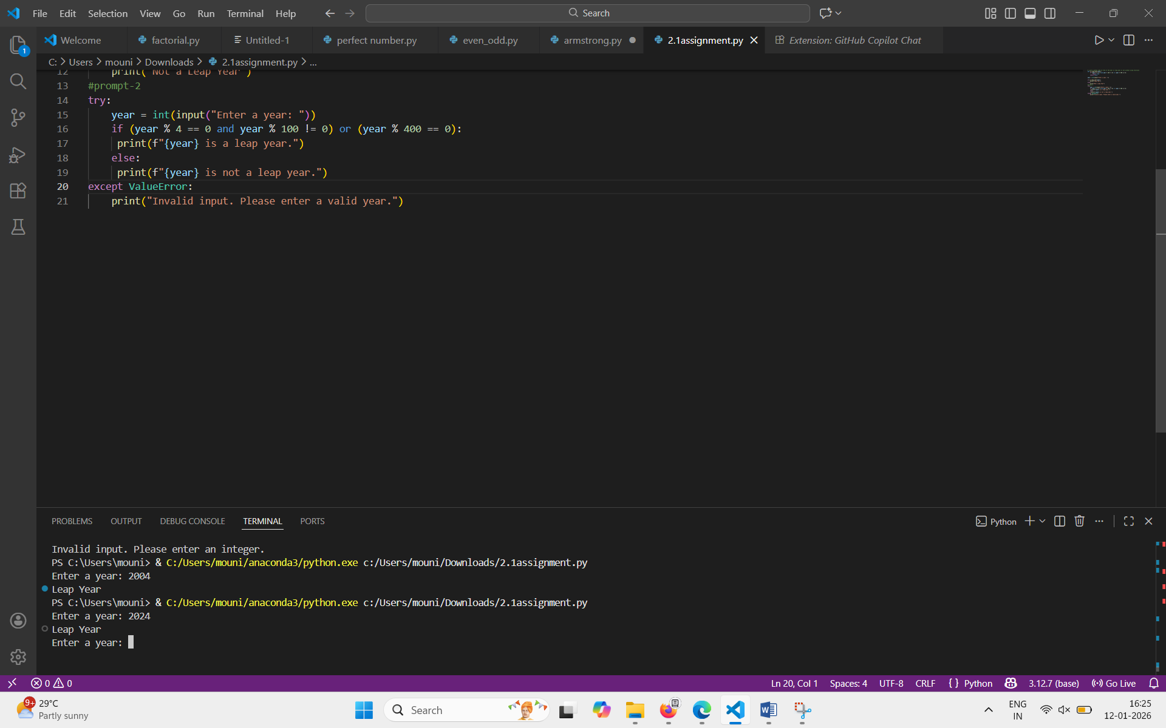

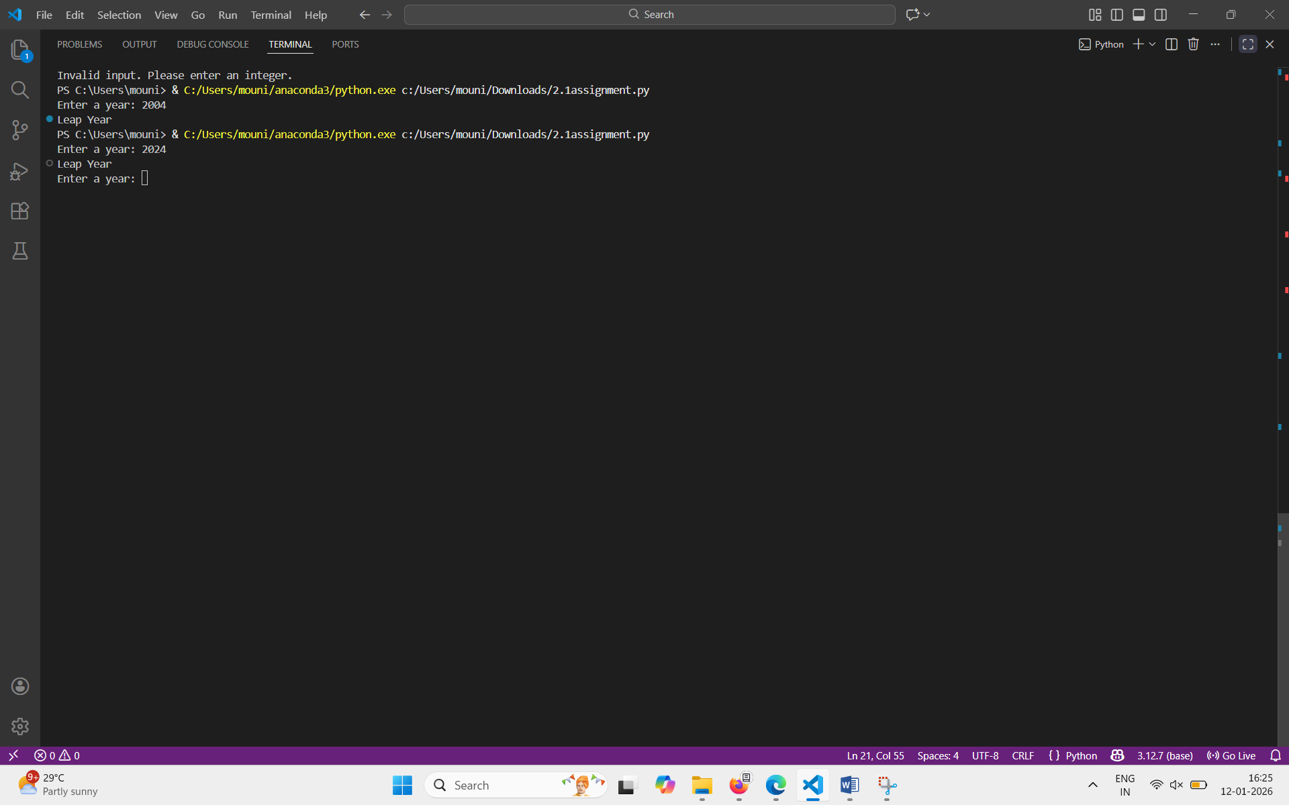

Task 4: Student Logic + AI Refactoring (Odd/Even Sum)
Scenario: Company policy requires developers to write logic before using AI.
Task: Write a Python program that calculates the sum of odd and even numbers in a tuple, then refactor it using any AI tool.
Expected Output:
Original code
Refactored code
Explanation of improvements

Original Code:
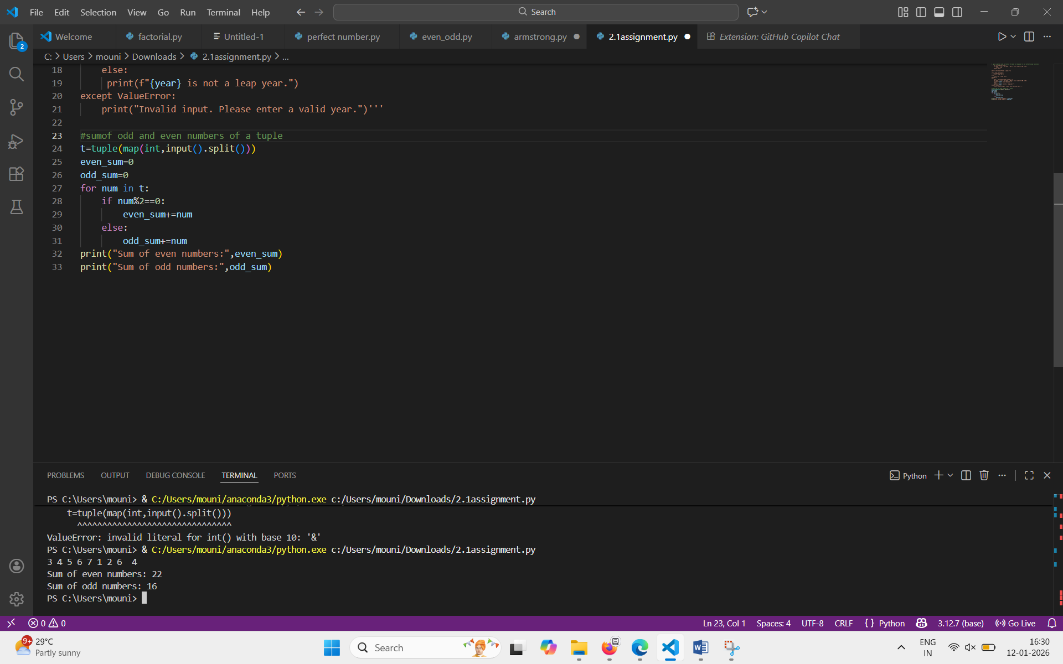

Refactored Code:
