VBA St. Paul Innovation Initiative for a
Rules-Based Processing System (RBPS)

Product Architecture Document



May 2011
Version 1.2

Department of Veterans Affairs
Financial Services Center (FSC)

Revision History

Date | Version | Description | Author
03/01/2011 | 1.0 | Document Creation | Omar Gaye
04/11/2011 | 1.1 | Updating document to reflect new architectural requirement/change: to read from and persist to data store, RBPS should use Web Services provided by AWARDS and eBenefits/Share teams: VBA BEP rules whoever owns the data should provide access (services) to the data. With no knowledge of that requirement, RBPS was designed to directly access eClaim data through its own Spring/Hibernate based Data Access Layer. Phasing out the Hibernate Data Access Layer. | Omar Gaye
05/04/2011 | 1.2 | Updating document based on new Data Access Layer requirement: RBPS will delegate CRUD operations to Web services provided by VETSNET teams. | Omar Gaye

Table of Contents
1. Introduction 1
1.1. Scope 1
1.2. Glossary 1
1.3. References 3
1.4. Overview 3
2. Application Context Overview 4
3. Architectural Representation 5
4. Architectural Goals and Constraints 6
5. Use-Case View 7
5.1. System Actors 7
5.2. Use-Cases 7
6. Logical View 10
6.1. Overview 10
6.2. Architecturally Significant Design Packages 11
6.2.1. RBPS main packages overview 11
6.2.2. RBPS Core framework 12
7. Process View 14
8. Deployment View 16
9. Implementation View 19
9.1. Overview 19
10. Layers 21
10.1. Business Service Layer 21
10.1.1. Data Access Layer 21
10.1.2. Domain Objects Layer 22
11. Data View 24
11.1. Actual Data Model 24
11.2. Database modifications for R1 (686c and 674 Forms) 25
11.2.1. Table changes 25
11.2.2. Type changes 27
12. Size and Performance 28
13. Test Architecture 28
14. Quality 29
14.1. Applicability to Technical Reference Model/Standards Profile (TRM/SP) 29
14.2. Applicability to Common Services Architecture 29
14.3. Applicability to HSD&D Core Specifications for Rehosting Initiatives 29
15. Architectural Mechanism 30
15.1. Analysis Mechanisms 30
15.2. Analysis-to-Design-to-Implementation Mechanisms Map 31
15.3. Implementation Mechanisms 32
Attachment A - Approval Signatures 33

Introduction
The Veterans Benefit Administration (VBA) has introduced an innovation initiative to develop a Veteran-centric Rules-Based Processing System (RBPS) to process certain claims and payment adjustments quickly, transparently, and accurately. The purpose of this document is to provide a detailed presentation of the RBPS Architecture.

Scope
The RPBS project requirements, concept, and detailed design are presented in the documents referenced on section 1.3; References. This document only provides a snapshot of the RBPS application software architecture, hardware deployment platform, basic use-cases, and performance and integrity consideration.

Glossary
Table 1 – Glossary: Acronyms, Abbreviations, Definitions, References
Acronym | Term | Extended Definition / References
API | Application Programming Interface
BEP | Benefit Enterprise Platform | The Weblogic infrastructure used by Corporate Weblogic Applications (applications that use the VBA CSS system to authenticate their users)
BRMS | Business Rules Management System
BOM | Business Object Model | With JRule, in order to write business rules, developers first need to set up the model upon which they apply, this model is called BOM. The BOM is a logical model of business domain which is mapped to a physical data model called Execution Object Model or XOM (java objects).
CDB | Coorporate Data Base | VBA Coorporate Data Base
CEST | Claims Establishment | Process in which a claim receives an EP code
CMMI | Capability Maturity Model Integration | http://www.sei.cmu.edu/cmmi/
CRUD | Create, Read (or Retrieve) Update, Delete (or Destroy) | Basic 4 functions of persistence storage
CSS | Common Security System | BEP security system along with Site Minder, LDAP, etc…
DAL | Data Access Layer | Logical layer in a J2EE application that manages persistent objects (CRUDS operations)
DAO | Data Access Object
DB | Data Base (or database)
ACID | Atomicity Consistency Isolation Durability | Traditionally, transactions have held these four (4) properties collectively referred to as ACID
RDBMS | Relational Data Base Management System
DVS | Decision Validation Services | IBM ILOG JRules module: the module used to test and simulate rules against scenarios  http://www-01.ibm.com/software/integration/business-rule-management/jrules/?cn=agus_aosgbs-20100812&cm=k&csr=google&cr=ibm_ilog_jrules&ct=USITK001&S_TACT=USITK001&ck=ibm_ilog_jrules&cmp=BLANK&mkwid=s0Numtu4U_6874828398_432k3p1502
EIS | Enterprise Information Sysem | Data
EP | End Product (Code)
ERD | Entity Relationship Diagram | http://www-106.ibm.com/developerworks/rational/library/content/03July/2500/2785/2785_uml.pdf
EVR | Eligibility Verification Report
IDE | Integrated Development Environment | Eclipse
PMAS | Program Management Accountability System | http://vaww.oed.wss.va.gov/process/Library/oed_propath_process_home.pdf.
POJO | Plain Old Java Object | A normal Java object that is not an EJB (Enterprise JavaBean) , a Servlet, etc., and does not serve any other special role or implement any special interfaces of any of the Java frameworks (EJB, JDBC, DAO, JDO, etc.)
RBPS | Rules-Based Processing System | St. Paul Initiative Project Name
RES | Rule Execution Server | IBM ILOG JRules module: the module for executing rules in a managed environment; runs on a Java EE application server:  http://www-01.ibm.com/software/integration/business-rule-management/jrules/?cn=agus_aosgbs-20100812&cm=k&csr=google&cr=ibm_ilog_jrules&ct=USITK001&S_TACT=USITK001&ck=ibm_ilog_jrules&cmp=BLANK&mkwid=s0Numtu4U_6874828398_432k3p1502
RFAC | Request For Architecture Change | Process for handling requests to make changes to the VBA Corporate DB model and schema.
RTS | Rule Team Server | IBM ILOG JRules module: a rule management repository and server for authoring, managing, validating, and deploying business rules; runs on a Java EE application server
SIT | System Integration Testing
SOA | Service Oriented Architecture
SOAP | Simple Object Access Protocol | http://www.w3.org/TR/SOAP/
VBA | Veterans Benefits Administration
VETSNET | Veterans Services Network | VBA Document repository
VONAPP | Veterans Online Applications | Current Online Application for Benefits
VSR | Veterans Service Representative | Agent who handles paper-based benefit claims
WEAMS | Web-Enabled Approval Management System
XOM | Execution Object Model | With JRules, in order to write business rules, developers first need to set up the model upon which they apply, this model is called BOM. The BOM is a logical model of business domain which is mapped to a physical data model called Execution Object Model or XOM (java objects).

References
The RPBS project requirements; concept, and detailed design are presented on the following documents:
- VBA St. Paul Innovation Initiative for Rules-Based Processing System – Requirements Specification Document v1.5.
- RBPS Use Cases for EP130\150\155 Claim Types
- RBPS System Design Document
- RPBS User Interface to Database

Overview
The RBPS technical architecture is decomposed along the following dimensions:
- Architectural constraints: known technical decisions that are independent of the use cases
- System functionality: represented by use cases
- Design layers separating concerns, leveraging the Spring framework
- Deployment concerns that focus on the constraints imposed by the VBA BEP infrastructure

Application Context Overview
RBPS is intended to automate VBA claims that do not require development to free up more Veterans Service Representatives (VSRs) for more complicated claims adjudication such as rating compensation claims that require human intervention.
The system takes over after the AutoCEST process assigns the claim an End Product (EP) code that is eligible for automated processing. Claim data entry is the responsibility of the Veteran via the eBenefits Claim Portal. Some eligibility validation occurs after hitting the Corporate Database to read the existing service connected disability rating and the existing beneficiaries on the award. The SSA service is used for external validation of income for Eligibility Verification Reports (EVRs).
The results of the RBPS will generate a decision that will be sent to and processed by the AWARDS Service. An adjustment can then be written back to the Corporate Database, and the notification letter to the Veteran and any appropriate diary entries for a courtesy follow-up by a VSR will be generated.
Figure 1 - Application Context Diagram
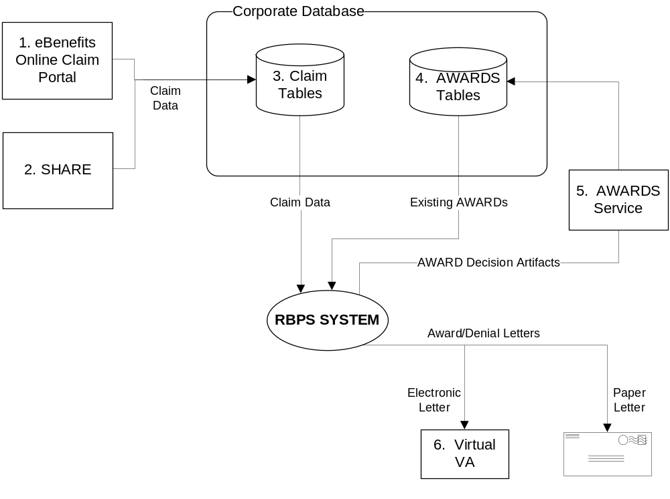

Architectural Representation
The architecture of the RBPS application is represented following the recommendations of the VBA Program Management Accountability System (PMAS) process. To illustrate the RBPS architecture, this document subscribes to the commonly used set of views known as the ‘4 + 1 Architecture View Model’ [Philippe Kruchten 1995] depicted in the following figure:
Figure 2 - Software Architecture: The ‘4+1 View’
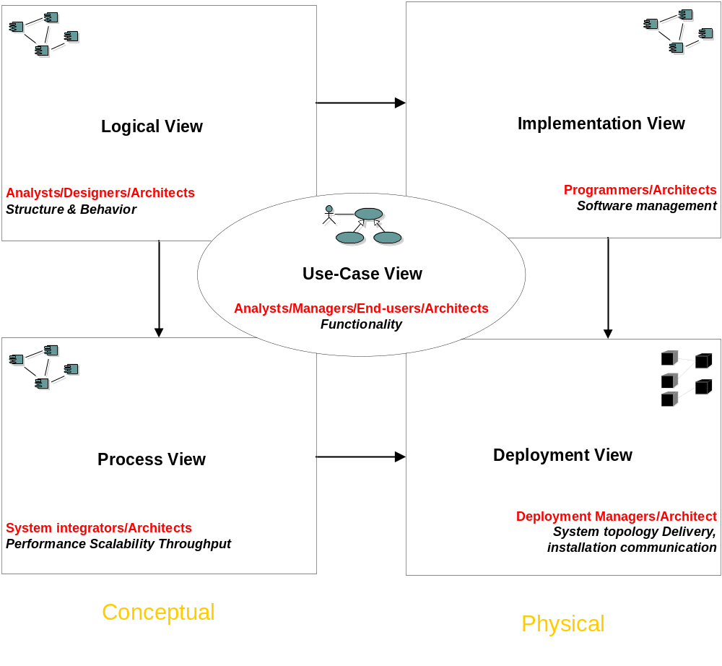
Table 2 – The ‘4+1 View’ defintions
4 + 1 Views | Architectural Concerns
Use-Cases | Describes the actors and use cases for the RBPS system.
Logical View | Domain Vocabulary and Services View: describes the key abstractions that comprise the RBPS domain.
Process View | Integration into the VBA BEP, security, scalability, etc.
Implementation View | Development methods, tools, and technologies
Deployment View | Describes deployment strategies on the Benefit Enterprise Platform (BEP) infrastructure.
The rest of this document is organized to present the RBPS architecture using this framework. In addition to the above views, a "Data View" is presented to describe the RBPS persistent data objects. The data view describes the logical data model of the system and includes an Entity Relationship Diagram (ERD).

Architectural Goals and Constraints
- The system will be designed to fully automate the processing of VBA benefit claims. For this reason, there is little to no user interaction.
- The input for the system will be dependent on the VBA eBenefits online claim system correctly capturing the claim data from the Veteran. In addition, the input for system is reliant on the VBA AutoCEST process correctly assigning the EP code, performing basic data validation, and flagging claims that should pass through the RBPS system or be sent to a VSR for further development.
- The system will integrate with the future VBA AWARDS web service for payment of benefits. This will require development of an interface by the VBA staff which must be scheduled for their next development cycle.
- Any new database tables will be developed to target the Corporate Database in Oracle and use the RFAC process for making changes.
- The business rules will be developed in IBM’s ILOG JRules 7.1 so that it will integrate and be re-usable in the larger VBMS system. The rules will be deployed to a Rules Execution Server (RES) for execution as well as a Rules Team Server (RTS) for maintenance and versioning control of the rules. User authoring of rules will require the Eclipse IDE as well as the Rule Studio plug-in for Eclipse. Testing will require the JRules Decision Validation Services (DVS) module to test and simulate rules against scenarios.
- The Spring for J2EE framework will be used to take advantage of the Inversion of Control (IoC) container to allow Spring to manage how the various services connect and communicate with each other. This will allow us to make changes, test, and re-deploy individual modules or services without impacting the rest of the application.
- The RBPS application will use a set of Web Services provided by the Veterans Services Network (VETSNET) team to access and persist data into the VBA databases.
- The RBPS application will be deployed into an Oracle WebLogic Application Server and run automatically and periodically based on configuration.

Use-Case View

System Actors
Following is a list of the known actors who will interact with the deployed system.
Table 3: Actors
Actors | Roles/Use-Cases
System Administrator | System Administration: configure when and how often the system will run.
CDB | Create, Read (or Retrieve) Update, Delete (or Destroy) (CRUD) operation between RBPS and the Corporate database (CDB).
AWARDS System | Request/Response Web Service: receive awards information from RBPS, send back awards dollar amount to RBPS.
Virtual VA | Awards Notification Letters, Award Prints
VSR | Receives Exceptions from RBPS.
VBA Business Analyst | Accesses Rule Team Server (RTS) for authoring, managing, validating, and deploying business rules.

Use-Cases
Figure 3 - Use-Case Model
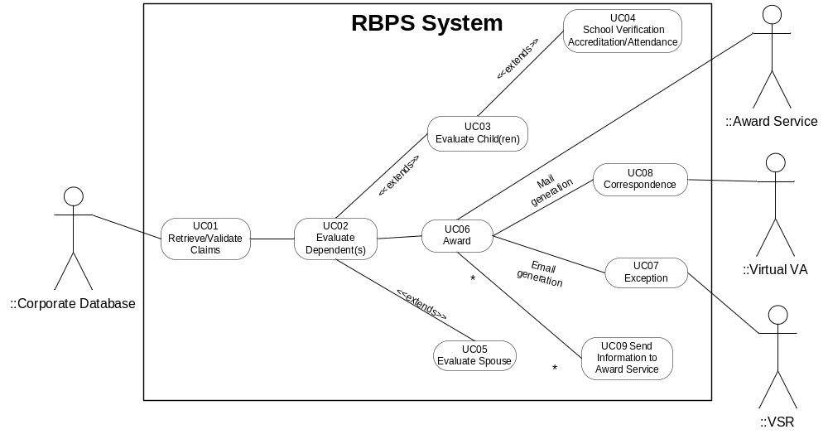
Table 4 - Use-Cases list
Use-Case | Use-Case summary | Business rules applied
UC01: Retrieve/Validate Claims | Retrieves/Validates Claims, collects the records from the claims database for automated processing and performs a series of initial checks to determine if the claim is eligible for automated processing. | CP0001 Eligible End Product Check  CP0003 Attachment Check  CP0004 Previous Rejection  CP0005 Eligible End Product Action  CP0007 Resides within US  CP0008 Veteran living  CP0011 Veteran Corporate Match  CP0012 Veteran Eligibility for Automated Claim Processing  CP0102 Veteran Disability Rating
UC02: Evaluate Dependent(s) | Describes the steps to be taken for claims that have completed processing and resulted in either an award change or a denial of the claim. | CP0100 Dependent Data  CP0101 Dependent Data Match  CP0103 Determine Current Award Status  CP0104 Evaluate Dependent Award Status  CP0013 Determine Relationship Type  CP0130 Number of Dependents Allowable
UC03: Evaluate Children | Describes the steps to be taken for claims that have completed processing and resulted in either an award change or a denial of the claim. | CP0013 Determine Relationship Type  CP0108 Evaluate Child’s Relationship Type  CP0109 Evaluate Biological Child  CP0110 Evaluate an Adopted Child  CP0111 Evaluate a Stepchild  CP0112 Child’s Previous Marriage  CP0113 Seriously Disabled Indicator  CP0114 Child’s Address  CP0115 Evaluate the Child’s Age  CP0120 Determine School Type  CP0133 Child living with Veteran
UC04: School Verification Accreditation/Attendance | Evaluates if a child between the ages of 18 and < 23 years should be added to or remain or award. | CP0118 Identify Data Needed for School Child Evaluation  CP0119 Evaluate United States Tuition Payment or Assistance  CP0120 Determine School Type  CP0121 Evaluate High School  CP0122 Evaluate Post-Secondary School  CP0123 Evaluate Full-Time Status  CP0129 Determine Course Start Date  CP0140 Part-Time Student Status
UC05: Evaluate Spouse | Evaluate the Veteran and spouse’s marriage history to determine if the spouse can be added to the award. | CP0105 Evaluate Veteran Previous Marriage  CP0106 Evaluate Spouse Previous Marriage
UC06: Award | Describes the steps to be taken for claims that have completed processing and resulted in an award, denial, or exception. | CP0006 Add dependent to corporate database  CP0104 Evaluate Dependent Award Status  CP0107 Determine Spouse Award Effective Date  CP0116 Determine Minor Child Award Effective Date  CP0117 Determine Minor Step Child Award Effective Date  CP0125 Establish the School Child Award Effective Date  CP0127 Exception processing  CP0128 Generate Correspondence
UC07: Exception | Describes the process to apply the correct template and populate the e-mail generation for decisions and development actions. | CP0127 Exception processing
UC08: Correspondance | Describes the process to apply the correct template and populate the letter template for decisions and development actions. | CP0128 Generate Correspondence
UC09: Send Information to AWARDS Service | Describes the data that must be sent to the Awards application for the automatic generation of the dependency award | CP0134 Determine Award Status  CP0135 Determine Award Decision  CP0136 Determine Event Date Spouse  CP0137 Determine Event Date Minor Child  CP0138 Determine Event Date Seriously Disabled Child  CP0139 Determine Event Date School Child  CP0140 Determine Event Date when Combined Eval <30%

For more information on Use-Cases and Business Rules, refer to the documents listed in Section 1.3, References.

Logical View
The Logical View section describes the architecturally significant parts of the RBPS design model such as its decomposition into subsystems and packages, and for each significant subsystem/package, its decomposition into classes and class utilities. This section will also introduce architecturally significant classes and describe their responsibilities as well as a few important relationships, operations, and attributes.

Overview
The following main components are part of the RBPS application:
- RBPS Core: the core RBPS application framework, which runs automatically on a WebLogic Application Server. The application can use the Spring framework integration with ‘OpenSymphony Quartz Scheduler’ API for scheduling a cron job. The Quartz Scheduler includes many enterprise-class features, such as JTA transactions and clustering. The clustering feature allows a cron job to safely run in a clustered environment. Based upon the latest requirements, the Quartz Scheduler option has been phased out in favor of providing the BEP Administrators with a remote call capability to RBPS. RBPS will expose its entry point main method through a single operation Web Service. The RBPS core classes and configuration files will be packaged in a .jar file and will be part of the enterprise archive RBPS.ear
- RBPS Bootstrap: also called ‘RBPS Web’; a small web application that will just ‘bootstrap’ the RBPS core application (by loading the Spring application context). This stand-alone component will also allow a UI-based test harness component for the QA team. The RBPS bootstrap components will be packaged in a .war file and will be part of the enterprise archive RBPS.ear
- RBPS Rules Application: this is a rule project. A rule project contains all artifacts related to rule authoring and ruleset creation. A rules project is packaged into a RuleApp. This component will be deployed to JRules Rule Execution Server (RES).
- RBPS ‘Rule Session API’: The custom java code (RBPS.ear) will be deployed to one WebLogic cluster and should access the RBPS engine deployed to a separate WebLogic cluster through this ‘Rule Session API’ which is an implementation of a comprehensive set of Rule Sessions provided by the JRules software suite. This component will be packaged in a JAR file an will be part of the application archive RBPS.ear deployed on WebLogic.

Architecturally Significant Design Packages

RBPS main packages overview
Figure 4: RBPS Main Packages
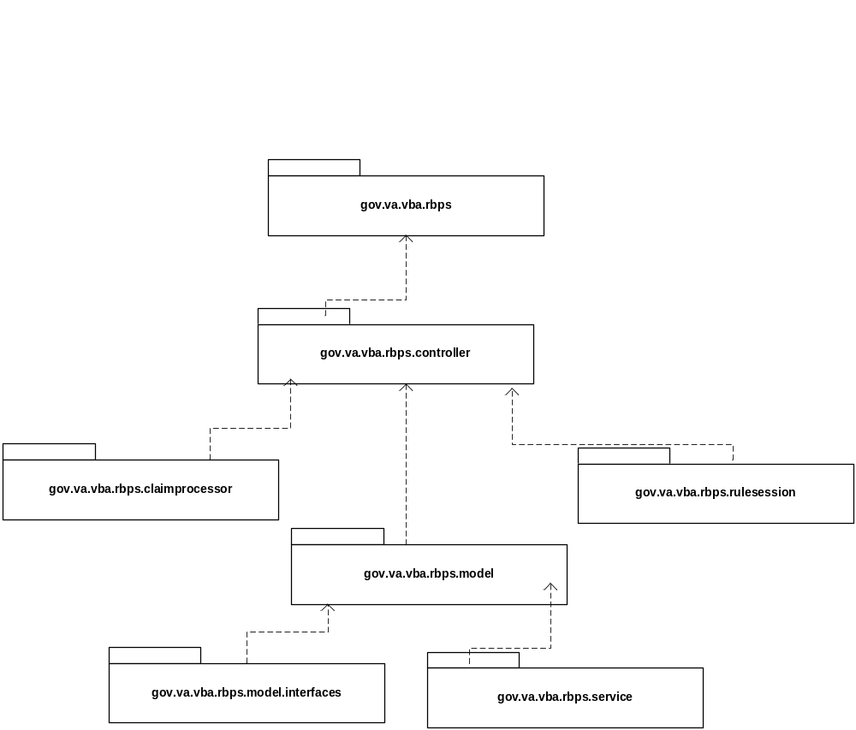

RBPS Core framework
The class diagram below represents the main classes of the the RBPS application core framework .
Figure 5: RBPS Core Framework Class Diagram
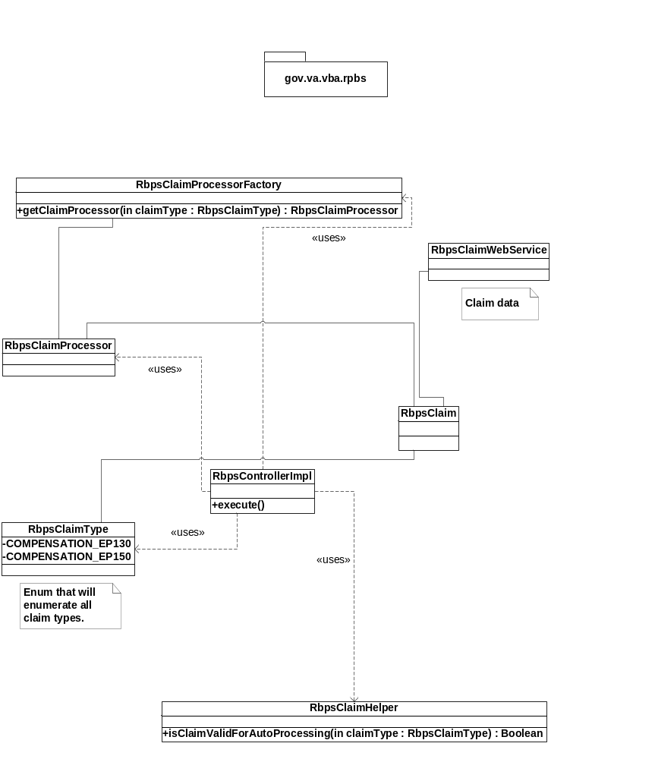
Figure 6 – RPBS Framework High-Level Sequence Diagram
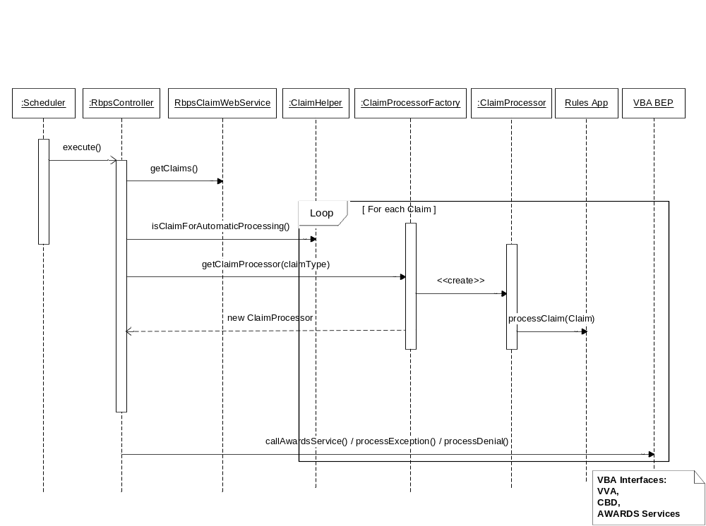
RBPS Flow Overview
When the application starts, the method RbpsControllerImpl.execute() is called; the sequence of events will then be as follows:
- Retrieve all claims from the database (VETSNET/SHARE Web Service)
- For each claim
  - validate/verify pre-conditions
    - log and move to next claim if claim check fail
  - get a ClaimProcessor instance from RBPS ClaimProcessorFactory class
  - process the Claim; invoke rules engine
  - process the result from rule engine claim processing
    - Award
      - Call AWARDS Web Service and generate letter
    - Exception
      - Call MAP-D Web Service
    - Deny:
      - Call AWARDS Web Service and generate letter
  - Update Claim status and Claim label (VETSNET/SHARE WS)
- Run RBPS/Virtual VA batch engine
  - Send PDF letters and Award prints to Virtual VA (java and shell script engine)
  - Call Virtual VA Web Service to get result
    - Failure: go back to step 3.1
    - Succes: delet file from the directory

Process View
This section describes the RBPS system's decomposition into processes and the processes interactions.
The figure below presents the JRules rules ‘life cycle’ from development (Rules Authoring Studio) or management (Rule Team Server) to runtime (Rule Execution Server).
Figure 7 – JRules 7.01 Architecture
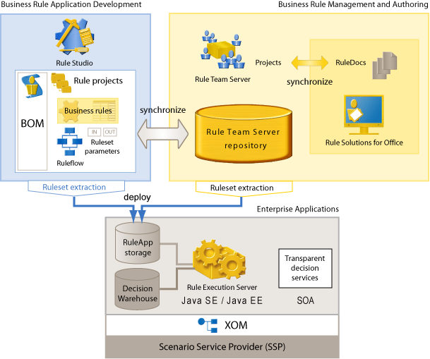
Note: we are planning to use the new JRules DVS (Decision Validation Services ) in lieu of JRules SSP (Scenario Service Provider).
Figure 8: JRules Rule Session Architecture
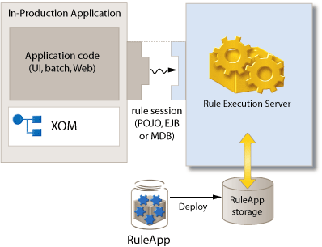
Note: RBPS uses an implementation of the stateless session bean rule session.
The following diagram describes how the RBPS system’s processes interact with the VBA Benefit Enterprise Platform (BEP) framework components.
Figure 9 – High-Level Application Design: RBPS Processes Interaction With VBA BEP Framework
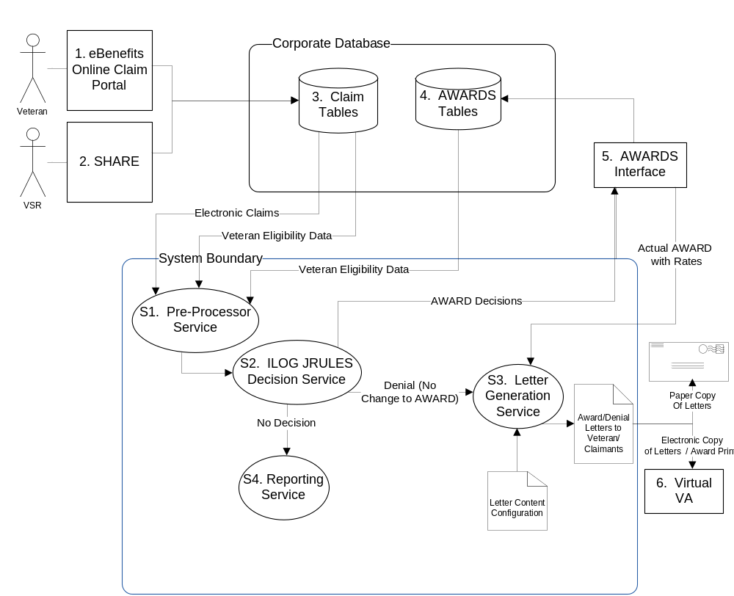
Table 5 - Objects in the High-Level Application Design
Objects
Name | ID | Description
Pre-Processor Service | S1 | Performs validation that the claim is eligible for automation and has all of the required data elements. Its sole responsibility is to create automation exceptions for claims that cannot be automatically processed.
ILOG JRules Decision Service | S2 | This service takes the established claim, re-verifies the Veterans’ eligibility, compares the claim against existing awards, and determines if any adjustment to the award or Corporate Database record is necessary.
Letter Generation Service | S3 | This service takes the output of the rules service (S2) and AWARD service (5) and combines the decisions with the content needed to create the letter for the Veteran.
Reporting Service | S4 | This service will record all claims that are ineligible for automation and place the results into MAP-D Notes.
Internal Data Stores
Name | ID | Data Stored
Claim Tables | 3 | This repository stores initial claim data and the status of the claim as it moves between different modules within the RBPS system.
AWARDS Tables | 4 | This repository represents the current snapshot of Beneficiaries on a Veterans Active Award.

Deployment View
This section describes how the RBPS application will deploy in the VBA Benefit Enterprise Platform (BEP) and the hardware and servers that will run it.
The RPBS Application will be deployed in the VBA clustered WebLogic environment and access the VBA EIS. The JRules BRMS (RES, RTS, and DVS) will be deployed to WebLogic cluster with two managed servers (SRV1 and SRV2), each running on a different machine in a classic load-balance and fail-over topology. The custom java code (RBPS.ear) will be deployed to a separate WebLogic cluster and should access the RBPS JRules BRMS through the RBPS implementation of the JRules Rule Session API.
The following diagram describes the Enterprise VBA Web Production environment that will host the RBPS application.
Figure 10: VBA Enterprise Production Infrastructure on Benefit Enterprise Platform (BEP) That Will Host the RBPS Application
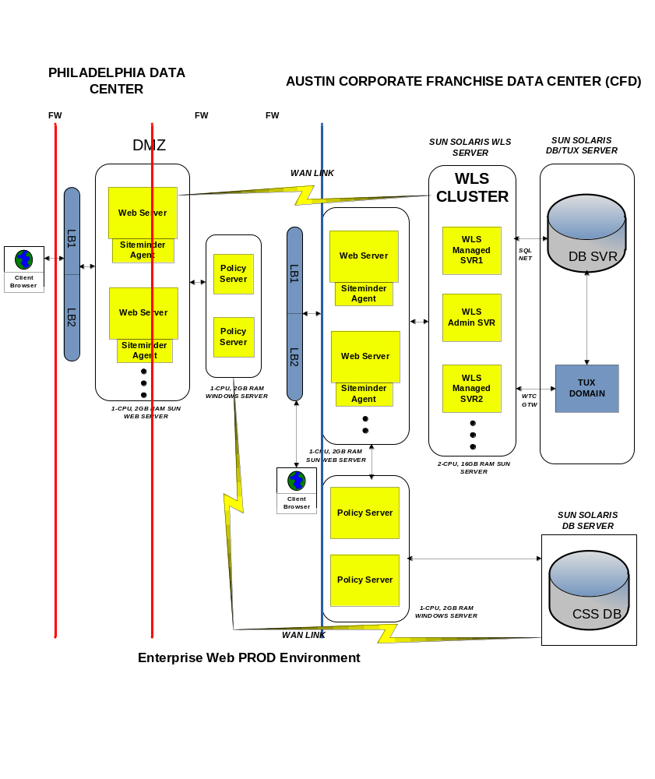
The following diagram describes the RBPS application production deployment.
Figure 11: A High-Level RPBS Production Deployment Diagram
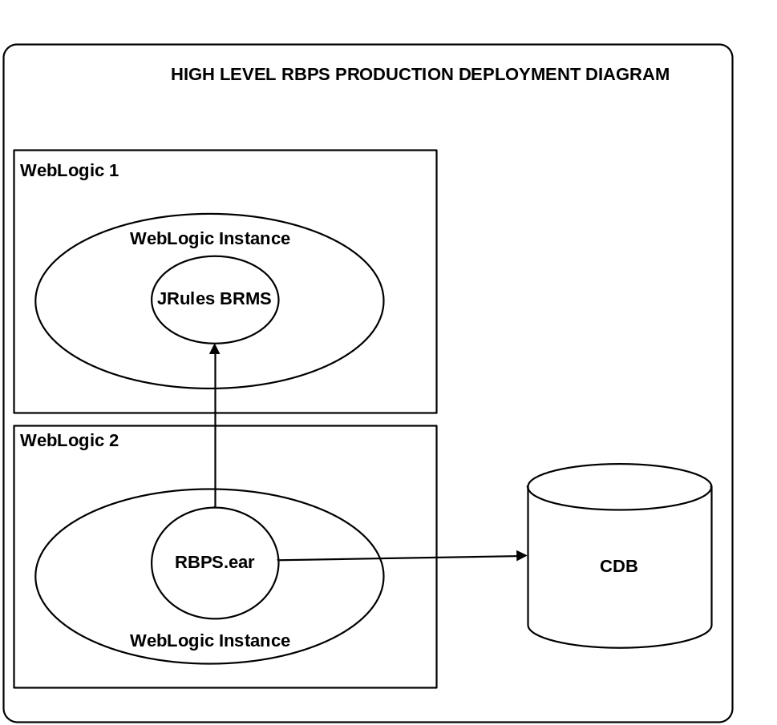
The JRules BRMS is composed of the appropriate JRules modules: Rule Execution Server (RES), Rule Team Server (RTS), and Decision Validation Services (DVS).

Implementation View
This section describes the overall structure of the implementation model, the decomposition of the RBPS application into layers and subsystems in the implementation model, and its architecturally significant components.

Overview
The RBPS system is a Plain Old Java Object (POJO)-based middleware: the Application will not have a Client Tier or Presentation layer via a custom GUI; instead, interaction with the system from the business rule perspective will be accomplished via the JRules Rule Team Server (RTS) web interface. The entry point of the Application will be the “execute()” method of its main Controller class. We will provide BEP Administrators with a remote call capability to RBPS. RBPS will expose its entry point main method through a single operation Web Service. The following high-level diagram provides a representation of the RBPS Application’s layers.
Figure 12 – High-Level Diagram of the RBPS Application Layers
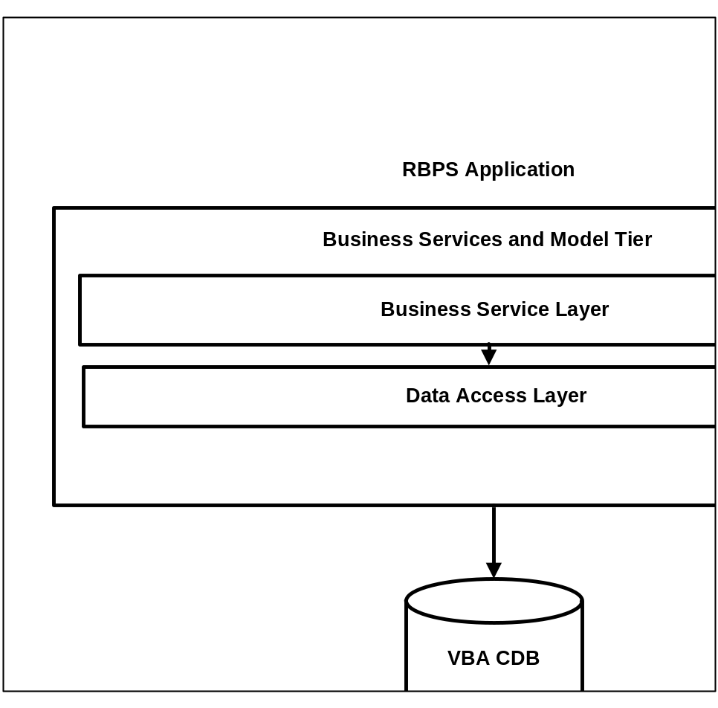
The RBPS Rules Application will be an Eclipse rule project: Eclipse with the JRules plug-in for Eclipse installed on the ‘Rules Authoring Studio’. A rule project contains all artifacts related to rule writing and ruleset creation. A rules project is packaged into a ruleset and deployed to the Rule Execution Server (RES). The following figure shows the flow of a rule project.
Figure 13 - Business Rule Application Development Flow
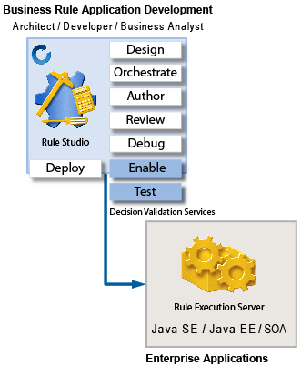

Layers

Business Service Layer
This layer will be accessed through the main RBPS Controller. This layer is responsible for:
- accesing the VBA data stores through VETSNETS-provided Web Services (RBPS will never perform direct CRUD operations on any VBA data store).
- performing a data integrity validation check before the Business Rules are invoked in the JRules BRMS.
- providing data for the JRules BRMS with access to any data related to claims.
- running the JRules rule session API. A rule session is a runtime connection between the RBPS Application and the JRules Rule Execution Server. Our rule session will be a remote stateless session bean. Refer to the JRules section for more details on the RBPS rule session API.

Data Access Layer
As per requirements and BEP rules, RBPS will not have direct access to any BVA data stores. RBPS will call Web Services owned and exposed by the VETSNETS teams (Share and AWARDS) to indirectly perform Read, Write, and Update operations. Therefore, the RBPS Data Access Layer will be a very thin one; it will just comprise a set of Web Service Client implementation. We use a Spring-provided API to implement our client calls.
Spring-WS provides a client-side Web service API that allows for consistent, XML-driven access to Web services. It also caters to the use of marshallers and unmarshallers (JAXB in our case) so that our service-tier code can deal exclusively with Java objects.
The org.springframework.ws.client.core package provides the core functionality for using the client-side access API. It contains template classes such as WebServiceTemplate that simplify the use of Web Services. The design principle common to Spring template classes is to provide helper methods to perform common operations, and for more sophisticated usage, delegate to user implemented callback interfaces. We use this feature to implement a VBA/BEP security header attached to any Web Service calls. The Spring Web Service template follows the same design. The classes offer various convenience methods for the sending and receiving of XML messages, marshalling objects to XML before sending, and allows for multiple transport options. RBPS uses Spring’s integrated Jakarta Commons HttpClient, which provides advanced and easy-to-use functionality such as authentication, HTTP connection pooling, and so forth.

Domain Objects Layer
RBPS Domain Objects Layer will consist of two types of Objects: the Persistent Domain Objects and the JRules Business Objects.
- Persistent Domain Objects
These objects are the classic objects that map to an application’s database objects. Since the RBPS application will not have its own database schema/model, RBPS will leverage the existing VBA Corporate DataBase (CBD) model. RBPS will use a set of Web Services provided by the VETSNET team to read data from and persist dat to the VBA databases. The main persistent domain objects are:
- VNP_PERSON
- VNP_PTCPNT
- FAMILY_RLNSHP
- VNP_PTCPNT_ADDRS
- JRules Business Objects:
These specific Domain Objects have been designed for the Rules Engine. Developers use JRules Rule Authoring Studio to create a rules project. A rules project is a type of (Eclipse) project dedicated to the development of business rule applications. These rules projects are managed separately from Java projects. In order to write business rules, developers first need to set up the model upon which they apply; this model is called Business Object Model (BOM). The BOM is a logical model of business domain that is mapped to a physical data model called Execution Object Model (XOM).
Business analysts work with the developers to define the vocabulary used in the business policy; this vocabulary is based on the BOM. Rules are packaged into rulesets. Rules projects contain all artifacts related to rules writing and ruleset creation. Ruleset parameters define the interface between the business rules and the calling client. They specify the input data for the rules to act upon and the output data produced after applying the business rules.
The JRules Business Objects will be built from the persistent Domain Objects retrieved from the database.
Examples of XOM Objects: Veteran, Claim, Dependant, Spouse, Child, Marriage, Parent, Claimant, Award, etc.
These java business domain objects, or XOM in the JRules realm, are mapped to their counterpart called BOM in the Rules Authoring Studio (Rules Development/Authoring) and Rules Team Server (Business Rules Management and Authoring). The following figure presents the main Domain Objects.
Figure 14 – RPBS Domain Class Diagram
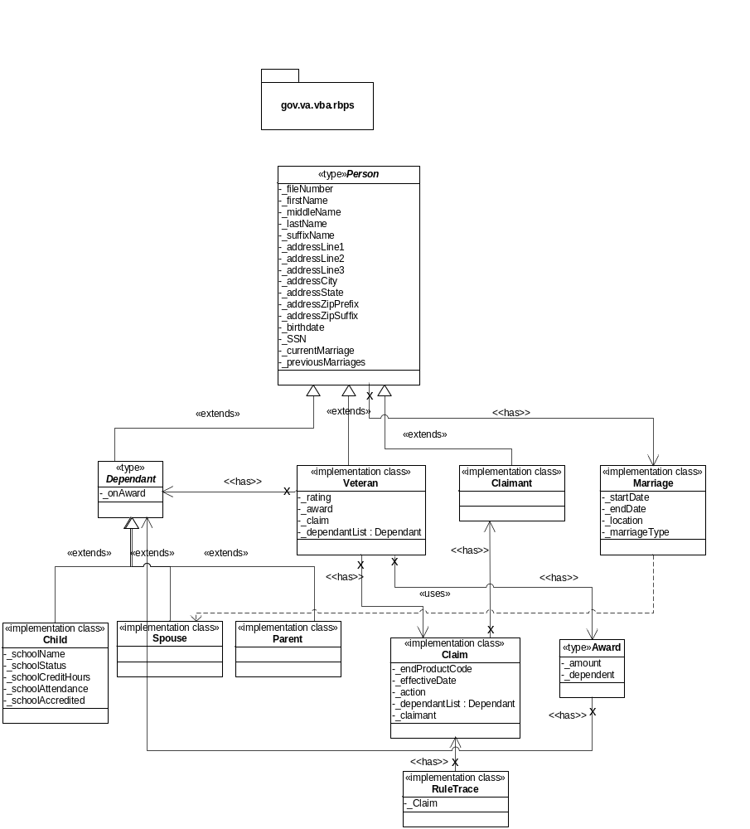

Data View

Actual Data Model
The RBPS data model will be the existing VBA CDB data model including modifications to support the new eBenefits electronic claim intake portal. RBPS will not have a new specific data model nor will it have its own schema. The RBPS system will retrieve data from multiple sources within the CDB. For the RBPS system to function, the system will need access (via a web service) to:
- The existing CORPPROD schema that stores the complete Veteran-Dependant relationships, independent of the current AWARD relationships.
- The existing CORPPROD schema that stores the Veteran-Dependant relationships as it applies to the current AWARD.
- The existing CORPPROD schema that will store the new electronic Claim data from SHARE and the eBenefits claim intake portal.
As per VBA policy, new claims data coming from the online eBenefits application will be stored in this temporary storage area before being copied over to the VBA Production DB once the RBPS adjudicates the claim and completes processing.
Figure 15 - EP-130 Entity-Relationship Diagram
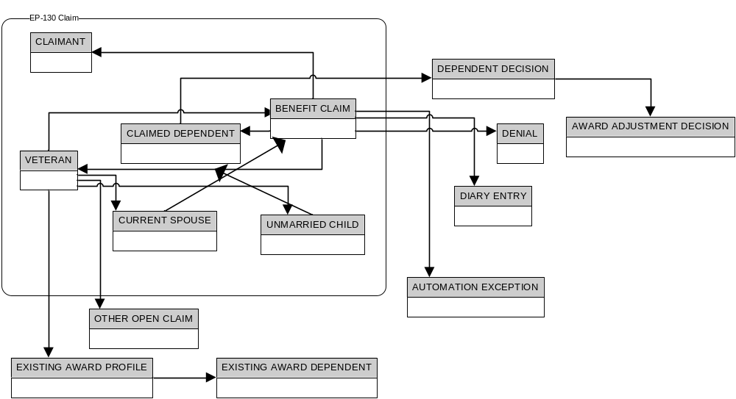

Database modifications for R1 (686c and 674 Forms)

Table changes
VNP_PERSON
- Add column MARTL_STATUS_TYPE_CD
- Add column SPOUSE_NUM (number of spouses the person has had, including current)
- Add column VNP_PROC_ID so that all rows specific to a process can be easily identified
- Add column VNP_SRUSLY_DSABLD_IND
- Add column VNP_SCHOOL_CHILD_IND
- Foreign key from VNP_PERSON. VNP_PROC_ID to VNP_PROC.VNP_PROC_ID
VNP_BNFT_CLAIM
- Add column ATCHMS_IND to indicate whether or not there were attachments to the claim
- Add column APPLCN_ID to identify the application that creates the claim (eBenefits will need to be added to the APPLCN as an application to support this)
- Add column END_PRDCT_TYPE_CD
- Foreign key from VNP_BNFT_CLAIM.BNFT_CLAIM_ID to BNFT_CLAIM.BNFT_CLAIM_ID
- Add column VNP_PROC_ID so that all rows specific to a process can be easily identified
- Foreign key from VNP_BNFT_CLAIM.VNP_PROC_ID to VNP_PROC.VNP_PROC_ID
VNP_PTCPNT_RLNSHP
- Add column MARAGE_CITY_NM
- Add column MARAGE_STATE_CD (maps to postal_cd)
- Add column MARAGE_CNTRY_TYPE_CD
- Add column MARAGE_TRMNTN_TYPE_CD (death or divorce)
- Add column MARAGE_TRMNTN_CITY_NM
- Add column MARAGE_TRMNTN_STATE_CD
- Add column MARAGE_TRMNTN_CNTRY_TYPE_CD
- Add column LIVES_WITH_RELATD_PERSON_IND
- Add column MTHLY_SUPRT_FROM_VET_AMT
- Add column FAMILY_RLNSHP_TYPE_NM
- Add column CHILD_PREVLY_MARIED_IND
- Add column VNP_PROC_ID so that all rows specific to a process can be easily identified
- Foreign key from VNP_PTCPNT_RLNSHP.VNP_PROC_ID to VNP_PROC.VNP_PROC_ID
VNP_PTCPNT
- Add column VNP_PROC_ID so that all rows specific to a process can be easily identified
- Foreign key from VNP_PTCPNT.VNP_PROC_ID to VNP_PROC.VNP_PROC_ID
VNP_PTCPNT_ADDRS
- Add column VNP_PROC_ID so that all rows specific to a process can be easily identified
- Foreign key from VNP_PTCPNT_ADDRS.VNP_PROC_ID to VNP_PROC.VNP_PROC_ID
VNP_CHILD_STUDNT
- Create new table to support form 21-674 (children who are students)
- Add column PTCPNT_ID containing the identifier of this person (this is also the pk of the table)
- Add column EVER_MARIED_IND to indicate whether the student was ever married
- Add column MARAGE_DT to store the date of marriage of the student
- Add column GOVT_PAID_TUITN_IND to indicate whether tuition is paid for by government funds for this person
- Add column EDU_INSTN_PTCPNT_ID to identify college student is enrolled in, if applicable (fk to the EDU_INSTN table)
- Add column SCHOOL_NM to store name of school
- Add column SCHOOL_ADDRS_ONE_TXT
- Add column SCHOOL_ADDRS_TWO_TXT
- Add column SCHOOL_ADDRS_THREE_TXT
- Add column SCHOOL_ADDRS_CITY_NM
- Add column SCHOOL_POSTAL_CD
- Add column SCHOOL_ADDRS_ZIP_PREFIX_NBR (can be from a select list, and can prepopulate city and state, if provided, from the ZIP_CODE_RFRNC table)
- Add column SCHOOL_TERM_START_DT to store the date that the next term starts
- Add column SCHOOL_ACTUAL_EXPCTD_START_DT to store the date student either did or expects to start next term
- Add column GRADTN_DT to store the expected date of graduation
- Add column FULL_TIME_STUDNT_TYPE_CD to specify whether student id enrolled full time in home school, college, or high school,
- Add column SCHOOL_SUBJECT_TXT to store the subject that the student is enrolled in
- Add column SESSNS_PER_WK_NUM to store the number of sessions per week in school
- Add column HOURS_PER_WK_NUM to store the number of hours per week in school
- Add column LAST_TERM_ENRLMT_IND to indicate whether the student was enrolled in school last completed term
- Add column LAST_TERM_START_DT to store the start date of the last completed term of school
- Add column LAST_TERM_END_DT to store the end date of the last completed term of school
- Add column TERM_YEAR_EMPLMT_INCOME_AMT to store earnings from all employment for year when term begins
- Add column NEXT_YEAR_EMPLMT_INCOME_AMT to store earnings from all employment for year after current term
- Add column TERM_YEAR_SSA_INCOME_AMT to store Social Security income for year when term begins
- Add column NEXT_YEAR_SSA_INCOME_AMT to store Social Security income for year after current term
- Add column TERM_YEAR_ANNTY_INCOME_AMT to store annuity income for year when term begins
- Add column NEXT_YEAR_ANNTY_INCOME_AMT to store annuity income for year after current term
- Add column TERM_YEAR_OTHER_INCOME_AMT to store other income for year when term begins
- Add column NEXT_YEAR_OTHER_INCOME_AMT to store other income for year after current term
- Add column SAVING_AMT to store the amount of money saved
- Add column STOCK_BOND_AMT to store the value of stocks and bonds
- Add column REAL_ESTATE_AMT to store the value of real estate
- Add column OTHER_ASSET_AMT to store the value of other assets
- Add column DEBT_AMT to store the value of debts
- Add column RMKS to store any remarks
- Add column VNP_PROC_ID so that all rows specific to a process can be easily identified
- Foreign key from VNP_CHILD_STUDENT.VNP_PROC_ID to VNP_PROC.VNP_PROC_ID

Type changes
- Add new type: FULL_TIME_STUDNT_TYPE
  - Home School
  - High School
  - College
- Add new type: MARTL_STATUS_TYPE
  - Married
  - Divorced
  - Widowed
  - Separated
  - Never Married
- Add new type: MARIAG_TRMNTN_TYPE
  - Death
  - Divorce
- Add new type: VNP_PROC_STATE_TYPE
  - Process started
  - Ready for RBPS
  - Requires Manual Processing
  - Rules engine In progress
  - Processing Complete
  - Processing Cancelled
  - Processing Expired
- Add new type FORM_TYPE to identify the form that was submitted for benefits (Values will correspond to the forms being submitted)
- Add values to FAMILY_RLNSHP_TYPE (note, to create a subset of the full list of types for drop down list, use TYPE_CATEGZ table)
  - Biological
- Add new values to BNFT_CLAIM_TYPE for the specific automated claim
  - 130 – Automated Dependency 686c
  - 130 – Automated School Attendance 674
When for whatever reason the Auto CEST fails from within the Rules Based Processing System, the above labels will be changed (via RBPS) to:
  - 130 – Automated Dependency 686c Reject
  - 130 – Automated School Attendance 674 Reject

Size and Performance
As of now, the RBPS is slated to run once every hour and is expected to process 25 claims each time. Some RBPS data access design characteristics:
- There will not be communication between the RuleApp running on RES and the VBA databases.
- All data pertaining to a specific Claim will be retrieved by the RBPS DAL (Data Access Layer), parsed, and forwarded to the Rules Engine.
- The Rules Engine processes the Claim, sends back the result to the RBPS Controller, and the Controller will invoke the DAL as needed to update the VBA CDB or call external services (AWARDS) that will update the CDB.
- The future RBPS target is one claim per minute.
- The application will require less than 1 GB of allocated disk space.
- At any given time, there will be only one instance of the RBPS unique cron job running.

Test Architecture
Test suites scopes:
- Business Rules scope:
  - QA Team will use a combination of the ILOG JRules modules Decision Validation Services (DVS) and Rule Team Server (RTS) to test and simulate rules against scenarios, which represent real cases.
- Data Access Layer scope:
  - QA Team will run queries against the databases to make sure the RBPS data access layer is fetching and persisting data as expected.
  - Each RBPS service module/component or Data Access Object (DAO) will be JUnit tested during development.
- RBPS Virtual VA batch engine scope
  - QA Team will verify that PDF letters and Award prints match templates in requirement.
  - QA Team will test sending zip files to Virtual VA. Pass and fail scenario will be tested and the ‘repeat’ feature (capability to resend in case of failure) will be tested along with the Virtual VA verification/acknowledgement web service.
- RBPS end-to-end test cases, RBPS Test Harness:
  - The RBPS application does not have a user interface. A single jsp page will be developed for the QA team to use for application end-to-end testing. This page will allow the user to select one or all claims data from a given database and run the RBPS application against. This page will be Spring RMI (Remote Method Invocation)-based and will not be deployed to the Production environment. The RBPS web bootstrap component will be used to host this single jsp.
- Enterprise integration testing:
  - Performance testing and enterprise integration testing will be deferred to the VBA Enterprise QA group.

For more details on the RBPS Test Architecture, refer to the RPBS Quality Assurance Plan document.

Quality
Built on top of the Spring framework, RBPS has been designed to achieve:
- Easy Integration into any SOA platform
- Seamless Integration into the VBA Benefit Enterprise Platform (BEP)
- Reusability and scalability
- Easy deployment on any Application Server
- Layered application that:
  - Reduces coupling
  - Increases cohesion
  - Improves re-usability
  - Improve testability
Spring enables you to build applications from plain old Java objects (POJOs) rather than special objects such as EJBs and to apply enterprise services non-invasively to POJOs. Application delivered as POJO are reusable in a variety of runtime environments. The key innovation in Dependency Injection is that it works with pure java syntax; no dependence on a container API is required. The IoC (Inversion of Control) container allows Spring to manage how the various services, resources, and components connect and communicate with each other.

Applicability to Technical Reference Model/Standards Profile (TRM/SP)
RBPS design and implementation fully adheres to the VA Technical Reference Model (TRM) best practices, standards, and guidelines to achieve interoperability, portability, and adaptability within the BEP systems.

Applicability to Common Services Architecture
RBPS aligns with the defined Common Services Architecture specified by the VA EA. The layered n-tiers architecture maximizes standardization and re-use while minimizing maintenance impacts, technology, and database dependence. RBPS adheres to the “use of common and shared services across the BEP” approach. RBPS delegates processing to external common services whenever possible. RBPS does not have a user interface. Authorization support is delegated to external services: AWARDS, eBenefits, and Share Web Services.

Applicability to HSD&D Core Specifications for Rehosting Initiatives
As described in Section 14.2. Applicability to Common Service Architecture, RBPS complies with all known VBA software implementation standards. At this time, we do not have knowledge of the HSD&D specification document. We will update this section upon request, once provided with the HSD&D Document.

Architectural Mechanism
This section describe how RBPS system’s design supports system load, growth, availability, concurrency, and distribution requirements.

Analysis Mechanisms
System core components:
- RBPS Rules Application: this is a rule project. A rule project contains all artifacts related to rule authoring and ruleset creation. A rules project is packaged into a RuleApp. This component will be deployed to the JRules Rule Execution Server (RES).
- RBPS Core: the core RBPS application framework runs automatically on a WebLogic Application Server. The application can use the Spring framework integration with ‘OpenSymphony Quartz Scheduler’ API for scheduling a cron job. The Quartz Scheduler includes many enterprise-class features, such as JTA transactions and clustering. The clustering feature allows a cron job to safely run in a clustered environment. Based upon the latest requirements, the Quartz Scheduler option has been phased out in favor of providing the BEP Administrators with a remote call capability to RBPS. The RBPS will expose through a single operation Web Service its entry point main method. The RBPS core classes and configuration files will be packaged in a .jar file and will be part of the enterprise archive RBPS.ear
- RBPS Bootstrap: also called ‘RBPS web’; a small web application that will just ‘bootstrap’ the RBPS core application (by loading the Spring application context). This stand-alone component will also allow a UI-based test harness component for the QA team. The RBPS bootstrap components will be packaged in a .war file and will be part of the of the enterprise archive RBPS.ear
System cluster deployment:
The ILog JRules BRMS different runtime server/components are: Rule Execution Server(RES), Rule Team Server(RTS), and Decision Validation Services(DVS). These JRules servers are J2EE applications that need to run on a full-fledged Application Server such as IBM Wesphere Application Server or Oracle WebLogic Application Server. We will use the VBA Benefit Enterprise Platform (BEP) WebLogic platform:
- All JRules components will be deployed to a WebLogic cluster with two managed servers (SRV1 and SRV2) each running on a different machine in a classic load-balance and fail-over topology.
- The custom java code (RBPS.ear) will be deployed to a separate WebLogic cluster and should access the RBPS JRules BRMS through the Rule session API detailed in the JRules section, in the RBPS Software Detail design document.
According to the requirement, persistence and security will be delegated to the BEP platform and other VBA system and components. Data CRUD operataion will be delegated to VBA AWARDS and eBenefits/Share set of Web Services provided to RBPS. The RBSP initial design of a Spring/Hibernate-based Data Access Layer has been phased out.
System Architecture risk evaluation: Transactions, Web Services, and data consistency:
- RBPS Data Access Layer: RBPS will get data from and persist data to VBA databases through Web Services provided by various VBA teams.
- Transactions: Transactions are a fundamental concept in building reliable distributed applications. A transaction is a mechanism to ensure all the participants in an application achieve a mutually agreed outcome (e.g.; persist a set of data). Traditionally, transactions held the ACID properties.
- Two phase commit (2PC): A type of atomic commitment protocol that coordinates all the processes that participate in a distributed atomic transaction (global transaction) on whether to commit or abort (roll back) the transaction. 2PC is a specialized type of coordination and consensus protocol (all or nothing).
- Web Services: Web services provide interoperable application-to-application communication, allowing new applications to leverage existing software functions in a platform-independent fashion.
  - The transactional behavior of a function accessed through a Web Service depends on the underlying implementation of the web service. Interaction between Web Services are typically handled through conversational transactions which, unlike traditional distributed transactions, do not assume the classical ACID properties: because of the loosely coupled nature and autonomy requirements of web services, traditional 2PC based protocols are not appropriate. If one or more sub-transactions abort, the conversational transaction may or may not need to be cancelled depending on the business logic of the service.
- VBA Web Services: To the best of our knowledge, there is no collaboration/coordination (global transaction-wise) between the various VBA Web Services. This might be highlighted as a possible risk because data inconsistency might be generated. RBPS does not have any control on the Web Services RBPS was required to call.

Analysis-to-Design-to-Implementation Mechanisms Map

Analysis Mechanisms | Design Mechanisms | Implementation Mechanisms
Persistency | VBA CDB: Oracle RDBMS | External Web Services
Distribution | Spring/Web Services | Sun Java 6, Spring Framework
Security |  | Deferred to VBA BEP infrastructure teams
Legacy Interface | Share | Share new ability to call the Auto-CEST service will allow RBPS to receive data, via web service, from Share

Analysis Mechanisms | Design Mechanisms | Implementation Mechanisms
Rules Engine | IBM ILog JRules BRMS. | Clustered deployment with remote Rules Session. Res and java custom code along with Execution Object Model (XOM) deployed in separate machines/application servers
Distribution
Security |  | Deferred to VBA BEP infrastructure teams
Legacy Interface

Implementation Mechanisms
Refer to Section 6.2.2. RBPS Core Framework and Section 9 Implementation View.

Attachment A - Approval Signatures

VBA St. Paul Innovation Initiative for a Rules-Based Processing System (RBPS)
Architecture Evaluation

System, Application, or Patch: RBPS

Version: 1.0

REVIEW DATE: <date>
SCRIBE: <name>

__________________________________________________________
Signed: Date:
< Program/Project Manager >

__________________________________________________________
Signed: Date:
< Business Subject Matter Experts Representative >

__________________________________________________________
Signed: Date:
< Software Engineering Representative >

__________________________________________________________
Signed: Date:
< Software Development Manager >

__________________________________________________________
Signed: Date:
< Information Protection Representative >

__________________________________________________________
Signed: Date:
< Section 508 Compliance Representative >

__________________________________________________________
Signed: Date:
< Enterprise Infrastructure Engineering (EIE) Representative >

__________________________________________________________
Signed: Date:
< Field Operations & Development (FOD) Representative >

__________________________________________________________
Signed: Date:
<Independent Verification and Validation Representative >

__________________________________________________________
Signed: Date:
< Operational Readiness Testing Representative >

__________________________________________________________
Signed: Date:
< Release Management Representative >

__________________________________________________________
Signed: Date:
< Product Support Representative >

__________________________________________________________
Signed: Date:
< Implementation Manager >

__________________________________________________________
Signed: Date:
< Planner >

__________________________________________________________
Signed: Date:
< Training Manager >

__________________________________________________________
Signed: Date:
< Contracting Officer >

__________________________________________________________
Signed: Date:
< General Counsel >

