A Strategic Framework for Identity Defense & Vault-Based Security

A Practical Guide for Securing Personal and Professional Digital Identities

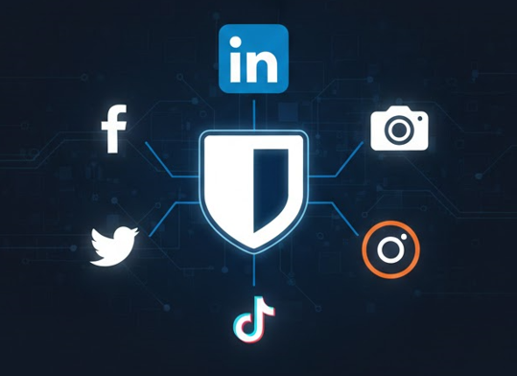

Version 1
January 2026

Disclaimer: This guide provides best practices but does not guarantee 100% immunity from all cyber threats.
Contents

Introduction: The Current Threat Landscape 3
Scope and Threat Model 3
The Objective of This Guide 3
Why This Matters Now 4
Your Primary Email: The Root of Digital Trust 5
Why Trust a Password Vault? 5
The Origin and Philosophy of Bitwarden 5
Zero-Knowledge Architecture: Your Data, Your Keys 5
Verifiable Security and Compliance 6
Bitwarden — The "Brain" of Your Security System 6
1. Setting Up the "Master Key" 6
2. Migrating Your Digital Life 7
3. Activating Integrated 2FA 8
4. Operational Zero-Trust Practices 8
Securing the Devices That Access Your Accounts 9
Hardening Your Social Media & The LinkedIn Deep-Dive 10
1. General Social Media "Hardening" Checklist 10
2. Specialized LinkedIn Security 10
3. If You Are Hacked Again 12
About the Author 13

Introduction: The Current Threat Landscape
In 2026, our digital identities are more valuable—and more vulnerable—than ever. We live in an era where data is the new currency, and personal accounts are the primary targets for sophisticated cyber-attacks. Whether it is identity theft on social media or professional sabotage on LinkedIn, the impact of a security breach goes beyond just "lost posts"; it can affect your reputation, your career, and your peace of mind.
Understanding this threat landscape is the first step toward building a resilient and structured personal security strategy.

Scope and Threat Model
This guide is designed for individual users, students, and professionals securing personal and professional online accounts. It focuses on defending against common real-world threats such as phishing, credential stuffing, account takeover, and social engineering.
It does not attempt to cover enterprise environments, advanced persistent threats (APT), or nation-state-level attackers.

The Objective of This Guide
The goal of this guide is to move beyond basic advice like "don't share your password." It is designed to provide a high-level, actionable framework for securing your digital life. By the end of this guide, you will have:
- Transformed your password habits from weak memory-based strings to a cryptographic vault system.
- Hardened your social media presence against unauthorized access.
- Optimized your professional LinkedIn profile to resist social engineering and account hijacking.
- Developed a "security-first" mindset that protects you across all platforms.

Why This Matters Now
Security is not a one-time setup; it is a continuous process. Hackers today use automated "credential stuffing" and AI-driven phishing to find a single weak link in your defenses.
- Account Interconnectedness: Most people use the same email or password across multiple sites. One breach at a minor website can lead to a "domino effect," giving hackers access to your banking, social, and professional accounts.
- Professional Integrity: For professionals and students, especially in tech fields like IT, your account security is a reflection of your technical competence.
- Data Permanence: Once data or private information is stolen, it is nearly impossible to "delete" it from the internet. Prevention is the only true cure.
" The best defense is not just having a strong lock, but making sure the intruder doesn't even know where the door is. "

Figure 1 : The Account Domino Effect

The 'Domino Effect' is technically known as a Credential Stuffing attack. When a minor, poorly secured website suffers a data breach, hackers obtain a list of email and password pairs. Because of account interconnectedness, they use automated bots to 'stuff' these same credentials into high-value targets like LinkedIn, Gmail, and banking portals. If you reuse passwords, a single leak doesn't just compromise one account—it provides a master key to your entire digital and professional life
This is why using a unique, randomly generated password for every service is a foundational security requirement, not an optional best practice.

Your Primary Email: The Root of Digital Trust
Your email account is the foundation of your entire digital identity. Most platforms rely on email-based password resets and security alerts, meaning that anyone who gains control of your email can take over all other accounts.
For this reason, your primary email must be protected at a higher level than any social media account:
- Use a unique, randomly generated password stored in your password vault.
- Enable app-based MFA or a hardware security key.
- Regularly audit recovery email addresses and phone numbers.
- Never reuse your email password on any other service.
Securing your email first prevents attackers from using password reset mechanisms to regain access after an account recovery.

Why Trust a Password Vault?

The Origin and Philosophy of Bitwarden
Bitwarden was founded in 2015 by Kyle Spearrin, a software engineer who sought to create a more transparent and platform-agnostic alternative to proprietary password managers. Unlike closed-source competitors, Bitwarden was built on the principle of open-source transparency, allowing the global cybersecurity community to inspect, audit, and improve its codebase continuously. This "trust-but-verify" model ensures that there are no hidden backdoors or proprietary flaws in the software.

Zero-Knowledge Architecture: Your Data, Your Keys
The most critical reason to trust Bitwarden is its Zero-Knowledge encryption model.
- Local Encryption: Your sensitive data is encrypted on your local device before it is ever transmitted to Bitwarden’s servers.
- Decryption occurs only on your device: Bitwarden only stores an "encrypted blob" of data that is mathematically indecipherable to them.
- No Master Password Access: Bitwarden never stores, transmits, or has access to your Master Password. This means that even if Bitwarden’s cloud infrastructure were fully compromised, your data remains secure because the "key" to open it exists only in your memory.

Verifiable Security and Compliance
As an SITBD student, you can appreciate that Bitwarden’s security claims are not just marketing—they are audited.
- Third-Party Audits: Bitwarden undergoes rigorous annual security assessments by reputable firms like Cure53 and IOActive, covering everything from network security to mobile app source code.
- Global Standards: It is compliant with major regulatory frameworks including GDPR, HIPAA, and SOC 2, making it a trusted choice for both individual security and enterprise-level data protection.
- Advanced Cryptography: It utilizes industry-standard AES-256 bit encryption and offers advanced key derivation functions like Argon2, which is designed specifically to resist modern GPU-based brute-force attacks.

Bitwarden — The "Brain" of Your Security System
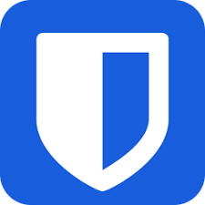
The foundation of modern digital security is moving from a memory-based system (trying to remember passwords) to a vault-based system. For this guide, we use Bitwarden because it is open-source, highly secure, and works across all your devices.

Figure 2 : Trusted Vault Foundation

Setting Up the "Master Key"
Your Master Password becomes the primary password you must protect and remember.
- Complexity is Key: Do not use names, birthdays, or common words.
- The Passphrase Method: Choose four random, unrelated words (e.g., Cyber-Tanger-Data-2026!). This is easier to remember but mathematically harder for a computer to crack.
- The "Golden Rule": If you lose this password, you lose access to your vault forever. Bitwarden has no "forgot password" button for your vault's contents.
- Secure Offline Backup
Because loss of the Master Password results in permanent loss of access, a secure offline backup is strongly recommended:
  - Write the Master Password clearly on paper (do not store it digitally or take photos).
  - Store it in a physically secure location (safe, locked drawer, or sealed envelope).
  - Do not label it as “Bitwarden” or “password manager”.
  - Do not store it in your wallet or carry it daily.
  - This offline backup protects against memory failure or emergencies while remaining immune to online attacks.
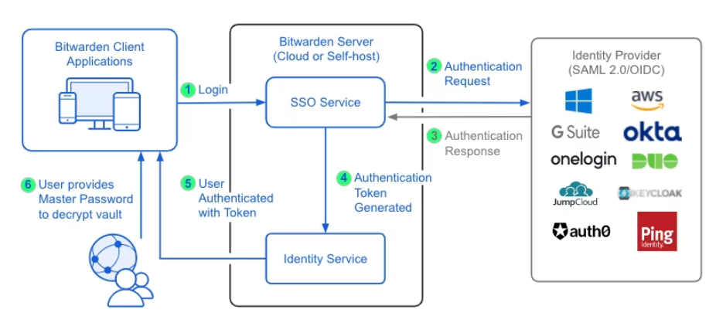
Figure 3 : Secure Vault Infrastructure
The vault infrastructure shown here highlights the importance of a single, strong Master Password protecting all stored credentials. Because the vault is encrypted locally before synchronization, the strength and protection of the Master Password directly determine the security of the entire system.

Migrating Your Digital Life
Once your vault is ready, you must stop using "standard" passwords.
- The Audit: Go through your existing accounts and identify reused passwords.
- Generate, Don't Create: Use the Bitwarden Generator to create unique, 16+ character passwords for every site.
  - Bitwarden Pro Tip: Use "Email Masking" to create unique aliases for every social account. This prevents your primary email from being part of a public data leak.
- Secure Notes: Use Bitwarden to store more than just passwords—save your security questions, recovery codes, and ID details in the "Secure Notes" section.

Activating Integrated 2FA
Bitwarden can do more than store passwords; it can act as your second factor.
- TOTP Generation: Premium Bitwarden accounts can generate the 6-digit codes (Time-based One-Time Passwords) required for login.
- Why it’s better: This is far more secure than SMS-based 2FA, which can be intercepted via SIM-swapping.
- Cross-Device Sync: Your codes and passwords sync instantly between your phone, laptop, and browser.
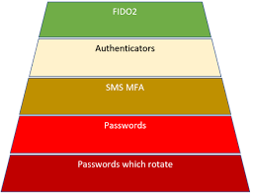
Security Trade-off Notice:
Storing TOTP codes inside the same password vault improves usability but slightly reduces MFA separation.
For high-risk accounts
(email, vault, cloud providers), consider using a separate authenticator app or hardware security key (FIDO2/YubiKey).

Figure 4 : MFA Security Tiers

This figure compares different multi-factor authentication methods by their resistance to real-world attacks. App-based authenticators and hardware security keys provide significantly stronger protection than SMS-based verification, which remains vulnerable to SIM-swapping and interception. Users should prioritize the strongest MFA method available for high-risk accounts.

Operational Zero-Trust Practices
- The Browser Extension: Install the Bitwarden extension to auto-fill passwords. This also protects you from phishing: if you are on a fake website, Bitwarden will not recognize the URL and won't auto-fill your credentials.
- Biometric Lock: Enable FaceID or Fingerprint unlock on your phone for quick, secure access without typing your Master Password every time.

Securing the Devices That Access Your Accounts
Even the strongest passwords and MFA protections can be bypassed if the device itself is compromised. Your laptop and smartphone are trusted endpoints and must be secured accordingly:
- Keep your operating system and browser fully updated.
- Enable full-disk encryption (BitLocker, FileVault, or device encryption).
- Use a strong screen lock (PIN, password, or biometrics).
- Avoid installing unknown software or browser extensions.
- Assume that a compromised device compromises all logged-in accounts.
Identity security is only as strong as the devices used to access it.

Hardening Your Social Media & The LinkedIn Deep-Dive
Social media accounts are common targets because they contain a wealth of personal intel—photos, family names, and birthdays—that hackers use to steal your identity or engineer targeted scams.

General Social Media "Hardening" Checklist
Apply these universal "digital hygiene" habits to every platform you use:
- The "Kill-Switch" for Sessions: Regularly visit your settings (often under "Security" or "Login Activity") and manually log out of every device you don't currently have in your hand.
- Audit Third-Party Apps: Review the list of "Connected Apps" or "Permitted Services". Remove any old games, quizzes, or tools that still have permission to access your data.
- Clean Your Footprint: Review old posts and remove any that reveal sensitive details like your birth year, home address, or phone number.
- Switch to Authenticator-Only: If a platform offers 2FA via an app (like Bitwarden or Google Authenticator), use it and disable SMS codes to prevent "SIM-swapping" attacks.

Specialized LinkedIn Security
Because your LinkedIn is your professional identity in the IT Security world, it requires a higher level of "stealth" and defense.
- Visibility Controls (Anti-Social Engineering)
Hackers use your connection list to find "targets" to phish while pretending to be you.
- Hide Your Connections: Go to Settings & Privacy > Visibility > Connections and set it to "Only you".
- Limit Email Discovery: Under Visibility, set "Who can see your email address" to "Only you" and disable "Profile discovery" via email.
- Manage "Active Status": Turn off your active status so attackers don't know exactly when you are online and potentially vulnerable.
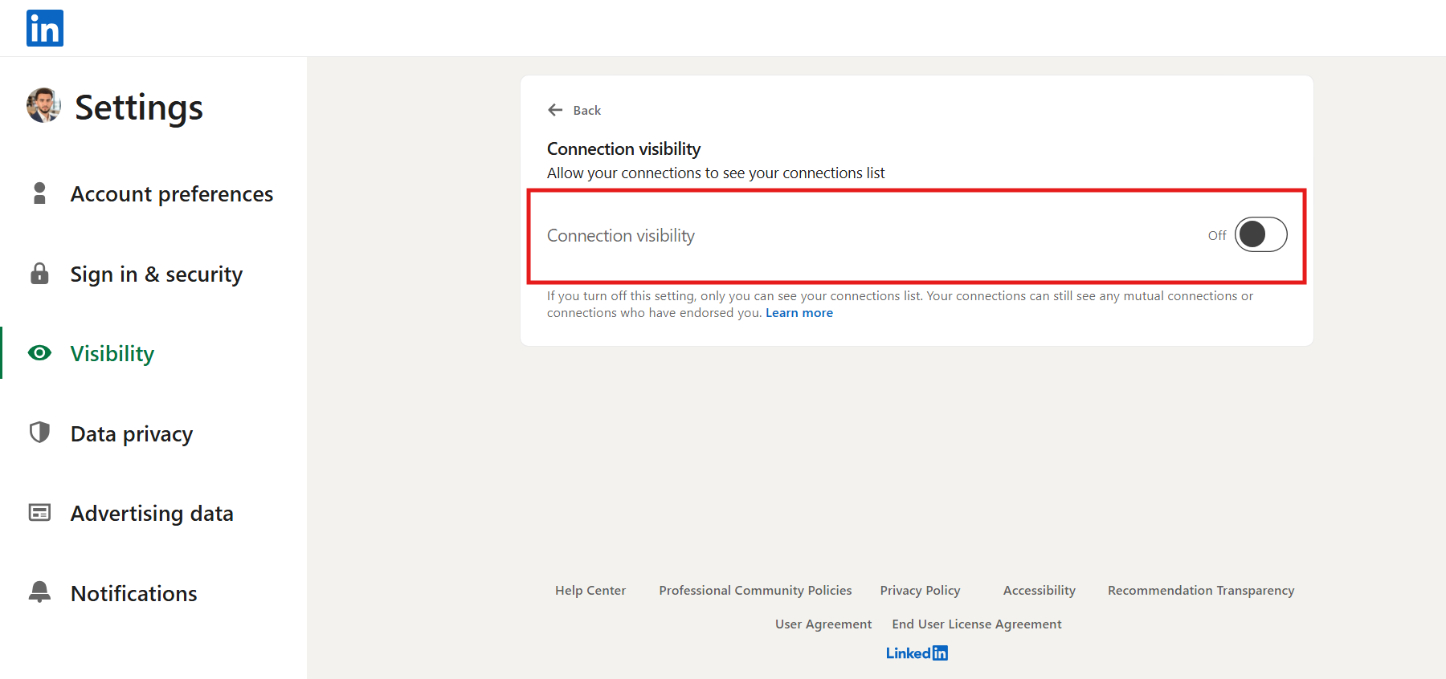

Figure 5 : Disabling Connections Map
- The Defensive Layer

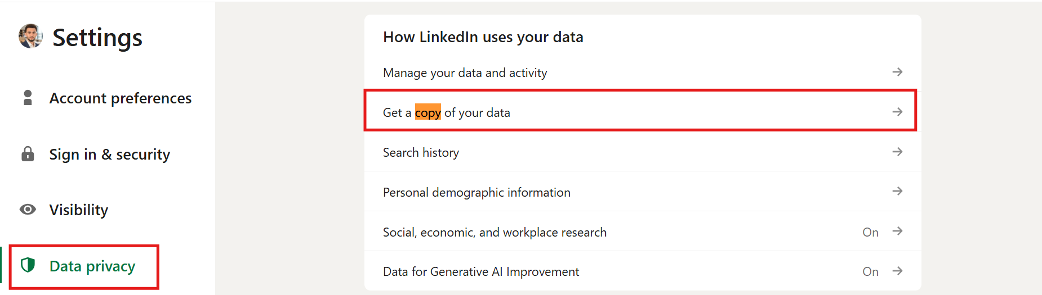
Data Backups: Periodically request your LinkedIn Data Archive to have a backup of your professional history in case of a permanent account loss.

Figure 6 : Professional Forensic Backup

If You Are Hacked Again
If you detect suspicious activity (like your name or email changing), act in this order:
- Secure your primary email account first
- Change the email password to a unique 20+ character random password stored in Bitwarden.
- Enable or re-verify app-based MFA.
- This step is critical: whoever controls your email controls account recovery.
- Log out all active sessions on LinkedIn
- Use Settings → Security → Where you’re logged in to invalidate all existing sessions.
- Change your LinkedIn password
- Generate a new 20+ character random password using Bitwarden.
- Do not reuse any previous password.
- Revoke all third-party app access
- Remove any connected apps or services you do not explicitly recognize or use.
- Verify recovery information
- Check and correct your recovery email address and phone number to ensure they are still under your control.
- Preserve forensic evidence
- Screenshot suspicious login locations, IP addresses, email change alerts, or security notifications before the attacker can delete them.
- Report the compromise to LinkedIn Support
- Submit a request through LinkedIn’s official Compromised Account form and attach your evidence.

About the Author

Mounim Nadir Candidate for Master in Sciences et Techniques (MST): Sécurité IT et Big Data (SITBD) Faculté des Sciences et Techniques de Tanger (FSTT)
As a specialized student in the intersection of Cybersecurity and Big Data, I focus on building resilient data architectures and defending digital identities against evolving 2026 threats. This guide was developed following a real-world account recovery process, intended to serve as a practical resource for the academic and professional community.

Connect with me on LinkedIn: https://www.linkedin.com/in/mounim-nadir-b6575b27a/

