ITI EXAMINATION

SYSTEM



Power BI Track, Menofia Branch.

Team Members :

* Abdelhamed Abdelazim Abdelhamed Ali
* Ahmed Mohamed Edrees Ali
* Ali Abdelfattah Mohamed Kamal
* Kirllos Mounir Samy Gendy
* Noran Fisal Saeed Elfeky

**Introduction**The Examination System is an automated solution designed to facilitate the creation, administration, and evaluation of online exams allowing ITI staff to efficiently manage exams, students, and course-related data. This documentation provides an overview of the system's features, database structure, stored procedures, and reporting capabilities.

Table of Contents

1. Database Design…………………………………………………………….4
2. Stored procedure……………………………………………………………11
3. Report and Dashboard…………………………………………………..17

Ssrs report

Power bi dashboard

I. Database Design

**Student**

* Each student is uniquely identified by ST_ID.
* Students have personal details such as ST_SSN, ST_name, ST_Age, ST_City, ST_Gender, mail, GPA and graduation year.
* Students can study one or many courses, represented by the relationship with the **Course** table.
* Students can perform freelance work or be hired, as represented by relationships with the **Freelancing** and **Hiring** tables.
* Each student can take multiple exams, represented by the relationship with the **Exam** table.
* Students can obtain multiple certificates, represented by the relationship with the **Certificate** table.

**Course**

* Courses are uniquely identified by Course_ID.
* Courses have attributes such as Course_Name , Course_Duration and Course_level
* A course can be taught by one or more instructors, as represented by the relationship with the **Instructor** table.
* Each topic includes a list of courses , represented by the relationship with the **Course** table.
* A course is associated with one or many exams, as represented by the relationship with the **Exam** table.
* Courses are studied by multiple students, represented by the relationship with the **Student** table.

**Instructor**

* Each instructor is uniquely identified by Instructor_ID.

Instructors have personal details such as Instructor_Fname, Instructor_Lname, Instructor_Age, Instructor_Gender, Salary, City, and Hire_Date.

* Instructors teach one or more courses, represented by the relationship with the **Course** table.
* Instructors manage a department, represented by the relationship with the **Department** table.

**Topic**

* Each topic is uniquely identified by Topic_ID.
* Topics have a name, represented by Topic_Name.
* Topics are associated with one or more courses, represented by the relationship with the **Course** table.

**Branch**

* Each branch is uniquely identified by Branch_ID.
* Branches have attributes such as Branch_Name, Address, and Phone, No of rooms.
* Branches are associated with many tracks , represented by the relationship with the **Track** table.

**Exam**

* Each exam is uniquely identified by Exam_ID.
* Exams have attributes such as Exam_Title, Exam_Duration, Exam_Date, Quest_Nums, and Exam_Grade.
* Exams are taken by multiple students, represented by the relationship with the **Student** table.
* Exams include a list of questions, represented by the relationship with the **Question** table.

**Question**

* Each question is uniquely identified by Question_ID.
* Questions have attributes such as Question_Type, Question_ModelAnswer, and Question.
* Questions are part of multiple exams, represented by the relationship with the **Exam** table.
* Questions may have multiple choices, represented by the relationship with the **Choice** table.

**Choice**

* Each choice is uniquely identified by Choice_ID.
* Choices have attributes such as Choice.
* Choices are associated with a specific question, represented by the relationship with the **Question** table.

**Department**

* Each department is uniquely identified by Dept_ID.
* Departments have attributes such as Dept_Name, Dept_Location, and Dept_Description.
* Departments are managed by instructors, represented by the relationship with the **Instructor** table.

**Certificate**

* Each certificate is uniquely identified by Certification_ID.
* Certificates have attributes such as Certification_Name, Platform, Certificate_URL, Certificate_Hour and Certificate_Date.
* Certificates are obtained by students, represented by the relationship with the **Student** table.

**Freelancing**

* Each freelance job is uniquely identified by Freelance_ID.
* Freelancing jobs have attributes such as Job_Name, Job_Website, Job_StartDate, Job_Tools, and Feedback_Rating.
* Freelancing jobs are performed by students, represented by the relationship with the **Student** table.

**Hiring**

* Each hiring is uniquely identified by Hiring_ID.
* Hiring have attributes such as Position, Hiring_Date,Hiring_Type, Company, and Location.
* Hiring are associated with students, represented by the relationship with the **Student** table.

**Track**

* **Track** represents a specific program or path of study that students can follow.
* Each track is uniquely identified by **Track_ID**.
* It includes attributes such as:
  + **Track_Name**: The name of the track, indicating the field or specialization (e.g., Data Science, AI).
  + **Supervisor_ID**: References the **Instructor** who supervises or manages the track.

ERD

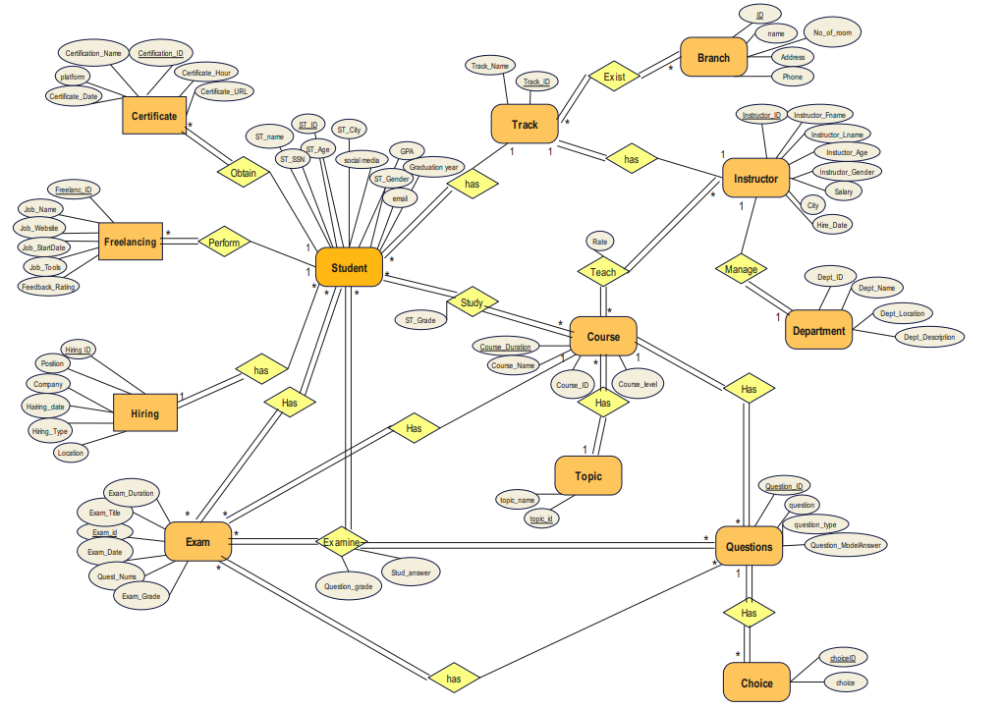

Mapping

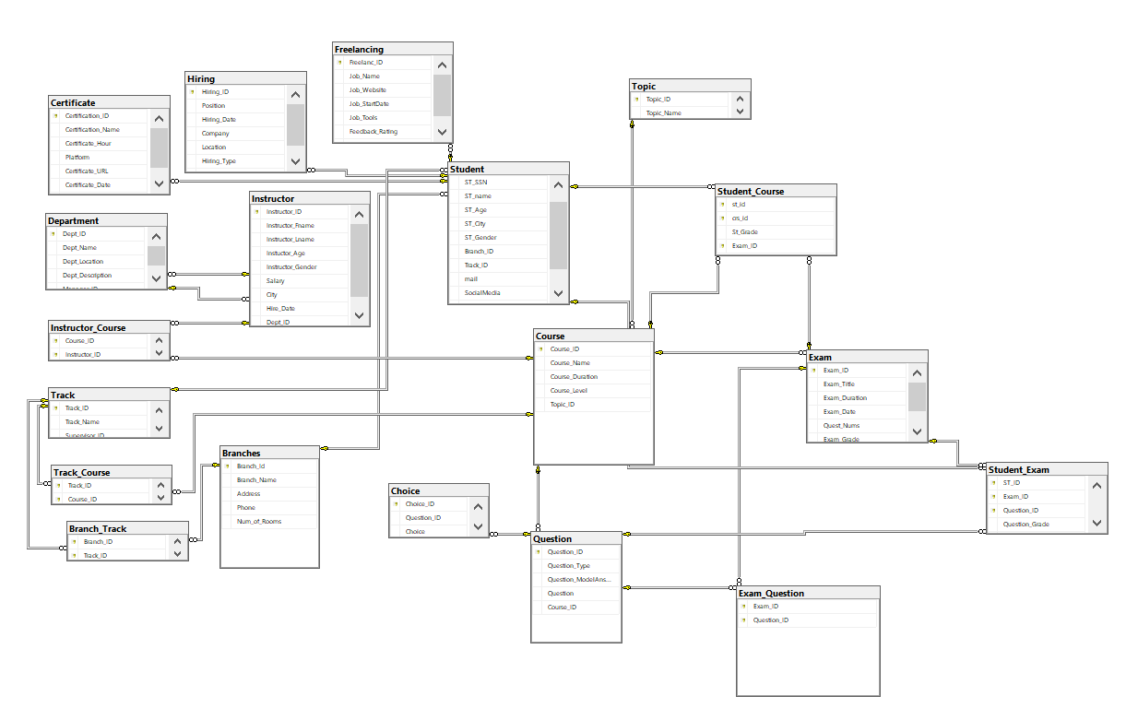

II.Stored Procedures on Database

There are four main required stored procedures :

The first is to generate an exam from existed questions .

The second is to insert answers from student for that questions in database .

The third is to correct that exam and give the grade .

The last one is to update or delete or insert or select from any table .

**Exam Generation :**

CREATE or alter proc [dbo].[GenerateExam]

@Exam_Title NVARCHAR(100),

@Exam_Duration INT,

@Exam_Date DATE,

@Exam_Grade DECIMAL(5,2),

@Course_Title NVARCHAR(100), -- Course title to retrieve Course_ID

@Quest_Nums INT =10 -- Optional parameter for number of questions, default is 10

AS

BEGIN

-- Variables to hold the new Exam_ID and Course_ID

DECLARE @Exam_ID INT;

DECLARE @Course_ID INT;

-- Retrieve the Course_ID based on the provided Course_Title

SELECT @Course_ID = Course_ID

FROM Course

WHERE Course_Name = @Course_Title;

-- Check if Course_ID was found

IF @Course_ID IS NULL

BEGIN

RAISERROR('Course not found for the provided title.', 16, 1);

RETURN;

END

-- Determine the next Exam_ID by finding the maximum existing ID and incrementing

SELECT @Exam_ID = ISNULL(MAX(Exam_ID), 0) + 1 FROM Exam;

-- Insert a new exam record

INSERT INTO Exam (Exam_ID, Exam_Title, Exam_Duration, Exam_Date, Quest_Nums, Exam_Grade, Course_ID)

VALUES (@Exam_ID, @Exam_Title, @Exam_Duration, @Exam_Date, @Quest_Nums, @Exam_Grade, @Course_ID);

-- Generate a random set of questions for the exam

INSERT INTO Exam_Question (Exam_ID, Question_ID)

SELECT TOP (@Quest_Nums) @Exam_ID, Question_ID

FROM Question

WHERE Course_ID = @Course_ID

ORDER BY NEWID(); -- Randomize the selection

-- Return the new Exam_ID and the number of questions selected

SELECT @Exam_ID AS NewExamID, @Quest_Nums AS NumberOfQuestions;

END;

EXEC GenerateExam

@Exam_Title = 'Midterm Exam',

@Exam_Duration = 60, -- Duration in minutes

@Exam_Date = '2024-10-15', -- Exam date

@Exam_Grade = 100.00, -- Maximum grade

@Course_Title = 'Database', -- Course title to retrieve Course_ID

@Quest_Nums = 10;

GO

**Exam Answer:**

CREATE OR ALTER PROCEDURE Exam_Answer

@student_Id INT,

@exam_Id INT,

@question_ID INT,

@Student_Answer VARCHAR(MAX)

AS

BEGIN

-- Check if the Exam_ID exists in the Exam table

IF NOT EXISTS (SELECT 1 FROM Exam WHERE Exam_ID = @exam_Id)

BEGIN

RAISERROR('Exam ID does not exist.', 16, 1);

RETURN;

END

-- Check if the Question_ID exists and is associated with the provided Exam_ID

IF NOT EXISTS (

SELECT 1

FROM Exam_Question

WHERE Exam_ID = @exam_Id AND Question_ID = @question_ID

)

BEGIN

RAISERROR('Question ID does not exist for the given Exam ID.', 16, 1);

RETURN;

END

-- Insert the student's answer into the Student_Exam table

INSERT INTO Student_Exam (st_id, Exam_ID, Question_ID, Student_Answer, Question_Grade)

VALUES (@student_Id, @exam_Id, @question_ID, @Student_Answer, 0);

END

GO

exec Exam_Answer

@student_Id =3,

@exam_Id =18,

@question_ID =15,

@Student_Answer ='c) Variable names cannot start with a digit'

exec Exam_Answer

@student_Id =3,

@exam_Id =18,

@question_ID =14,

@Student_Answer ='b) Variable names cannot start with a digit'

exec Exam_Answer

@student_Id =3,

@exam_Id =18,

@question_ID =13,

@Student_Answer ='b) Variable names cannot start with a digit'

exec Exam_Answer

@student_Id =3,

@exam_Id =18,

@question_ID =12,

@Student_Answer ='c) Dennis Ritchie'

**Exam Correction :**

ALTER PROCEDURE ExamCorrection @exam_id INT, @student_id INT

WITH ENCRYPTION

AS

BEGIN TRY

----Store the model answer for each question compared to the Student answer---

DECLARE @correctAns TABLE (Qid int, ModelAns varchar(100), userAns varchar(100))

INSERT @correctAns(Qid, ModelAns, userAns)

SELECT Q.Question_ID, Question_ModelAnswer, SE.Student_Answer

FROM Student_Exam As SE, Question AS Q

WHERE SE.Question_ID= Q.Question_ID AND ST_ID = @student_id AND Exam_ID = @exam_id

------Set the grade for the correct answers-------

UPDATE Student_Exam

SET Question_Grade= 1

WHERE Question_ID IN

(

SELECT Qid FROM @correctAns

WHERE ModelAns = userAns

AND ST_ID = @student_id AND Exam_ID = @exam_id

) and ST_ID = @student_id AND Exam_ID = @exam_id

---------Set the null values by zero--------------

UPDATE Student_Exam

SET Question_Grade = 0

WHERE Question_ID not IN

(SELECT Qid FROM @correctAns

WHERE ModelAns = userAns

AND ST_ID = @student_id AND Exam_ID = @exam_id

)and ST_ID = @student_id AND Exam_ID = @exam_id

---------Compute student final grade--------------

DECLARE @StudentDegree FLOAT = (SELECT SUM(Question_Grade) FROM Student_Exam

WHERE ST_ID = @student_id AND Exam_ID = @exam_id )

DECLARE @ExamDegree FLOAT = (SELECT COUNT(Question_ID) FROM Exam_Question

WHERE Exam_ID = @exam_id

Group by Exam_ID )

DECLARE @Student_percentage FLOAT = (@StudentDegree/@ExamDegree) * 100

IF(@Student_percentage IS NULL)

BEGIN

SELECT 'Student Did not take this exam' as Caution

RETURN

END

--- update the new info

UPDATE Student_Course

SET St_Grade= @Student_percentage ,Exam_id =@exam_id

WHERE ST_ID = @student_id AND crs_id = (select Course_ID from Exam where exam_id= @exam_id)

--- preview student grade in the exam id

SELECT sc.st_id, s.st_name, sc.Exam_ID, ex.Exam_Title, sc.crs_id, c.Course_Name, sc.St_Grade

FROM Student_Course sc

JOIN Student s

on sc.st_id = s.st_id

AND sc.st_id = @student_id

JOIN Exam ex

on sc.Exam_ID = ex.Exam_ID

AND sc.Exam_ID = @exam_id

JOIN Course c

on sc.crs_id = c.Course_ID

END TRY

BEGIN CATCH

SELECT 'Error in Correcting Exam!!' AS Error

END CATCH

There are many tables which the four main stored procedures created on( Select, Update, Insert,Delete). we will show the query for only Instructor table in that documentation and the rest are attached in the main sql file .

----- SP SELECT

CREATE PROCEDURE SelectInstructor

@Instructor_ID INT = NULL

AS

BEGIN

IF @Instructor_ID IS NULL

BEGIN

SELECT * FROM Instructor;

PRINT 'Select operation completed successfully.';

END

ELSE

BEGIN

IF EXISTS (SELECT 1 FROM Instructor WHERE Instructor_ID = @Instructor_ID)

BEGIN

SELECT * FROM Instructor WHERE Instructor_ID = @Instructor_ID;

PRINT 'Select operation completed successfully.';

END

ELSE

BEGIN

PRINT 'No records found with the specified Instructor_ID.';

END

END

END;

--EXEC SelectInstructor;

--EXEC SelectInstructor @Instructor_ID = 1;

--EXEC SelectInstructor @Instructor_ID = 9999;

GO

----- SP INSERT

CREATE PROCEDURE InsertInstructor

@Instructor_ID int,

@Instructor_Fname VARCHAR(200),

@Instructor_Lname VARCHAR(200),

@Instructor_Age INT,

@Instructor_Gender VARCHAR(200),

@Salary INT,

@City VARCHAR(200),

@Hire_Date DATE,

@Dept_ID INT

AS

BEGIN

BEGIN TRY

INSERT INTO Instructor (Instructor_ID , Instructor_Fname, Instructor_Lname, Instuctor_Age, Instructor_Gender, Salary, City, Hire_Date, Dept_ID)

VALUES (@Instructor_ID ,@Instructor_Fname, @Instructor_Lname, @Instructor_Age, @Instructor_Gender, @Salary, @City, @Hire_Date, @Dept_ID);

PRINT 'Insert operation completed successfully.';

END TRY

BEGIN CATCH

PRINT 'An error occurred during the insert operation.';

END CATCH

END;

/*EXEC InsertInstructor

@Instructor_ID = 30 ,

@Instructor_Fname = 'Kirllos',

@Instructor_Lname = 'Mounir',

@Instructor_Age = 45,

@Instructor_Gender = 'Male',

@Salary = 70000,

@City = 'New York',

@Hire_Date = '2023-08-01',

@Dept_ID = 20;*/

GO

----- SP UPDATE

CREATE PROCEDURE UpdateInstructor

@Instructor_ID INT,

@Instructor_Fname VARCHAR(200) = NULL,

@Instructor_Lname VARCHAR(200) = NULL,

@Instructor_Age INT = NULL,

@Instructor_Gender VARCHAR(200) = NULL,

@Salary INT = NULL,

@City VARCHAR(200) = NULL,

@Hire_Date DATE = NULL,

@Dept_ID INT = NULL

AS

BEGIN

BEGIN TRY

IF EXISTS (SELECT 1 FROM Instructor WHERE Instructor_ID = @Instructor_ID)

BEGIN

UPDATE Instructor

SET

Instructor_Fname = COALESCE(@Instructor_Fname, Instructor_Fname),

Instructor_Lname = COALESCE(@Instructor_Lname, Instructor_Lname),

Instuctor_Age = COALESCE(@Instructor_Age, Instuctor_Age),

Instructor_Gender = COALESCE(@Instructor_Gender, Instructor_Gender),

Salary = COALESCE(@Salary, Salary),

City = COALESCE(@City, City),

Hire_Date = COALESCE(@Hire_Date, Hire_Date),

Dept_ID = COALESCE(@Dept_ID, Dept_ID)

WHERE Instructor_ID = @Instructor_ID;

PRINT 'Update operation completed successfully.';

END

ELSE

BEGIN

PRINT 'No records found with the specified Instructor_ID.';

END

END TRY

BEGIN CATCH

PRINT 'An error occurred during the update operation.';

END CATCH

END;

/*EXEC UpdateInstructor

@Instructor_ID = 1,

@Salary = 4000*/

/*EXEC UpdateInstructor

@Instructor_ID = 9999,

@Salary = 75000;*/

GO

----- SP DELETE

CREATE PROCEDURE DeleteInstructor

@Instructor_ID INT

AS

BEGIN

BEGIN TRY

IF EXISTS (SELECT 1 FROM Instructor WHERE Instructor_ID = @Instructor_ID)

BEGIN

DELETE FROM Instructor WHERE Instructor_ID = @Instructor_ID;

PRINT 'Delete operation completed successfully.';

END

ELSE

BEGIN

PRINT 'No records found with the specified Instructor_ID.';

END

END TRY

BEGIN CATCH

PRINT 'An error occurred during the delete operation.';

END CATCH

END;

--EXEC DeleteInstructor @Instructor_ID = 30;

III. Report And Dashboards

• SSRS REPORTS

* Report that takes the student ID and returns the grades of the student in all courses. %

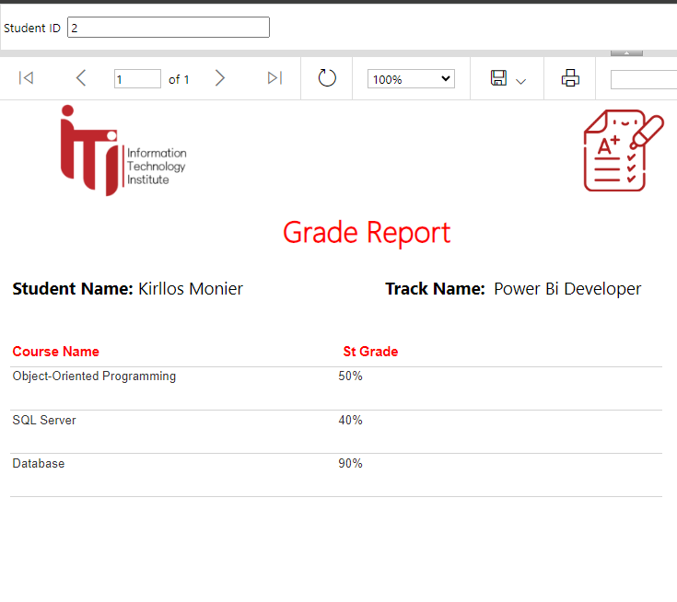

* Report that takes course ID and returns its topics

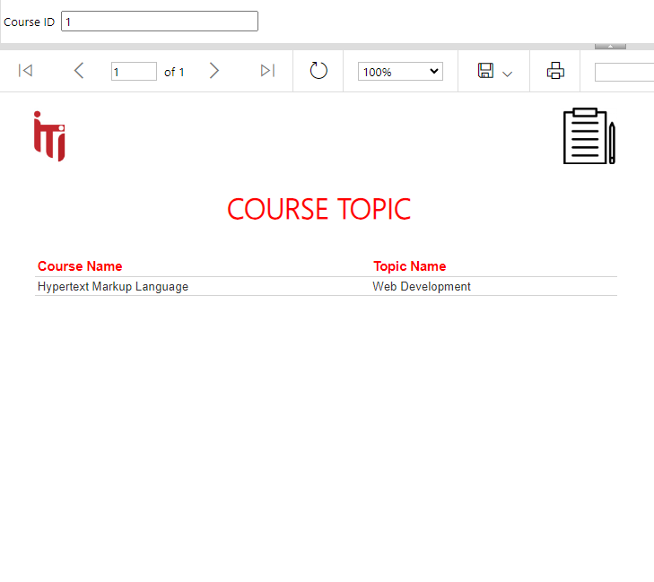

* Report that takes the instructor ID and returns the name of the courses that he teaches and the number of students per course.

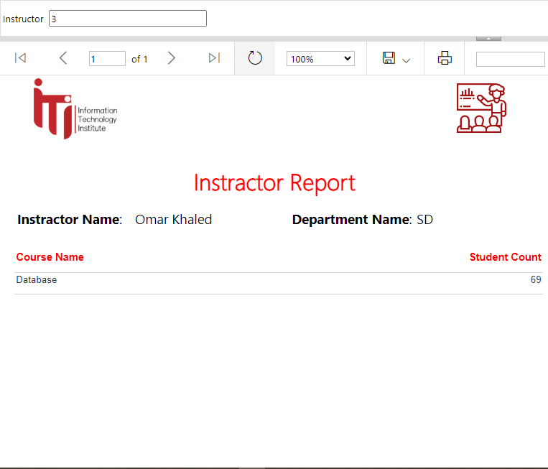

* Report that takes exam number and returns the Questions in it and chocies.

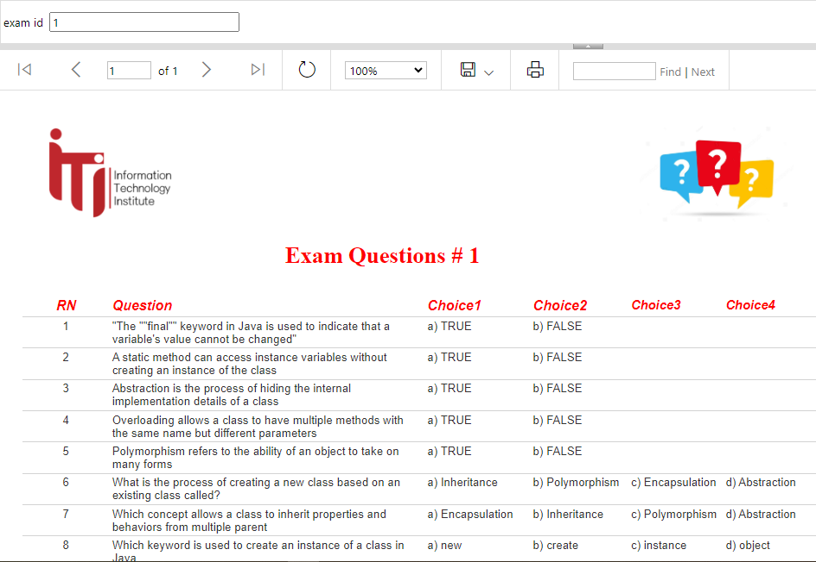

* Report that takes exam number and the student ID then returns the Questions in this exam with the student answers.

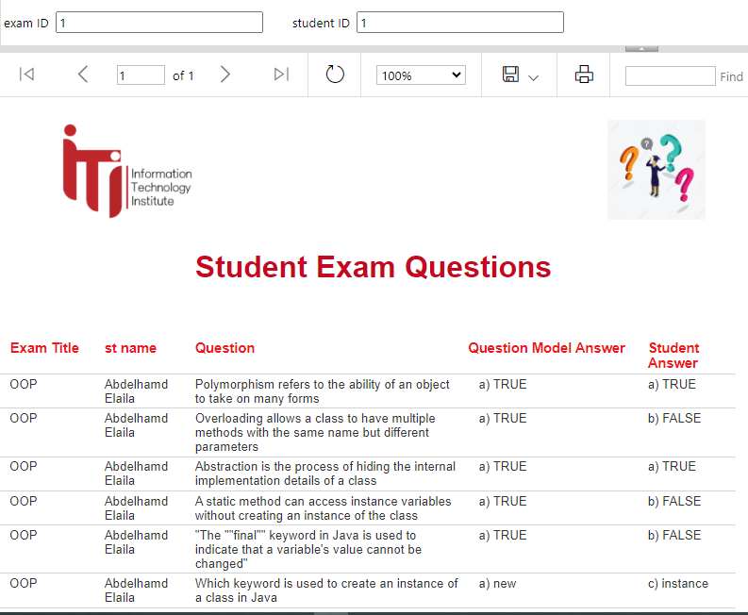

* Report that returns the students information according to Track No parameter.

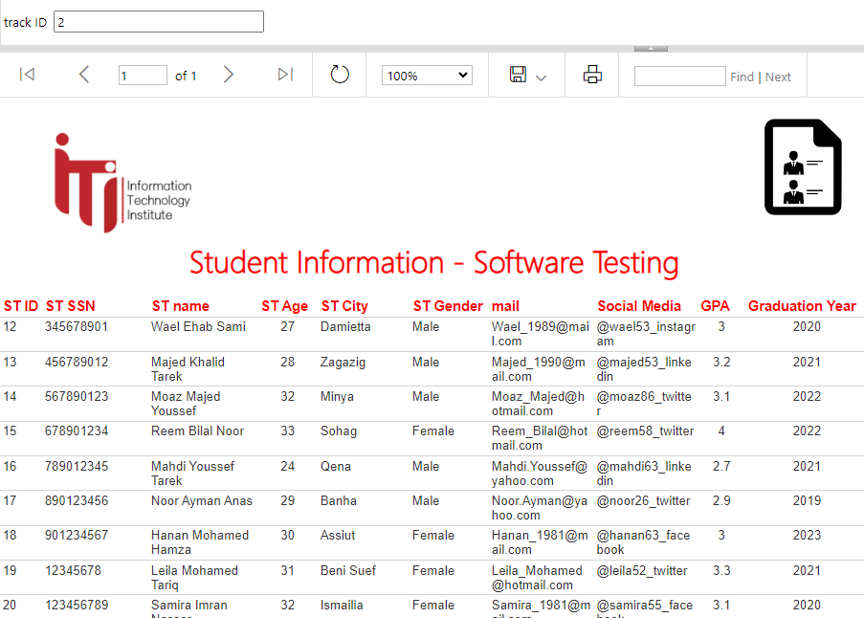

**POWER BI DASHBOARDS**

