IT Salaries and what affects them.

As student studying a computer related course, it is of interest to see what will affect our potential earnings when we graduate and progress through our careers

Introduction
As students we send time, money and effort developing our skills in the hope that this will provide us with rewarding opportunities in future. One element of this is financial reward we all need to earn enough to live and to for fill our life ambitions.
We have taken a data set of salaries in the IT industry (Kaggle, no date). The data was gathered from an online survey on gathering real data from people who work in the industry. This has been examined to see what factors are important for increasing our potential salary.

Data in data set

Work_year – indicates the year the survey response was made
Experience_level – level of experience (EN = Entry, MI = Middle, SE = Senior, EX = Expert)
Employement_type – shows whether it is full time (FT), part time (PT), contract (CT) or freelance (FL)
Job_title – refers to the title of the job
Salary – salary in currency of the country wherever the employee lives.
Salary_in_currency – currency of the country
Salary_in_usd – salary in dollars
Employee_residence – place where the candidates are living in
Remote_ratio – whether they work remotely (office (0) / hybrid (50) / home (100))
Company_location – location of the company
Company_size – the size of the company like how many candidates are working in the company.

Exploring the Data
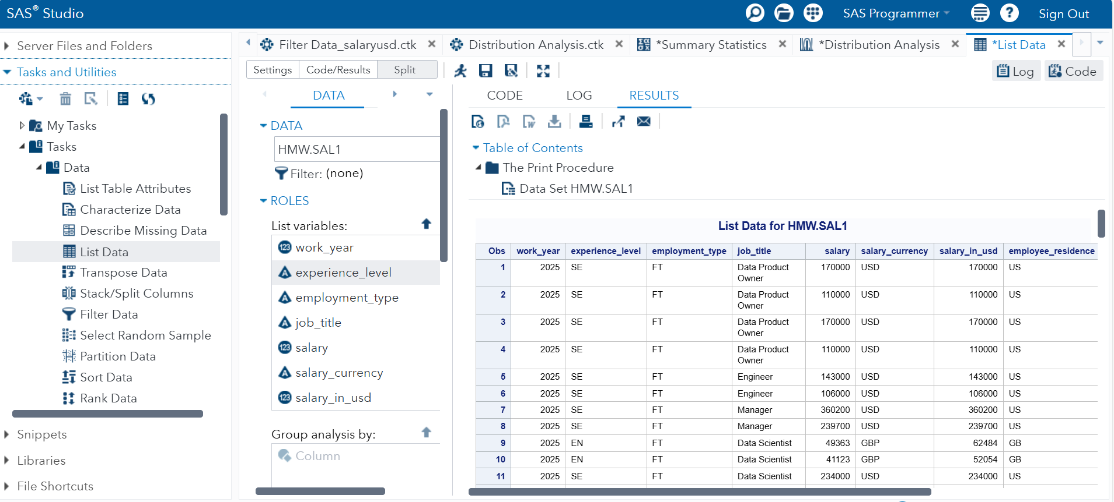

The main feature in the data set is salary. The salary has been included in currencies local to where it is paid, however that has been standardised to American Dollars (USD) which is probably going to be the most useful measure for comparison.

Employment type
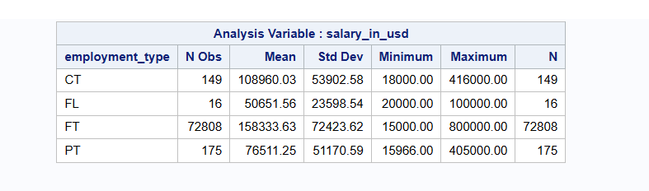
Most of the values are at full time employment because the number of observations are high compared to part time, contract and freelance.
The largest range of data is for Full time, going up to a maximum of 800,000.
Part time working has an average and maximum rough half that of Full time, but a higher minimum.
Freelance work has an average less than Part Time, but a higher minimum. This might be awkward to compare if this is payment for pieces of work rather than set hours
The average salary and maximum salary are highest for Full time working, However, the data set does not indicate the number of hours worked, so comparisons between Full Time and other working patterns are hard to make.

Experience Level
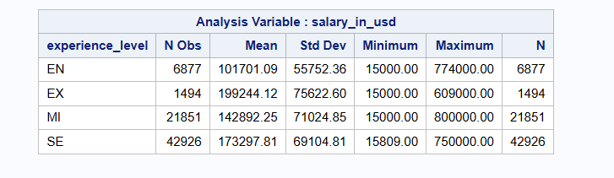
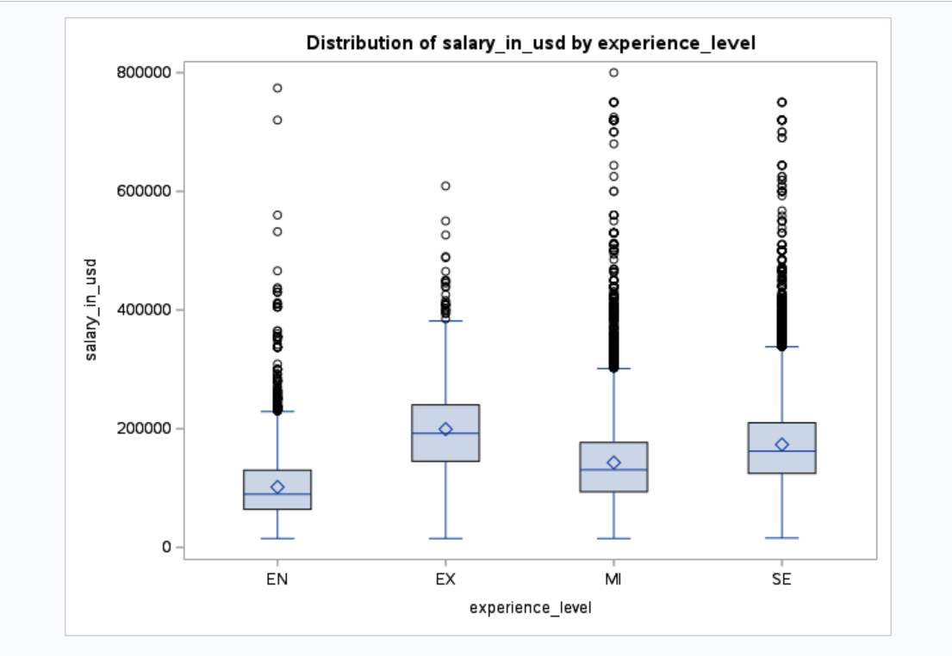

The number of observations are highest at senior level and lowest for expert and entry level.
There might be a pattern of mean/median salaries increase over the experience level, The maximum salaries are similar for all experience level.
Since the data has been compiled by an online survey, some the data could be erroneous or deliberately inflated. The box plot it shows these maximums have considerable outlier data on upper are due outlier data.
We need to do some data cleaning to remove these.

Employee Residence
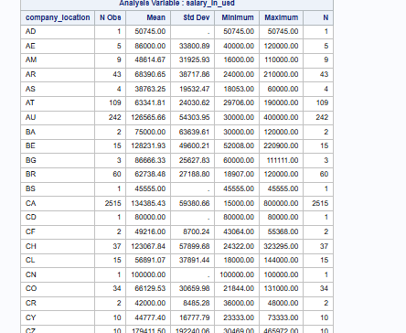

Number of observations varies with countries. The largest number of observations are from the US (65,044), followed by Canada (2494) and GB (2085). These three countries cover over 95.6% of the data.
36 of the 86 countries have 5 or less observations.

Company country and Employee location
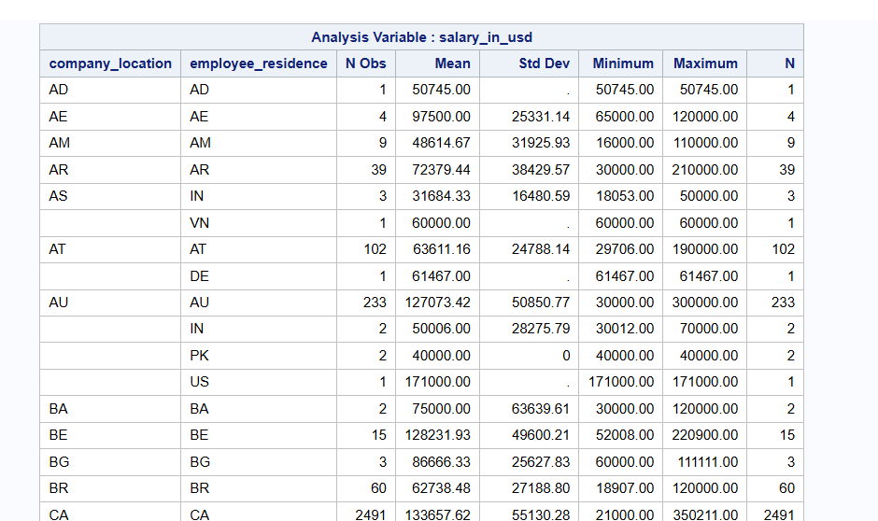

The pattern looks like most employees work for a company in the same country that they live in.
People who live is a different country to their company, could be living in the company’s country temporary, working remote, or working in a local branch/office of the company. Without extra data it would be difficult to assess any patterns here
The observations of employees that live in a different country to the company location are generally below 5 for each combination of countries. This is not enough to be able to look at.

Job Title

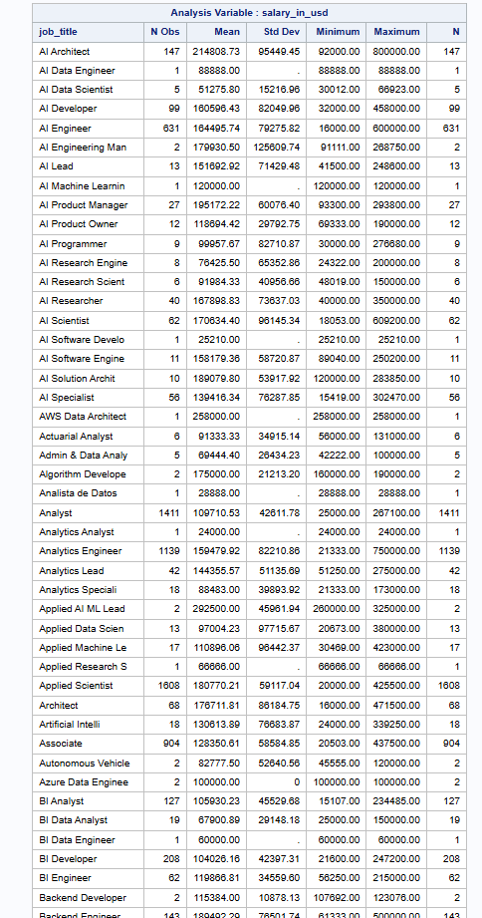

The data has been gathered from a survey, so users were able to put in different job titles for similar job roles. The number of different values makes it complex to investigate easily. We could group some of the titles together to make it easier to analyse.
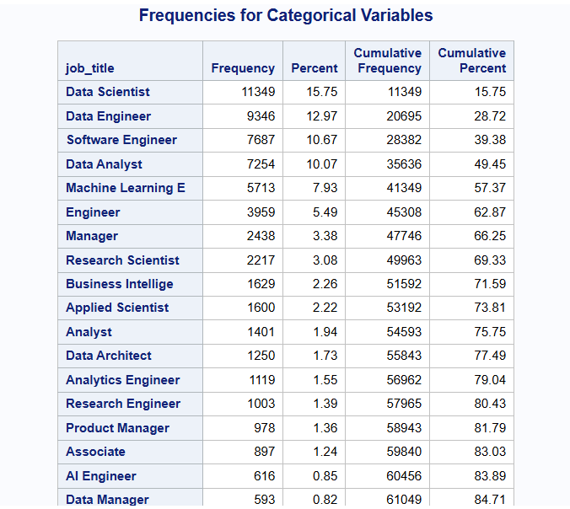
Looking at the frequencies for the submitted job titles, 18 different titles cover near 85% of the data. 84 job titles have 5 or fewer observations.
There are 258 different job titles in the dataset. There are many similar job tiles e.g. Software Engineer, Engineer, Software Developer, Systems Engineer, developer

Initial hypotheses
- Does experience level significantly influence salary?
- Does working remotely significantly influence salary?
- Which job role would pay best?

Data cleaning
Since the data does not have enough information to provide a good comparison between Full time and parttime/contract/Freelance working, the data will be reduced to just Full-time roles.
The data does not have any information about how much time is spent in the office and remote working. There are two ways of considering this is that a role is entirely office base or has at least some remote working. Alternatively, a role is entirely remote or has at least some office-based working
The salary data has outlying data, especially on the upper end of the values. As these many be errors or deliberately exaggerated responses data about the 99 percentile will be removed.

References
Kaggle (no date) Available at: https://www.kaggle.com/datasets/aijobs/global-salaries-in-ai-ml-data-science (Accessed: 10/11/2025)

