Overview
The following questions have been investigated and testing carried out
Are the salaries in local currencies sensibly converted to USD?
Does working entirely office-based affect salary?
Does working entirely remotely affect salary?
Does experience level affect salary?
Does job role affect salary?

Tests

Are the salaries in local currency sensibly converted to USD?
To investigate this a Two-Sample t-test will be carried out to see if the average salary for office-based workers is significantly different to those with at least some remote working.
H0: There is no linear relationship between the salary in GBP and the salary in USD.
H1: There is a linear relationship between the salary in GBP and the salary in USD.

Assumption checks

Normality
H0: The data normally distributed.
H1: The data not normally distributed.
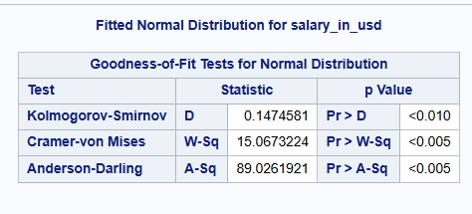
The values show that the p value is below the 5% threshold the null hypothesis is rejected, and the test will require a Spearman’s Rank test with be used.

Spearman’s Rank Test

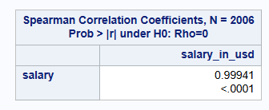

The correlation is shown to be positively related and is significant at the 5% threshold.
This shows that the GBP to USD has probably been made sensibly and so we can make comparisons using the generated values.

Does working entirely office-based affect salary?
The investigation here compares roles that are office based with those that have at least some remote working.
To investigate this a Two-Sample t-test will be carried out to see if the average salary for office-based workers is significantly different to those with at least some remote working.
H0: There is no difference in the average salary for office-based workers compared to those with at least some remote working.
H1: There is a difference between the average salary for office-based workers and those with at least some remote working

Assumption checks

Normality
H0: The data normally distributed.
H1: The data is not normally distributed.

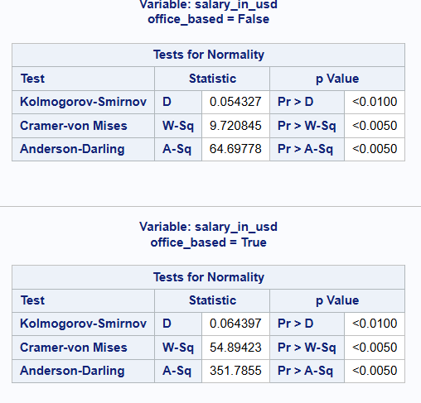
Both values show that the p value is below the 5% threshold the null hypothesis is rejected, and the test will require a Wilcoxon rank Sum Test with be used.

Equality of variances
H0: The group variances are equal.
H1: The group variances are not equal.
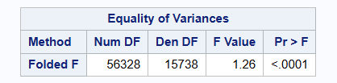
In this case the p value is below the 5% threshold so the variance are not equal. The Satterthwaite values will be used in the test.

Wilcoxon rank Sum Test
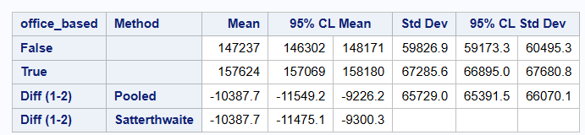
The interval on the Satterthwaite line does not include 0, therefore the null hypothesis is rejected, there is a significant difference between being office base and having at least some remote working.

Does working entirely remotely affect salary?
The investigation here compares roles that are entirely remote based with those that have at least some office-based working.
To investigate this a Two-Sample t-test will be carried out to see if the average salary for entirely remote workers is significantly different to those that have at least some office-based working.
H0: There is no difference in the average salary for entirely remote workers compared to those with at least some office-based working.
H1: There is a difference between the average for entirely remote workers compared to those with at least some office-based working.

Assumption checks

Normality
H0: The data normally distributed.
H1: The data normally distributed.
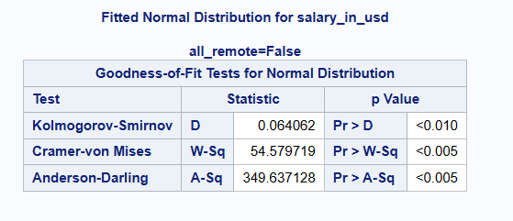
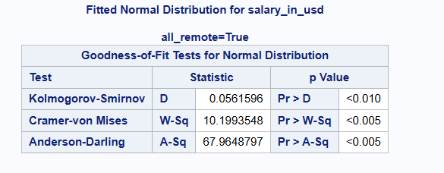
Both values show that the p value is below the 5% threshold the null hypothesis is rejected, and the test will require a Wilcoxon rank Sum Test with be used.

Equality of variances
H0: The group variances are equal.
H1: The group variances are not equal.
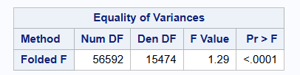
In this case the p value is below the 5% threshold so the variance are not equal. The Satterthwaite values will be used in the test.

Wilcoxon rank Sum Test
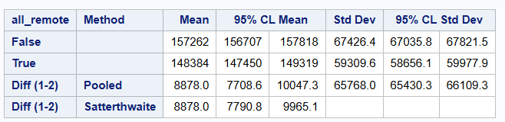
The interval on the Satterthwaite line does not include 0, therefore the null hypothesis is rejected, there is a significant difference between being entirely remote and having at least some office-based working.

Does experience level affect salary?
There are 4 levels of experience in the dataset, Entry, Middle, Senior and Expert.
H0: There is no significant different between the average salaries of the 4 experience levels.
H1: There are significant differences between the average salaries of at least one of the experience levels.

Assumption checks

Normality
H0: The data normally distributed.
H1: The data is not normally distributed.

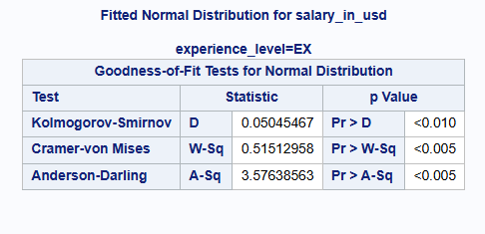
All the distribution show that the p value is below the 5% threshold the null hypothesis is rejected, and the test will require a Kruskal-Wallis test will be used.

Independence
Each row in the data only has one experience level, so the samples are independent

Greater than 5 observations
There are more than 5 observations in each of the categories

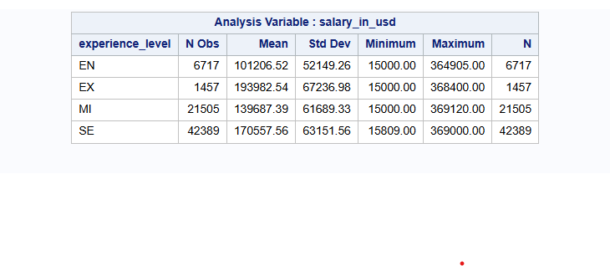

Kruskal-Wallis Test
A non-parametric One-Way Anova test will be run (Kruskal-Wallis)
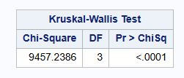
The p value is below the 5% threshold, so we reject the null hypothesis, there is a difference in salary based on experience level.

Post-hoc Comparison
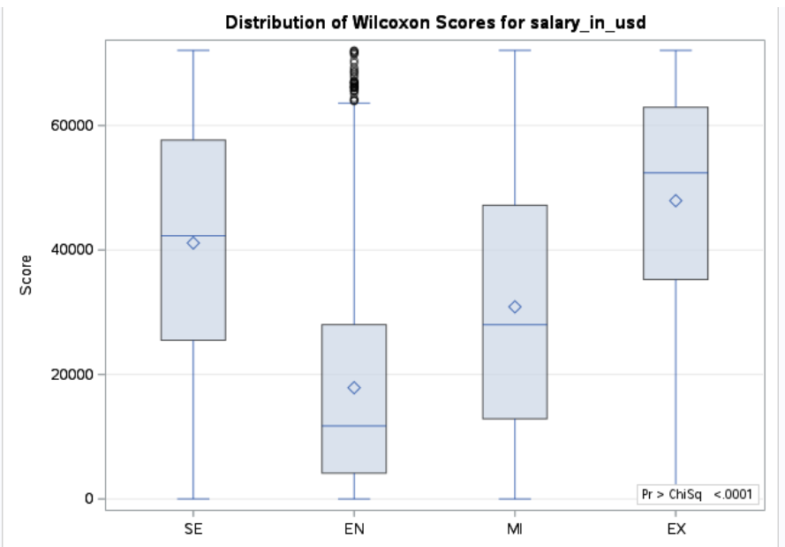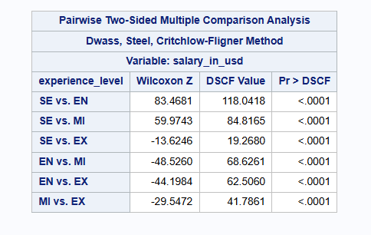
The pairwise tests show all pairings are significantly different, the all the average salaries are significantly different.
Moving up the scale of Entry, Mid, Senior and Expert level we can expect salary to increase.

Does job role affect salary?
The have been 5 different types of roles identified in the dataset -, Research, Ai, Management, Developer and Data Science. This allows similar jobs and job titles to be considered together
H0: There is no significant different between the average salaries of the 5 job roles.
H1:There are significant differences between the average salaries of at least one of the job roles.

Assumption checks

Normality
H0: The data normally distributed.
H1: The data normally distributed.

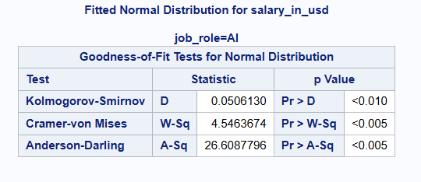
The distributions show that the p value is below the 5% threshold the null hypothesis is rejected, and the test will require a Kruskal-Wallis test will be used.

Independence
Each row in the data only has one job title, so has only been grouped into one job role, so the samples are independent

Greater than 5 observations
There are more than 5 observations in each of the categories

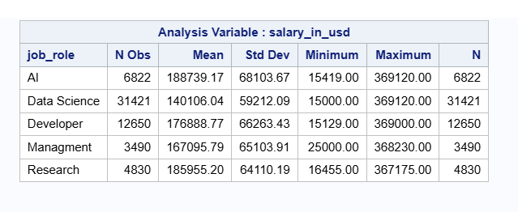

Kruskal-Wallis Test
A non-parametric One-Way Anova test will be run (Kruskal-Wallis)
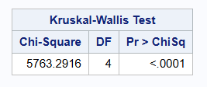
The p value is below the 5% threshold, so we reject the null hypothesis, there is a difference in salary based on experience level.
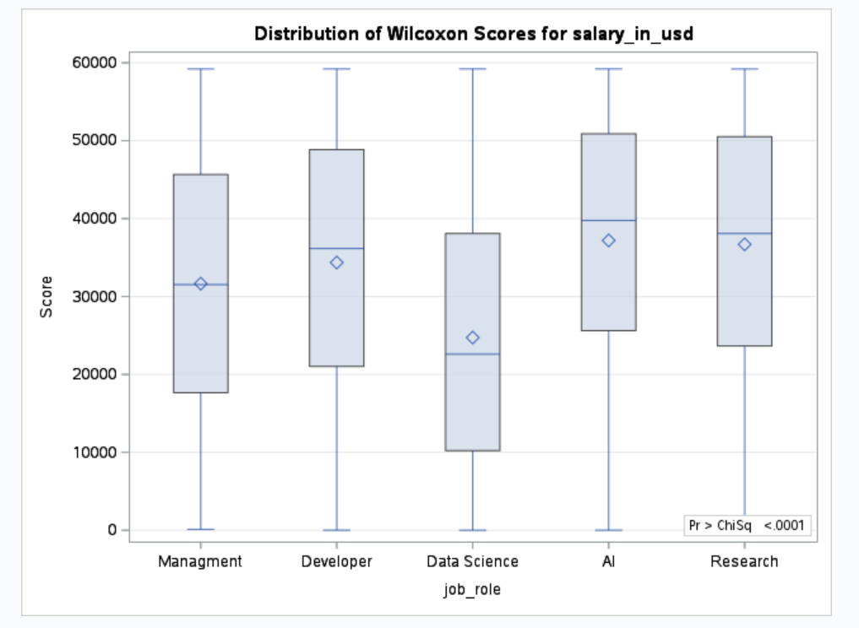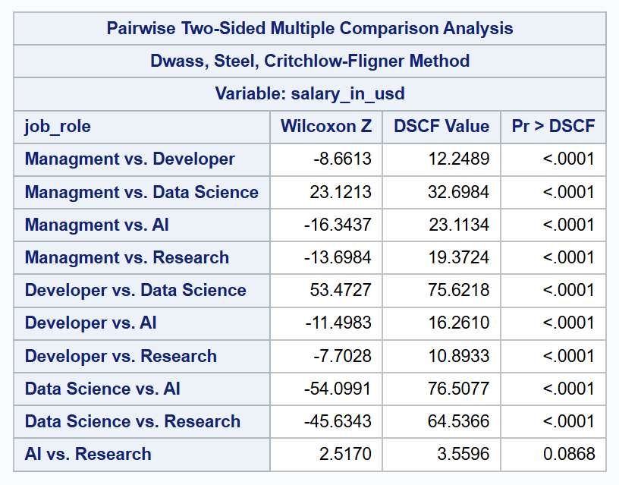
The pairwise test shows that the AI V Research comparison is not significantly different, but all other comparisons are significantly different.

Conclusions

Possible further Question

