**Secure a Network Using Cisco Security Features**

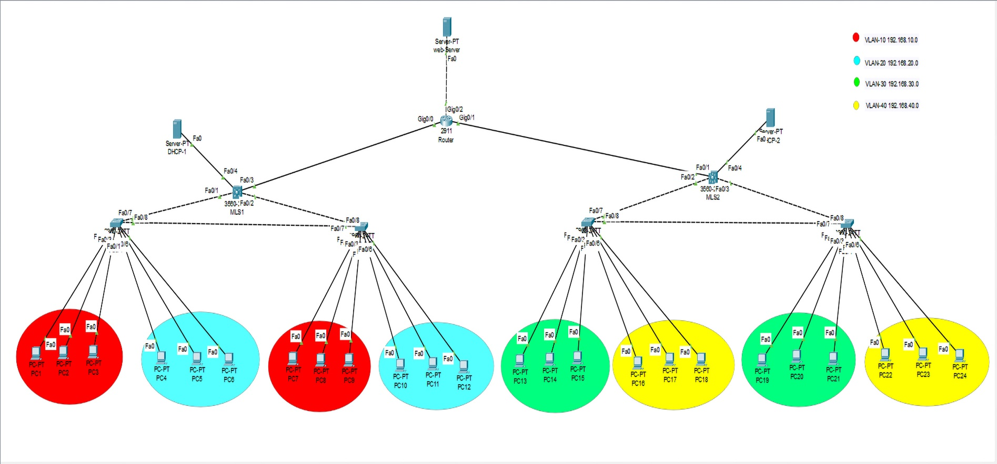

**Overview**

The goal is to ensure efficient communication between different VLANs while maintaining security through various mechanisms such as

1. ACLs
2. DHCP Snooping
3. Dynamic ARP Inspection (DAI)
4. Port Security
5. IP source guard

And

1. Disable CDP on ports connected to end device
2. use NTP
3. SSH
4. Make passwords

**VLAN and IP Assignments**

1. **VLAN 10:**
   * **Switch 1:** Ports f0/1-3
   * **Switch 2:** Ports f0/1-3
   * **Subnet:** 192.168.10.0/24
2. **VLAN 20:**
   * **Switch 1:** Ports f0/4-6
   * **Switch 2:** Ports f0/4-6
   * **Subnet:** 192.168.20.0/24
3. **VLAN 30:**
   * **Switch 3:** Ports f0/1-3
   * **Switch 4:** Ports f0/1-3
   * **Subnet:** 192.168.30.0/24
4. **VLAN 40:**
   * **Switch 3:** Ports f0/4-6
   * **Switch 4:** Ports f0/4-6
   * **Subnet:** 192.168.40.0/24

**DHCP Servers**

* **On VLAN 100 : IP Address:** 192.168.100.2

**-VLAN 10 pool :**

**Default-gateway:** 192.168.10.1

**Start IP: 192.168.10.4**

**Subnet-Mask: 255.255.255.0**

**Maximum number of users : 32**

**-VLAN 20 pool :**

**Default-gateway:** 192.168.20.1

**Start IP: 192.168.20.4**

**Subnet-Mask: 255.255.255.0**

**Maximum number of users : 32**

* **On VLAN 101 : IP Address:** 192.168.101.2

**-VLAN 30 pool :**

**Default-gateway:** 192.168.30.1

**Start IP: 192.168.30.4**

**Subnet-Mask: 255.255.255.0**

**Maximum number of users : 32**

**-VLAN 40 pool :**

**Default-gateway:** 192.168.40.1

**Start IP: 192.168.40.4**

**Subnet-Mask: 255.255.255.0**

**Maximum number of users : 32**

**Management VLANs (SSH Access)**

* **VLAN 5:** Switch 1 SSH - IP Address: 192.168.5.2
* **VLAN 6:** Switch 2 SSH - IP Address: 192.168.6.2
* **VLAN 7:** Switch 3 SSH - IP Address: 192.168.7.2
* **VLAN 8:** Switch 4 SSH - IP Address: 192.168.8.2

**Loopback Addresses for SSH**

* **MLS1 Loopback:** SSH IP Address: 192.168.2.1
* **MLS2 Loopback:** SSH IP Address: 192.168.3.1
* **Router Loopback:** SSH IP Address: 192.168.4.1

**Interconnect Networks**

* **Between MLS1 and Router:** Subnet 10.10.10.0/24
* **Between MLS2 and Router:** Subnet 10.10.20.0/24
* **Router and Web Server:**
  + **Router IP:** 30.0.0.1
  + **Web Server IP:** 30.0.0.2

**Router IDs**

* **MLS1 Router ID:** 50.0.0.1
* **MLS2 Router ID:** 60.0.0.1
* **Main Router ID:** 70.0.0.1

**OSPF**

* **OSPF Configuration** between MLS1, Router and MLS2.

**Default static route:**

Configured for potential future use : serial0/0/0 is used

**VLANs and routing:**

SW1(config)#vlan 10

SW1(config)#vlan 20

SW1(config)#vlan 5

SW1(config)#ip default-gateway 192.168.5.1

SW1(config)#int vlan 5

SW1(config-if)#ip address 192.168.5.2 255.255.255.0

SW1(config)#interface range f0/1-3

SW1(config-if-range)#switchport mode access

SW1(config-if-range)#switchport access vlan 10

SW1(config)#interface range f0/4-6

SW1(config-if-range)#switchport mode access

SW1(config-if-range)#switchport access vlan 20

SW1(config)#interface range f0/7-8

SW1(config-if-range)#switchport mode trunk

**Apply similar configurations on SW2 but on SW3,4 change vlans**

MLS1(config)#ip routing

MLS1 (config)#vlan 5

MLS1 (config)#vlan 6

MLS1(config)#vlan 10

MLS1(config)#vlan 20

MLS1(config)#vlan 100

MLS1(config)#int vlan 5

MLS1(config-if)#ip address 192.168.5.1 255.255.255.0

MLS1(config)#int vlan 6

MLS1(config-if)#ip address 192.168.6.1 255.255.255.0

MLS1(config)#int vlan 10

MLS1(config-if)#ip address 192.168.10.1 255.255.255.0

MLS1(config-if)#ip helper-address 192.168.100.2

MLS1(config)#no shutdown

MLS1(config-if)#int vlan 20

MLS1(config-if)#ip address 192.168.20.1 255.255.255.0

MLS1(config-if)#ip helper-address 192.168.100.2

MLS1(config-if)#no shutdown

MLS1(config-if)#int vlan 100

MLS1(config-if)#ip address 192.168.100.1 255.255.255.0

MLS1(config-if)#int f0/4

MLS1(config-if)#switchport mode access

MLS1(config-if)#switchport access vlan 100

MLS1(config-if)#int rang f0/1-2

MLS1(config-if-range)#switchport mod trunk

MLS1(config-if)#int loopback 1

MLS1(config-if)#no shutdown

MLS1(config-if)#ip address 192.168.2.1 255.255.255.0

MLS1(config-if-range)#int f0/3

MLS1(config-if)#no switchport

MLS1(config-if)#ip address 10.10.10.2 255.255.255.0

MLS1(config-if)#no shutdown

**Apply similar configurations on MLS2 but change vlans and ip**

**OSPF**

MLS1(config)#router ospf 1

MLS1(config-router)#router-id 50.0.0.1

MLS1(config-router)#network 192.168.5.0 0.0.0.255 area 0

MLS1(config-router)#network 192.168.6.0 0.0.0.255 area 0

MLS1(config-router)#network 192.168.10.0 0.0.0.255 area 0

MLS1(config-router)#network 192.168.20.0 0.0.0.255 area 0

MLS1(config-router)#network 192.168.2.0 0.0.0.255 area 0

MLS1(config-router)#network 10.10.10 0 0.0.0.255 area 0

**Apply similar configurations on MLS2 and Router but by its networks**

**Default Static Route:**

MLS1(config)#ip route 0.0.0.0 0.0.0.0 f0/3

MLS2(config)#ip route 0.0.0.0 0.0.0.0 f0/1

**Security Configuration**

**DHCP Snooping**

**To mitigate the risk of rogue DHCP servers, DHCP Snooping is enabled on the layer 2 switches:**

* **SW4 Configuration:**

SW4(config)#ip dhcp snooping

SW4(config)#ip dhcp snooping vlan 30,40

SW4(config)#int f0/7

SW4(config-if)#ip dhcp snooping trust

SW4(config)#int range f0/1-6

SW4(config-if-range)#ip dhcp snooping limit rate 4

SW4(config)#no ip dhcp snooping information option

* **Repeat similar configuration for SW1,SW2,SW3**

**MLS DHCP Snooping**

On the MLS:

MLS2(config)#ip dhcp snooping

MLS2(config)#ip dhcp snooping vlan 30,40,101

MLS2(config)#int f0/4

MLS2(config-if)#ip dhcp snooping trust

**Apply similar configurations on MLS1**

**Dynamic ARP Inspection (DAI)**

**Enable ARP Inspection based on the DHCP Snooping Binding Table to prevent ARP spoofing attacks:**

SW1(config)#ip arp inspection vlan 10,20

SW4(config)#ip arp inspection vlan 30,40

**Apply similar configurations on SW2 and SW3**.

**NTP Configuration**

Enable Network Time Protocol (NTP) to ensure time synchronization across devices:

Router(config)#ntp master 1

Router# clock set hh:mm:ss Day Month Year

…….

SW1(config)#ntp server [Router Loopback IP]

**Repeat similar configuration for all network devices**

**Port Security Configuration**

Implement Port Security to limit the number of MAC addresses per port:

SW1(config)#int range f0/1-6

SW1(config-if-range)#switchport port-security

SW1(config-if-range)#switchport port-security maximum 1

SW1(config-if-range)#switchport port-security mac-address sticky

SW1(config-if-range)#switchport port-security violation shutdown

* **Repeat for SW2, SW3, and SW4.**

**ACL Configurations**

1. **Only permit vlan10 to access other devices via ssh**

SW1(config)#ip access-list extended ssh

SW1(config-ext-nacl)#permit tcp 192.168.10.0 0.0.0.255 any eq 22

SW1(config-ext-nacl)#den tcp any any eq 22

SSW1(config-ext-nacl)#permit ip any any

**Apply ACL to VLAN interfaces:**

SW1(config)#line vty 0 4

SW1(config-line)#access-class ssh in

**- Apply similar configurations on all network devices**

1. **Deny VLAN 30 from Reaching Web Server**

MLS2(config)#ip access-list extended deny-vlan30-web

MLS2(config-ext-nacl)#deny tcp 192.168.30.0 0.0.0.255 host 30.0.0.2 eq 80

MLS2(config-ext-nacl)#deny tcp 192.168.30.0 0.0.0.255 host 30.0.0.2 eq 443

MLS2(config-ext-nacl)#permit ip any any

**Apply ACL to VLAN 30 interface:**

MLS2(config)#int vlan 30

MLS2(config-if)#ip access-group deny-vlan30-web in

**Additional Configurations**

**CDP Configuration**

Disable CDP on selected interfaces to enhance security:

SW1(config)#int range f0/1-6

SW1(config-if-range)#no cdp enable

* **Repeat for SW2, SW3, SW4, and Router g0/2.**

**Passwords:**

SW4(config)#enable secret Cisco2@#

SW4(config)#line console 0

SW4(config-line)#password Cisco1@#

SW4(config-line)#login

SW4(config)#service password-encryption

**Apply similar configurations on all network devices**

**SSH**

SW4(config)#username cisco secret Cisco3@#

SW4(config)#ip domain-name cisco.com

SW4(config)#crypto key generate rsa

1024

SW4(config)#line vty 0 4

SW4(config-line)#login local

SW4(config-line)#transport input ssh

**Apply similar configurations on all network devices**

**IP Source Guard**

To prevent IP spoofing, enable IP Source Guard on access ports:

SW1(config)#int range f0/1-6

SW1(config-if-range)#ip verify source