USING DATABASES FINAL PROJECT

Emmanuelle Isis Mbeugmo Manekeu
Mounsif Ed-Daoudi

420-350-LE: Using Databases
Caroline Fortier
08 December 2025

B- CRUD OPERATIONS
Create and demonstrate the full set of read, insert, update, and delete operations.
Required operations:
- Insert new menu items

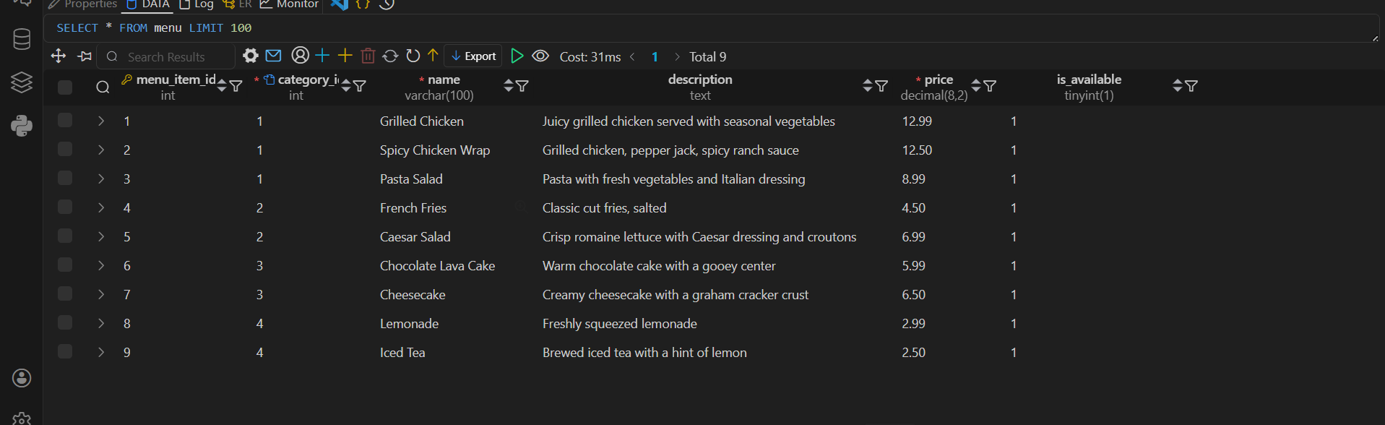
- Update prices
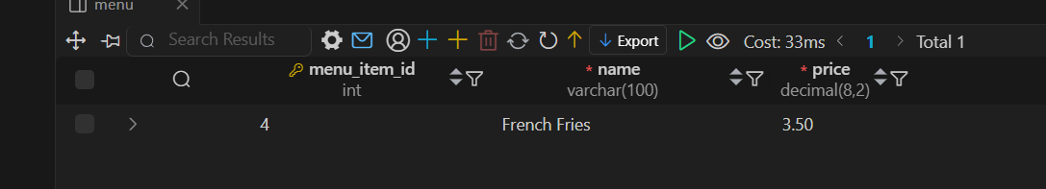
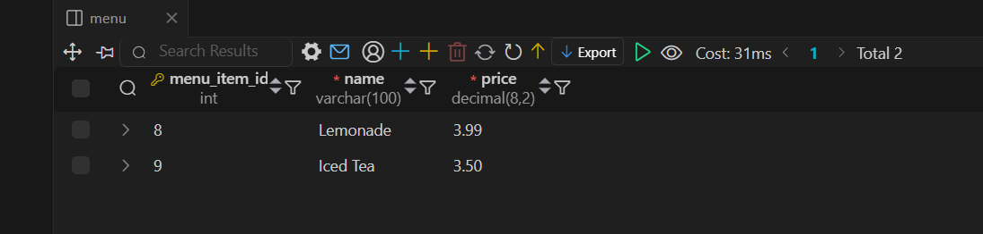
- Remove discontinued dishes
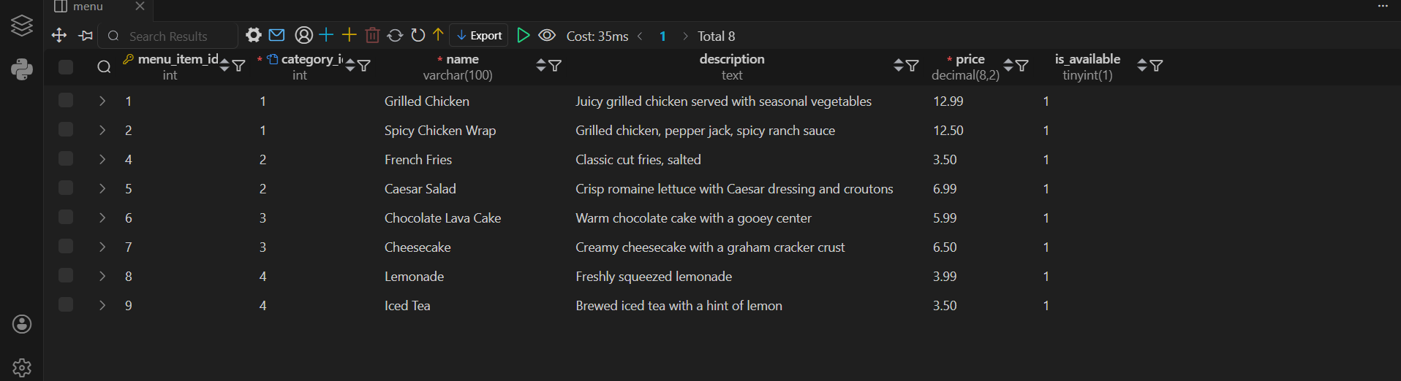
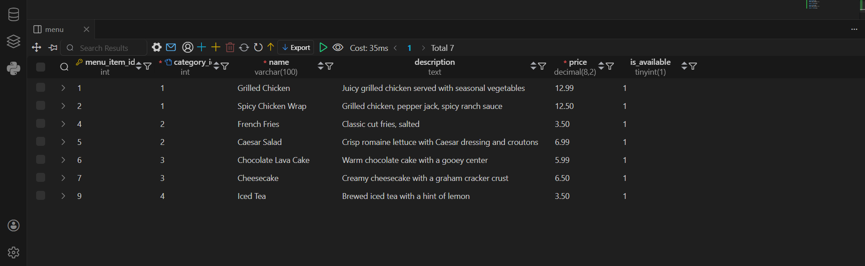
- Place a new order with multiple items
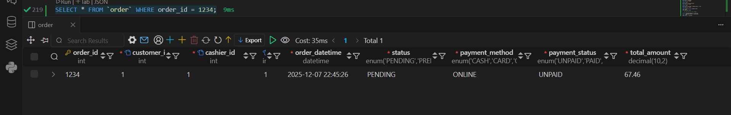
- Assign a delivery driver
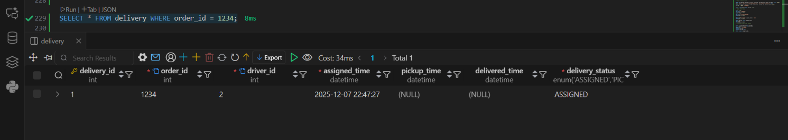
- Update order status
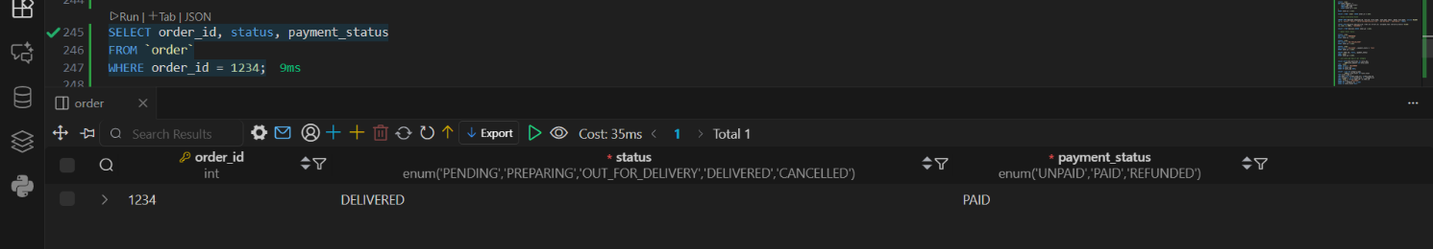
- List sales per day or per category
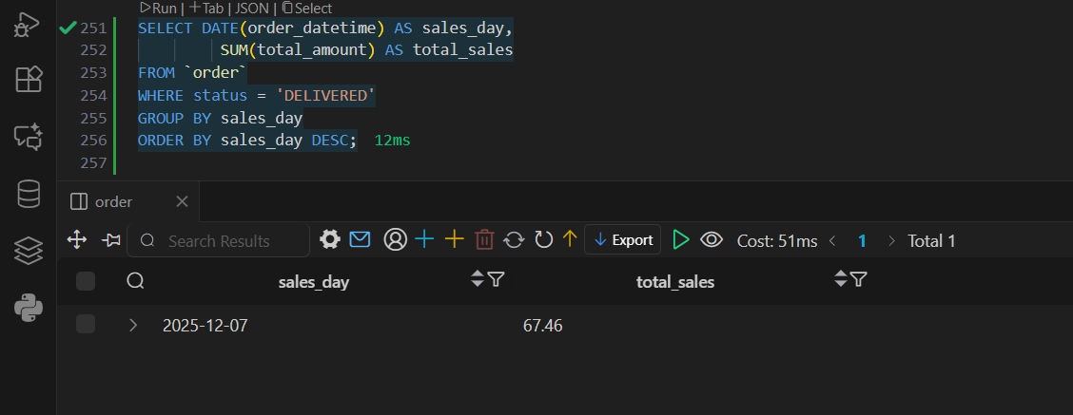
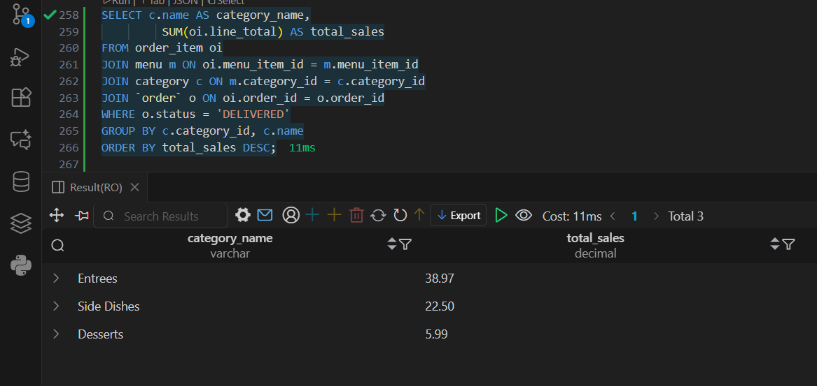
- Delete an order (only if permitted by business rules)

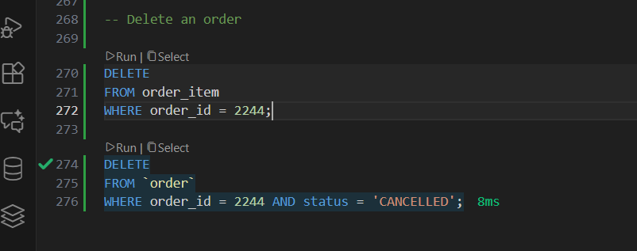
C - Confidentiality, Authorization & Integrity
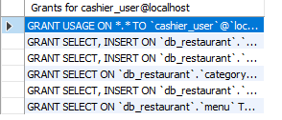
SHOW GRANTS FOR cashier_user:

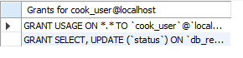
SHOW GRANTS FOR cook_user:
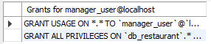
SHOW GRANTS FOR manager_user:

Screenshots of 1 successful and failed operations for every user:
Cashier:
Success:
It worked because we gave the user the privilege to select and insert in the customer table.
Failed:
We did not give the permission to update customer, so it did not work.
Cook:
Success:
This user has the privilege to see whats in the order table so it worked successfully.
Failed:
It failed because he doesn’t have the previlege to DELETE in the order table.
Manager:
Success:
This user has all privileges so it worked successfully.
Failed: No fail, manager has all privileges.

D — Stored Procedures & Automated Operations
You must implement at least three stored procedures or functions, such as:
- Calculate total order price (Function)
Code: 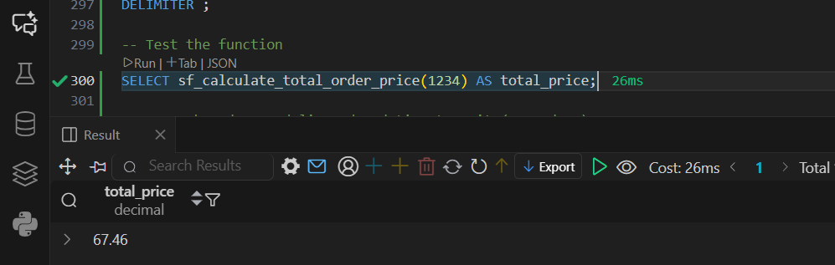
We use deterministic because we want the function to always return the same result for the same set of input values.
- Validate if an order can be cancelled
Code:
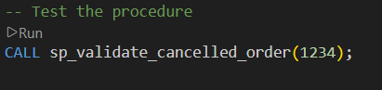
- Mark order as delivered and timestamp it
Code:
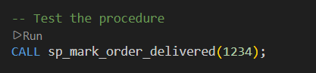

E — Triggers
Create at least two triggers. Examples:
- Automatically update inventory when an item is ordered
To test the trigger, you need to create a new order and update the order_item quantity, so that the current quantity in the inventory will change when you run the trigger.
Code:
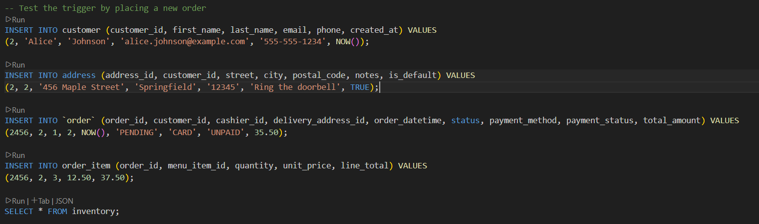

- Prevent deletion of a menu item that is used in existing orders
To test the trigger, we attempt to delete a menu item used in an order and if yes, the MySQL shows an error message saying, “Cannot delete menu item as it is associated with existing orders.”
Code:
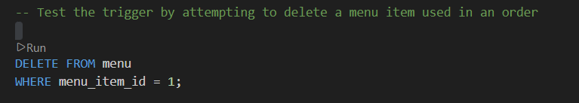

F — Backup & Restore
Commands used: mysqldump -u root -p db_restaurant > db_restaurant_backup.sql
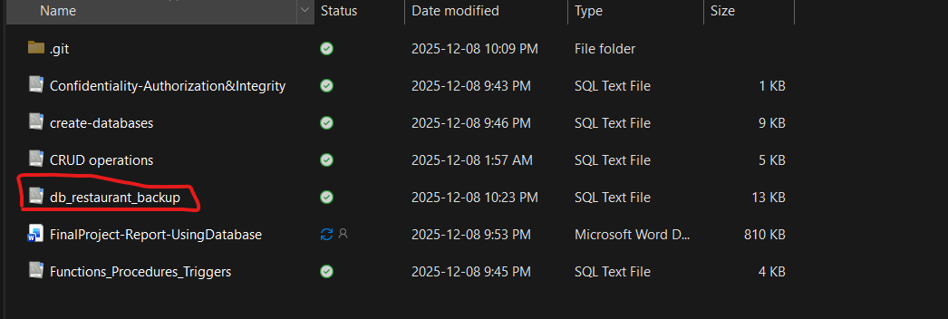
Screenshot of the file:

First 20 lines of the SQL dump:
-- MySQL dump 10.13 Distrib 8.0.44, for Win64 (x86_64)
--
-- Host: localhost Database: db_restaurant
-- ------------------------------------------------------
-- Server version 8.0.44

/*!40101 SET @OLD_CHARACTER_SET_CLIENT=@@CHARACTER_SET_CLIENT */;
/*!40101 SET @OLD_CHARACTER_SET_RESULTS=@@CHARACTER_SET_RESULTS */;
/*!40101 SET @OLD_COLLATION_CONNECTION=@@COLLATION_CONNECTION */;
/*!50503 SET NAMES utf8mb4 */;
/*!40103 SET @OLD_TIME_ZONE=@@TIME_ZONE */;
/*!40103 SET TIME_ZONE='+00:00' */;
/*!40014 SET @OLD_UNIQUE_CHECKS=@@UNIQUE_CHECKS, UNIQUE_CHECKS=0 */;
/*!40014 SET @OLD_FOREIGN_KEY_CHECKS=@@FOREIGN_KEY_CHECKS, FOREIGN_KEY_CHECKS=0 */;
/*!40101 SET @OLD_SQL_MODE=@@SQL_MODE, SQL_MODE='NO_AUTO_VALUE_ON_ZERO' */;
/*!40111 SET @OLD_SQL_NOTES=@@SQL_NOTES, SQL_NOTES=0 */;

--
-- Table structure for table `address`
--

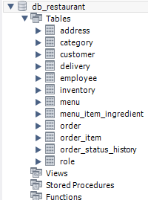
Restore Success:
Steps to make the restoration a success:
After Droping the database, we had to create another empty one. Then, we used this command: mysql -u root -p db_restaurant < db_restaurant_backup.sql. It used the backup file to restore the database in the empty one.

