DSR versus NRR Survival Analysis

Kevin E. See1, Michael W. Ackerman2,✉, Nick Porter3,✉, Mike Hall3, and Richie Carmichael3

12 June, 2022

1 Washington Department of Fish and Wildife, Fish Program, Science Division, 1111 Washington Street NE, Olympia, Washington, 98501, USA  
2 Mount Hood Environmental, PO Box 4282, McCall, Idaho, 83638, USA  
3 Biomark, Inc., 705 South 8th Street, Boise, Idaho, 83702, USA

✉ Correspondence: [Michael W. Ackerman <[mike.ackerman@mthoodenvironmental.com](mailto:mike.ackerman@mthoodenvironmental.com)>](mailto:mike.ackerman@mthoodenvironmental.com), [Nick Porter <[Nicholas.Porter@merck.com](mailto:Nicholas.Porter@merck.com)>](mailto:Nicholas.Porter@merck.com)

# Introduction

There are two dominant life history strategies employed by spring-summer Chinook salmon spawned in the Lemhi River; downstream rearing (DSR or smolt) and natal reach rearing (NRR or smolt) (Copeland et al. 2014). The DSR migrants leave their natal area as subyearlings between June and November and typically overwinter in downstream, mainstem habitats until the following spring when they emigrate to the ocean as smolts. Alternatively, NRR migrants remain in their natal areas for approximately one year after emergence until emigration to the ocean as smolts. Both life history types reach Lower Granite Dam in the spring, and subsequently move to the ocean.

Recently, the DSR life history has dominated within the Lemhi River population i.e., they are more abundant at the lower Lemhi rotary screw trap (RST). It is unclear whether their abundance is a result of local adaptation where DSR fish have a survival advantage, or the result of habitat degradation within the Lemhi River leading to limited rearing habitat during winter months and thereby preventing the NRR type. Here, we explore the abundance, emigration timing, and survival between the two strategies across several brood years, attempting to compare the relative success of one versus the other.

## Objectives

* Estimate the abundance of each life history strategy (DSR and NRR), by brood year.
  + We hypothesize DSR are more abundant than NRR.
* Estimate timing of arrival at LGR and BON.
  + We expect DSR arrive sooner to LGR and BON, suggesting an earlier ocean entry.
* Estimate survival of each life history strategy to LGR, by brood year.
  + We hypothesize NRR survival > DSR survival, but because NRR emigrants already survived winter i.e., DSR survival includes winter mortality.
* Estimate LGR to BON SARs for DSR versus NRR life history strategies.
  + We hypothesize SARs to be roughly equal unless DSRs do have a much earlier ocean entry, then perhaps DSRs have a higher SAR.
* If possible, estimate adult recruitment to the Lemhi River for DSR and SRR.
  + We expect that DSR adult escapement is greater than NRR adult escapement, but largely due to a numerical advantage (i.e., greater juvenile abundance).

# Methods

## Mark Data

We compiled a list of all PIT tags deployed within the Lemhi River using two PTAGIS queries. The first was a “Tagging Details” query, with filters set such that the mark subbasin is Lemhi, capture method is screw trap, species is Chinook, and mark year is 1986-2020. We filtered these results further to focus on fish tagged at the lower Lemhi RST, which are assumed to be emigrating out of the Lemhi River, by focuing on mark site codes “LEMHIR” or “LLRTP” (the former was used prior to 2016) and filtering out any tags released at LEMHIW (the upper Lemhi RST). The second was a “Recapture Details” query, with similar filters set: mark subbasin is Lemhi, capture method is screw trap, species is Chinook, and recap year is 1986-2020. Again, we further refined these results by filtering for recapture site code of “LEMHIR” or “LLRTP”, and recapture released that were not released at LEMHIW.

These two queries often resulted in tags showing up in both the mark and recapture lists. For tags recaptured within a week of marking, we used the mark date as the starting point, but for fish recaptured more than a week after marking (sometimes months later) we used the maximum recapture date to indicate when we believe that fish left the Lemhi River.

We further filtered our fish that were less than 25 mm or greater than 200 mm as these seemed to be either fry, precocials, or errant sizes, and thus, were not assigned to the DSR or NRR strategies. Generally, parr and presmolts were classified as DSR whereas smolts were classified as NRR. Size and time of capture were used to differentiate smolts and parr as DSR or NRR during the spring period when both migratory types were captured concurrently (Figure 1). DSR fish were assigned a brood year on year prior to their emigration date in the fall, and NRR fish were assigned a brood year two years prior. The number of tags assigned to each brood year and emigrant strategy are shown in Table 1.

Table 1: Number of PIT tags deployed at Lower Lemhi rotary screw trap by brood year and life history type.

Brood Year

DSR

NRR

2004

1,178

62

2005

1,366

56

2006

694

98

2007

1,634

127

2008

1,055

323

2009

2,096

799

2010

977

0

2011

96

3,554

2012

2,118

1,272

2013

3,121

2,550

2014

4,905

2,580

2015

3,510

2,275

2016

4,927

1,531

2017

3,202

1,667

2018

3,325

1,742

2019

3,814

0

Total

38,018

18,636

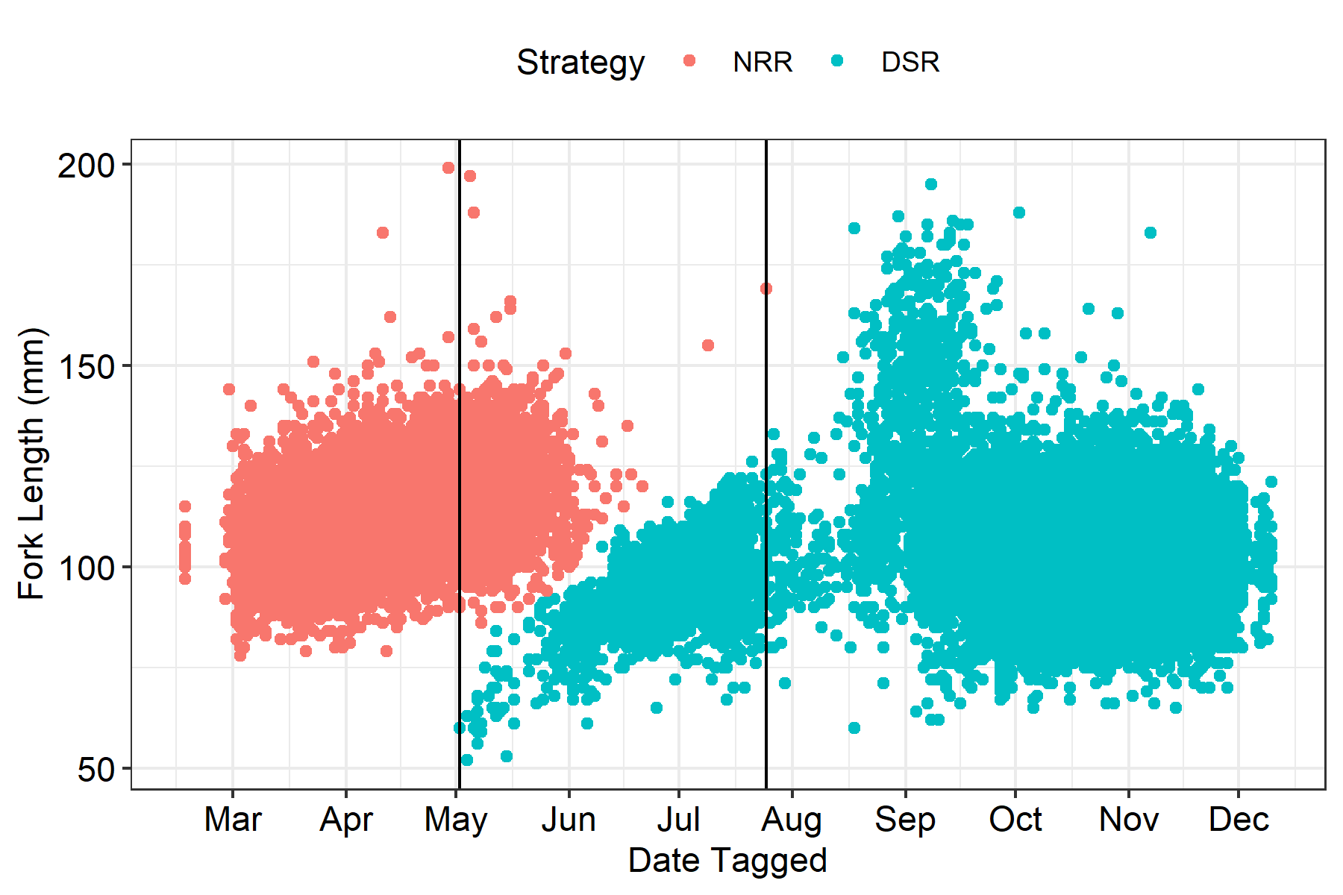

Figure 1: Separation of natal-reach rearing (NRR) and downstream-rearing (DSR) types of Chinook salmon based on length and time of capture at the lower Lemhi rotary screw trap, brood years 2004-2019. Vertical lines indicate the period of time when the two strategies overlapped.

## Abundance

Estimates of emigrant abundance at the lower Lemhi River rotary screw trap (LLRTP) by brood year and life stage were provided by the Idaho Department of Fish and Game (S. Meyer, personal communication, April 4, 2022) which were summarized from annual reports (e.g., Poole et al. 2019; Feeken et al. 2020; McClure et al. 2021). Detailed methods are provided by Copeland et al. (2021). Briefly, the spring trapping period occurs through June 30 and is dominated by age-1 smolts which will be emigrating past Lower Granite Dam and Bonneville Dam the same year. Age-0 fry can also be captured during the spring period, but are differentiated from smolts based on size. The summer parr period is July 1 through August 31. The fall presmolt period is September 1 through the end of the year. Seasonal abundance by life stage are calculated by stratifying fish into smaller date ranges based on recapture efficiency of the trap and processing the strata in R statistical software (R Core Team 2021).

Emigrant abundance estimates from trap operations were estimated using the stratified Lincoln-Peterson estimator with Bailey’s modification:

where is the estimate of abundance in a given season or year, is season, is the number of all unique fish captures in season , is the number of tagged fish released in season , and is the number of recaptures in season (Bailey 1951). The estimator is computed using an interative maximization of the log likelihood (Steinhorst et al. 2004). The method assumes that fish are captured independently with probability (equivalent to trap efficiency) and tagged fish mix thoroughly with untagged fish. The 95% confidence intervals were computed using 10,000 bootstraps (Steinhorst et al. 2004). Emigrant abundance estimates do not account for periods where the trap was not in operation. DSR abundance includes both parr and presmolt abundance whereas NRR abundance includes only smolts.

## Body Condition

We investigated differences in fork length (mm) and Fulton’s body condition factor (Fulton 1904) between DSR and NRR Chinook salmon captured at the lower Lemhi rotary screw trap (LLRTP). Fulton’s body condition factor is estimated as:

where is the weight in grams and is the fork length of the fish in millimeters. is a constant for normalizing within reasonable values; we used an which is typical for salmonids.

## Arrival Timing

We also investigate the difference in arrival timing between DSR and NRR Chinook salmon to Lower Granite Dam as juveniles, to Bonneville Dam as juveniles, and further, back to Bonneville Dam as adults. Our assessment of arrival timing relies on tags that were detected at GRJ, BOJ, or BON, respectively. We converted the dates of detection to Julian day, and calculated the mean arrival day for each life-history strategy and brood year combination. We then estimated the mean arrival day of each strategy across all brood years. For arrivals at Bonneville, detections were based only observations at Bonneville Dam, not using the consolidated nodes as described in the Survival section. We hypothesize that DSR juveniles will arrive to LGR and BOJ sooner due to starting closer to those locations in the spring; however, we expect no difference in arrival timing of adults to Bonneville Dam after their duration in the ocean.

## Survival

We estimated survival with a Cormack-Jolly-Seber (CJS) model (Lebreton et al. 1992). We initially included some detections from dams between Lower Granite and Bonneville, but decided to drop them instead to ease the interpretation of results. We included detections from the floowing sites or “nodes”:

* LLRTP (lower Lemhi River screw trap)
* GRJ (juvenile detections at Lower Granite)
* BOJ (juvenile detections at Bonneville)
* BON (adult detections at Bonneville)
* GRA (adult detections at GRA)
* above_GRA (any adult detection upstream of GRA)

We included “above_GRA” so we could estimate survival and detection to GRA, since the last survival and detection parameters are confounded in a CJS model. We now had a capture history for every tag consisting of 6 columns, each representing a node. We also had an assigned life-history strategy (DSR or NRR) for each tag. A CJS model was then fit for each brood year and strategy combination independently using the rstan package (Stan Development Team 2022) in R (R Core Team 2021). Each CJS model estimated separate survival () and detection () parameters for each life stage between or at each node. This resulted in ’s and ’s, as the *GRA-to-above_GRA* and *above_GRA* are confounded, and the at *LLRTP* is essentially fixed at 100%.

To examine the relative success of each life-history, we computed the log odds ratios of several combinations of ’s, including:

* Survival between LLRTP and GRJ
* Survival between GRJ and BOJ
* Survival between LLRTP and BOJ ()
* Survival between LLRTP and BON ()
* Survival between LLRTP and GRA ()
* SAR for GRJ-to-BON ()
* SAR for GRJ-to-GRA ()

The log odds ratio of any combination of survival parameters is computed as

Because we constructed these with DSR ’s in the numerator, log odds ratios less than zero indicate a higher relative survival for NRR fish, which if it is greater than zero that indicates greater relative survival for DSR fish. When these log odds ratios are exponentiated, they provide a measure of the relative success for DSR fish compared to NRR fish. For example, if the log odds ratio is 0.693, then indicating that DSR fish have about double the survival of NRR fish in that particular metric.

## Smolt-to-Adult Return Rates (SAR)

We anticipated that the survival between LLRTP and GRJ would be higher for smolts, because they spend much less time in that stretch of river. DSR fish alternatively overwinter in the mainstem Salmon and Snake rivers, and their survival to GRJ includes that overwinter survival, while NRR fish’s survival does not account for their overwinter survival in the Lemhi River. Therefore, we wanted to examine a few survivals that excluded that initial stretch of river. Assuming that a fish arrives at Lower Granite Dam as a juvenile, what are the chances it makes it back to Bonneville Dam as an adult, or back to Lower Granite Dam as an adult? These are the two smolt-to-adult return (SAR) metrics that we calculated.

# Results

## Abundance

Table 2: Estimates of emigrant abundance by life stage and brood year at the lower Lemhi rotary screw trap (LLRTP). Table provided by Idaho Department of Fish and Game (S. Meyer, personal communication, April 4, 2022).

Brood Year

Fry

Parr

Presmolt

Smolt

Total

Total LCI

Total UCI

2004

–

–

–

–

17,728

14,356

21,874

2005

–

–

–

–

16,042

13,297

19,932

2006

–

–

–

–

7,656

6,318

9,426

2007

–

–

–

–

21,001

18,581

23,548

2008

–

–

–

–

16,298

14,126

18,909

2009

–

–

–

–

57,301

49,763

66,387

2010

–

–

–

–

–

–

–

2011

–

–

–

16,842

16,842

15,772

17,912

2012

–

–

15,307

6,519

21,825

20,343

23,307

2013

–

–

17,056

14,440

31,496

29,519

33,473

2014

–

2,878

56,436

19,186

79,130

75,404

82,856

2015

–

862

52,523

11,964

65,349

61,616

69,082

2016

–

965

51,025

7,688

51,991

49,400

54,580

2017

51

101

14,944

6,070

21,167

20,198

22,390

2018

1,084

298

37,900

8,978

46,822

42,161

53,631

2019

136

35

24,366

13,804

38,341

35,855

41,748

Table 2: Estimates of emigrant abundance by emigrant strategy and brood year at the lower Lemhi rotary screw trap (LLRTP). DSR emigrant abundances for brood years 2012 and 2013 do not include parr abundance estimates, which were unavailable.

Brood Year

DSR

NRR

DSR (%)

NRR (%)

2012

15,307

6,519

70.1

29.9

2013

17,056

14,440

54.2

45.8

2014

59,314

19,186

75.6

24.4

2015

53,385

11,964

81.7

18.3

2016

51,990

7,688

87.1

12.9

2017

15,045

6,070

71.3

28.7

2018

38,198

8,978

81.0

19.0

2019

24,401

13,804

63.9

36.1

Total

274,696

88,649

75.6

24.4

The DSR life history was more abundant for all years in which abundance by life history was available (Table 2). The percent of DSR ranged from a minimum of 54.2% in BY2013 to a maximum of 87.1% in BY2016. Again, these abundances do not account for periods in which the trap was not in operation due to high flows, icing events, etc. and so estimates of percent DSR or NRR may be biased to an unknown degree.

## Body Condition

In every case, NRR juveniles were longer; however, DSR juveniles often had a greater factor (Figure 2).

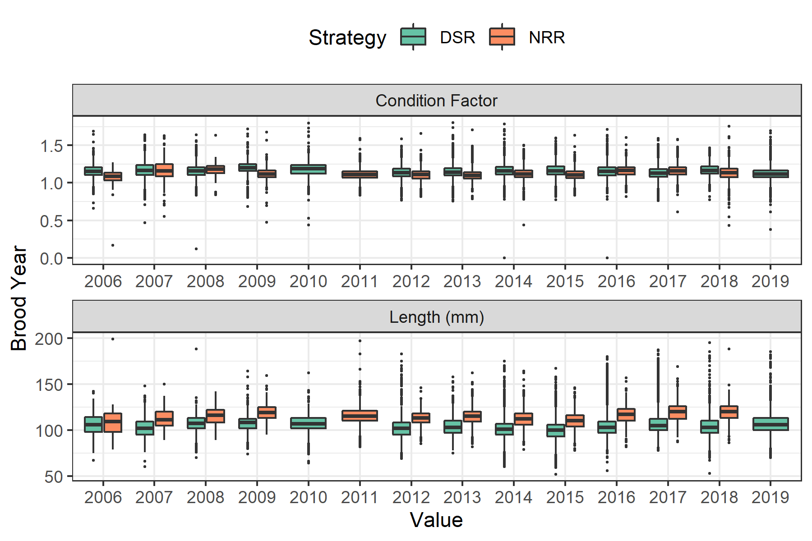

Figure 2: Boxplots showing the condition factor and length (mm) among brood years, colored by life history strategy.

## Arrival Timing

DSR juveniles arrive at both Lower Granite Dam and Bonneville Dam at an earlier date than NRR juveniles for all brood years in which comparisons were available (Figure 3). Comparisons were not possible for brood years 2010 and 2011. However, that relationship did not hold for arrival timing of adults to Bonneville Dam after freshwater entry. For the 10 brood years in which comparisons were made, DSR adults arrived sooner at Bonneville Dam in six years whereas NRR adults arrived sooner in four.

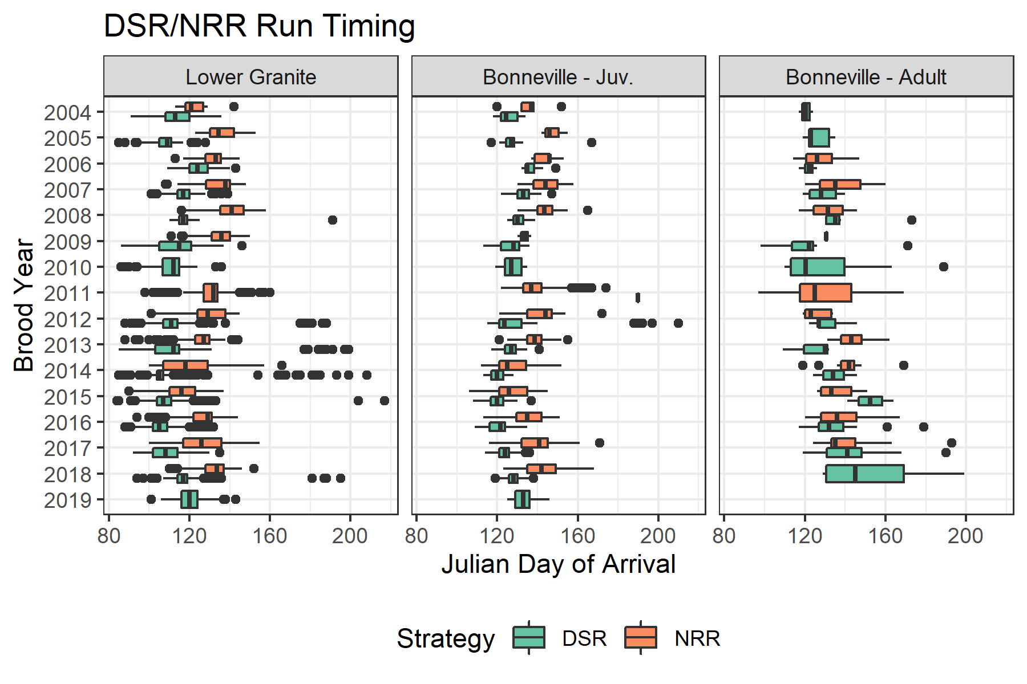

Figure 3: Boxplots showing the range of arrival timing to Lower Granite as juveniles, Bonneville as juveniles and Bonneville again as adults, colored by life history strategy.

On average, DSR juveniles from the Lemhi River arrived at Lower Granite Dam 15 days earlier and at Bonneville Dam a week earlier than NRR juveniles (Table 3). However, the difference was only 2 days for adults at Bonneville Dam after freshwater entry. Differences in adult arrival timing at Bonneville Dam could potentially be influence by ocean-age composition differences in the strategies; however, we did not account for those here.

Table 3: Mean Julian day of arrival at a few locations by strategy, and the difference in days.

Location

DSR

NRR

Difference (days)

Lower Granite

114

129

15

Bonneville - Juv.

132

138

7

Bonneville - Adult

133

135

2

## Survival

Juvenile NRR emigrants from the Lemhi River survived at a higher rate than DSR juveniles to Lower Granite Dam for all brood years where comparisons were possible except for BY2008 (upper-left facet, Figure 4) which was expected because NRR survival rates do not include mortality during winter months. However, differences in survival were less apparent for juveniles between Lower Granite Dam and Bonneville Dam where NRR emigrants had greater survival for only 7 of 12 brood years where comparisons were available (upper-right facet, Figure 4). NRR juveniles appeared to have higher ocean survival in earlier years (BY2004 - 2009), but differences are less apparent in BY2012 and after (lower-left facet, Figure 4)

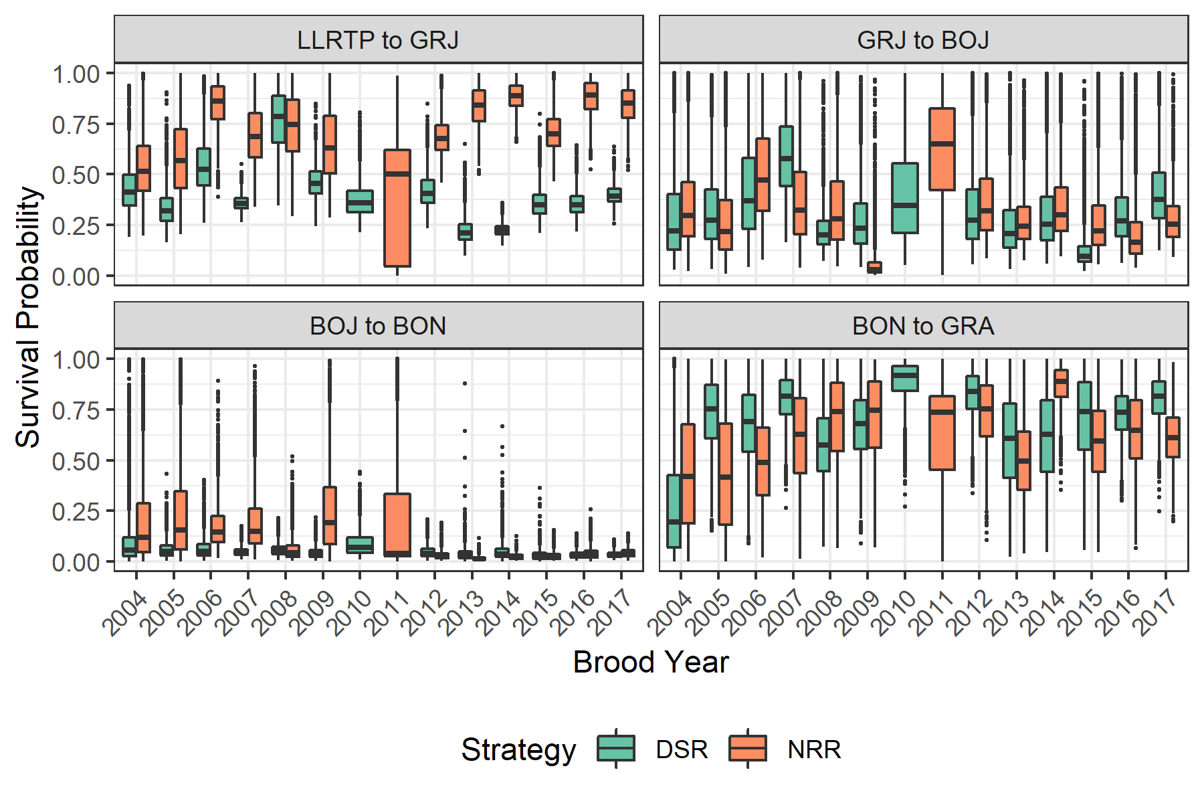

Figure 4: Boxplots showing posteriors of survival probability between detection sites, colored by life history. Boxes represent the middle 50% of the posterior draws and the median is shown by the bisecting line. Whiskers show range of values within 1.5 times the interquartile range. Outliers are represented by points.

The NRR life-history strategy had higher relative survival from the lower Lemhi River rotary screw trap to GRJ for all brood years except BY2008 (Figure 5, Table 4). The pattern was less apparent looking just at mainstem juvenile survival between GRJ and BOJ; however, evaluating the “entire” juvenile survival from the lower Lemhi River to BOJ, the NRR strategy again had higher relative survival in all years except BY009 (Figure 5, Table 4). Higher relative juvenile survival for the NRR strategy from LLRTP to GRJ and BOJ in most years is likely largely due to NRR juveniles having already survived through winter months.

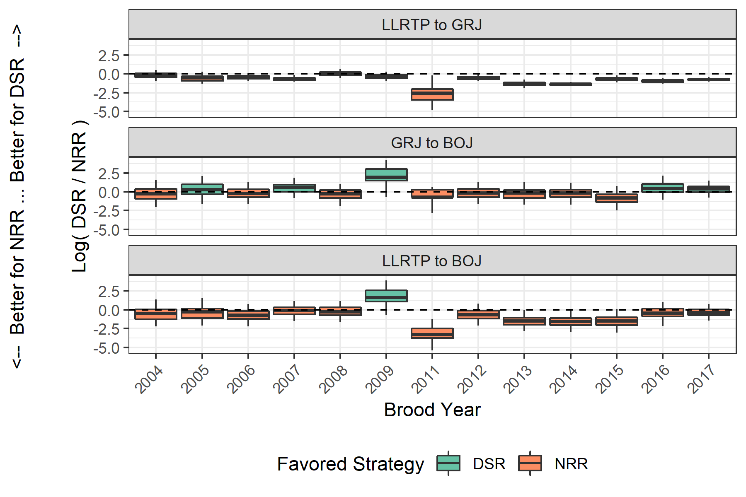

Figure 5: Boxplots of posteriors of log odds ratios of survival between DSR and NRR tags. Values greater than 0 indicate relatively better survival for DSR fish and less than 0 indicates relatively better survival for NRR fish. Color indicates which life history strategy was favored for that brood year. Boxes represent the middle 50% of the posterior draws and the median is shown by the bisecting line. Whiskers show 95% credible intervals.

Table 4: Odds ratio (90% credible interval) of survival between various detection points, comparing DSR to NRR. Values less than 1 indicate NRR has better relative survival, while values greater than 1 favor DSR. Cells in bold show statistically significant differences.

Brood Year

LLRTP to GRJ

GRJ to BOJ

LLRTP to BOJ

2004

0.81 (0.41, 1.51)

0.77 (0.16, 3.6)

0.62 (0.14, 2.9)

2005

0.58 (0.3, 1.19)

1.3 (0.3, 6.93)

0.76 (0.18, 3.62)

2006

0.64 (0.4, 1.03)

0.78 (0.22, 2.88)

0.5 (0.13, 1.71)

2007

0.53 (0.36, 0.76)

1.75 (0.55, 5.62)

0.92 (0.28, 2.83)

2008

1.05 (0.63, 1.76)

0.74 (0.21, 2.49)

0.77 (0.23, 2.48)

2009

0.73 (0.42, 1.21)

7.04 (1.04, 57.48)

5.14 (0.79, 37.01)

2011

0.08 (0.01, 0.51)

0.5 (0.12, 1.94)

0.04 (0.01, 0.18)

2012

0.61 (0.41, 0.91)

0.84 (0.26, 3.18)

0.51 (0.15, 1.82)

2013

0.26 (0.16, 0.43)

0.85 (0.24, 3.26)

0.22 (0.07, 0.82)

2014

0.26 (0.2, 0.32)

0.85 (0.24, 2.82)

0.22 (0.07, 0.83)

2015

0.5 (0.34, 0.71)

0.45 (0.11, 1.67)

0.22 (0.05, 0.73)

2016

0.4 (0.3, 0.56)

1.59 (0.39, 5.9)

0.64 (0.16, 2.29)

2017

0.47 (0.36, 0.6)

1.46 (0.57, 3.78)

0.69 (0.29, 1.78)

Interestingly, daily survival rates were higher for DSR emigrants for 7 of 12 brood years (Figure 6) which is in slight contrast to results for overall juvenile survival to downstream locations.

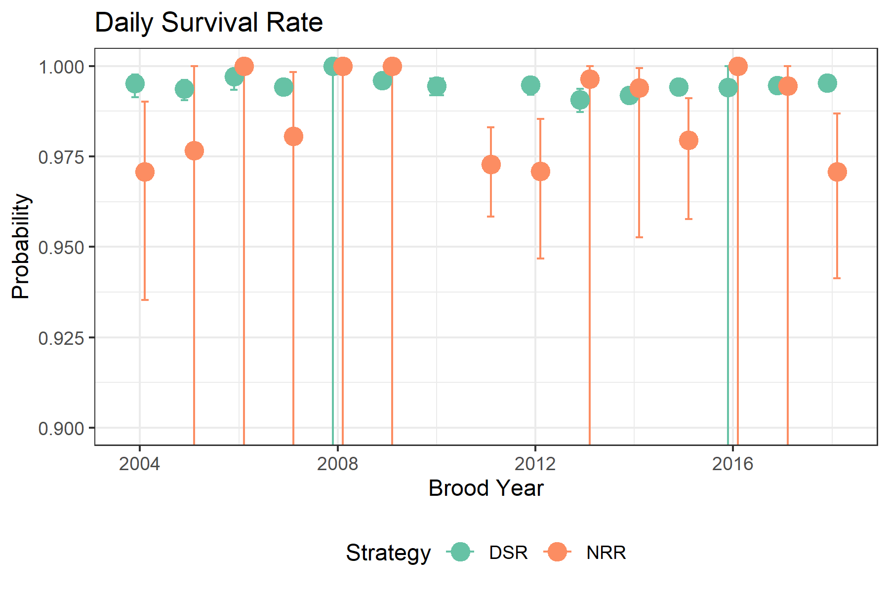

Figure 6: Juvenile survival to Lower Granite Dam between DSR and NRR tags, scaled temporally by days i.e., daily survival rates by brood year for juveniles tagged at the lower Lemhi River rotary screw trap.

## Smolt-to-Adult Return Rates (SAR)

The SARs favored the DSR strategy during early cohorts (BY2004 - BY2008), but NRR emigrants during later cohorts (BY2009 - BY2017) (Figure 7). However, differences were only significant in one case where GRJ -> BON SARs favored the NRR strategy in BY2006 (Table 5).

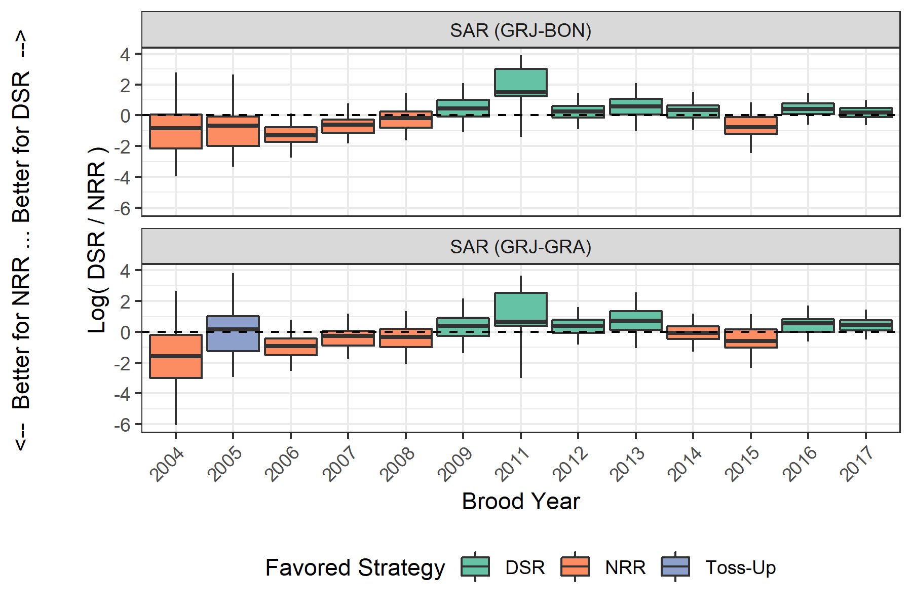

Figure 7: Boxplots of posteriors of log odds ratios of SARs between DSR and NRR tags. Values greater than 0 indicate relatively better survival for DSR fish and less than 0 indicates relatively better survival for NRR fish. Color indicates which life history was favored for that brood year. Boxes represent the middle 50% of the posterior draws and the median is shown by the bisecting line. Whiskers show 95% credible intervals.

Table 5: Odds ratio (90% credible interval) of SARs to BON and GRA, comparing DSR to NRR. Values less than 1 indicate NRR has better relative survival, while values greater than 1 favor DSR Cells in bold show statistically significant differences.

Brood Year

SAR (GRJ-BON)

SAR (GRJ-GRA)

2004

0.44 (0.03, 6.88)

0.21 (0.01, 7.18)

2005

0.51 (0.05, 5.86)

1.19 (0.06, 17.18)

2006

0.27 (0.08, 0.84)

0.4 (0.1, 1.57)

2007

0.54 (0.18, 1.56)

0.77 (0.22, 2.53)

2008

0.84 (0.24, 3.13)

0.7 (0.16, 3.02)

2009

1.54 (0.39, 5.45)

1.49 (0.38, 6.7)

2011

4.53 (0.44, 38.76)

1.91 (0.11, 31.32)

2012

1.29 (0.5, 3.44)

1.48 (0.53, 3.98)

2013

1.76 (0.48, 5.97)

2.05 (0.51, 10.24)

2014

1.43 (0.53, 3.87)

0.94 (0.35, 2.8)

2015

0.46 (0.12, 1.85)

0.55 (0.14, 2.58)

2016

1.5 (0.61, 3.38)

1.76 (0.67, 5.04)

2017

1.2 (0.6, 2.38)

1.59 (0.74, 3.68)

# Discussion

Discussion text to follow…

# Literature Cited

Bailey, N. T. J. 1951. [On Estimating the Size of Mobile Populations from Recapture Data](https://doi.org/10.2307/2332575). Biometrika 38:293–306.

Copeland, T., B. Barnett, W. C. Schrader, K. A. Apperson, L. Janssen, and R. V. Roberts. 2021. Protocols for Trapping Anadromous Emigrants in Idaho. Page 93. IDFG Report Number 21-05.

Copeland, T., D. A. Venditti, and B. R. Barnett. 2014. [The importance of juvenile migration tactics to adult recruitment in stream-type Chinook Salmon populations](https://doi.org/10.1080/00028487.2014.949011). Transactions of the American Fisheries Society 143(6):1460–1475.

Feeken, S. F., B. Barnett, E. Felts, E. J. Stark, M. Davison, J. R. Poole, C. McClure, B. A. Knoth, and M. E. Dobos. 2020. Idaho Anadromous Emigrant Monitoring, 2019 Annual Report. IDFG Report Number 20-09:67.

Fulton, T. W. 1904. The rate of growth of fishes. 20th Annual Report of the Fishery Board of Scotland 1902(3):326–446.

Lebreton, J.-D., K. P. Burnham, J. Clobert, and D. R. Anderson. 1992. [Modeling Survival and Testing Biological Hypotheses Using Marked Animals: A Unified Approach with Case Studies](https://doi.org/10.2307/2937171). Ecological Monographs 62(1):67–118.

McClure, C., B. Barnett, E. A. Felts, M. Davison, N. Smith, B. A. Knoth, J. R. Poole, and S. F. Feeken. 2021. Idaho Anadromous Emigrant Monitoring, 2020 Annual Report. IDFG Report Number 21-11:65.

Poole, J. R., E. Felts, M. Dobos, B. Barnett, M. Davison, C. J. Roth, B. A. Knoth, and E. J. Stark. 2019. Idaho Anadromous Emigrant Monitoring, 2018 Annual Report. IDFG Report Number 19-11:71.

R Core Team. 2021. R: A language and environment for statistical computing. R Foundation for Statistical Computing, Vienna, Austria.

Stan Development Team. 2022. RStan: The R interface to Stan.

Steinhorst, K., Y. Wu, B. Dennis, and P. Kline. 2004. [Confidence intervals for fish out-migration estimates using stratified trap efficiency methods](https://doi.org/10.1198/108571104X3325). Journal of Agricultural, Biological, and Environmental Statistics 9(3):284–299.