Habitat Use versus Availability by Juvenile Chinook Salmon in Winter Months, Lemhi River

Kevin E. See1, Michael W. Ackerman2,✉, Nick Porter3,✉, Tulley Mackey4, Mike Hall3, and Richie Carmichael3

28 April, 2022

1 Washington Department of Fish and Wildife, Fish Program, Science Division, 1111 Washington Street NE, Olympia, Washington, 98501, USA  
2 Mount Hood Environmental, PO Box 4282, McCall, Idaho, 83638, USA  
3 Biomark, Inc., 705 South 8th Street, Boise, Idaho, 83702, USA  
4 Mount Hood Environmental, 1009 South Daisy Street, Salmon, Idaho, 83467, USA

✉ Correspondence: [Michael W. Ackerman <[mike.ackerman@mthoodenvironmental.com](mailto:mike.ackerman@mthoodenvironmental.com)>](mailto:mike.ackerman@mthoodenvironmental.com), [Nick Porter <[Nicholas.Porter@merck.com](mailto:Nicholas.Porter@merck.com)>](mailto:Nicholas.Porter@merck.com)

# Background

Degradation of tributary habitat has been implicated as a major factor contributing to declines of Pacific salmon *Oncorhynchus* spp. Tributary habitat rehabilitation actions are necessary towards stemming population declines. However, habitat use information for juvenile salmonids, particularly during winter months, is somewhat lacking.

Fish habitat is composed of physical and biological components that are necessary to complete a fish’s life history (Newcomb et al. 2007). Habitat availability is the accessibility and procurability of those physical and biological resources by a fish (Johnson 1980). Alternatively, habitat use is the way a fish uses the physical and biological resources available to them. Habitat suitability is a measure of the capacity of a specific available habitat to support a fish, with those habitats being most suitable being optimal (Bovee 1986). Available habitats can be hierarchically characterized employing a spectrum ranging from least suitable (i.e., avoided) to most suitable (i.e., optimal). Habitat selection is the process of choosing a physical or biological component from a suite of available habitats (Johnson 1980). In general, habitat use is considered random (i.e., no preference) if habitat use is proportionally equivalent to habitat availability. However, preferred habitat refers to a specific physical or biological component that is preferentially selected under equal availabilities (e.g., laboratory experiment: Johnson (1980)). Lastly, critical habitat areas exhibit characteristics important to sensitive life stages (e.g., early life history: Pitlo (1989), Newcomb et al. (2007)).

## Objectives

The goal of this study was to characterize microhabitat use and preference for juvenile Chinook salmon *O. tshawytscha* in the lower Lemhi River during winter months. Habitat availability data and use data were collected in the lower Lemhi River using methods similar to those described by Favrot et al. (2018) and implemented in Catherine Creek, Oregon. The habitat availability and use information will be used to describe habitat preference of juvenile Chinook salmon overwintering in the lower Lemhi River, which can in turn be used to describe target habitat conditions to be used in habitat restoration planning and designs.

# Methods

## Habitat Availability

Microhabitat availability data were collected in the lower Lemhi River using line-transect survey techniques similar to those described by Favrot et al. (2018). Line-transect techniques can minimize measurement error and are more repeatable than visual techniques (McMahon et al. 1996; Stanfield and Jones 1998). Microhabitat availability data were collected during base-flow conditions in August 2019 and variables measured at each transect point corresponded to microhabitat use variables (described below). Points were placed each 1 m along a linear network of the lower Lemhi River from its confluence with Hayden Creek downstream to its confluence with the Salmon River, resulting in 53,119 points in total. Each point was then categorized as occurring within a low, medium, or high sinuosity reach (calculated at the 500m reach scale) of the lower Lemhi River (Table 1).

Table 1: The number of points within each sinousity category including the minimum and maximum sinuosity values for reach category.

Category

Minimum

Maximum

Length (m)

Low

1.003

1.118

23,616

Med

1.118

1.277

22,179

High

1.278

1.815

7,324

We then randomly sampled an approximately equal number of points within each sinuosity category (Table 2) and transects were placed at a right angle to the flow at each of the sampled points. At each transect, we then started at the wetted width midpoint (xs_point_number = 0) of the river and sampled every 1m to river right and river left (facing downstream), including the midpoint, to the wetted margin. Points to river right were designated positive (+) and points towards river left were designated negative (-) and habitat availability measurements were taken at each point. Habitat availability measurements were taken at each point describing channel unit type, bank condition, dominant substrate, availability of substrate concealment, presence of adjacent side channels, dominant cover type, and distance to cover. In addition, depth and velocity estimates for each point were available from LiDAR-derived 2D numerical models. In total, habitat measurements were collected from 173 transects and 2,012 points, resulting in an average of 11.6 points per transect.

Table 2: The number of points within each sinousity category including the minimum and maximum sinuosity values for reach category.

Category

n Transects

n Transect Points

Avg. Points per Transect

Low

56

695

12.4

Med

59

670

11.4

High

58

647

11.2

## Habitat Use

Microhabitat use data were collected from radio-tagged juvenile Chinook salmon in the lower Lemhi River and during winter months.

## Habitat Availability Power Analysis

First, we wanted to assess whether the habitat availability data collected in August 2019 was sufficient to capture the overall distribution of available habitat throughout the lower Lemhi River, or whether addition habitat availablity data were needed. Again, in August 2019, a total of 173 transects (cross-sections) were sampled, based on a stratified sample where strata were defined by low, medium, and high sinuosity (Tables 1 & 2). We started by examining the depth and velocity values available from raster build on 2D numerical models for the entire lower Lemhi. We then extracted depth and velocity values from points along the sampled transects, and compared those distributions with the distributions of depth and velocity for the entire available raster. Our hypothesis is that if the distributions are similar between the enitre raster and the sampled transects, then the sample has done an adequate job of capturing the distribution of available habitat.

## Habitat Preference

After filtering the found radio tags to include only those fish that we deemed selected a given location, we compared the available habitat to the habitat used by radio-tagged juvenile Chinook salmon. To date, we made comparisons for the following categories:

* Channel Unit Types
* Substrate Concealment
* Cover within 1.5 m

### Channel Unit Types

Because there are multiple types of channel units, we employed a goodness-of-fit test for discrete multivariate data. This test compares the observed channel unit type that radio-tagged juveniles were found in with the proportion of channel unit types from the habitat availability dataset. The null hypothesis is that the “use” tags will be found in similar channel unit types relative to what is available. Because there are 7 channel unit types, this leads to a large number of potential arrangements. Therefore, we used a Monte Carlo approach to simulate 100,000 samples of $n$ observations ( $n$ being the number of selected “use” channel units) using the habitat availability proportions of channel unit types. The p-value is then calculated by summing the relative frequencies of outcomes occurring less frequently than the observed ones, so a low p-value indicates that the observed “use” channel types are distributed differently that the available ones, suggesting that fish are not randomly distributed in overwinter habitat. We also used a log likelihood ratio goodness of fit test (G-test).

### Concealment

Because concealment is binary (either available or not), we tested whether there were differences between habitat availability and use using a Chi-squared test, as well as a G-test.

### Cover

For the purposed of our initial cover analysis, we grouped all types of cover into a single category, and compared that with the category of “no cover.” This made cover a binary variable, like concealment, allowing us to also use the Chi-squared and G-test.

# Results

## Habitat Availability

Habitat availability text…

## Habitat Use

Habitat use text…

## Habitat Availability Power Analysis

Results of the habitat availability power analysis are shown in Figure 1.

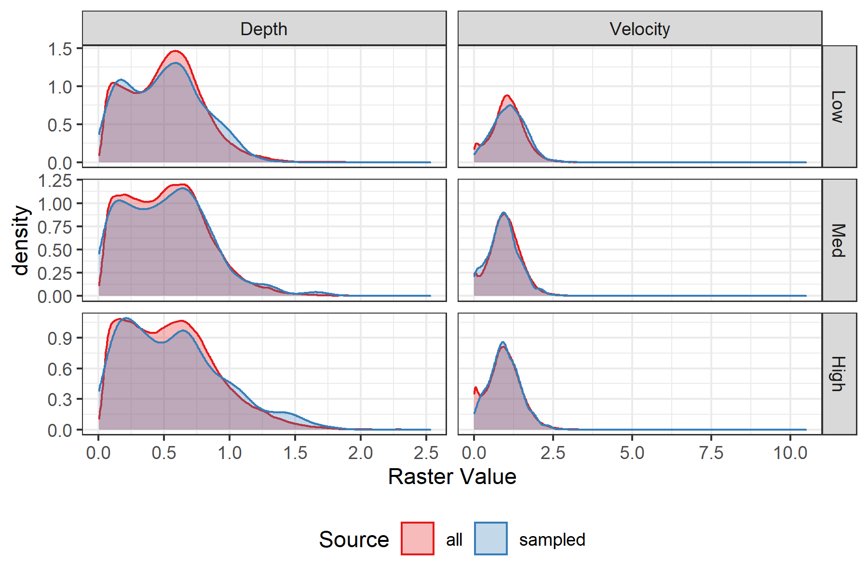

Figure 1: Density plots of depth and velocity, colored by whether taken from the entire raster (All) or the sampled transects (Sampled), faceted by sinuosity category.

## Habitat Preference

### Channel Unit Types

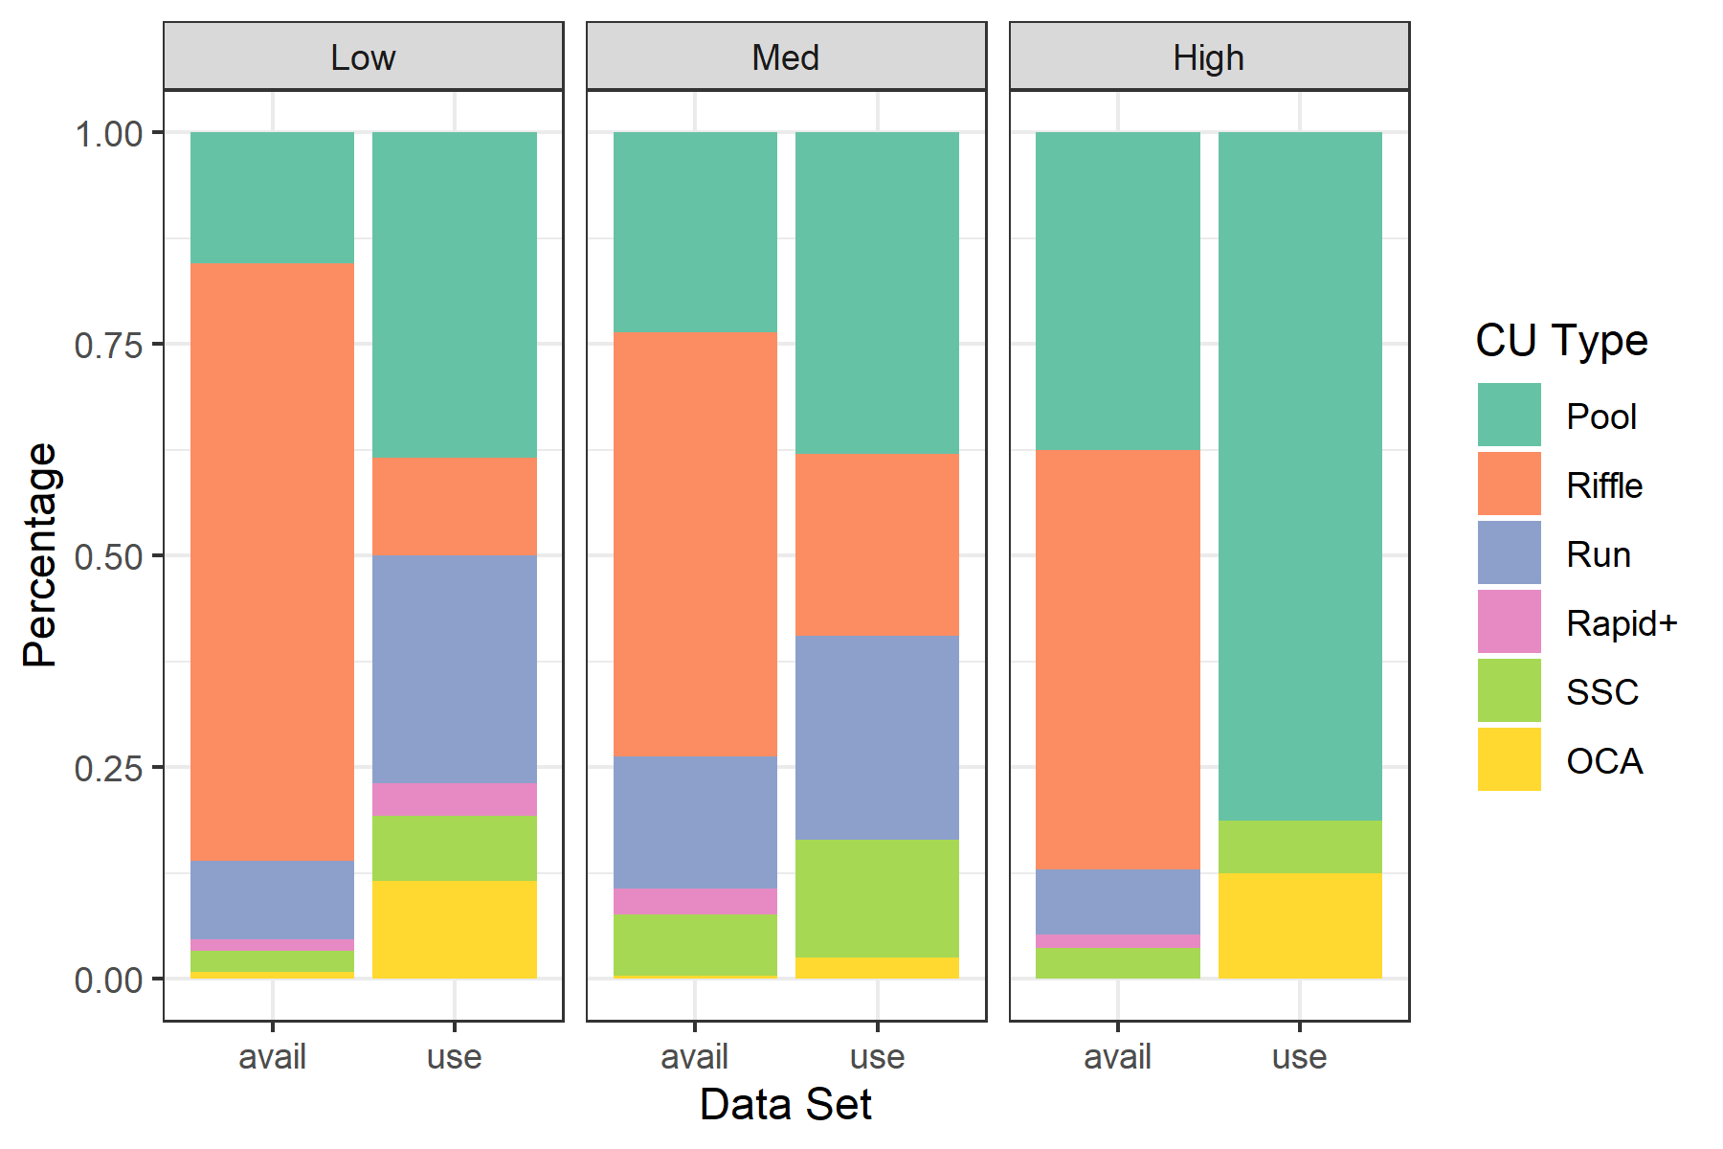

Table 3: P-values of multinomial and G-tests for differences in channel unit type proportions between available and selected habitat.

Sinuosity Category

Multinomial p-value

G-test p-value

Low

1e-04

0e+00

Med

8e-04

5e-07

High

0e+00

0e+00

There are statistically significant differences in the distribution of channel units selected by radio-tagged juvenile Chinook salmon during winter months and what is available in the lower Lemhi River, across all three sinuosity categories (Table 3). It appears that juvenile Chinook salmn tend to use pools and off-channel areas at a higher frequency than their availability, and riffles at a lower frequency compared to what is available (Figure ??).

### Concealment

### Cover

# Discussion

## Habitat Availability Power Analysis

The distributions of the depths and velocities from the sampled transects and the rasters covering the entirety of the lower Lemhi River are nearly identical within each sinuosity class. This suggest that the sampled transects are capturing the distribution of available habitat well, and did not need to be supplemented with additional transects. Certainly, we are interested in habitat metrics other than depth and velocity, but without somehow simulating the true distributions of those metrics (e.g., substrate class, fish cover, etc.)) it would be diffucult to conduct a worthwhile power analysis to evaluate whether our current dataset is sufficient to capture those distributions. Depth and velocity were used as proxies for everything elese, because we had model outputs for them across the entire Lemhi River, which we treated as the “truth.” We feel that the habitat availability dataset available from line transects in the lower Lemhi River is sufficient to capture the true available habitat.

## Habitat Preference

Habitat preference discussion here…

# Literature Cited

Bovee, K. D. 1986. Development and evaluation of habitat suitability criteria for use in the Instream Flow Incremental Methodolgy. Pages 235 pp. Instream Flow Paper 21. U.S. Fish Wildl. Serv. Biol. Rep. 86(7).

Favrot, S. D., B. C. Jonasson, and J. T. Peterson. 2018. Fall and Winter Microhabitat Use and Suitability for Spring Chinook Salmon Parr in a U.S. Pacific Northwest River. Transactions of the American Fisheries Society 147(1):151–170.

Johnson, D. H. 1980. The Comparison of Usage and Availability Measurements for Evaluating Resource Preference. Ecology 61(1):65–71.

McMahon, T. E., A. V. Zale, and D. J. Orth. 1996. Aquatic habitat measurements. Pages 83–120 B.R. Murphy and D.W. Willis, editors. Fisheries techniquesSecond. American Fisheries Society, Bethesda, Maryland.

Newcomb, T. J., D. J. Orth, and D. F. Stauffer. 2007. Habitat evaluation. Pages 843–886 C.S. Guy and M.L. Brown, editors. Analysis and interpretation of freshwater fisheries data. American Fisheries Society, Bethesda, Maryland.

Pitlo, J., Jr. 1989. Walleye spawning habitat in Pool 13 of the Upper Mississippi River. North American Journal of Fisheries Management 9:303–308.

Stanfield, L. W., and M. L. Jones. 1998. A comparison of full-station visual and transect based methods of conducting habitat surveys in support of habitat suitability index models for southern Ontario. North American Journal of Fisheries Management 18:657–675.