Habitat Use versus Availability by Juvenile Chinook Salmon in Winter Months, Lemhi River

Tulley Mackey1,✉, Kevin E. See2, Nick Porter3,✉, Mike Hall3, Richie Carmichael3, and Michael W. Ackerman4,✉

21 June, 2022

1 Mount Hood Environmental, 1009 South Daisy Street, Salmon, Idaho, 83467, USA  
2 Washington Department of Fish and Wildife, Fish Program, Science Division, 1111 Washington Street NE, Olympia, Washington, 98501, USA  
3 Biomark, Inc., 705 South 8th Street, Boise, Idaho, 83702, USA  
4 Mount Hood Environmental, PO Box 4282, McCall, Idaho, 83638, USA

✉ Correspondence: [Tulley Mackey <[tulley.mackey@mthoodenvironmental.com](mailto:tulley.mackey@mthoodenvironmental.com)>](mailto:tulley.mackey@mthoodenvironmental.com), [Nick Porter <[Nicholas.Porter@merck.com](mailto:Nicholas.Porter@merck.com)>](mailto:Nicholas.Porter@merck.com), [Michael W. Ackerman <[mike.ackerman@mthoodenvironmental.com](mailto:mike.ackerman@mthoodenvironmental.com)>](mailto:mike.ackerman@mthoodenvironmental.com)

# Background

Degradation of tributary habitat has been implicated as a major factor contributing to declines of Pacific salmon *Oncorhynchus* spp. Tributary habitat rehabilitation actions are necessary towards stemming population declines. However, habitat use and preference for juvenile salmonids to inform those rehabilitation actions, particularly during winter months, are not well documented.

Habitat requirements for fish include physical and biological components necessary to complete life histories and ensure population viability (Rosenfeld 2003; Newcomb et al. 2007). Habitat availability can be defined as the accessibility of such components by a fish (Johnson 1980). Alternatively, habitat use is the way a fish exploits the physical and biological resources available to them (Favrot et al. 2018). Habitat suitability measures a specific available habitat’s capacity to support a fish, the most suitable habitats being optimal (Bovee 1986). Available habitats can be hierarchically characterized by a spectrum ranging from least suitable (i.e., avoided) to most suitable (i.e., optimal). Habitat selection is determined when a fish chooses a physical or biological component from a spectrum of available habitats (Johnson 1980). If habitat use is proportionally equivalent to habitat availability (i.e., no preference), then habitat use is considered random. However, when a fish selects for a specific physical or biological component given that multiple habitat types are available, this is considered preferred habitat (e.g., laboratory experiment: Johnson (1980)). Critical habitat provides components essential to sensitive life stages (e.g., early life history: Pitlo (1989), Newcomb et al. (2007)). Winter habitat is thought be critical because of specific biological conditions required by fish for maintenance of body condition and survival during this time period (Favrot et al. 2018). However, due to extreme environs (e.g., surface ice), little research has characterized winter microhabitat use and suitability empirically for Pacific salmon juveniles (Huusko et al. 2007).

## Objectives

The goal of this study was to characterize microhabitat use and preference for juvenile Chinook salmon *O. tshawytscha* in the lower Lemhi River during winter months. Habitat availability and use data were collected in the lower Lemhi River using methods similar to those described by Favrot et al. (2018), which were previously implemented in Catherine Creek, Oregon. We used similar habitat availability and use data to describe habitat selection and preference of juvenile Chinook salmon overwintering in the lower Lemhi River, which can in turn be used to inform target habitat conditions to be used in habitat restoration planning and designs.

# Methods

## Habitat Availability

Microhabitat availability data were collected in the lower Lemhi River using line-transect survey techniques similar to those described by Favrot et al. (2018). Line-transect techniques can minimize measurement error and are more repeatable than visual techniques (McMahon et al. 1996; Stanfield and Jones 1998). Microhabitat availability data were collected during base-flow conditions in August 2019 and variables measured at each transect point corresponded to microhabitat use variables (described below). Points were placed every meter along a linear network of the lower Lemhi River from its confluence with Hayden Creek downstream to its confluence with the Salmon River, resulting in 53,119 points in total. Each point was then categorized as occurring within a low, medium, or high sinuosity reach (calculated at the 500m reach scale) of the lower Lemhi River (Table 1).

Table 1: The number of points within each sinousity category including the minimum and maximum sinuosity values for reach category.

Category

Minimum

Maximum

Length (m)

Low

1.003

1.118

23,616

Med

1.118

1.277

22,179

High

1.278

1.815

7,324

We then randomly sampled an approximately equal number of points within each sinuosity category (Table 2) and transects were placed at a right angle to the flow at each of the sampled points. At each transect, we then started at the wetted width midpoint of the river and sampled every meter to river right and river left (facing downstream), including the midpoint, to the wetted margin. The midpoint was designated as the zero point, points to river right were designated positive (+) and points towards river left were designated negative (-). Habitat availability measurements were taken at each point and described channel unit type, bank condition, dominant substrate, availability of substrate concealment, presence of adjacent side channels, dominant cover type, and distance to cover. In addition, depth and velocity estimates for each point were available from LiDAR-derived 2D numerical models. In total, habitat measurements were collected from 173 transects and 2,012 points, resulting in an average of 11.6 points per transect.

Table 2: The number of points within each sinousity category including the minimum and maximum sinuosity values for reach category.

Category

n Transects

n Transect Points

Avg. Points per Transect

Low

56

695

12.4

Med

59

670

11.4

High

58

647

11.2

## Habitat Use

Microhabitat use data were collected from radio-tagged juvenile Chinook salmon in the lower Lemhi River beginning in November 2019 through March 2020. For this study, a total of 279 fish were tagged from October 9 - 31, 2019 at three rotary screw trap (RST) locations in the Lemhi River: upper Lemhi RST (LEMTRP), Hayden Creek RST (HYDTRP), and lower Lemhi RST (LLRTRP). Advanced Telemetry Systems, Inc. (ATS; hhtps://atstrack.com) radio transmitters (Model #ST100L) were surgically implanted into the abdomen of Chinook salmon presmolts (juveniles surviving to their first winter prior to spring emigration), ranging in length from 98 - 138 mm and weight from 10.4 - 31.1 g. Fish were also implanted with a Passive Integrated Transponder tag (PIT tag). Tagged fish were held for a minimum of six hours in live wells and released at night below the tagging sites once they had fully recovered from surgery.

Because of limited battery life, radio tags were programmed to operate in three batches to cover the entire winter season. Batch 1 transmitters (181 fish) were programmed to operate continuously upon activation, batch 2 transmitters (47 fish) operated for an hour upon activation then shutdown to reactivate at day 50, and batch 3 transmitters (51 fish) operated for an hour upon activation then shutdown to reactivate at day 100.

Throughout the winter, mobile tracking surveys were completed by boat and on foot, dependent on weather and river conditions. Surveys covered 50 km of the lower Lemhi River from its confluence with Hayden Creek downstream to its confluence with the Salmon River and were completed approximately every two weeks. When a transmitter was detected, surveyors pin-pointed the signal location to the finest scale possible (typically $<1m^{2}$), attempted to determine whether the tag was in a live fish, and recorded the location using an EOS Arrow 100 GNSS GPS receiver. The same habitat metrics collected for the habitat availability dataset were also collected at each tag location.

Mobile tracking surveys resulted in the detection of 99 unique radio tags of which 22 were physically recovered (one confirmed mortality). The high recovery rate of detected tags (22%) combined with the inability to confirm tag detections as live fish created some uncertainty about the validity of fish use data. To address this, a decision tree was developed based on professional expertise and published literature (Holleman et al. 2022) to qualify tag detection locations as selected for habitat (Figure 1). Using the decision tree, 74 unique selected habitat locations were identified as habitat use.

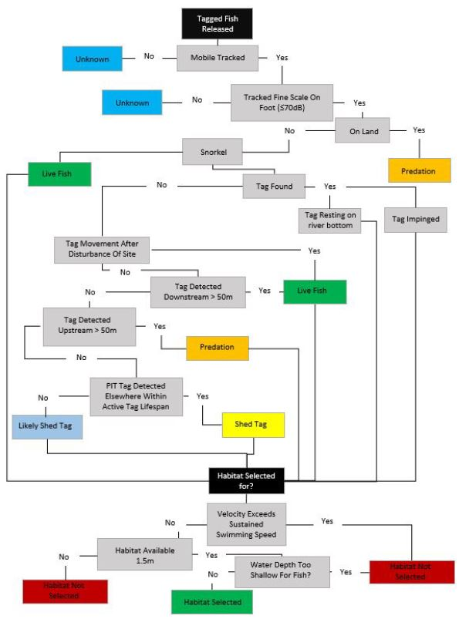

Figure 1: Decision tree for determining qualified tag detection locations as selected habitat.

## Habitat Availability Power Analysis

To determine if the 173 transects sampled for habitat availability were sufficient to capture the overall distribution of habitat metrics throughout the lower Lemhi River, we focused on depth and velocity measurements taken at each transect point. We compared the distributions of those measured values with the distributions of all depth and velocity values available from raster datasets derived from 2D numerical flow models by performing a Kolmogorov–Smirnov test on data from each sinuosity category. If the test is insignificant, this indicates that the data from the transects described the distribution of available habitat well. We were only able to perform this test on depth and velocity because they were the only metrics with data available for the entire section of the lower Lemhi. Our assumption is that if the transect data is sufficient for depth and velocity, it also captures the distributions of the other habitat metrics as well.

## Habitat Preference

After filtering the identified radio tags to include only those fish that we deemed selected a given location, we then compared the total available habitat in the lower Lemhi River to the habitat that was selected by radio-tagged Chinook salmon presmolts. Comparisons were made for the following habitat characteristics:

* Sinuosity
* Stream Depth and Velocity
* Channel Unit Type
* Substrate Concealment
* Cover

### Sinuosity

We estimate the proportion of the total available habitat in the lower Lemhi River that fell into each of the sinuosity categories (Table 1) which was compared to the proportion of each category that Chinook salmon presmolts used.

### Depth and Velocity

Depth (m) and mean column velocity (m/s) were measured at 47 of the 74 selected habitat locations during typical winter flows. Environmental conditions at the time of sampling, primarily surface ice and depth, prevented collection of depth and velocity measurements at some locations, likely introducing some bias e.g., use locations with the greatest depths were most difficult to measure. However, because our decision tree accounted for velocity limits of sustained swimming of juvenile salmonids, we feel confident the locations where mean column velocity was measured is a representative sample of habitat use locations in the lower Lemhi.

We compared the available depths and velocities at the transect location points (n = 2,012; derived from raster available from 2D-numerical models) to the measured depths and velocities taken in the field during microhabitat use surveys. We used a variance test (F test; how far each data point is from the group mean), to evaluate variances between the habitat availability and habitat use datasets. This led us to use an unpooled, two-sample test (Welch test) to determine if there’s a significant difference (p-value < 0.05) between mean available depth and velocity and mean selected depth and velocity in the lower Lemhi.

### Channel Unit Type

Channel unit types included pools, riffles, runs, rapid+, small side-channels (SSC), and off-channel areas (OCA), similar to channel units delineated using the DASH protocol (Carmichael et al. 2019). Because there are multiple types of channel units, we employed a goodness-of-fit test for discrete multivariate data. This test compares the observed channel unit types that radio-tagged juveniles were observed using to the proportion of channel unit types from the habitat availability dataset. The null hypothesis was that radio-tagged juvenile Chinook salmon would be found in channel units in the same (or similar) proportion to what is available. Because there are 7 distinct channel unit types, this leads to a large number of potential arrangements. Therefore, we used a Monte Carlo approach to simulate 100,000 samples of $n$ observations ( $n$ being the number of selected “use” channel units) using the habitat availability proportions of channel unit types. The p-value is then calculated by summing the relative frequencies of outcomes occurring less frequently than the observed ones, so a low p-value indicates that the observed “use” channel types are distributed differently that the available ones, suggesting that fish are not randomly distributed in overwinter habitat. We also used a log likelihood ratio goodness of fit test (G-test).

### Concealment

At each point of habitat availability transects and at observed “use” locations by radio-tagged individuals, we estimated whether concealment habitat was available to juvenile Chinook salmon. Because concealment is binary (either available or not), we tested whether there were differences between habitat availability and use using a Chi-squared test, as well as a G-test.

### Cover

We determined whether fish cover was available within 1.5 m of each habitat availability transect point and at each “use” location. Cover types considered included artificial cover, aquatic vegetation, boulders, small and large wood, terrestrial vegetation, and undercut banks. Here, we grouped all types of cover into a single category, and compared whether cover was available with the category of “no cover”. This resulted in a binary variable, like concealment, allowing us to also use the Chi-squared and G-test.

# Results

## Habitat Availability Power Analysis

Comparisons of the distributions of depths and velocities estimated from 1) the randomly placed transects used to estimate habitat availability, and 2) the entirety of the rasters derived from 2D numerical models were favorable (Figure 2). Distributions of depths and velocities were similar among all sinuosity categories (Figure 2). These findings suggest that the habitat availability data collected during August 2019 were sufficient to capture the available habitat throughout the lower Lemhi River.

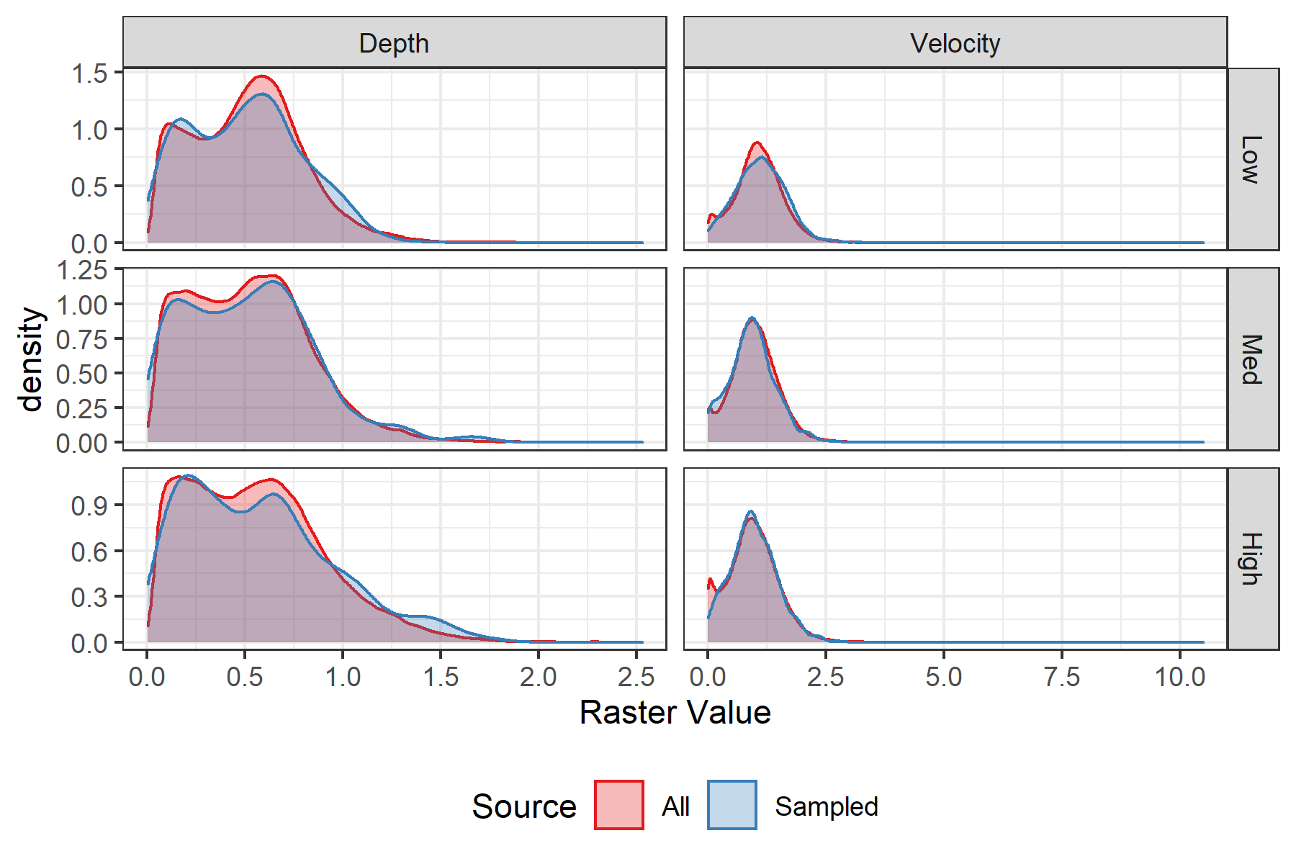

Figure 2: Density plots of depth and velocity, colored by whether taken from the entire raster (all) or the sampled transects (sampled), and faceted by sinuosity category.

## Habitat Preference

### Sinuosity

Sinuosity categories selected by radio-tagged juvenile Chinook salmon, during later fall and winter months, were similar to the proportions of available habitat (Figure 3). In other words, Chinook salmon presmolts were *not* observed using “high” sinuosity reaches of the lower Lemhi River at a higher rate than was available, as we might expect. However, sinuosity categories were calculated at the 500 m reach scale, and this observation could be (at least partially) due to fish not selecting for habitat at this more coarse (e.g., reach) scale, but rather at a finer (e.g., microhabitat) scale.

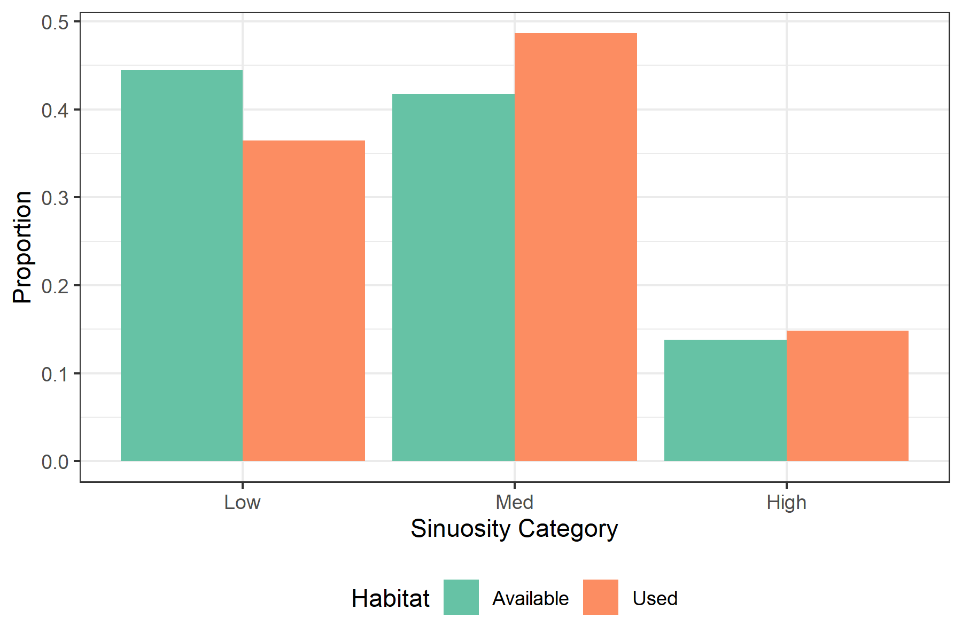

Figure 3: Percent of available and selected habitat by sinuosity category in the lower Lemhi.

### Depth and Velocity

The distributions between available stream depths and those depths used by Chinook salmon presmolts were similar (Figure 4); despite the “used” mean depth being significantly lower than the available mean (p < 0.05; Table 3. However, this significance could (at least partially) be explained by a potential sampling bias explored further in the Discussion.

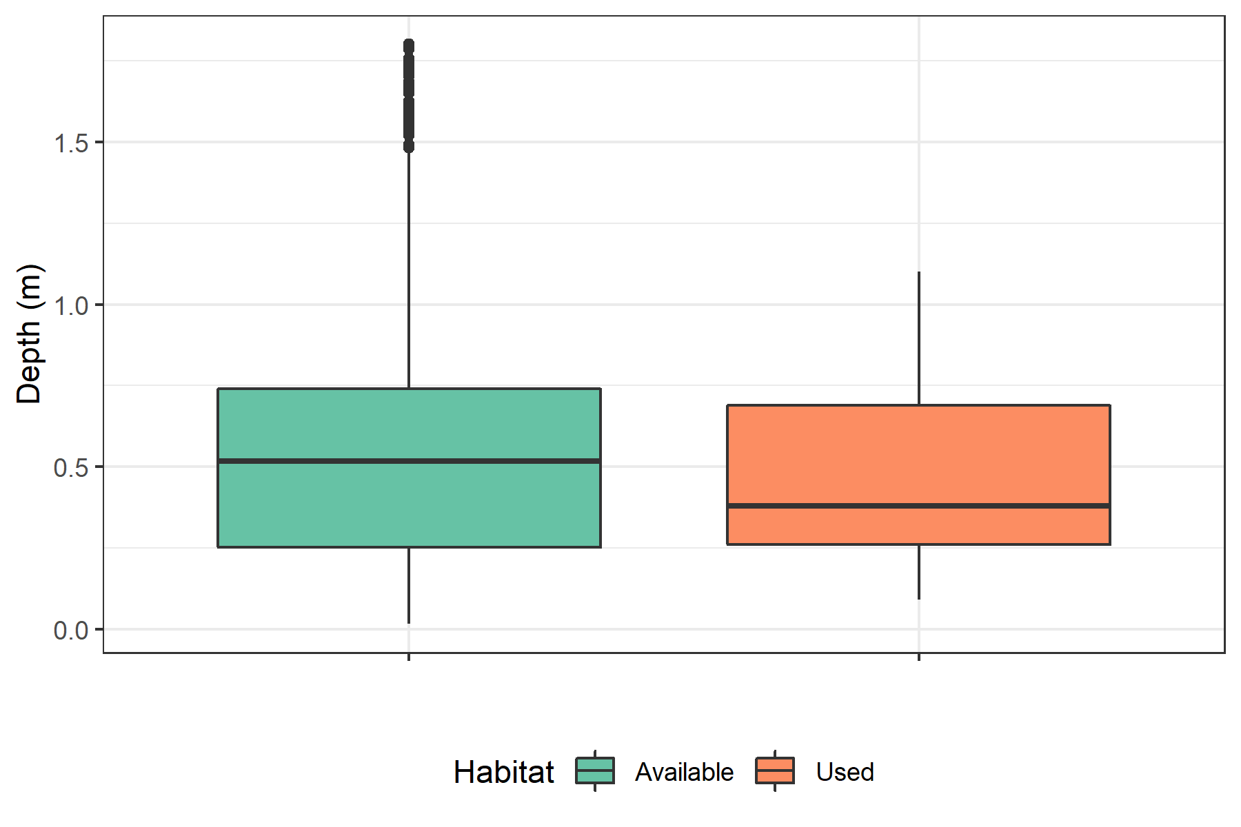

Figure 4: Distributions of all available stream depths in the lower Lemhi River derived from a 2D numerical model (available) and depths used by radio-tagged juvenile Chinook salmon during late fall and winter months (use).

Table 3: Estimated mean depth for available and selected habitat and Welch t-test p-value.

Mean Available Depth (m)

Mean Select Depth (m)

Welch t-test p-value

0.5341115

0.4529787

0.0415213

Mean stream velocities used by Chinook salmon presmolts were significantly lower than those available throughout the lower Lemhi River (Figure 5; Table 4, suggesting that juvenile Chinook salmon are selecting for slower water habitats during late fall and early winter months.

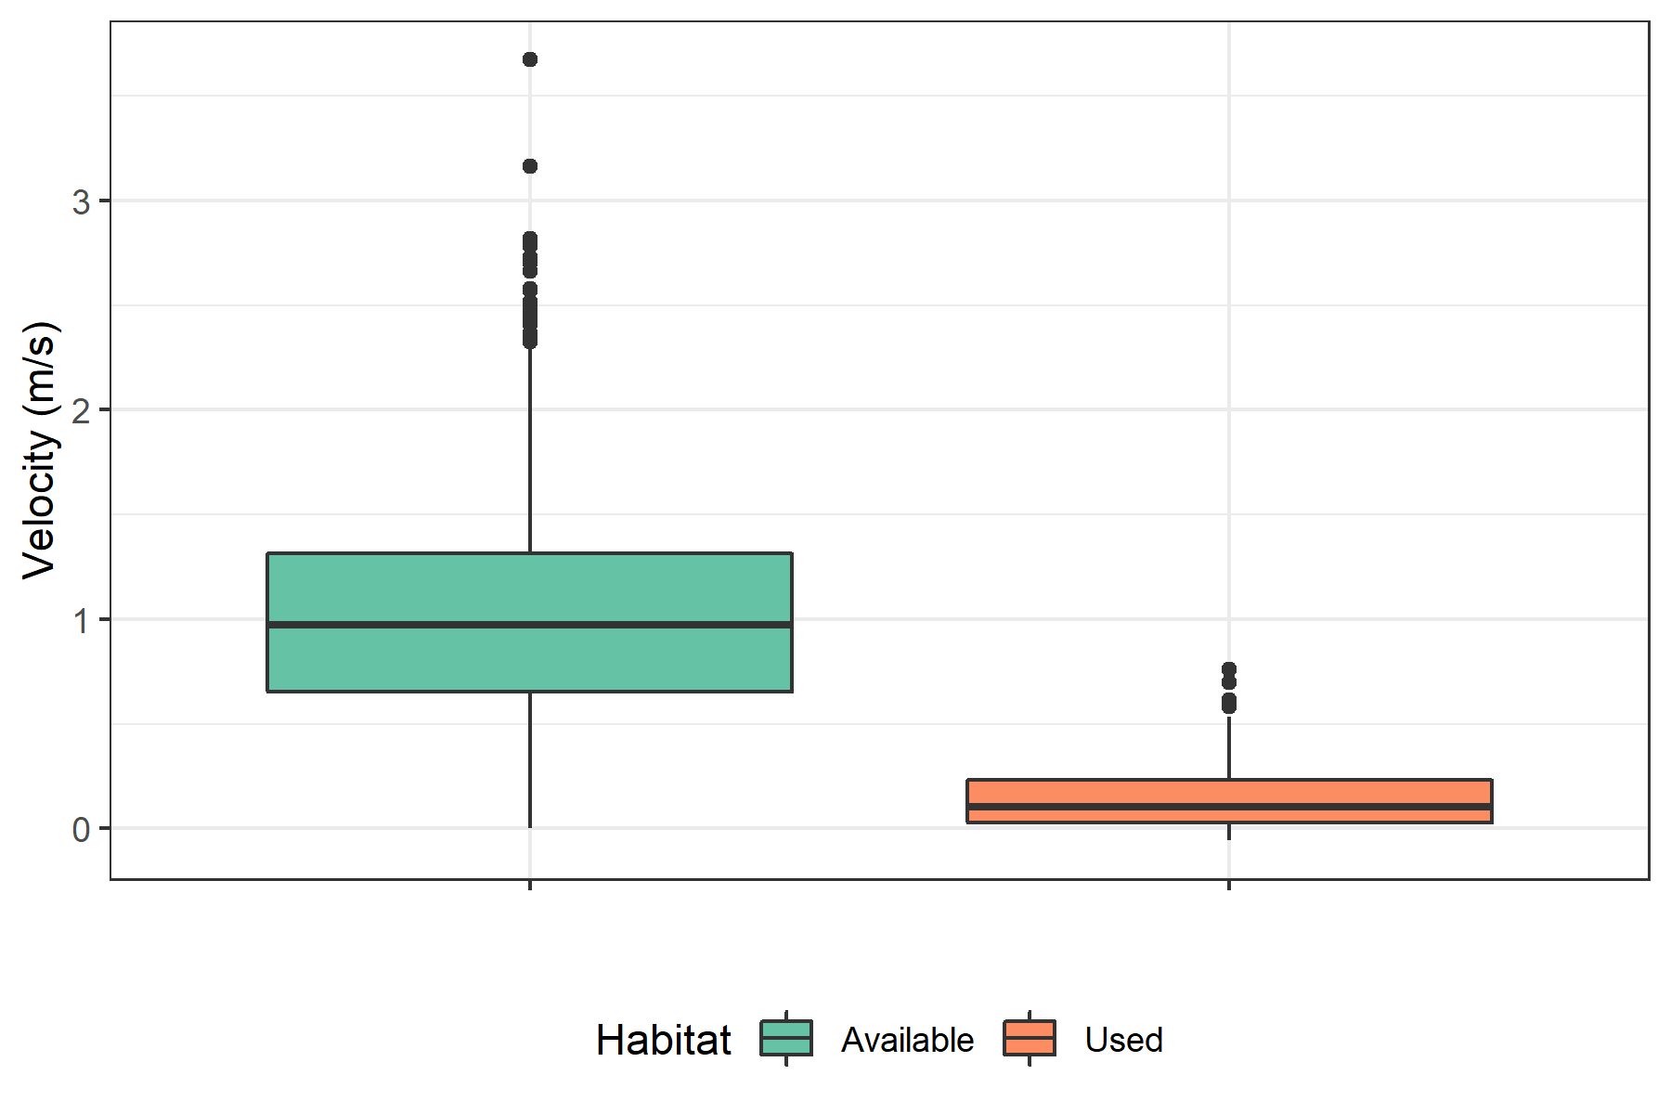

Figure 5: Distributions of all available stream velocities in the lower Lemhi River derived from a 2D numerical model (available) and velocities used by radio-tagged juvenile Chinook salmon during late fall and winter months (use).

Table 4: Estimated mean velocity for available and selected habitat and Welch t-test p-value.

Mean Available Velocity (m/s)

Mean Select Velocity (m/s)

Welch t-test p-value

0.9938558

0.177766

0

### Channel Unit Type

There were significant differences in the distribution of channel unit types used by radio-tagged juvenile Chinook salmon during winter months and what is available throughout the lower Lemhi River, across all three sinuosity categories (Table 5). Juvenile Chinook salmon appear to use pools and off-channel areas at a higher proportion relative to their availability, and riffles at a lower proportion compared to what is available (Figure 6).

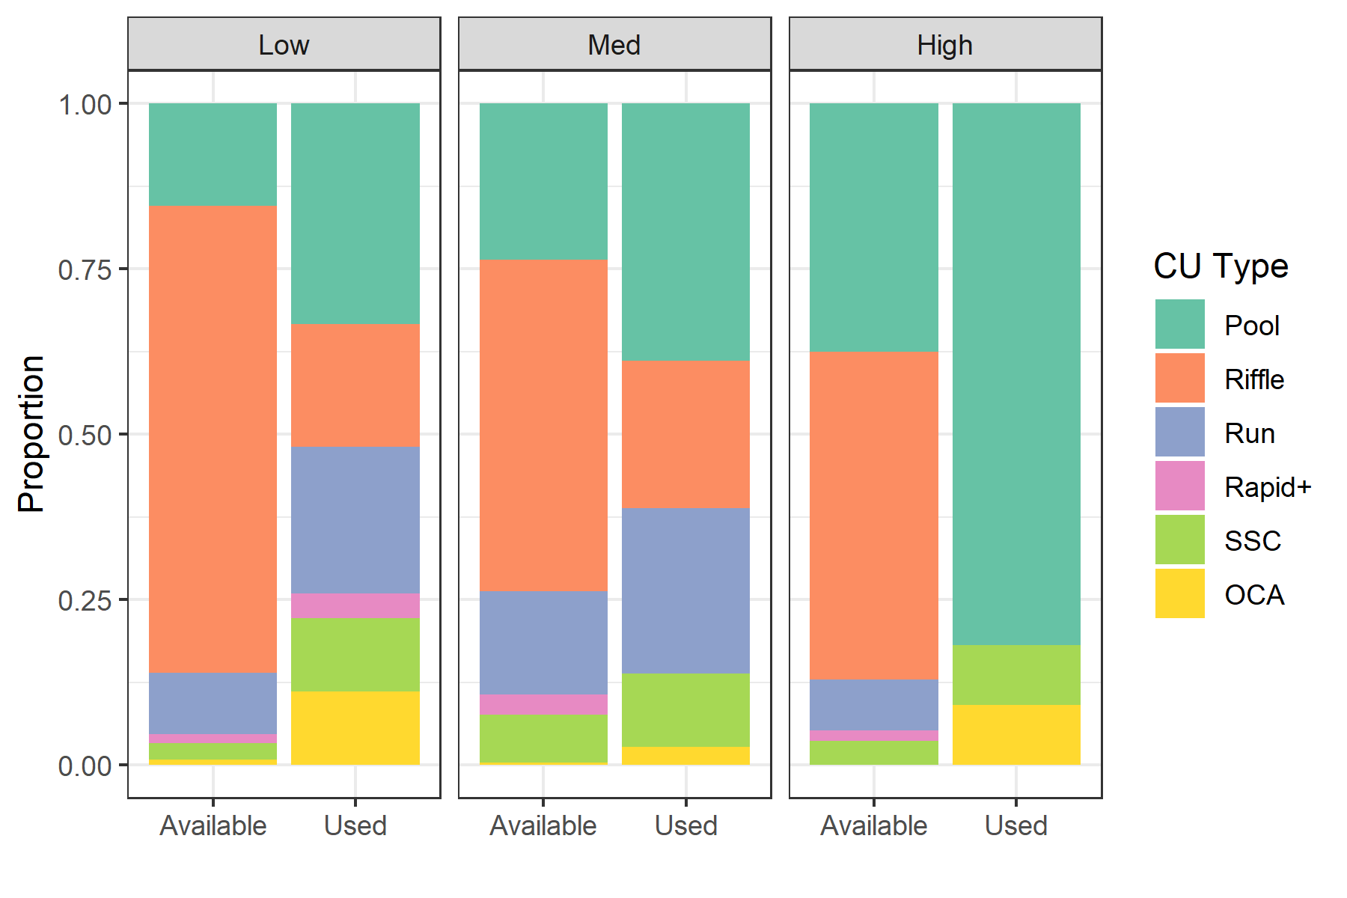

Figure 6: Percent of channel unit types available in the entire lower Lemhi compared with percent where fish were using them, faceted by low, medium and high sinuosity classes.

Table 5: P-values of multinomial and G-tests for differences in channel unit type proportions between available and selected habitat.

Sinuosity Category

Multinomial p-value

G-test p-value

Low

0.0000

0.0000009

Med

0.0026

0.0060995

High

0.0000

0.0000000

### Concealment

We observed little/no difference between the proportion of locations where concealment substrate was available and locations used by juvenile Chinook salmon with concealment habitat, for both the medium and high sinuosity categories (Figure 7). There was a significant difference within the low sinuosity category (Table 6); however; Figure 7 indicates that in low sinuosity reaches, fish were more likely to select habitat that does not contain substrate concealment, contrary to our suspicions.

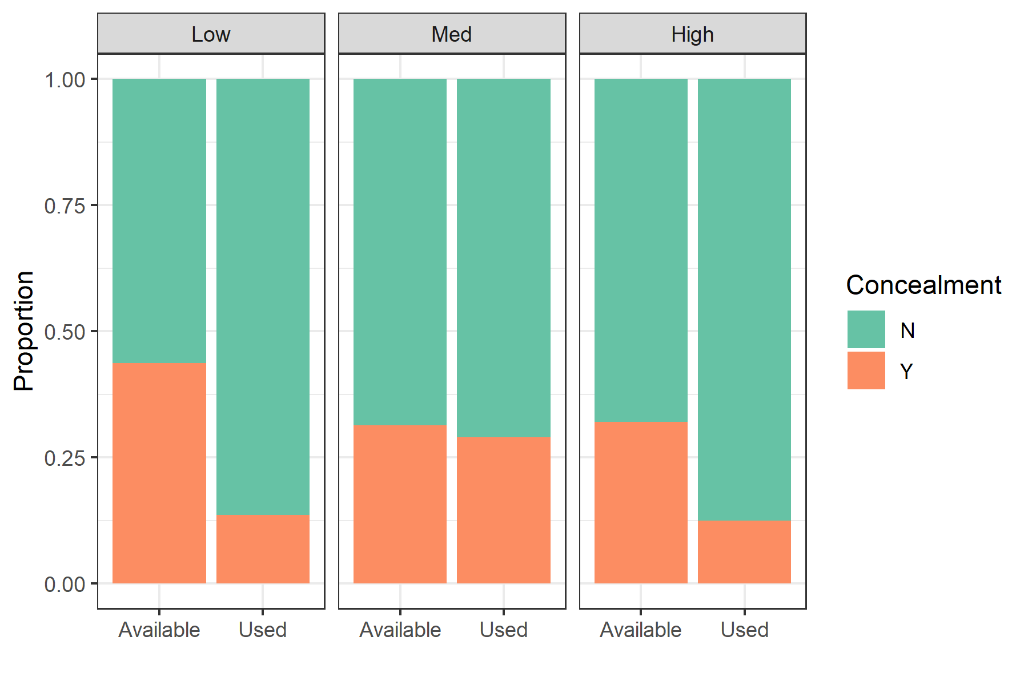

Figure 7: Proportion of locations where concealment habitat was available throughout the lower Lemhi River compared with the proportion where fish had selected, faceted by low, medium and high sinuosity classes.

Table 6: P-values of G- and Chi-squared tests for differences in availability of concealment between available and selected habitat.

Sinuosity Category

G-test p-value

Chi Squared p-value

Low

0.00610

0.00452

Med

0.93377

0.77483

High

0.40068

0.23493

### Cover

Radio-tagged juvenile Chinook salmon were more likely to select habitat where some form of cover was available (within a 1.5 m radius), compared to what was available, including across all three sinuosity categories (Figure 8; Table 7).

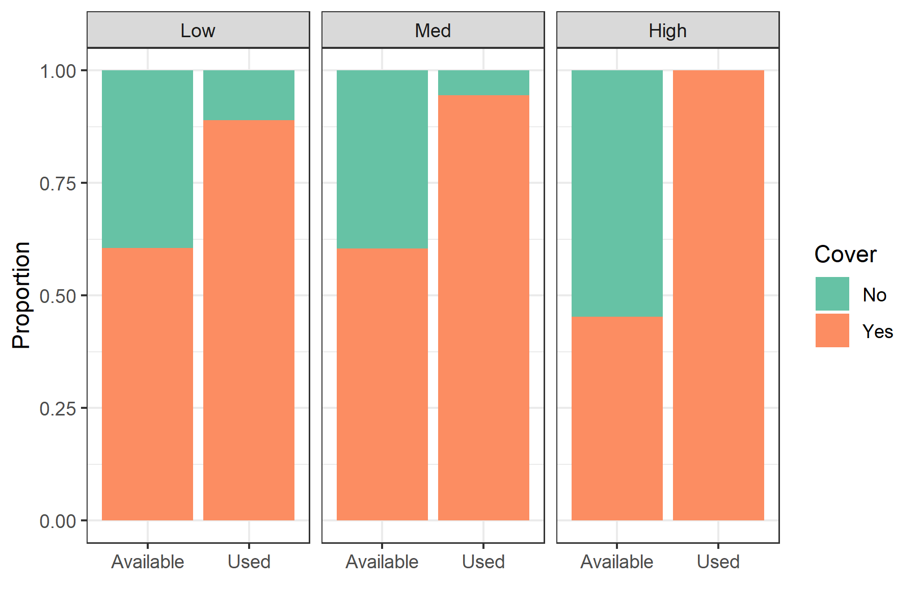

Figure 8: Proportion of transect points where cover was available throughout the entire lower Lemhi River compared to the proportion where fish had selected, faceted by low, medium, and high sinuosity categories.

Table 7: P-values of G- and Chi-squared tests for differences in availability of cover within 1.5 m radius between available and selected habitat.

Sinuosity Category

G-test p-value

Chi Squared p-value

Low

0.00274

0.00255

Med

0.00001

0.00003

High

0.00032

0.00027

# Discussion

In this study, we identified that radio-tagged juvenile Chinook salmon selected for slower stream velocities and slightly deeper areas than were typically available in the lower Lemhi River during the late fall and winter months; and further, selected for slow-water channel unit types, including pools and off-channel areas, at a higher rate than those types were available. Additionally, we identified that juveniles selected for locations with adjacent cover (of any type), regardless of the reach-scale sinuosity of the river. We did not identify a pattern regarding the selection (or not) of locations with available concealment habitat. In the following, we further discuss these results and potential limitations of our dataset that should be considered during interpretation.

## Habitat Availability Power Analysis

The distributions of the depths and velocities from the sampled transects and the rasters covering the entirety of the lower Lemhi River were nearly identical within each sinuosity class. This suggested that the sampled transects sufficiently captured the distribution of available habitat, and did not need to be supplemented with additional transects. Certainly, we were interested in habitat metrics beyond depth and velocity, but without somehow simulating the true distributions of those metrics (e.g., substrate class, fish cover, etc.)) it would have been difficult to conduct a worthwhile power analysis to evaluate whether the current dataset was sufficient to capture those distributions. Depth and velocity were used as proxies for other habitat characteristics, because we had model outputs for them across the entire lower Lemhi River, which we treated as the “truth”. We feel that the habitat availability dataset available from line transects in the lower Lemhi River is sufficient to capture the true available habitat.

## Habitat Preference

### Sinuosity

We hypothesized that juvenile Chinook salmon would select high sinuosity reaches in the lower Lemhi River at a higher rate than they were available; however, this was not the case (Figure 3). There did not appear to be a real pattern in fish use relative to sinuosity categories. Our theory was that high sinuosity reaches of the lower Lemhi River would be more likely to have low velocity areas and slow-water channel units which are typically more appealing to juvenile Chinook salmon (supported by findings here). That didn’t necessarily seem to be the case, though, as all sinuosity categories appeared to have similar distributions of velocity (Figure 2) despite high sinuosity reaches having higher pool frequency (Figure 6). These findings may suggest that juvenile Chinook salmon are not selecting for habitat at the reach scale, but rather more at a micro-habitat scale at which the fish is experiencing.

### Depth and Velocity

While our analysis demonstrated a significant difference between the mean water depth used by juvenile Chinook salmon and the mean available depth, with fish selecting for shallower depths, we believe this result could partially be explained by a sampling bias. For example, some depths were not collected at fish use (tag) locations because, at the time of sampling, those locations were too deep to safely and accurately measure. Had these omitted data points been included, bias in used depths may have been reduced (albeit to an unknown degree), and a significant difference may not have been found.

Alternatively, we feel the significant difference in stream velocities found at the used locations compared to the available stream velocities to be a valid and interesting finding. Had higher velocities been included in the dataset to potentially shift the use distribution, those locations would have been filtered out based on literature detailing the upper limit of sustained swimming for juvenile salmonids (used as criteria in decision tree for qualifying habitat use). Strikingly, the mean velocity for available habitat (0.99 m/s) is significantly greater than the upper limit for sustained swimming speed (0.67 m/s) of a 111 mm fish, the average size among juvenile Chinook salmon in our study.

### Channel Unit Type

We found that juvenile Chinook salmon selected slower velocity channel unit types (pools and off-channel areas) at a higher frequency than was available throughout the lower Lemhi River. This supports the idea that these fish are seeking refuge from high velocities (i.e., riffles) which could be an important survival and fitness strategy during the winter months when fish are trying to maintain condition factor.

Statistical analysis shows juvenile Chinook selecting for pools and off-channel areas at a higher frequency than what is available.

### Concealment

Contrary to our hypothesis, there was more concealment habitat available in the lower Lemhi River than what was being used by juvenile Chinook, at least in low sinuosity reaches (Figure 7). This may be partially explained by fish instead seeking and preferring slow velocity habitats, which are generally associated with finer bed material (i.e., gravel, sands, fines) deposition. Juvenile Chinook salmon may not be selecting for areas where concealment is absent, but rather it may be that stream velocity is a more important habitat component than substrate concealment. Also, while surveyors did their best to categorize substrate accurately, turbidity in the Lemhi River, especially at higher winter flows, made substrate observations challenging.

### Cover

We found that juvenile Chinook salmon selected for microhabitats with cover (within a 1.5 m radius) in greater proportions than was available throughout the lower Lemhi River. We believe this finding could be understated, as well. The microhabitat availability surveys were conducted in August, when overhanging vegetation was likely more prominent and with leaves. In the winter, during microhabitat use surveys, trees and plants had lost their leaves resulting in less available cover, at least for overhanging vegetation. The magnitude of the bias resulting from the difference in timing of surveys is unknown; however, should be considered in the context of the seasonality of the two surveys.

### Conclusions

We identified that juvenile Chinook salmon selected for slower velocity microhabitats and channel unit types, and preferred locations with cover. Our habitat availability surveys additionally suggest that this habitat type may be limiting throughout the lower Lemhi River (Figure 6). We believe that restoration efforts in the lower Lemhi River directed at improving overwintering habitat should look towards increasing the availability of slow-water habitats with available cover.

While we believe this habitat availability and use study has been worthwhile and its findings are relevant to restoration efforts in the Lemhi River, it must be understood that the study does not come without some major confounding factors. Those factors include:

* Radio telemetry technology
* Predation
* Sample size
* Sampling bias due to environmental conditions

Because we were unable to confirm if radio tag detections were truly live fish and a high percentage of radio were physically recovered because they were no longer attached to fish (22% of detected tags during microhabitat surveys), we hypothesize that tag antennas became entangled with physical habitat features when fish sought cover resulting in shed tags. Predation also likely contributed to the high tag recovery rate. Ideally, we would have had a larger sample size of habitat use observations for a more robust analysis and better representation of the population sampled.

Largely due to environmental conditions microhabitat use surveys were not always feasible during certain times of the winter or in certain sections of the river. When the river was not navigable by boat due to surface ice, we were forced to conduct surveys by foot which limited access to only those areas where we had landowner permission. Also, river conditions prevented us from collecting all desired metrics (i.e., depth and velocity) at all detected tag locations.

# Literature Cited

Bovee, K. D. 1986. Development and evaluation of habitat suitability criteria for use in the Instream Flow Incremental Methodolgy. Pages 235 pp. Instream Flow Paper 21. U.S. Fish Wildl. Serv. Biol. Rep. 86(7).

Carmichael, R. A., M. W. Ackerman, K. See, B. Lott, T. Mackay, and C. Beasley. 2019. Drone Assisted Stream Habitat (DASH) Protocol, DRAFT. Biomark, Applied Biological Services.

Favrot, S. D., B. C. Jonasson, and J. T. Peterson. 2018. [Fall and Winter Microhabitat Use and Suitability for Spring Chinook Salmon Parr in a U.S. Pacific Northwest River](https://doi.org/10.1002/tafs.10011). Transactions of the American Fisheries Society 147(1):151–170.

Holleman, R. C., E. S. Gross, M. J. Thomas, A. L. Rypel, and N. A. Fangue. 2022. [Swimming behavior of emigrating Chinook Salmon smolts](https://doi.org/10.1371/journal.pone.0263972). PLOS ONE 17(3):e0263972.

Huusko, A., L. Greenberg, M. Stickler, T. Linnansaari, M. Nykänen, T. Vehanen, S. Koljonen, P. Louhi, and K. Alfredsen. 2007. [Life in the ice lane: The winter ecology of stream salmonids](https://doi.org/10.1002/rra.999). River Research and Applications 23(5):469–491.

Johnson, D. H. 1980. [The Comparison of Usage and Availability Measurements for Evaluating Resource Preference](https://doi.org/10.2307/1937156). Ecology 61(1):65–71.

McMahon, T. E., A. V. Zale, and D. J. Orth. 1996. Aquatic habitat measurements. Pages 83–120 B.R. Murphy and D.W. Willis, editors. Fisheries techniquesSecond. American Fisheries Society, Bethesda, Maryland.

Newcomb, T. J., D. J. Orth, and D. F. Stauffer. 2007. Habitat evaluation. Pages 843–886 C.S. Guy and M.L. Brown, editors. Analysis and interpretation of freshwater fisheries data. American Fisheries Society, Bethesda, Maryland.

Pitlo, J., Jr. 1989. Walleye spawning habitat in Pool 13 of the Upper Mississippi River. North American Journal of Fisheries Management 9:303–308.

Rosenfeld, J. 2003. [Assessing the Habitat Requirements of Stream Fishes: An Overview and Evaluation of Different Approaches](https://doi.org/10.1577/T01-126). Transactions of the American Fisheries Society 132(5):953–968.

Stanfield, L. W., and M. L. Jones. 1998. A comparison of full-station visual and transect based methods of conducting habitat surveys in support of habitat suitability index models for southern Ontario. North American Journal of Fisheries Management 18:657–675.