PITcleanr_lite

PTAGIS and Biologic Process Documentaiton

Last modified: 5/16/2022

Modified by: Mark Roes

This is a step-by-step process guide for the draft version of PITcleanr_lite (2022) to import and combine fish mark and recapture histories from PTAGIS and Biologic. The process requires:

1. A PTAGIS account to create and execute queries (<https://www.ptagis.org/>)
2. Access to Biomark’s Biologic database
3. A recent version of R software installed
4. A local copy of the PITcleanr_lite Github repo (<https://github.com/Mount-Hood-Environmental/PITcleanr_lite>)

1. Download PTAGIS data

Three PTAGIS queries are required:

1. All fish marked at Lemhi RSTs
2. All recaptures at Lemhi RSTs
3. Complete tag histories for all tagged fish listed in queries 1. *or* 2. This report will contain all of the records to be downloaded from PTAGIS.

To create these queries, you will need to:

1. Navigate to <https://www.ptagis.org/>
2. Login
3. Navigate to Advance Reporting Home Page
4. Create Query Builder2 Report

Mark Query

Tagging Details

1. Report type: Tagging Detail
2. Select Attributes
   1. Add Length & Weight
3. Filters
   1. **4** Capture Method = Screw Trap
   2. **9** Mark Site Subbasin = 17060204:Lemhi
   3. **10** Mark Year = 2020 – Present
   4. **16** Species = Chinook, Steelhead
4. Save query
   1. **Note:** The query must be saved as “static”. Be sure to check the box as in the highlighted image below

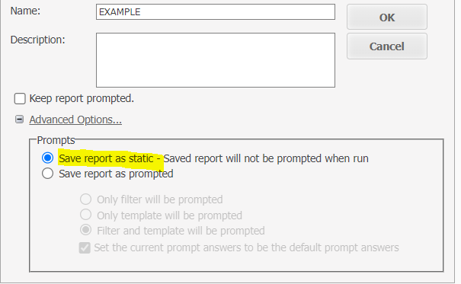

1. Run Report

Recapture Query

1. Report type: Recapture Detail
2. Select Attributes
   1. Add Recap Length & Recap Weight
3. Filters
   1. **10** Mark Site Subbasin = 17060204:Lemhi
   2. **19** Recap Capture Method = Screw Trap
   3. **27** Recap Year = 2020 – Present
   4. **32** Recap Species = Chinook, Steelhead
4. Save query
   1. **Note:** The query must be saved as “static”. Be sure to check the box as in the highlighted image below



1. Run Report

Tag History Query

This query filters the entire PTAGIS database to tags that are recorded in queries 1 or 2.

1. Report type: Complete Tag History
2. Attributes
   1. 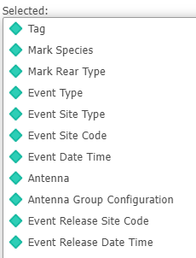
3. Filters
   1. **6** Event Site = HYC, LRW, EVU, S2I, S2O, BHC, S3B, S3A, EVL, LLRTP, LLR
   2. **31** Tag – Saved Report (UNION)
      1. In this window, navigate to “My Reports” and select the “mark” and “recapture” queries created earlier in the process. See image below for details.

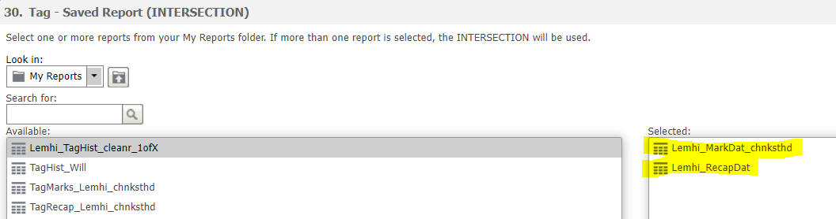

1. Save report. Unlike the first two, this report can be saved as “prompted”
2. Run Report
   1. **NOTE: Running this query for all sites will likely cause PTAGIS to error out due to too many records. Recommend running the report once for the “HYC” event site only, then again for all other sites.**
3. Export
   1. Whole report
   2. CSV file format
   3. Remaining as default
   4. Export
4. Name the downloaded file using the following convention: “TagHist_basin_sitenames_year.csv” e.g., “TagHist_Lemhi_HYC_20-22.csv”
5. Save the downloaded file within the “input” folder of in PITcleanr_lite.

Biologic Observation Data

Observation data

PIT tag detection data downloaded from biologic should consist of 5 columns: site, tag, detected, reader, and antenna. Biologic data downloads are saved to the “input/observation” folder and start with “0LL_tag” in the filename to indicate that the data is tagging observations from the Lower Lemhi (e.g., “0LL_tag_7-30-2022.csv”).

Site metadata

Site metadata information is contained in “input/site/site_metadata.csv”. Any modifications or additions must be made within this file.

Filtering out Tags

If any tags need to be filtered out from results (e.g., test tags), then they need to be entered into the “input/mark/filter_tags.csv” file. List all tags that will be removed in the “filter_tags” column.

Running the Scripts