Temperature in the North Cascades

Forty-six temperature sensors were deployed and recorded temperature data at twenty-three different sites in North Cascades National Park from September 2007 to August 2008. Temperature data was recorded every 1.5 hours for the duration of sensor deployment. Two sensors were placed at each site, one beneath the ground’s surface and the other in a nearby tree in order to measure both the ground and air temperature. Air sensors were deployed using a sling-shot apparatus that launched the sensor high enough into a tree so that it remained above the snow line as shown in Figure 1. A white funnel with holes drilled through it was used to cover the sensor, shielding it from sunlight and making the sensors more visible for retrieval.

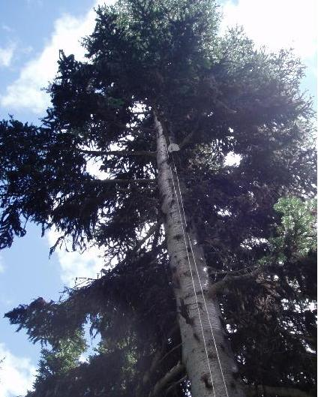
Figure 1. An air temperature sensor placed high up in a tree near Lake Ann (Photo by Jessica Lundquist).
Temperature sensors were deployed in three different transects within North Cascades National Park. The first transect was made up of twelve different campsites, all located just off of highway 20. A second transect consisted of five locations at varying elevations along the Maple Pass hiking trail. The final transect included six stops off of Thunder Creek hiking trail, also at varying elevations. A map of these sites can be seen in Figure 2.

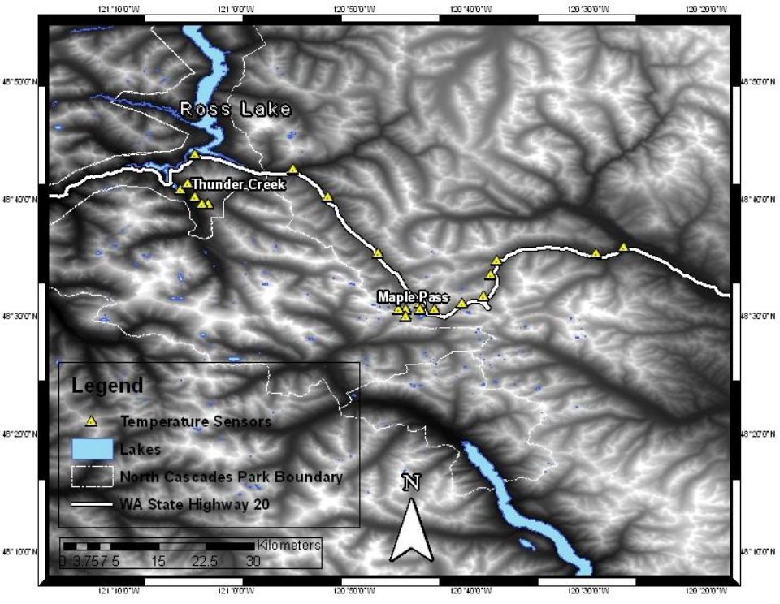
Once temperature sensors were retrieved, the validity of the data was assessed. This involved plotting sensor data both individually and collectively. Plotting individual data enabled large deviations to be filtered out. For example, when a temperature sensor the snow line, diurnal temperature cycles get buffered out resulting in a flat lining effect in the data. Therefore, any air sensors data that flat-lined in the winter were eliminated. An example of this is shown in Figure 3. Additionally, collective plots of multiple sensor data allowed deviations between that data to be deciphered. As a result of these quality control checks, three data points were removed from the data set.
Figure 2. Map of temperature sensors in North Cascades National Park.
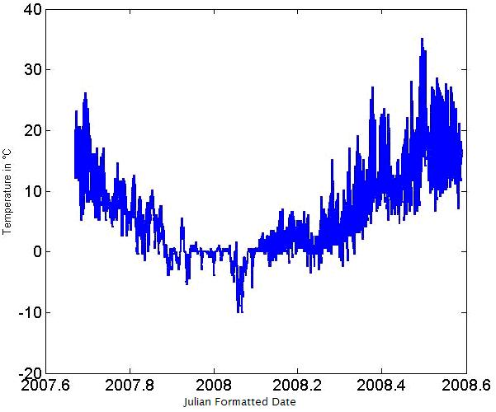
Figure 3. Thunder Creek air sensor at 364m that got buried in the snow from November 26, 2007 to February 9, 2008.
The lapse rate defined as the negative change in temperature with elevation gain for our case, was then determined for our North Cascades data set. First, the “annual” lapse rate was plotted, meaning the lapse rate across the year’s worth of data. This is shown in Figure 4, where the average lapse rate was found to be -4.7°C per km. Lapse rates were then broken down by season, as shown in Figure 5. From this we found that the seasonal lapse rates varied greatly, ranging from -2.3 to -5.8°C per km.
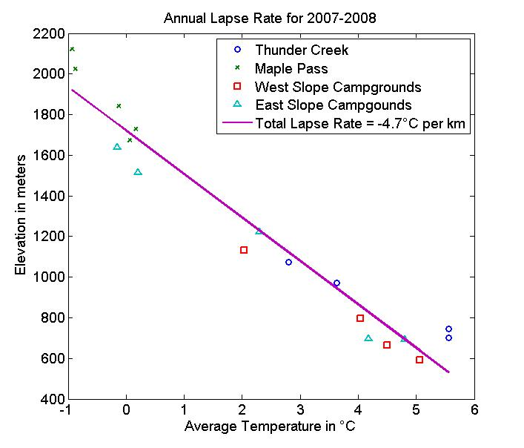
Figure 4. Lapse rate across the entire data set.
Additionally, lapse rates were assessed for each day. A normal daily lapse rate was defined to be between -2.5 and -10°C per km. Any daily lapse rates lying outside of this range were flagged and plotted to insure that these outliers were reflective of true data. In total 33 anomalies were found out of 327 days, or 10.1% of the total days. These 33 anomalies were then be broken down seasonally as follows: 1 in summer (3%), 13 in autumn (39%), 15 in winter (46%), and 4 in spring (12%). This tells us that the majority of temperature inversions occurred in the autumn or winter. An example of one of these anomalies is shown in Figure 6.

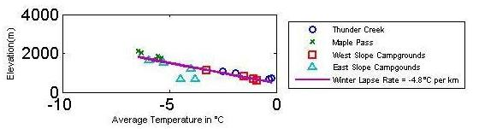
(a) Winter Lapse Rate
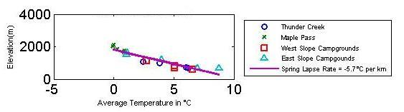
(b) Spring Lapse Rate
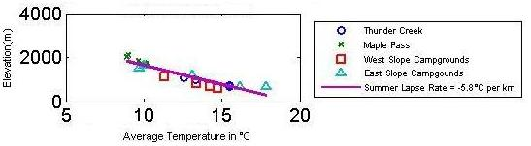
(c) Summer Lapse Rate
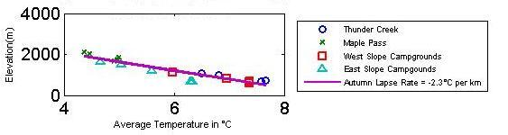
(d) Autumn Lapse Rate
Figure 5. Lapse rates for the data set broken down by season.
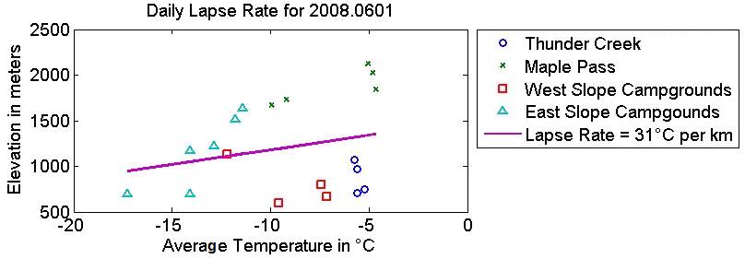
Figure 6. This inverted lapse rate occurred on January 22, 2008, where we find the higher elevations to have the warmest temperatures.
In addition to lapse rate analysis, empirical orthogonal function (EOF) analysis was also performed on the data set. This analysis enables us to look at how the data varies and/or co-varies both temporally and spatially. Figure 7 is an EOF analysis of the mean air temperature, showing how the data varies spatially. In this figure, the green line represents Highway 20 through North Cascades National Park, the magenta circles are positive (_____something???____), and the blue circles are negative (_____something???____), where large circles represent a lack of variance and small circles indicating correlation. Similarly, Figures 8 and 9 are EOF analyses of the minimum and maximum air temperatures, respectively. Figure 10 shows how the mean air temperatures vary temporally, with larger peaks indicating a lack of correlation and small peaks being high correlation. Figures 11 and 12 are temporal EOF plots for the minimum and maximum air temperatures, respectively.

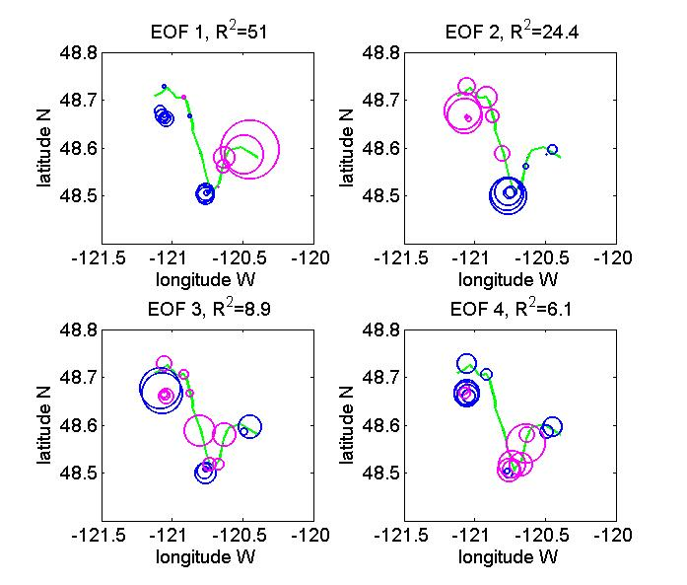
Figure 7. Spatial EOF of mean air temperature.
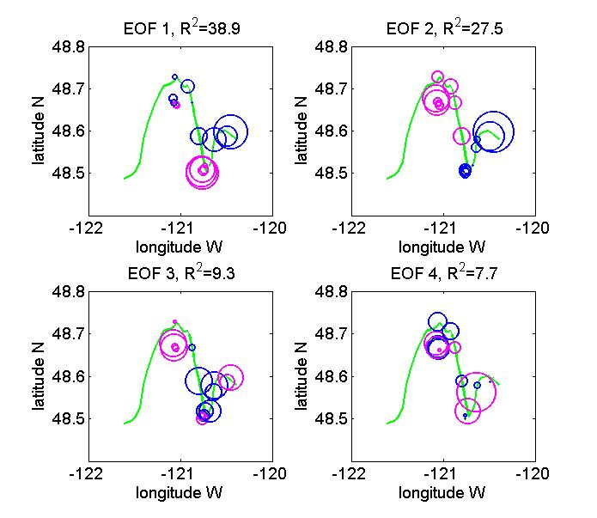
Figure 8. Spatial EOF of minimum air temperature.

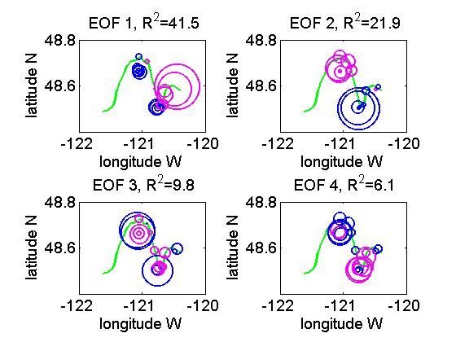
Figure 9. Spatial EOF of maximum air temperature.

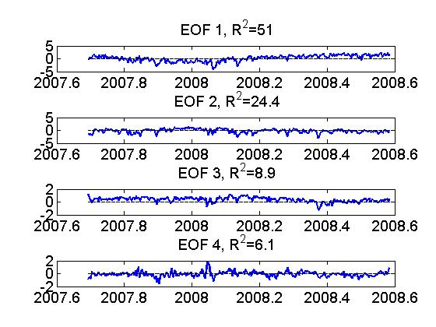
Figure 8. Temporal EOF of mean air temperature.
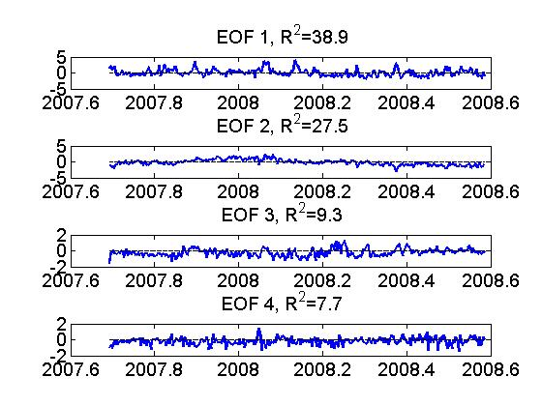
Figure 9. Temporal EOF of minimum air temperature.

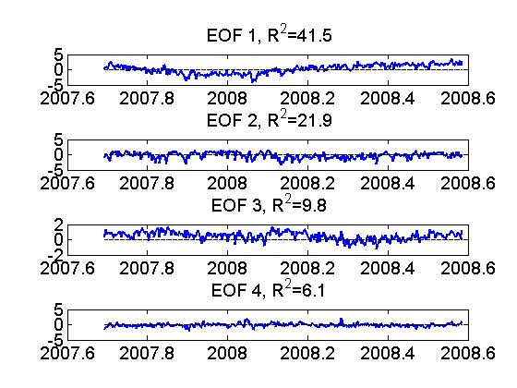
Figure 9. Temporal EOF of maximum air temperature.

