Untitled

Untitled

Alessandro Samuel-Rosa

## R Markdown

This is an R Markdown document. Markdown is a simple formatting syntax for authoring HTML, PDF, and MS Word documents. For more details on using R Markdown see [http://rmarkdown.rstudio.com](http://rmarkdown.rstudio.com/).

When you click the **Knit** button a document will be generated that includes both content as well as the output of any embedded R code chunks within the document. You can embed an R code chunk like this:

pander::pander(summary(cars))

|  |  |
| --- | --- |
| speed | dist |
| Min. : 4.0 | Min. : 2.00 |
| 1st Qu.:12.0 | 1st Qu.: 26.00 |
| Median :15.0 | Median : 36.00 |
| Mean :15.4 | Mean : 42.98 |
| 3rd Qu.:19.0 | 3rd Qu.: 56.00 |
| Max. :25.0 | Max. :120.00 |

## Including Plots

You can also embed plots, for example:

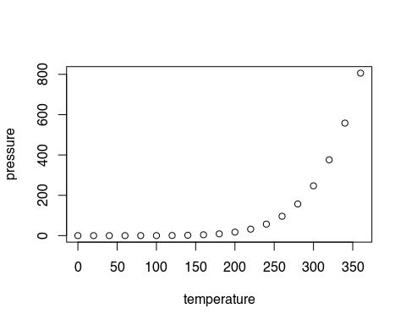

Note that the echo = FALSE parameter was added to the code chunk to prevent printing of the R code that generated the plot.