2683. Neighboring Bitwise XOR
A 0-indexed array derived with length n is derived by computing the bitwise XOR (⊕) of adjacent values in a binary array original of length n.
Specifically, for each index i in the range [0, n - 1]:
- If i = n - 1, then derived[i] = original[i] ⊕ original[0].
- Otherwise, derived[i] = original[i] ⊕ original[i + 1].
Given an array derived, your task is to determine whether there exists a valid binary array original that could have formed derived.
Return true if such an array exists or false otherwise.
- A binary array is an array containing only 0's and 1's
Example 1:
Input: derived = [1,1,0]
Output: true
Explanation: A valid original array that gives derived is [0,1,0].
derived[0] = original[0] ⊕ original[1] = 0 ⊕ 1 = 1
derived[1] = original[1] ⊕ original[2] = 1 ⊕ 0 = 1
derived[2] = original[2] ⊕ original[0] = 0 ⊕ 0 = 0
Example 2:
Input: derived = [1,1]
Output: true
Explanation: A valid original array that gives derived is [0,1].
derived[0] = original[0] ⊕ original[1] = 1
derived[1] = original[1] ⊕ original[0] = 1
Example 3:
Input: derived = [1,0]
Output: false
Explanation: There is no valid original array that gives derived.
Constraints:
- n == derived.length
- 1 <= n <=
- The values in derived are either 0's or 1's

Overview
We are given an integer array of length . This array is formed by taking a binary array (an array containing only and ) and computing the bitwise between adjacent elements in it.
For the last element in derived, the is calculated as:
Our task is to determine if there exists a binary array that could have generated the array.
To understand how to approach the problem, let’s recall some fundamental properties of :
- Commutativity:
The order in which you two numbers doesn’t matter.
- Associativity:
Grouping of operations doesn’t affect the result.
- Identity:
with leaves the number unchanged.
- Self-inverse:
XORing a number with itself results in .
- Inversion:
If , then:

These properties will help us manipulate equations in coming sections to solve the problem.

2683. Neighboring Bitwise XOR
/*
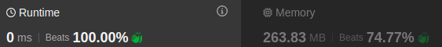
Xor properties
Time complexity: O(n)
Space complexity: O(1)
*/

class Solution {
public:
bool doesValidArrayExist(std::vector<int>& derived){
int total_xor=0;
for(auto& e: derived) total_xor^=e;
return total_xor==0;
}
};

2683. Neighboring Bitwise XOR
/*
Based on Xor properties: count #1s
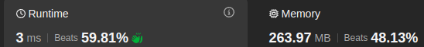
Time complexity: O(n)
Space complexity: O(1)
*/
class Solution {
public:
bool doesValidArrayExist(std::vector<int>& derived){
int s=std::accumulate(derived.begin(),derived.end(),0);
return s%2==0;
}
};

