1368. Minimum Cost to Make at Least One Valid Path in a Grid
Given an m x n grid. Each cell of the grid has a sign pointing to the next cell you should visit if you are currently in this cell. The sign of grid[i][j] can be:
- 1 which means go to the cell to the right. (i.e go from grid[i][j] to grid[i][j + 1])
- 2 which means go to the cell to the left. (i.e go from grid[i][j] to grid[i][j - 1])
- 3 which means go to the lower cell. (i.e go from grid[i][j] to grid[i + 1][j])
- 4 which means go to the upper cell. (i.e go from grid[i][j] to grid[i - 1][j])
Notice that there could be some signs on the cells of the grid that point outside the grid.
You will initially start at the upper left cell (0, 0). A valid path in the grid is a path that starts from the upper left cell (0, 0) and ends at the bottom-right cell (m - 1, n - 1) following the signs on the grid. The valid path does not have to be the shortest.
You can modify the sign on a cell with cost = 1. You can modify the sign on a cell one time only.
Return the minimum cost to make the grid have at least one valid path.
Example 1:
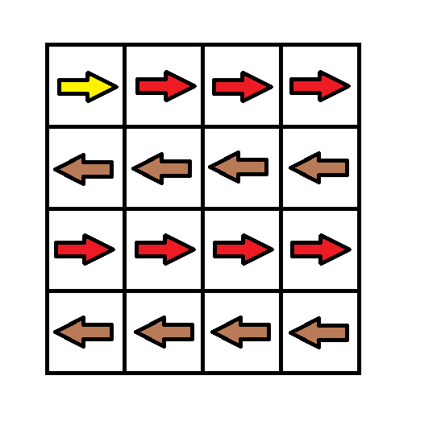

Input: grid = [[1,1,1,1],[2,2,2,2],[1,1,1,1],[2,2,2,2]]
Output: 3
Explanation: You will start at point (0, 0).
The path to (3, 3) is as follows. (0, 0) --> (0, 1) --> (0, 2) --> (0, 3) change the arrow to down with cost = 1 --> (1, 3) --> (1, 2) --> (1, 1) --> (1, 0) change the arrow to down with cost = 1 --> (2, 0) --> (2, 1) --> (2, 2) --> (2, 3) change the arrow to down with cost = 1 --> (3, 3)
The total cost = 3.
Example 2:
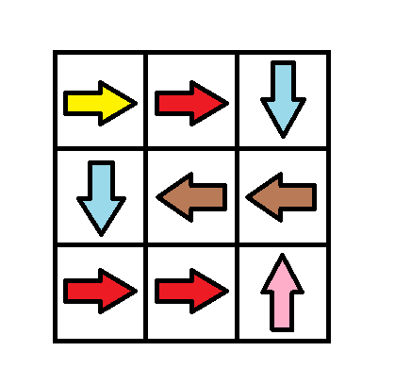

Input: grid = [[1,1,3],[3,2,2],[1,1,4]]
Output: 0
Explanation: You can follow the path from (0, 0) to (2, 2).
Example 3:
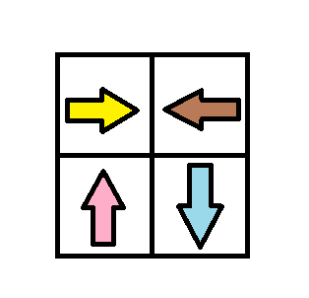

Input: grid = [[1,2],[4,3]]
Output: 1

Constraints:
- m == grid.length
- n == grid[i].length
- 1 <= m, n <= 100
- 1 <= grid[i][j] <= 4

1368. Minimum Cost to Make at Least One Valid Path in a Grid
/*
Dijkstra
Time complexity: O(mnlog(mn))
Space complexity: O(2mn)
*/
typedef std::vector<int> vi;
typedef std::vector<vi> vvi;
typedef std::pair<int,int> ii;
typedef std::pair<int,ii> iii;
typedef std::vector<iii> viii;

class Solution {
private:
// Directions for movement: right, left, down, up
vvi directions= {{0,1},{0,-1},{1,0},{-1,0}};
public:
int minCost(vvi& grid){
int m=grid.size(),n=grid[0].size();

vvi min_costs(m,vi(n,INT_MAX));
min_costs[0][0]=0;

std::priority_queue<iii,viii,std::greater<iii>> min_heap;
min_heap.push({0,{0,0}});

while(!min_heap.empty()){
// Pick the cell with minimum cost
auto[cur_cost,cur_cell]=min_heap.top();
min_heap.pop();

int cur_row=cur_cell.first;
int cur_col=cur_cell.second;

if(cur_row==m-1 && cur_col==n-1) return min_costs[m-1][n-1];

for(int i=0;i<4;++i){
vi dir=directions[i];
int new_row=cur_row+dir[0];
int new_col=cur_col+dir[1];

if(new_row<0 || new_col<0 || new_row>m-1 || new_col>n-1) continue;

// Update the current cost of the current cell
// If we need to change directions add1 to the current cost
int new_cost=cur_cost+(grid[cur_row][cur_col]!=(i+1));

// Path relaxation: Update the cost if we found a better path
if(min_costs[new_row][new_col]>new_cost){
min_costs[new_row][new_col]=new_cost;
min_heap.push({new_cost,{new_row,new_col}});
}
}
}
return min_costs[m-1][n-1];
}
};

1368. Minimum Cost to Make at Least One Valid Path in a Grid

Approach#2: 0-1 Breadth-First Search
Dijkstra's algorithm works well for finding the shortest path, but our problem has a unique feature: the path costs are either or . This is key because any path with only 0-cost edges, no matter how long, will always be better than one that uses even a single 1-cost edge. Therefore, it makes sense to prioritize exploring 0-cost edges first. Only after all 0-cost edges have been explored, should we move on to the 1-cost edges. This insight leads us to a modification of the Breadth-First Search (BFS) algorithm, known as 0-1 BFS.
In 0-1 BFS, we adjust the traditional BFS by using a deque (double-ended queue) instead of a regular queue. The deque allows us to prioritize 0-cost edges more efficiently. Each element of the deque will store the row and column indices of a cell, and we will maintain a grid to track the minimum cost to reach each cell.
As we visit each cell, we evaluate its four neighboring cells. If moving to a neighbor doesn’t require a sign change (i.e., the move is a 0-cost move), we add that neighbor to the front of the deque because we want to explore it immediately. On the other hand, if a sign change is required (making it a 1-cost move), we add the neighbor to the back of the deque, ensuring it gets explored later, after all the 0-cost moves.
For each neighbor we explore, we calculate the cost to reach it and compare it to the current value in the grid. If the calculated cost is lower, we update with the new, cheaper value.
Once the BFS traversal completes and all cells have been processed, the minimum cost to reach the bottom-right corner will be stored in . We return this value as the solution to the problem.
The below slideshow demonstrates the algorithm in action:

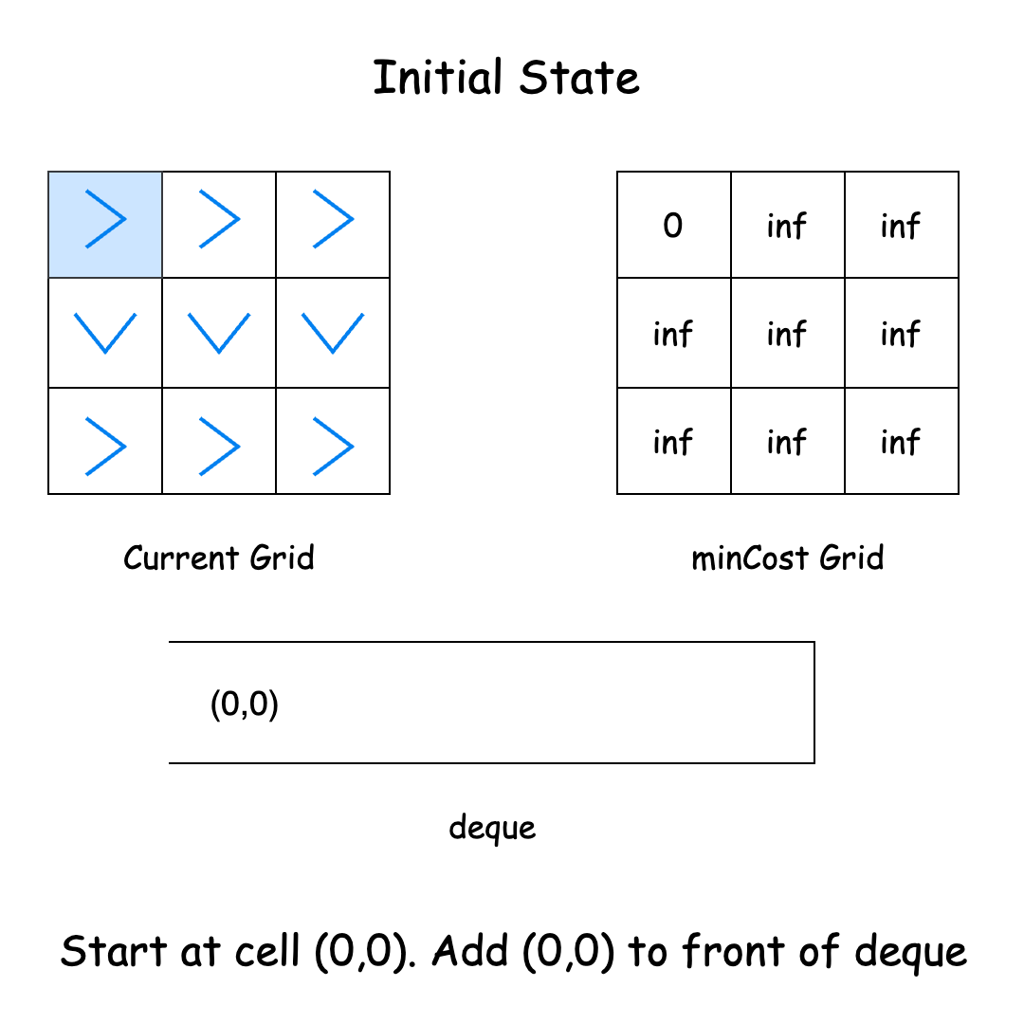

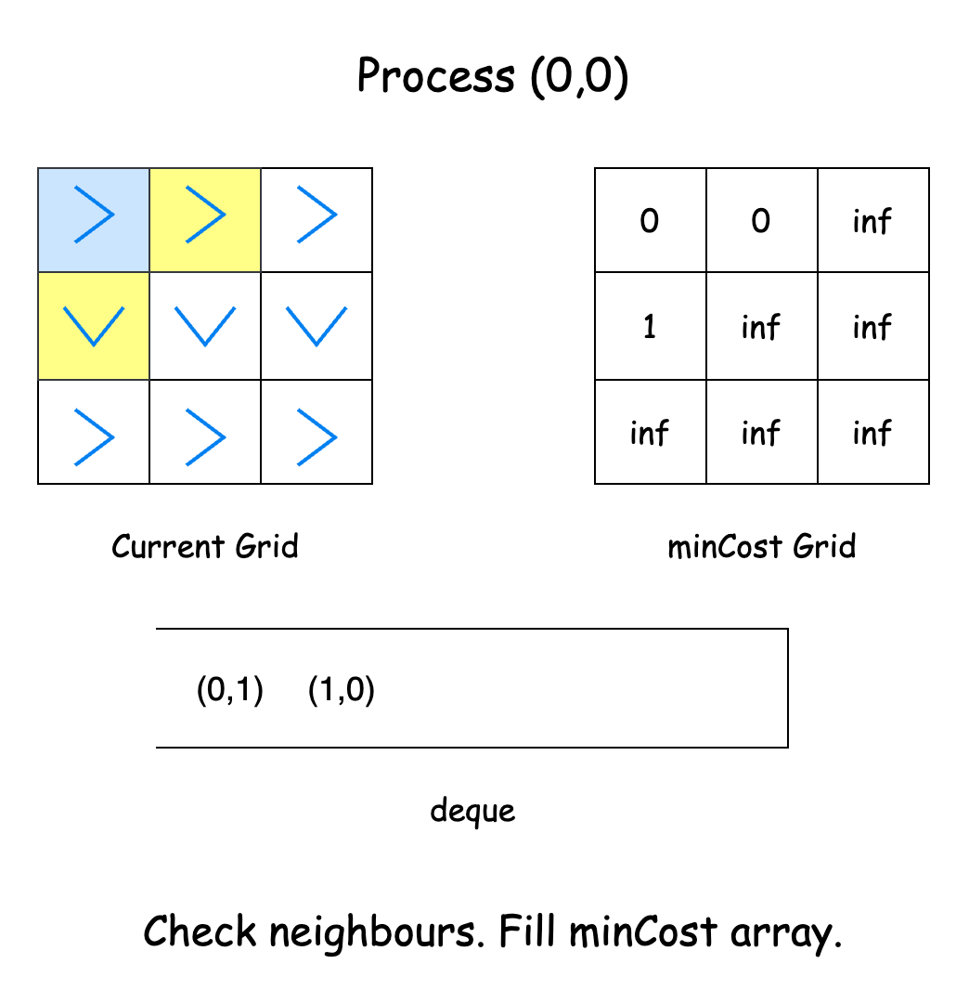

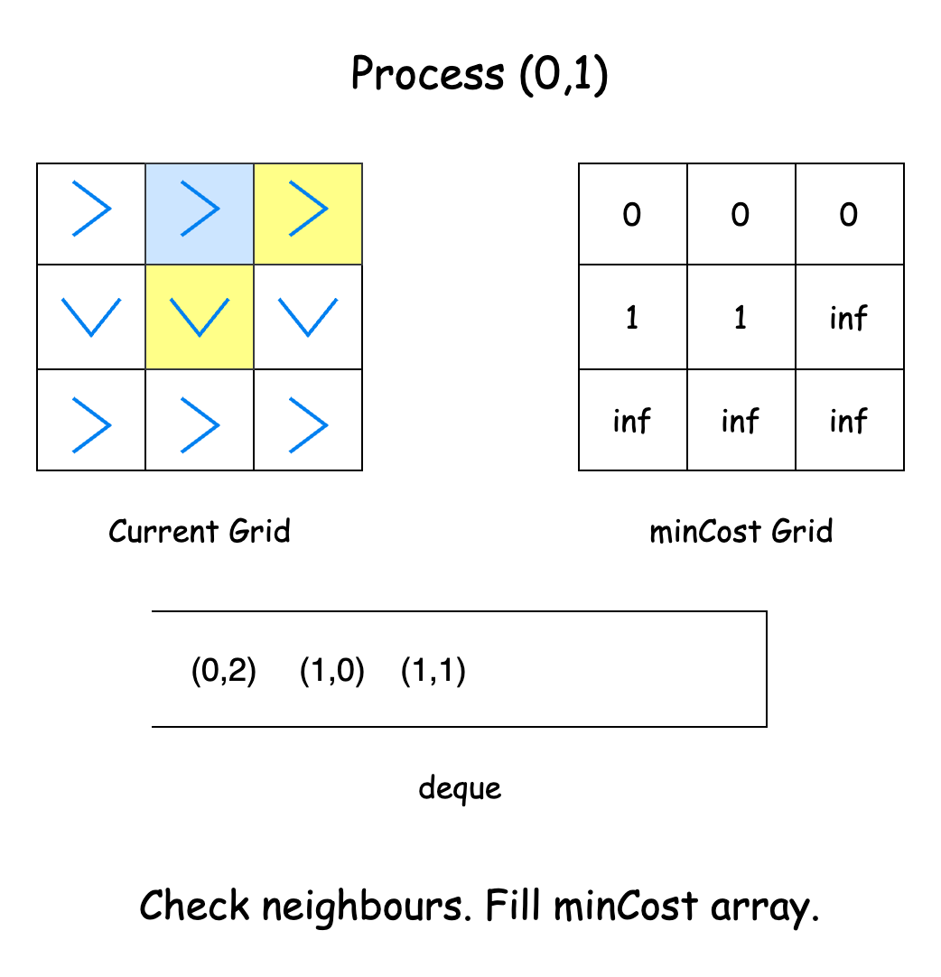

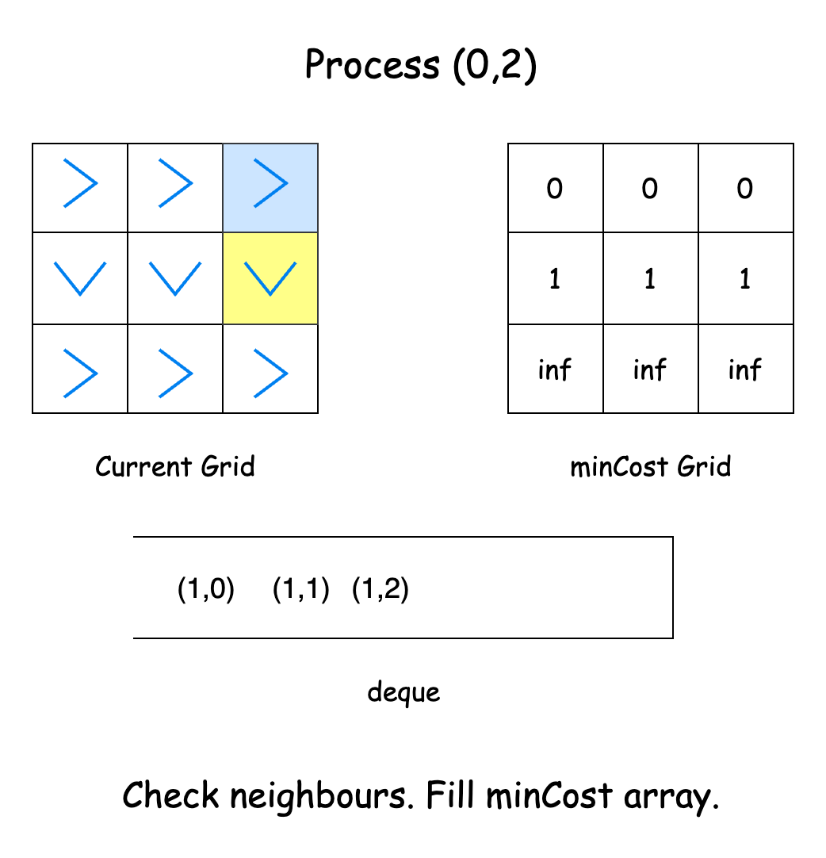

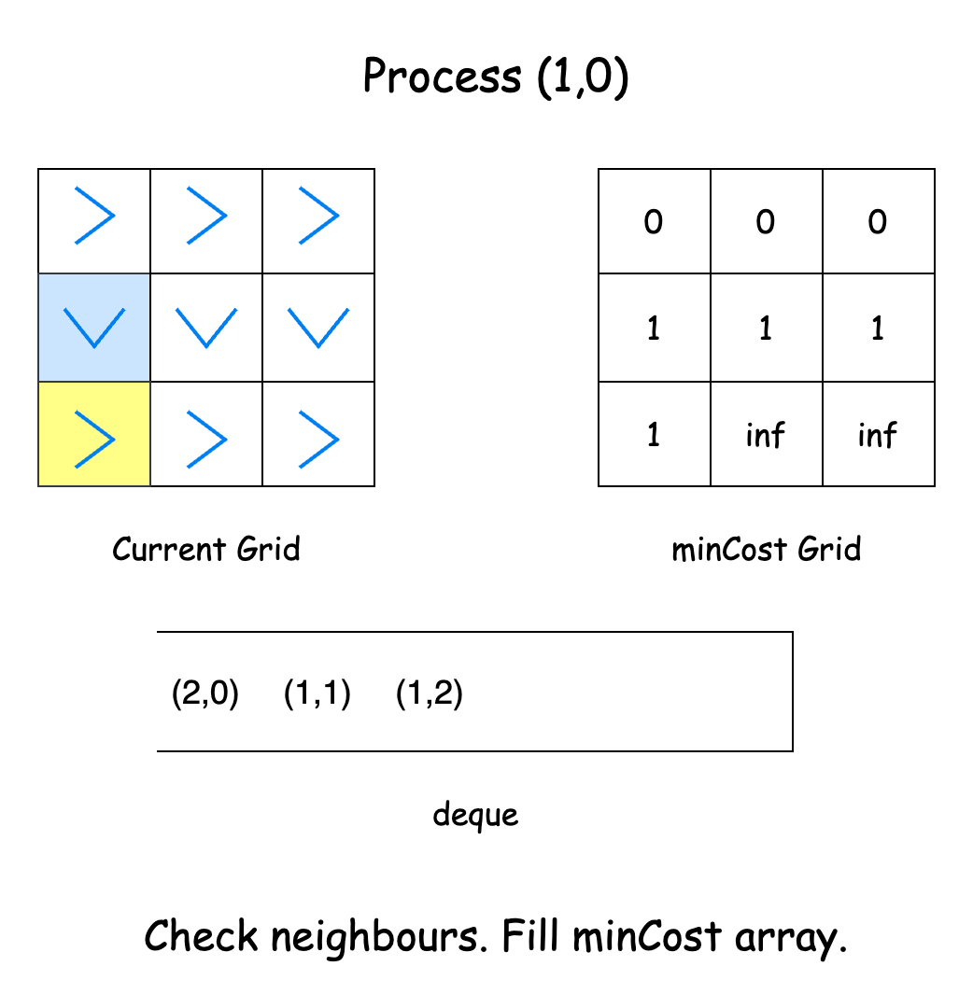

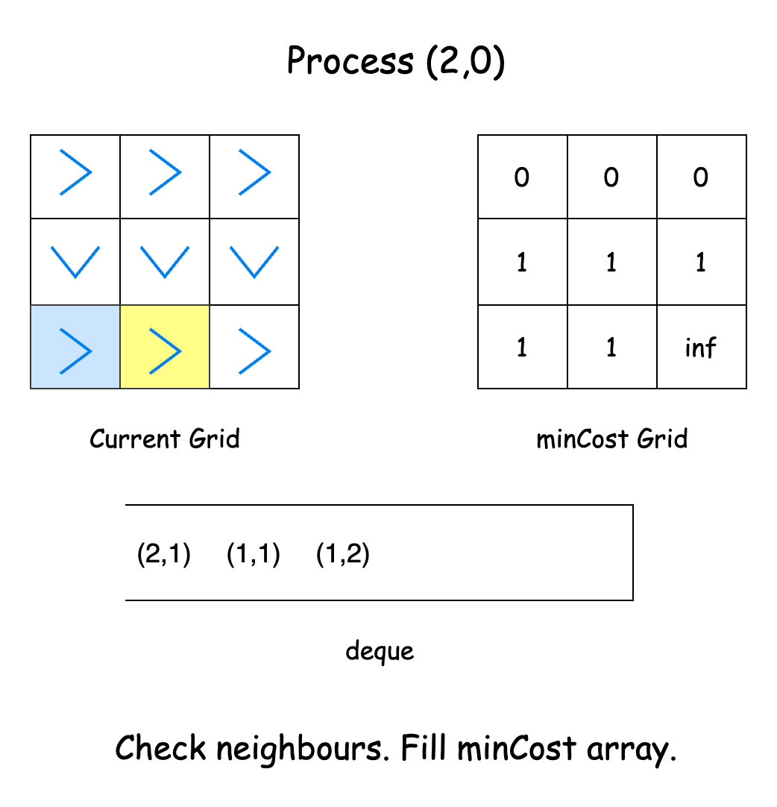

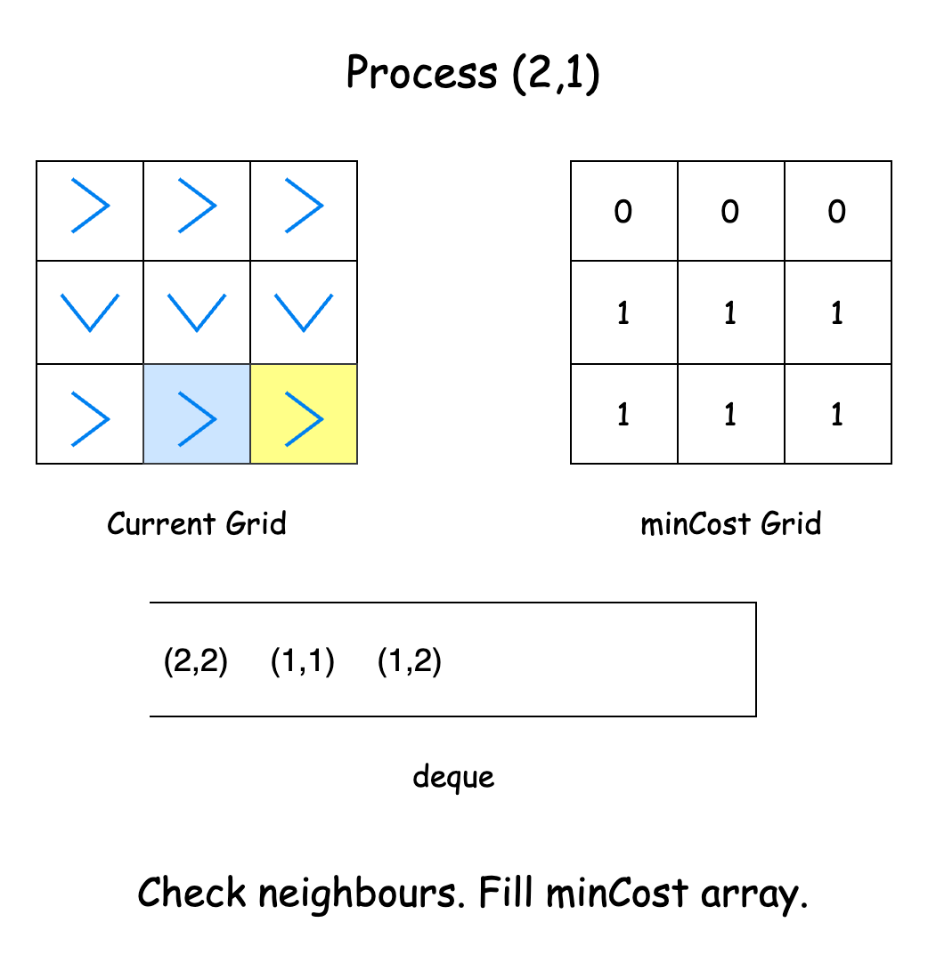

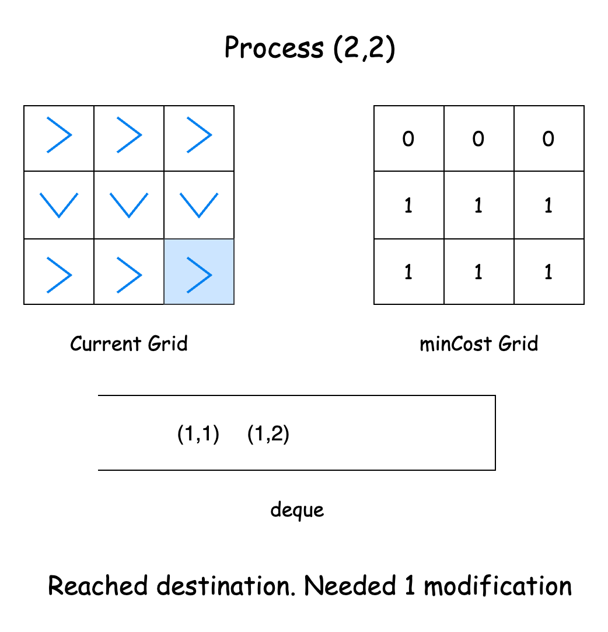

1368. Minimum Cost to Make at Least One Valid Path in a Grid
/*
0/1 BFS
Time complexity: O(mn)
Space complexity: O(2mn)
*/

typedef std::vector<int> vi;
typedef std::vector<vi> vvi;
typedef std::pair<int,int> ii;
class Solution {
private:
// Directions for movement: right, left, down, up
vvi directions= {{0,1},{0,-1},{1,0},{-1,0}};
public:
int minCost(vvi& grid){
int m=grid.size(),n=grid[0].size();

vvi min_costs(m,vi(n,INT_MAX));
min_costs[0][0]=0;

std::deque<ii> deq; // {row,col}
deq.push_back({0,0});

while (!deq.empty()){
auto [cur_row,cur_col]=deq.front();
deq.pop_front();

if(cur_row==m-1 && cur_col==n-1) return min_costs[m-1][n-1];

for (int i=0;i<4;++i){
vi dir=directions[i];
int new_row=cur_row+dir[0];
int new_col=cur_col+dir[1];

if(new_row<0 || new_col<0 || new_row>m-1 || new_col>n-1) continue;

// Compute the cost of the current cell
// 1: if we need to change direction
// 0: otherwise
int cost=grid[cur_row][cur_col]!=(i+1);

// If the cost at the new cell is greater than the cost of the current
// cell + the cost of the current cell, then update the cost of the new cell
if(min_costs[new_row][new_col]>min_costs[cur_row][cur_col]+cost){
min_costs[new_row][new_col]=min_costs[cur_row][cur_col]+cost;

// If the we need to change direction from the current cell to
// reach the new cell, push the new cell to the back to deal with it later
if(cost==1) deq.push_back({new_row,new_col});
// Otherwise, push it to the front to deal with it as soon as possible
else deq.push_front({new_row,new_col});
}
}
}

return min_costs[m-1][n-1];
}
};

