407. Trapping Rain Water II
Given an m x n integer matrix heightMap representing the height of each unit cell in a 2D elevation map, return the volume of water it can trap after raining.
Example 1:
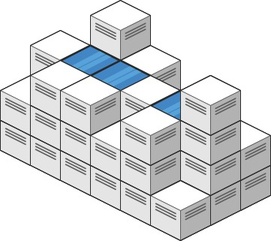

Input: heightMap = [[1,4,3,1,3,2],[3,2,1,3,2,4],[2,3,3,2,3,1]]
Output: 4
Explanation: After the rain, water is trapped between the blocks.
We have two small ponds 1 and 3 units trapped.
The total volume of water trapped is 4.

Example 2:
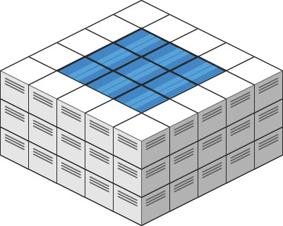

Input: heightMap = [[3,3,3,3,3],[3,2,2,2,3],[3,2,1,2,3],[3,2,2,2,3],[3,3,3,3,3]]
Output: 10
Constraints:
- m == heightMap.length
- n == heightMap[i].length
- 1 <= m, n <= 200
- 0 <= heightMap[i][j] <= 2 * 104

407. Trapping Rain Water II
/*
BFS + Min heap
Time compelxity: O(2mn+mnlog(mn))
Space compelxity: O(2mn)
*/

typedef std::pair<int,int> ii;
typedef std::pair<int,ii>iii;
typedef std::vector<int> vi;
typedef std::vector<vi> vvi;
typedef std::vector<ii> vii;
typedef std::vector<iii> viii;

class Solution {
public:
int trapRainWater(vector<vector<int>>& heightMap){
int m=heightMap.size();
int n=heightMap[0].size();

// Directions for movement: right, left, down, up
vvi directions={{0,1},{0,-1},{1,0},{-1,0}};

// To mark visited cells
vvi visited(m,vi(n,0));

// Min heap to process cels in increasing height order
std::priority_queue<iii,viii,std::greater<iii>> min_heap;

/*Add the boundary to yhe min heap*/
// Add the first and the last row the the min heap
for(int i=0;i<n;++i){
min_heap.push({heightMap[0][i],{0,i}});
min_heap.push({heightMap[m-1][i],{m-1,i}});
// and mark their cells as visited
visited[0][i]=visited[m-1][i]=1;
}

// Add the first and the last column to the min heap
for(int i=0;i<m;++i){
min_heap.push({heightMap[i][0],{i,0}});
min_heap.push({heightMap[i][n-1],{i,n-1}});
// and mark their cells as visited
visited[i][0]=visited[i][n-1]=1;
}

int ans=0;
while(!min_heap.empty()){
// Get the cell with min height from the boundary
auto[cur_height,cur_cell]=min_heap.top();
min_heap.pop();
int cur_row=cur_cell.first;
int cur_col=cur_cell.second;
// Explore the four neighbor of the current cell
for(auto& dir: directions){
// For each neighbor
int row=cur_row+dir[0];
int col=cur_col+dir[1];
// If it is not in the grid, no need to process it and pass to next
if(row<0 || col<0 || row>m-1 || col>n-1) continue;

// If it is visited, no need to process it and pass to next
if(visited[row][col]) continue;

/*Otherwise*/
// Get its height
int height=heightMap[row][col];

// If its height is greater than or equal to the height of the current cell
// means, it can not trap water
// Otherwise, it can trap water
// Add the volume to the answer
ans+=std::max(0,cur_height-height);

// Propagate the higher height max(current height, neighbor's height)
// Add the neighbor to the min heap with the new height
min_heap.push({std::max(cur_height,height),{row,col}});
// Mark it as visited
visited[row][col]=1;
}
}
return ans;
}
};

