2661. First Completely Painted Row or Column
You are given a 0-indexed integer array arr, and an m x n integer matrix mat. arr and mat both contain all the integers in the range [1, m * n].
Go through each index i in arr starting from index 0 and paint the cell in mat containing the integer arr[i].
Return the smallest index i at which either a row or a column will be completely painted in mat.
Example 1:
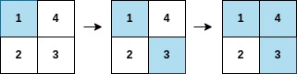

Input: arr = [1,3,4,2], mat = [[1,4],[2,3]]
Output: 2
Explanation: The moves are shown in order, and both the first row and second column of the matrix become fully painted at arr[2].
Example 2:
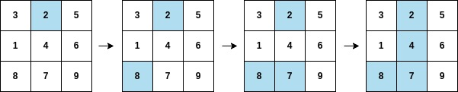
Input: arr = [2,8,7,4,1,3,5,6,9], mat = [[3,2,5],[1,4,6],[8,7,9]]
Output: 3
Explanation: The second column becomes fully painted at arr[3].
Constraints:
- m == mat.length
- n = mat[i].length
- arr.length == m * n
- 1 <= m, n <= 105
- 1 <= m * n <= 105
- 1 <= arr[i], mat[r][c] <= m * n
- All the integers of arr are unique.
- All the integers of mat are unique

Overview
We are given two inputs: an array arr and a matrix mat. The array arr is a list of numbers, and the matrix mat is a grid where each cell contains one of these numbers. Both arr and mat contain all integers from 1 to m⋅n, where m is the number of rows in the matrix and n is the number of its columns.
Our goal is to simulate a process where we "paint" the cells of the matrix in the order defined by arr. Starting from the first number in arr, we find the corresponding cell in mat and mark it as painted. As we progress through arr, more cells in mat will become painted.
We need to find the smallest index i in arr such that, after painting the cell corresponding to arr[i], either:
- An entire row in the matrix becomes completely painted (all cells in the row are marked).
- An entire column in the matrix becomes completely painted (all cells in the column are marked).
Note: Each number in arr corresponds to a unique cell in mat. This means no number is repeated, and every cell in the matrix will eventually be painted.

2661. First Completely Painted Row or Column
/*
Mapping+Counting
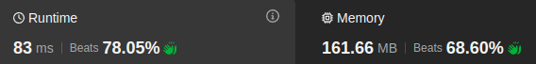
Time complexity: O(2mn)
Space complexity: O(mn+(m+n))
*/
typedef std::vector<int> vi;
typedef std::vector<vi> vvi;

class Solution {
public:
int firstCompleteIndex(vi& arr, vvi& mat) {
int m=mat.size();
int n=mat[0].size();
// Preprocessing by each cell value in the matrix to its position (row,col)
vvi val_pos(m*n+1); // Store cell_value: (row,col)
for(int row=0;row<m;++row){
for(int col=0;col<n;++col){
int cell_value=mat[row][col];
val_pos[cell_value]={row,col};
}
}
// Create frequency array:
// --rows--columns--
// [0~(m-1)~m~(m+n-1)]
vi freq(m+n,0);

// For each row and column, determine the number of painting
for(int i=0;i<m*n;++i){
// Element to paint
int e=arr[i];
// Lookup its position in matrix
int row=val_pos[e][0];
int col=val_pos[e][1];
// Increment the row and column that belong to the element to paint
freq[row]++;
freq[m+col]++;
// If the whole row is painted, or the whole column is painted return the index
if(freq[row]==n || freq[m+col]==m) return i;
}
// Never reached, because it is guarantee that we have answer
return m+n-1;
}};

2661. First Completely Painted Row or Column
/*
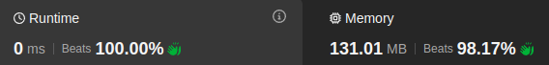
Reverse mapping
Time complexity: O(3mn)
Space complexity: O(mn)
*/
typedef std::vector<int> vi;
typedef std::vector<vi> vvi;
class Solution {
public:
int firstCompleteIndex(vi& arr, vvi& mat) {
int m=mat.size();
int n=mat[0].size();
// Store the index of each number in the arr
vi val_pos(m*n+1);
for(int i=0;i<m*n;++i){
val_pos[arr[i]]=i;
}
int ans=INT_MAX;
// Determines the smallest index row completely painted
for(int row=0;row<m;++row){
// Tracks the greatest index in this row
int max_row_index=INT_MIN;
for(int col=0;col<n;++col){
int e=mat[row][col];
max_row_index=max(max_row_index,val_pos[e]);
}
// Update result with the minimum index where this row is fully
// painted
ans=std::min(ans,max_row_index);
}
// Determines the smallest index column completely painted
for(int col=0;col<n;++col){
// Tracks the greatest index in this column
int max_col_index=INT_MIN;
for(int row=0;row<m;++row){
int e=mat[row][col];
max_col_index=max(max_col_index,val_pos[e]);
}
// Update the answer with the minimum index where this column is fully
// painted
ans=std::min(ans,max_col_index);
}
return ans;
}};

