2017. Grid Game
You are given a 0-indexed 2D array grid of size 2 x n, where grid[r][c] represents the number of points at position (r, c) on the matrix. Two robots are playing a game on this matrix.
Both robots initially start at (0, 0) and want to reach (1, n-1). Each robot may only move to the right ((r, c) to (r, c + 1)) or down ((r, c) to (r + 1, c)).
At the start of the game, the first robot moves from (0, 0) to (1, n-1), collecting all the points from the cells on its path. For all cells (r, c) traversed on the path, grid[r][c] is set to 0. Then, the second robot moves from (0, 0) to (1, n-1), collecting the points on its path. Note that their paths may intersect with one another.
The first robot wants to minimize the number of points collected by the second robot. In contrast, the second robot wants to maximize the number of points it collects. If both robots play optimally, return the number of points collected by the second robot.
Example 1:
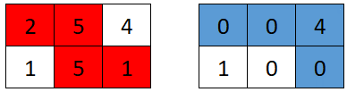

Input: grid = [[2,5,4],[1,5,1]]
Output: 4
Explanation: The optimal path taken by the first robot is shown in red, and the optimal path taken by the second robot is shown in blue.
The cells visited by the first robot are set to 0.
The second robot will collect 0 + 0 + 4 + 0 = 4 points.
Example 2:
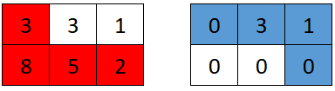

nput: grid = [[3,3,1],[8,5,2]]
Output: 4
Explanation: The optimal path taken by the first robot is shown in red, and the optimal path taken by the second robot is shown in blue.
The cells visited by the first robot are set to 0.
The second robot will collect 0 + 3 + 1 + 0 = 4 points.
Example 3:
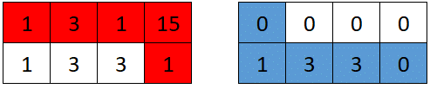

Input: grid = [[1,3,1,15],[1,3,3,1]]
Output: 7
Explanation: The optimal path taken by the first robot is shown in red, and the optimal path taken by the second robot is shown in blue.
The cells visited by the first robot are set to 0.
The second robot will collect 0 + 1 + 3 + 3 + 0 = 7 points.

Constraints:
- grid.length == 2
- n == grid[r].length
- 1 <= n <= 5 * 104
- 1 <= grid[r][c] <= 105

Overview
We are given a matrix grid containing 2 rows and n columns. Each cell contains a value representing the number of points for that cell in the grid. Two robots are playing a game where they are initially positioned at (0, 0) and aim to reach (1, n - 1).
Each robot can only move right or down in the grid. The task is to compute the points collected by the second robot, given the strategies of both robots.
The challenge is that the first robot moves first, and its goal is to reduce the points available for the second robot. The second robot then takes the best path to collect as many points as possible.

2017. Grid Game
/*
Prefix sum+suffix sum+sliding path
Time complexity: O(2n)
Space compelxity: O(1)
*/

typedef long long ll;
class Solution{
public:
ll gridGame(std::vector<std::vector<int>>& grid) {
int m=grid.size(); // m=2
int n=grid[0].size();

// Suffix sum for upper row
ll upper_portion_sum=std::accumulate(grid[0].begin(),grid[0].end(),0LL);

// Prefix sum for lower row
ll lower_portion_sum=0;

// Slide the path
ll ans=LONG_LONG_MAX;
for(int i=0;i<n;++i){
// Substract the current value in the 1st row from the upper row's suffix sum
upper_portion_sum-=grid[0][i];

// Update the answer by minmizing the maximum of boths sums
ans=std::min(ans,std::max(upper_portion_sum,lower_portion_sum));

// Add the current value in the 2nd row to the lower row's prefix sum
lower_portion_sum+=grid[1][i];
}
return ans;
}
};

