802. Find Eventual Safe States
There is a directed graph of n nodes with each node labeled from 0 to n - 1. The graph is represented by a 0-indexed 2D integer array graph where graph[i] is an integer array of nodes adjacent to node i, meaning there is an edge from node i to each node in graph[i].
A node is a terminal node if there are no outgoing edges. A node is a safe node if every possible path starting from that node leads to a terminal node (or another safe node).
Return an array containing all the safe nodes of the graph. The answer should be sorted in ascending order.
Example 1:
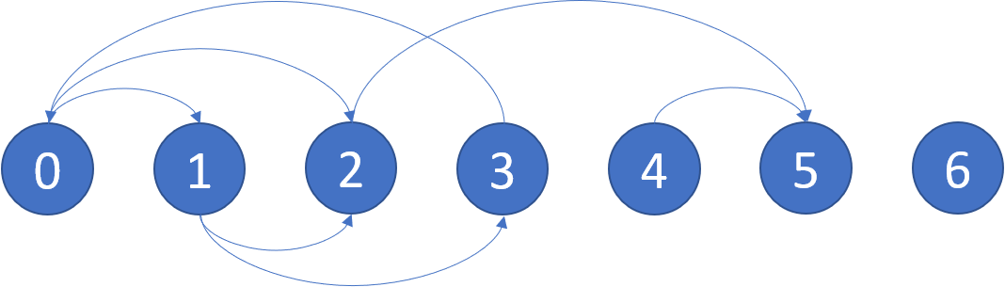
Input: graph = [[1,2],[2,3],[5],[0],[5],[],[]]
Output: [2,4,5,6]
Explanation: The given graph is shown above.
Nodes 5 and 6 are terminal nodes as there are no outgoing edges from either of them.
Every path starting at nodes 2, 4, 5, and 6 all lead to either node 5 or 6.
Example 2:
Input: graph = [[1,2,3,4],[1,2],[3,4],[0,4],[]]
Output: [4]
Explanation:
Only node 4 is a terminal node, and every path starting at node 4 leads to node 4.

Constraints:
- n == graph.length
- 1 <= n <= 104
- 0 <= graph[i].length <= n
- 0 <= graph[i][j] <= n - 1
- graph[i] is sorted in a strictly increasing order.
- The graph may contain self-loops.
- The number of edges in the graph will be in the range [1, 4 * 104].

Overview
We are given a directed graph of n nodes with each node labeled from 0 to n - 1. The graph is represented by a 2D integer array graph where graph[i] is an integer array of nodes that have an incoming edge from node i.
The problem states that a node is a terminal node if there are no outgoing edges. A node is a safe node if every possible path starting from that node leads to a terminal node (or another safe node).
Our task is to return a sorted array of all the safe nodes of the graph.

802. Find Eventual Safe States
/*
BFS-Topological sort (Kahn's algorithm)
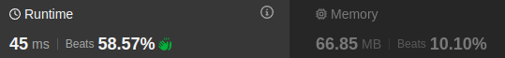
Time complexity: O(n+m)
Space complexity: O(n+m)
n: #nodes
m: #edges

*/
typedef std::vector<int> vi;
typedef std::vector<std::vector<int>> vvi;

class Solution {
public:
vi eventualSafeNodes(vvi& graph){
int n=graph.size();

vvi g(n); // <O(n),O(n+m)>
std::vector<int> indegree(n,0); // <O(n),O(n)>
// <O(m),O(1)>
for(int v=0;v<n;++v){
for(auto& u: graph[v]){
g[u].push_back(v);
indegree[v]++;
}
}

// <O(n),O(n)>
std::queue<int> q;
for(int node=0;node<n;++node){
if(indegree[node]==0) q.push(node);
}

vi is_safe(n,0); // <O(n),O(n)>
// <O(m),O(1)>
while(!q.empty()){
int node=q.front();
q.pop();

is_safe[node]=1;

for(auto& u: g[node]){
indegree[u]--;
if(indegree[u]==0) q.push(u);
}
}

// <O(n),O(n)>
vi ans;
for(int node=0;node<n;++node){
if(is_safe[node]) ans.push_back(node);
}

return ans;
}
};

802. Find Eventual Safe States
/*
DFS traversal
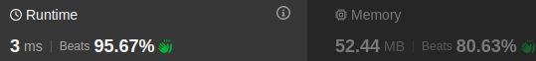
Time complexity: O(n+m)
Space complexity: O(3n)
n: #nodes
m: #edges
*/
typedef std::vector<int> vi;
typedef std::vector<std::vector<int>> vvi;
class Solution {
public:
vi eventualSafeNodes(vvi& graph){
int n=graph.size();
vi visited(n,0),has_back_edge(n,0);
// Detect cycles
// Return true, if a node u belongs to a cycle.
// False, otherwise
auto dfs=[&](int u,auto& self)->bool{
visited[u]=1;
has_back_edge[u]=1;
for(auto& v: graph[u]){
// Cycle found or a back edge to v exists
if(!visited[v] && self(v,self) || has_back_edge[v]) return true;
}
// The ingoing edge to the current node u is not a back edge
has_back_edge[u]=0;

// current node u does not lead to a cycle
return false;
};
for(int node=0;node<n;++node){
if(visited[node]) continue;
dfs(node,dfs);
}
vi ans;
for(int node=0;node<n;++node){
if(!has_back_edge[node]) ans.push_back(node);
}return ans;}};

