684. Redundant Connection
n this problem, a tree is an undirected graph that is connected and has no cycles.
You are given a graph that started as a tree with n nodes labeled from 1 to n, with one additional edge added. The added edge has two different vertices chosen from 1 to n, and was not an edge that already existed. The graph is represented as an array edges of length n where edges[i] = [ai, bi] indicates that there is an edge between nodes ai and bi in the graph.
Return an edge that can be removed so that the resulting graph is a tree of n nodes. If there are multiple answers, return the answer that occurs last in the input.
Example 1:
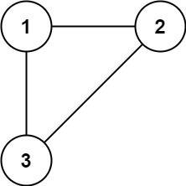 | Input: edges = [[1,2],[1,3],[2,3]]  Output: [2,3]
Example 2:
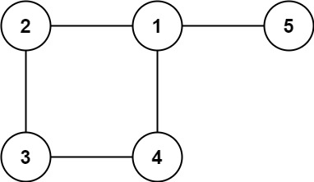 | Input: edges = [[1,2],[2,3],[3,4],[1,4],[1,5]]  Output: [1,4]

Constraints:
- n == edges.length
- 3 <= n <= 1000
- edges[i].length == 2
- 1 <= ai < bi <= edges.length
- ai != bi
- There are no repeated edges.
- The given graph is connected.

Overview
We are given a graph consisting of N nodes and N−1 edges, which means the graph initially forms a tree. A tree is a special type of graph that is connected (there is a path between any two nodes) and acyclic (it does not contain any cycles). However, a new edge is added to the tree, connecting two nodes that are already part of the graph. This new edge creates a cycle because there are now two distinct paths between some pairs of nodes. As a result, the graph is no longer a tree but a single-cycle graph.
Our goal is to identify the edge that, if removed, will restore the graph to its original state as a tree. Since the tree must be connected and acyclic, removing any edge from the cycle will break the cycle and turn the graph into a tree. However, if there are multiple edges that can be removed to achieve this, we are required to return the edge that appears last in the given list of edges.

684. Redundant Connection
/*
Union Find: Kruskal's MST algorithm
Time complexity: O(nα(n))
Space complexity: O(3n)
n: #node = #edges
*/
typedef std::vector<int> vi;
typedef std::vector<vi> vvi;

class DSU{
public:
vi parent;
vi group;

DSU(int _N){
parent.resize(_N);
group.resize(_N,1);
for(int i=0;i<_N;++i){
parent[i]=i;
}
}

int find(int p){
if(p==parent[p]) return p;
return parent[p]=find(parent[p]);
}

bool unify(int p,int q){
int parent_p=find(p);
int parent_q=find(q);
if(parent_p==parent_q) return false;

if(group[parent_p]<group[parent_q]){
group[parent_q]+=group[parent_p];
group[parent_p]=1;
parent[parent_p]=parent_q;

}
else{
group[parent_p]+=group[parent_q];
group[parent_q]=1;
parent[parent_q]=parent_p;
}

return true;
}
};

class Solution {
public:
vi findRedundantConnection(vvi& edges) {
int n=edges.size();

DSU dsu=DSU(n);

for(auto& edge: edges){
int u=--edge[0];
int v=--edge[1];
if(!dsu.unify(u,v)) return {++u,++v};
}

return {};
}
};

