145. Binary Tree Postorder Traversal
Given the root of a binary tree, return the postorder traversal of its nodes' values.
Example 1:
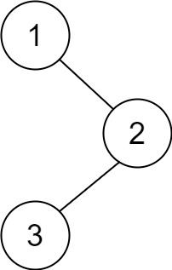 | Input: root = [1,null,2,3]  Output: [3,2,1]
Example 2:
Input: root = []
Output: []
Example 3:
Input: root = [1]
Output: [1]
Example 4:
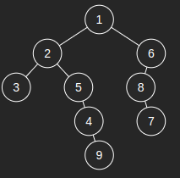 | Input: [1,2,6,3,5,8,null,null,null,null,4,null,7,null,9]  Output: [3,9,4,5,2,7,8,6,1]

Constraints:
- The number of the nodes in the tree is in the range [0, 100].
- -100 <= Node.val <= 100

145. Binary Tree Postorder Traversal
/*
Recursion DFS
Time complexity: O(n)
Space complexity: O(n)
n: #nodes in the binary tree
*/
typedef std::vector<int> vi;
class Solution {
public:
vi ans={};
public:
vi postorderTraversal(TreeNode* root) {
if(!root) return ans;
postorderTraversal(root->left);
postorderTraversal(root->right);
ans.push_back(root->val);
return ans;
}
};

145. Binary Tree Postorder Traversal
/*
Iterative DFS
Time complexity: O(n)
Space complexity: O(n)
n: #nodes in the binary tree
*/
typedef std::vector<int> vi;
class Solution {
public:
vi postorderTraversal(TreeNode* root) {
if(!root) return {};
vi ans;
std::stack<TreeNode*> st;
st.push(root);
while(!st.empty()){
auto cur_node=st.top();
st.pop();
ans.push_back(cur_node->val);
if(cur_node->left) st.push(cur_node->left);
if(cur_node->right) st.push(cur_node->right);
}
reverse(ans.begin(),ans.end());
return ans;
}
};

145. Binary Tree Postorder Traversal
/*
Morris: adapted to post traversal
Time complexity: O(n)
Space complexity: O(1)
n: #nodes in the binary tree
*/
typedef std::vector<int> vi;
class Solution {
public:
vi postorderTraversal(TreeNode* root) {
vi ans;
TreeNode* cur=root;
while (cur){
TreeNode* ptr = cur->right;
if (!ptr) {
ans.push_back(cur->val);
cur=cur->left;
}
else {
while (ptr->left && ptr->left!=cur) ptr=ptr->left;

if (!ptr->left) {
ans.push_back(cur->val);
ptr->left = cur;
cur=cur->right;
}
else {
ptr->left = NULL;
cur=cur->left;
}
}
}

reverse(ans.begin(), ans.end());
return ans;
}
};

