94. Binary Tree Inorder Traversal
Given the root of a binary tree, return the inorder traversal of its nodes' values.
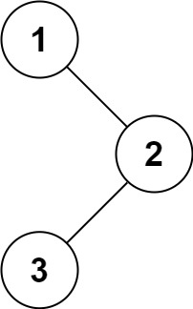
Example 1:
Input: root = [1,null,2,3]
Output: [1,3,2]
Example 2:
Input: root = []
Output: []
Example 3:
Input: root = [1]
Output: [1]
Example 4:
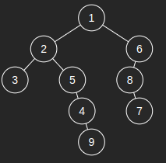 | Input: [1,2,6,3,5,8,null,null,null,null,4,null,7,null,9]  Output: [3,2,5,4,9,1,8,7,6]
Constraints:
- The number of nodes in the tree is in the range [0, 100].
- -100 <= Node.val <= 100

Follow up: Recursive solution is trivial, could you do it iteratively?

94. Binary Tree Inorder Traversal
/*
Morris
Time complexity: O(n)
Space complexity: O(1)
n: #nodes in the binary tree
*/

typedef std::vector<int> vi;

class Solution {
public:
vi inorderTraversal(TreeNode* root) {
vi ans;
TreeNode* cur=root;
while(cur){
TreeNode* ptr=cur->left;
if(!ptr){
ans.push_back(cur->val);
cur=cur->right;
}
else{
while(ptr->right) ptr=ptr->right;
ptr->right=cur;
TreeNode* temp=cur;
cur=cur->left;
temp->left=nullptr;
}
}
return ans;
}
};

