1514. Path with Maximum Probability
You are given an undirected weighted graph of n nodes (0-indexed), represented by an edge list where edges[i] = [a, b] is an undirected edge connecting the nodes a and b with a probability of success of traversing that edge succProb[i].
Given two nodes start and end, find the path with the maximum probability of success to go from start to end and return its success probability.
If there is no path from start to end, return 0. Your answer will be accepted if it differs from the correct answer by at most 1e-5.
Example 1:
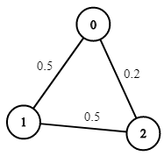 | Input: n = 3, edges = [[0,1],[1,2],[0,2]], succProb = [0.5,0.5,0.2], start = 0, end = 2  Output: 0.25000  Explanation: There are two paths from start to end, one having a probability of success = 0.2 and the other has 0.5 * 0.5 = 0.25.
Example 2:
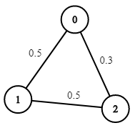 | Input: n = 3, edges = [[0,1],[1,2],[0,2]], succProb = [0.5,0.5,0.3], start = 0, end = 2  Output: 0.30000
Example 3:
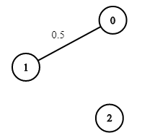 | Input: n = 3, edges = [[0,1]], succProb = [0.5], start = 0, end = 2  Output: 0.00000  Explanation: There is no path between 0 and 2.
Constraints:
- 2 <= n <= 10^4
- 0 <= start, end < n
- start != end
- 0 <= a, b < n
- a != b
- 0 <= succProb.length == edges.length <= 2*10^4
- 0 <= succProb[i] <= 1
- There is at most one edge between every two nodes.

1514. Path with Maximum Probability
/*
Anti Dijkstra
Time complexity: O(m+nm)=O(nm)
Space complexity: O(n+n+nm+2n)=O(n+nm)=O(nm)
n: #nodes
m: #edges
*/
typedef std::vector<int> vi;
typedef std::vector<vi> vvi;

typedef std::pair<double,int> di;
typedef std::vector<di> vdi;
typedef std::vector<vdi> vvdi;

typedef std::vector<double> vd;

class Solution {
vvdi graph;
public:
void build_graph(int n,vvi& edges, vd& succProb){
int m=edges.size();
graph.resize(n);
for(int i=0;i<m;++i){
auto edge=edges[i];
int u= edge[0];
int v= edge[1];
double w=succProb[i];
graph[u].push_back({w,v});
graph[v].push_back({w,u});
}
}

double anti_dijkstra(int n,int start, int target){
vd ans(n,INT_MIN);
ans[start]=1;
vi visited(n,false);
std::priority_queue<di,vdi,std::greater<di>> min_heap;
min_heap.push({0,start});
while(!min_heap.empty()){
di cur=min_heap.top();
min_heap.pop();
int u=cur.second;
if(visited[u]) continue;
visited[u]=true;
if(u==target) return ans[u];
for(auto& edge: graph[u]){
int v=edge.second;
double w=edge.first;
if(ans[v]<=ans[u]*w){
ans[v]=ans[u]*w;
min_heap.push({1.0/ans[v],v});
}
}
}
return ans[target]!=INT_MIN?ans[target]:0;
}

double maxProbability(int n, vvi& edges, vd& succProb, int start_node, int end_node){
build_graph(n,edges,succProb);
return anti_dijkstra(n,start_node,end_node);
}
};

