3217. Delete Nodes From Linked List Present in Array
You are given an array of integers nums and the head of a linked list. Return the head of the modified linked list after removing all nodes from the linked list that have a value that exists in nums.
Example 1:
Input: nums = [1,2,3], head = [1,2,3,4,5]  Output: [4,5] | Explanation:  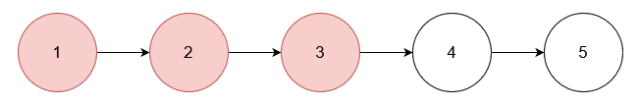  Remove the nodes with values 1, 2, and 3.
Example 2:

Input: nums = [1], head = [1,2,1,2,1,2]  Output: [2,2,2] | Explanation:  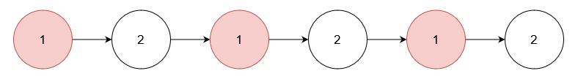  Remove the nodes with value 1.
Example 3:

Input: nums = [5], head = [1,2,3,4]  Output: [1,2,3,4] | Explanation:  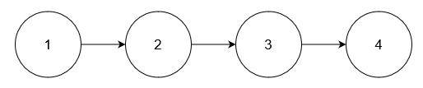  No node has value 5.

Constraints:
- 1 <= nums.length <= 105
- 1 <= nums[i] <= 105
- All elements in nums are unique.
- The number of nodes in the given list is in the range [1, 105].
- 1 <= Node.val <= 105
- The input is generated such that there is at least one node in the linked list that has a value not present in nums.

3217. Delete Nodes From Linked List Present in Array
/**
* Definition for singly-linked list.
* struct ListNode {
* int val;
* ListNode *next;
* ListNode() : val(0), next(nullptr) {}
* ListNode(int x) : val(x), next(nullptr) {}
* ListNode(int x, ListNode *next) : val(x), next(next) {}
* };
*/

3217. Delete Nodes From Linked List Present in Array
/*
Sorting+Binary search (Memory leaks)
if head... else...

Time complexity: O(nlogn)
Space complexity: O(logn)
*/
typedef std::vector<int> vi;

class Solution {
public:
ListNode* modifiedList(vi& nums, ListNode* head){
std::sort(nums.begin(),nums.end());

ListNode* fast=head;
ListNode* slow=head;
while(fast){
if(std::binary_search(nums.begin(),nums.end(),fast->val)){
if(fast==head) {
head=head->next;
fast=slow=head;
}
else{
slow->next=fast->next;
fast=fast->next;
}
}
else{
slow=fast;
fast=fast->next;
}
}
return head;
}
};

3217. Delete Nodes From Linked List Present in Array
/*
Sorting+Binary search (Memory leaks)
Use dummy node to make a unified pattern to all nodes

Time complexity: O(nlogn)
Space complexity: O(logn)
*/
typedef std::vector<int> vi;
class Solution {
public:
ListNode* modifiedList(vi& nums, ListNode* head){
std::sort(nums.begin(),nums.end());

ListNode* dummy=new ListNode(0,head);
ListNode* fast=head;
ListNode* slow=dummy;
while(fast){
if(std::binary_search(nums.begin(),nums.end(),fast->val)) slow->next=fast->next;
else slow=fast;
fast=fast->next;
}
return dummy->next;
}
};

3217. Delete Nodes From Linked List Present in Array
/*
Sorting+Binary search (No memory leaks)
Use dummy node to make a unified pattern to all nodes

Time complexity: O(nlogn)
Space complexity: O(logn)
*/
typedef std::vector<int> vi;
class Solution {
public:
ListNode* modifiedList(vi& nums, ListNode* head){
std::sort(nums.begin(),nums.end());

ListNode* dummy=new ListNode(0,head);
ListNode* fast=head;
ListNode* slow=dummy;
ListNode* to_delete=nullptr;

while(fast){
if(std::binary_search(nums.begin(),nums.end(),fast->val)){
slow->next=fast->next;
to_delete=fast;
}
else slow=fast;

fast=fast->next;
delete to_delete;
to_delete=nullptr;
}

head=fast=slow=to_delete=nullptr;

return dummy->next;
}
};

3217. Delete Nodes From Linked List Present in Array
/*
bitset (No memeory leaks)
Use dummy node to make a unified pattern to all nodes

Time complexity: O(n)
Space complexity: O(10^5)
*/
typedef std::vector<int> vi;
class Solution {
public:
ListNode* modifiedList(vi& nums, ListNode* head){
std::bitset<100001> to_delete=0;
for(auto& e: nums) to_delete[e]=1;

ListNode* dummy=new ListNode(0,head);
ListNode* fast=head;
ListNode* slow=dummy;
ListNode* to_delete_ptr=nullptr;

while(fast){
if(to_delete[fast->val]){
slow->next=fast->next;
to_delete_ptr=fast;
}
else slow=fast;

fast=fast->next;
delete to_delete_ptr;
to_delete_ptr=nullptr;
}

head=fast=slow=to_delete_ptr=nullptr;

return dummy->next;
}
};

