1367. Linked List in Binary Tree
Given a binary tree root and a linked list with head as the first node.
Return True if all the elements in the linked list starting from the head correspond to some downward path connected in the binary tree otherwise return False.
In this context downward path means a path that starts at some node and goes downwards.
Example 1:
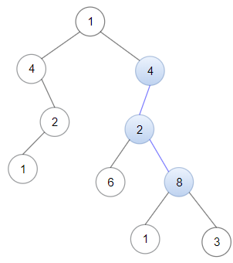 | Input: head = [4,2,8], root = [1,4,4,null,2,2,null,1,null,6,8,null,null,null,null,1,3]  Output: true  Explanation: Nodes in blue form a subpath in the binary Tree.
Example 2:
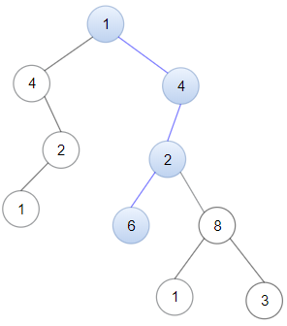 | Input: head = [1,4,2,6], root = [1,4,4,null,2,2,null,1,null,6,8,null,null,null,null,1,3]  Output: true
Example 3:
Input: head = [1,4,2,6,8], root = [1,4,4,null,2,2,null,1,null,6,8,null,null,null,null,1,3]
Output: false
Explanation: There is no path in the binary tree that contains all the elements of the linked list from head.
Constraints:
- The number of nodes in the tree will be in the range [1, 2500].
- The number of nodes in the list will be in the range [1, 100].
- 1 <= Node.val <= 100 for each node in the linked list and binary tree.

1367. Linked List in Binary Tree
/*
DFS (inorder)
Time complexity: O(nm)
Space complexity: O(n)
n: number of nodes in binary tree
m: number of nodes in linked list
*/
class Solution {
public:
bool dfs(TreeNode*& root,ListNode* head,ListNode* cur){
if(!cur) return true;
if(!root) return false;

if(root->val==cur->val) cur=cur->next;
else if(root->val==head->val) head=head->next;
else cur=head;

return dfs(root->left,head,cur) || dfs(root->right,head,cur);

}

bool isSubPath(ListNode* head, TreeNode* root) {
return dfs(root,head,head);
}
};

