2326. Spiral Matrix IV
You are given two integers m and n, which represent the dimensions of a matrix.
You are also given the head of a linked list of integers.
Generate an m x n matrix that contains the integers in the linked list presented in spiral order (clockwise), starting from the top-left of the matrix. If there are remaining empty spaces, fill them with -1.
Return the generated matrix.
Example 1:
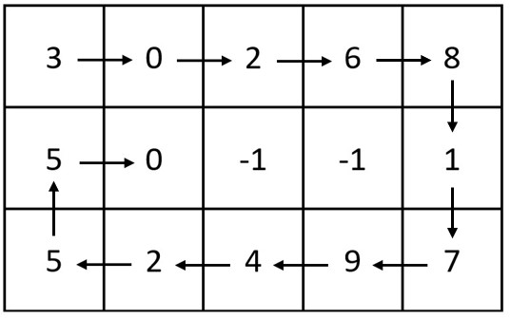 | Input: m = 3, n = 5, head = [3,0,2,6,8,1,7,9,4,2,5,5,0]  Output: [[3,0,2,6,8],[5,0,-1,-1,1],[5,2,4,9,7]]  Explanation: The diagram above shows how the values are printed in the matrix.  Note that the remaining spaces in the matrix are filled with -1.
Example 2:
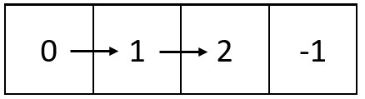 | Input: m = 1, n = 4, head = [0,1,2]  Output: [[0,1,2,-1]]  Explanation: The diagram above shows how the values are printed from left to right in the matrix.  The last space in the matrix is set to -1.
Constraints:
- 1 <= m, n <= 105
- 1 <= m * n <= 105
- The number of nodes in the list is in the range [1, m * n].
- 0 <= Node.val <= 1000

2326. Spiral Matrix IV
/**
* Definition for singly-linked list.
* struct ListNode {
* int val;
* ListNode *next;
* ListNode() : val(0), next(nullptr) {}
* ListNode(int x) : val(x), next(nullptr) {}
* ListNode(int x, ListNode *next) : val(x), next(next) {}
* };
*/

2326. Spiral Matrix IV
/*
Time complexity: O(L*(m+n))
Space complexity: O(1)
L: size of the linked list
m: number of rows
n: number of columns
*/
typedef std::vector<int> vi;
typedef std::vector<vi> vvi;
class Solution {
public:
vvi spiralMatrix(int m, int n, ListNode* head){
int top=0,right=n-1,bottom=m-1,left=0;
vvi ans(m,vi(n,-1));
bool ok=left<=right && top<=bottom;
ListNode* trav=head;
while(trav&&ok){
if(ok){
for(int i=left;trav!=nullptr && i<=right;++i){
ans[top][i]=trav->val;
trav=trav->next;
}
top++;
for(int i=top;trav!=nullptr && i<=bottom;++i){
ans[i][right]=trav->val;
trav=trav->next;
}
right--;
}
ok=left<=right && top<=bottom;
if(ok){
for(int i=right;trav!=nullptr && i>=left;--i){
ans[bottom][i]=trav->val;
trav=trav->next;
}
bottom--;

for(int i=bottom;trav!=nullptr && i>=top;--i){
ans[i][left]=trav->val;
trav=trav->next;
}
left++;
}
}
return ans;
}};

