2022. Convert 1D Array Into 2D Array
You are given a 0-indexed 1-dimensional (1D) integer array original, and two integers, m and n. You are tasked with creating a 2-dimensional (2D) array with m rows and n columns using all the elements from original.
The elements from indices 0 to n - 1 (inclusive) of original should form the first row of the constructed 2D array, the elements from indices n to 2 * n - 1 (inclusive) should form the second row of the constructed 2D array, and so on.
Return an m x n 2D array constructed according to the above procedure, or an empty 2D array if it is impossible.
Example 1:
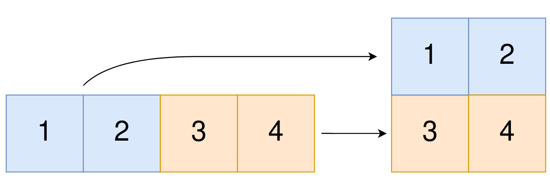 | Input: original = [1,2,3,4], m = 2, n = 2  Output: [[1,2],[3,4]]  Explanation: The constructed 2D array should contain 2 rows and 2 columns.  The first group of n=2 elements in original, [1,2], becomes the first row in the constructed 2D array.  The second group of n=2 elements in original, [3,4], becomes the second row in the constructed 2D array.
Example 2:
Input: original = [1,2,3], m = 1, n = 3
Output: [[1,2,3]]
Explanation: The constructed 2D array should contain 1 row and 3 columns.
Put all three elements in original into the first row of the constructed 2D array.
Example 3:
Input: original = [1,2], m = 1, n = 1
Output: []
Explanation: There are 2 elements in original.
It is impossible to fit 2 elements in a 1x1 2D array, so return an empty 2D array.

Constraints:
- 1 <= original.length <= 5 * 104
- 1 <= original[i] <= 105
- 1 <= m, n <= 4 * 104

2022. Convert 1D Array Into 2D Array
/*
Time complexity: O(m*n)
Space complexity: O(1)
*/
typedef std::vector<int> vi;
typedef std::vector<std::vector<int>> vvi;
class Solution {
public:
vvi construct2DArray(vi& original, int m, int n) {
if(m*n!=original.size()) return {};
vvi ans(m,vi(n));
for(int i=0;i<m;++i){
for(int j=0;j<n;++j){
ans[i][j]=original[i*n+j];
}
}
return ans;
}
};

2022. Convert 1D Array Into 2D Array
/*
Time complexity: O(m*n)
Space complexity: O(1)
*/
typedef std::vector<int> vi;
typedef std::vector<std::vector<int>> vvi;
class Solution {
public:
vvi construct2DArray(vi& original, int m, int n) {
if(m*n!=original.size()) return {};
vvi ans(m);
for(int i=0;i<m;++i){
ans[i]=vi(original.begin()+(i*n),original.begin()+(i*n+n));
}
return ans;
}
};

