2641. Cousins in Binary Tree II
Given the root of a binary tree, replace the value of each node in the tree with the sum of all its cousins' values.
Two nodes of a binary tree are cousins if they have the same depth with different parents.
Return the root of the modified tree.
Note that the depth of a node is the number of edges in the path from the root node to it.
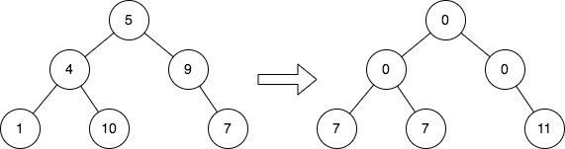
Example 1:
Input: root = [5,4,9,1,10,null,7]
Output: [0,0,0,7,7,null,11]
Explanation: The diagram above shows the initial binary tree and the binary tree after changing the value of each node.
- Node with value 5 does not have any cousins so its sum is 0.
- Node with value 4 does not have any cousins so its sum is 0.
- Node with value 9 does not have any cousins so its sum is 0.
- Node with value 1 has a cousin with value 7 so its sum is 7.
- Node with value 10 has a cousin with value 7 so its sum is 7.
- Node with value 7 has cousins with values 1 and 10 so its sum is 11.
Example 2:
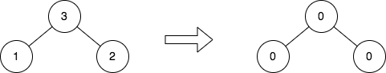

Input: root = [3,1,2]
Output: [0,0,0]
Explanation: The diagram above shows the initial binary tree and the binary tree after changing the value of each node.
- Node with value 3 does not have any cousins so its sum is 0.
- Node with value 1 does not have any cousins so its sum is 0.
- Node with value 2 does not have any cousins so its sum is 0.
Constraints:
- The number of nodes in the tree is in the range [1, 105].
- 1 <= Node.val <= 104

2641. Cousins in Binary Tree II
/*
Two passes BFS (level order traversal)
Time complexity:
Space complexity:
: total number of nodes in the tree
: height of the binary tree=
*/
class Solution{
public:
TreeNode* replaceValueInTree(TreeNode* root){
if(!root) return root;

std::queue<TreeNode*> q;
std::vector<long long> levels_sums;

// Pass1: compute the sum of each level
q.push(root);

while(!q.empty()){
int cur_subtree_size=q.size();
long long s=0;
while(cur_subtree_size>0){
TreeNode* cur_node=q.front();
q.pop();

cur_subtree_size--;

s+=cur_node->val;

if(cur_node->left) q.push(cur_node->left);
if(cur_node->right) q.push(cur_node->right);
}

levels_sums.push_back(s);
}

// Pass2:
q.push(root);
int level=1;
root->val=0;
while(!q.empty()){
int cur_subtree_size=q.size();
while(cur_subtree_size>0){
TreeNode* cur_node=q.front();
q.pop();

cur_subtree_size--;

int brothers_sums=0;
if(cur_node->left) brothers_sums=cur_node->left->val;
if(cur_node->right) brothers_sums+=cur_node->right->val;

if(cur_node->left) cur_node->left->val=levels_sums[level]-brothers_sums,q.push(cur_node->left);
if(cur_node->right) cur_node->right->val=levels_sums[level]-brothers_sums,q.push(cur_node->right);
}

level++;
}

return root;
}
};

2641. Cousins in Binary Tree II
/*
One passe BFS (level order traversal)
Time complexity: Ω(n),O(n)
Space complexity: Ω(n),O(n)
n: total number of nodes in the tree
*/
class Solution{
public:
TreeNode* replaceValueInTree(TreeNode* root){
if(!root) return root;
std::queue<TreeNode*> q;
q.push(root);
int prev_level_sum=root->val;
while(!q.empty()){
int cur_subtree_size=q.size();
long long cur_level_sum=0;
while(cur_subtree_size>0){
TreeNode* cur_node=q.front();
q.pop();
cur_subtree_size--;
// Update node value to cousin sum.
cur_node->val=prev_level_sum-cur_node->val;
// Compute the sum for both the brothers
int brothers_sum=0;
if(cur_node->left) brothers_sum=cur_node->left->val;
if(cur_node->right) brothers_sum+=cur_node->right->val;
if(cur_node->left){
cur_level_sum += cur_node->left->val; // Accumulate current level sum.
cur_node->left->val=brothers_sum; // Update left child's value.
q.push(cur_node->left); // Add to queue for next level.
}
if(cur_node->right){
cur_level_sum += cur_node->right->val; // Accumulate current level sum.
cur_node->right->val=brothers_sum; // Update left child's value.
q.push(cur_node->right); // Add to queue for next level.
}
}
prev_level_sum=cur_level_sum; // Update previous level for next iteration
}
return root;
}
};

