951. Flip Equivalent Binary Trees
For a binary tree T, we can define a flip operation as follows: choose any node, and swap the left and right child subtrees.
A binary tree X is flip equivalent to a binary tree Y if and only if we can make X equal to Y after some number of flip operations.
Given the roots of two binary trees root1 and root2, return true if the two trees are flip equivalent or false otherwise.
Example 1:
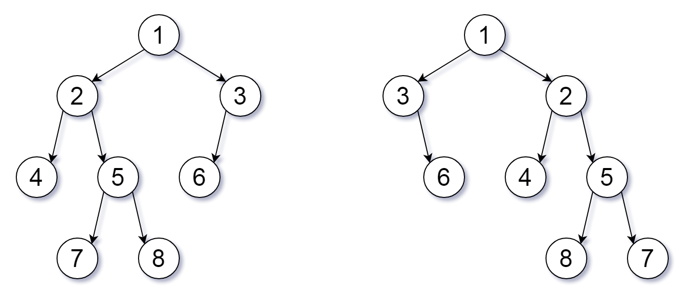
Input: root1 = [1,2,3,4,5,6,null,null,null,7,8], root2 = [1,3,2,null,6,4,5,null,null,null,null,8,7]
Output: true
Explanation: We flipped at nodes with values 1, 3, and 5.
Example 2:
Input: root1 = [], root2 = []
Output: true
Example 3:
Input: root1 = [], root2 = [1]
Output: false
Constraints:
- The number of nodes in each tree is in the range [0, 100].
- Each tree will have unique node values in the range [0, 99].

951. Flip Equivalent Binary Trees
/*
DFS: Recursion
Time complexity: O(n)
Space complexity: O(n)
n: number of nodes
*/
class Solution{
public:
bool flipEquiv(TreeNode* root1, TreeNode* root2){
if(!root1 || !root2) return root1==root2;
if(root1->val==root2->val)
return flipEquiv(root1->left,root2->left) && flipEquiv(root1->right,root2->right)
|| flipEquiv(root1->left,root2->right) && flipEquiv(root1->right,root2->left);

return false;
}
};

951. Flip Equivalent Binary Trees
/*
DFS: Iterative
Time complexity: O(n)
Space complexity: O(n)
n: number of nodes
*/
class Solution{
public:
bool check(TreeNode* node1,TreeNode* node2){
if(!node1 || !node2) return node1==node2;
return node1->val == node2->val;
}
bool flipEquiv(TreeNode* root1, TreeNode* root2){
std::stack<std::pair<TreeNode*,TreeNode*>> st;
st.push({root1,root2});
while(!st.empty()){
auto[node1,node2]=st.top();
st.pop();
// If both nodes are null, go the next level
if(!node1 && !node2) continue;
// If one of the nodes is null and the other is not null
// means the current subtrees have not same structure
// so the trees are not the same
if(!node1 || !node2) return false;
// If both nodes are not null, check their values
// This done in the function `check(TreeNode*,TreeNode*)`
// return `false`, if the have node the same values
if(!check(node1,node2)) return false;

// Check if the left and right children are the same, il we leave
// the them as they are (no swap)
else if(check(node1->left,node2->left) && check(node1->right,node2->right)){
st.push({node1->left,node2->left});
st.push({node1->right,node2->right});
}
// Check if the left and right children are the same, il we swap them
else if(check(node1->left,node2->right) && check(node1->right,node2->left)) {
st.push({node1->left,node2->right});
st.push({node1->right,node2->left});
}
// If they are the same in return false
else return false;
}
// If no false is returned, means:
// Both given binary trees are equivalent, either with swap ot not
return true;
}
};

951. Flip Equivalent Binary Trees
/*
Canonical forms
Time complexity: O(n)
Space complexity: O(n)
n: number of nodes
*/
class Solution {
public:
void canonical_form(TreeNode*& root){
if(!root) return;

// DFS preorder
canonical_form(root->left);
canonical_form(root->right);

// If no right child, back to parent
if(!root->right) return;

// If no left child
if(!root->left){
root->left=root->right; // right child become left child
root->right=nullptr; // No right child
return;
}

// If both of left and right child exist
TreeNode* left=root->left;
TreeNode* right=root->right;

// If left child's value is greater than right child's value
if(left->val<right->val){
root->left=right; // parent's left child points to the parent's right child
root->right=left; // parent's right child points to the parent's left child
}
}

bool flipEquiv(TreeNode* root1, TreeNode* root2){
canonical_form(root1);
canonical_form(root2);

if(!root1 || !root2) return root1==root2;
if(root1->val==root2->val)
return flipEquiv(root1->left,root2->left) && flipEquiv(root1->right,root2->right);
return false;
}
};

